**SCREENSHOTS OF PROJECT**

**TIMETABLE GENERATOR**

**THARUN BHARGAV 18BCE1314**

**ARAVIND KRISHNA 18BCE1315**

**1. Selecting year.**

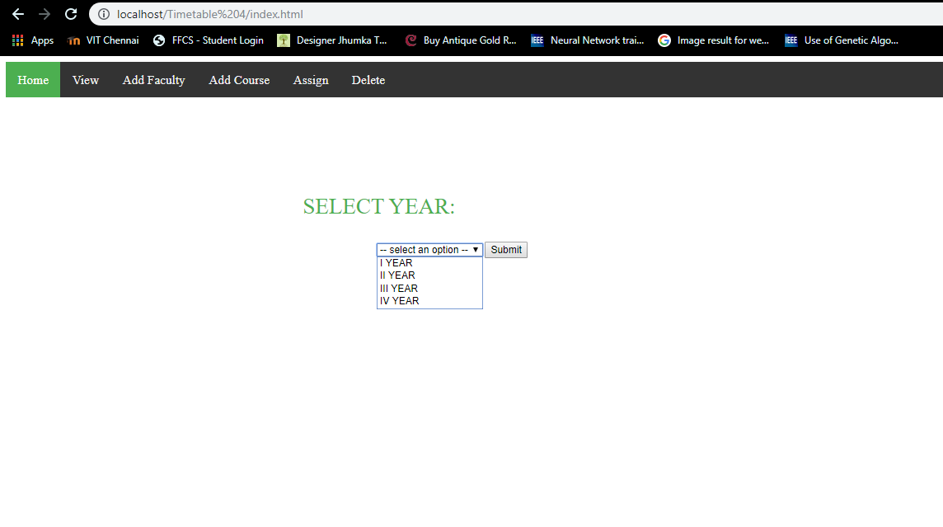

**2. Selecting department.**

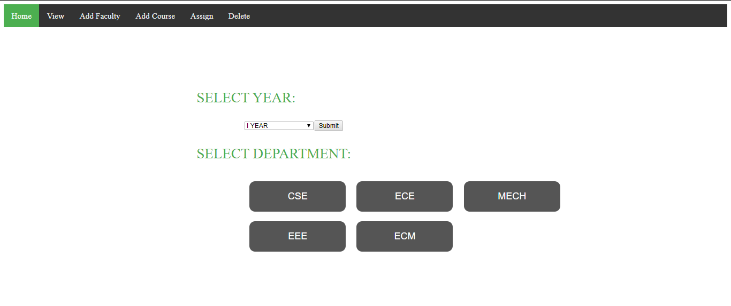

**3. Selecting subjects or courses.**

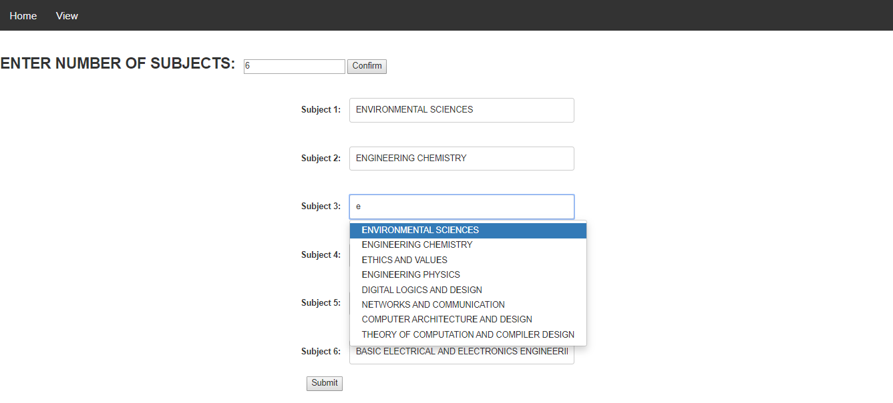

**4. Once submitted, generate option will be available if timetable is possible.**

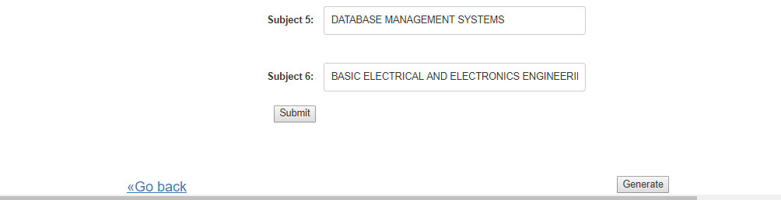

**If not possible,**

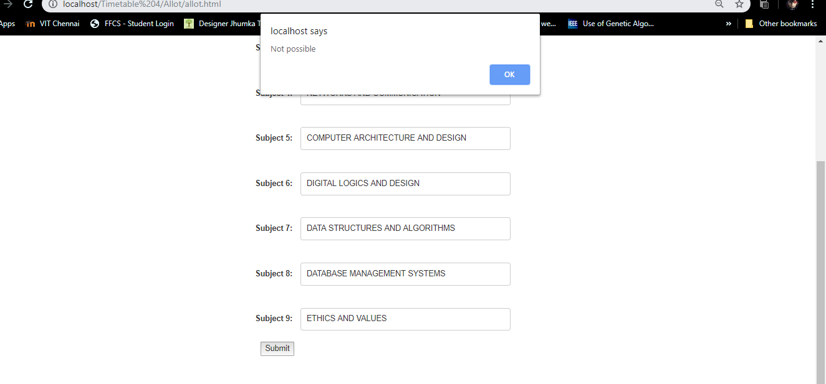

**5. Viewing the generated timetable.**

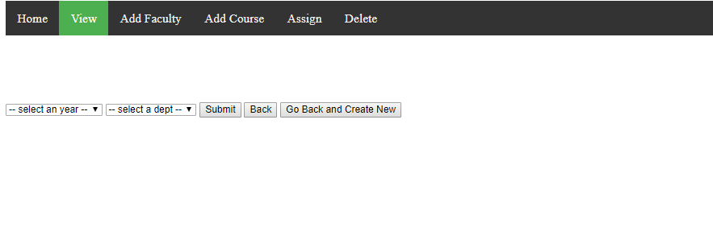

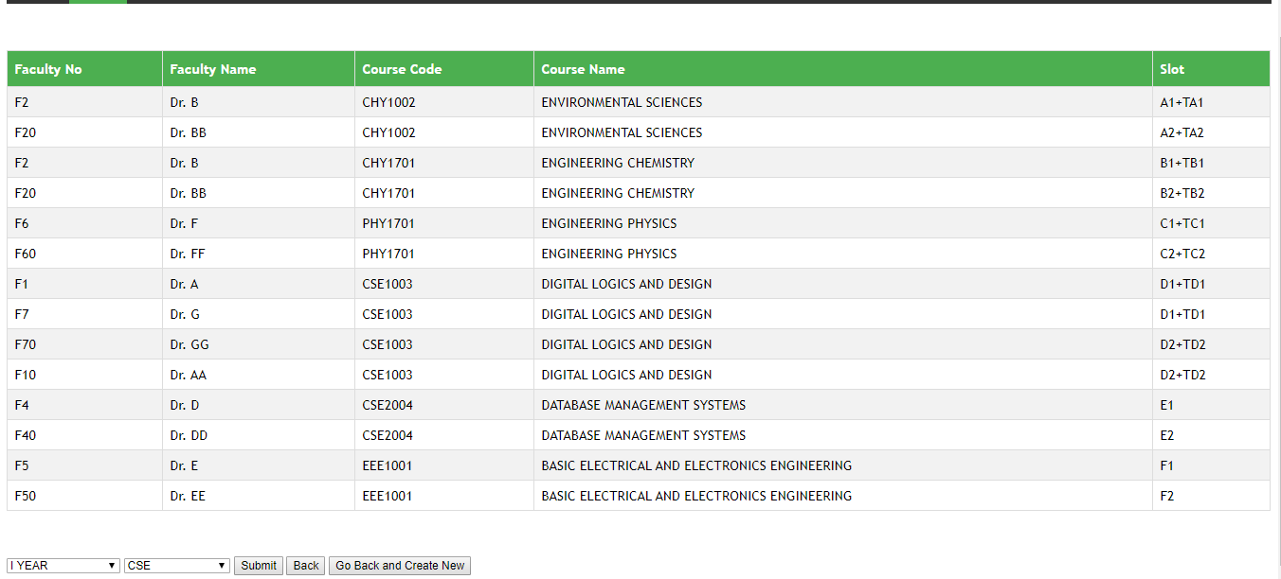

**6. Slot allotment for 1st and 2nd year CSE.**

**1ST YEAR:**

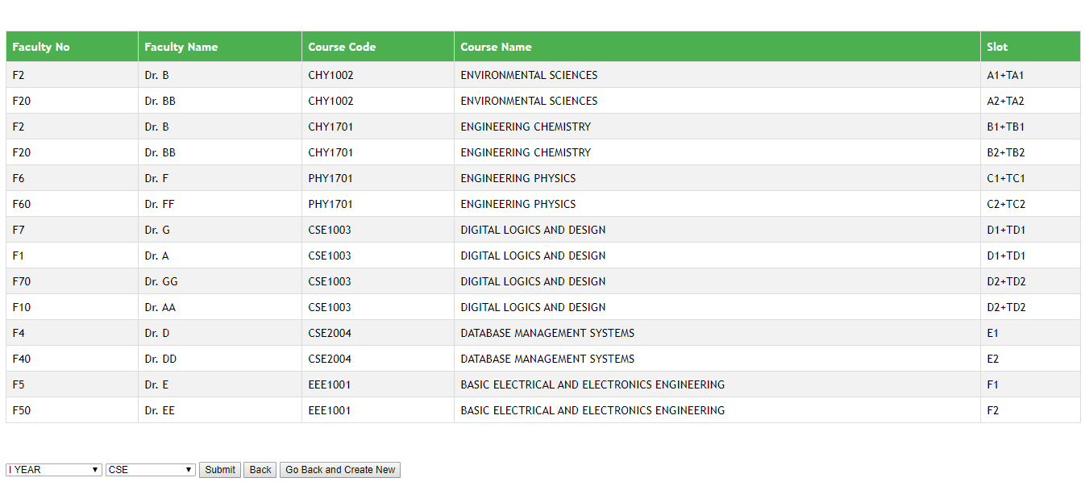

**2nd YEAR:**

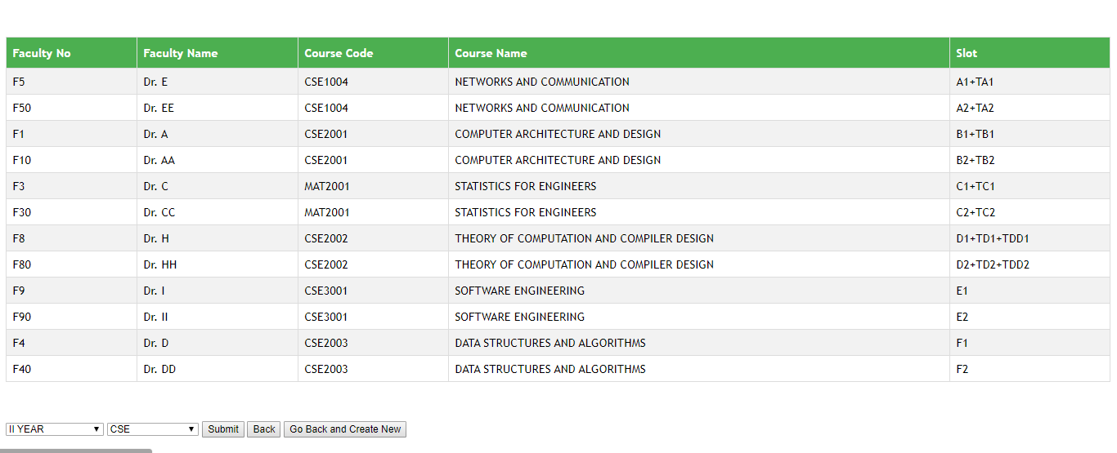

**Faculties are allotted to slots without overlap.**

**7. Adding Faculty.**

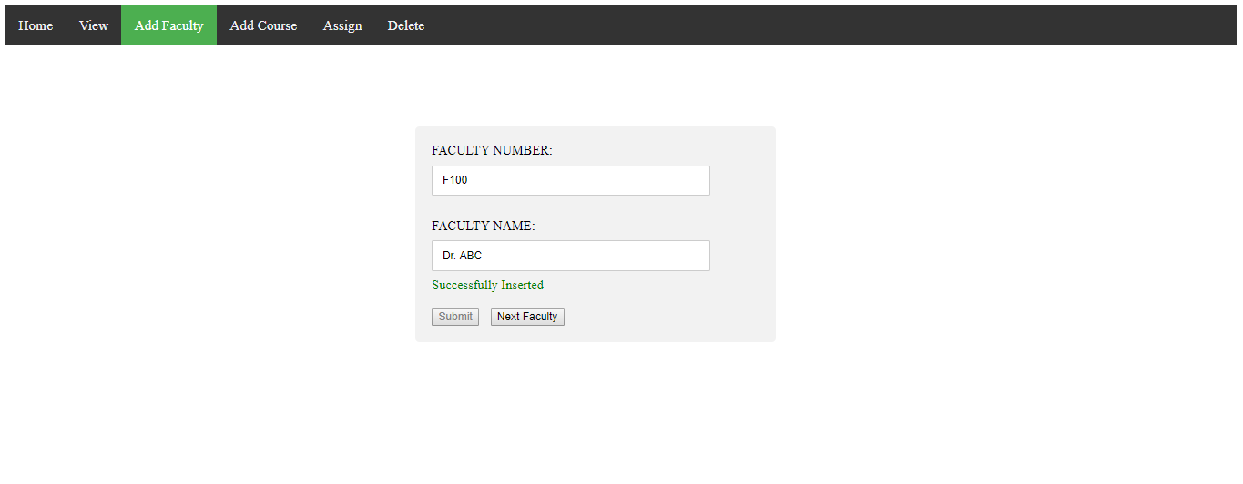

**8. Adding Courses.**

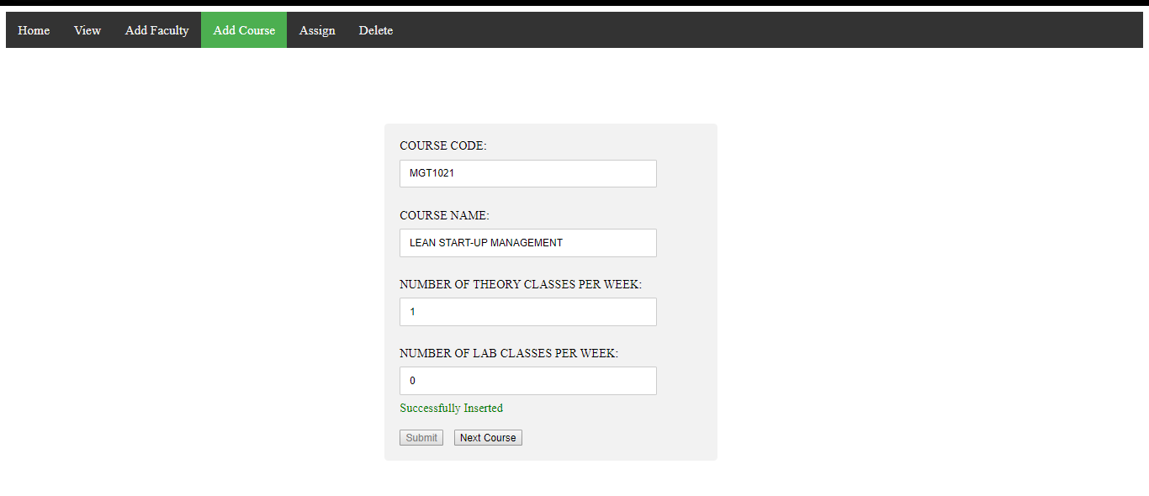

**9. Assigning Faculty to course.**

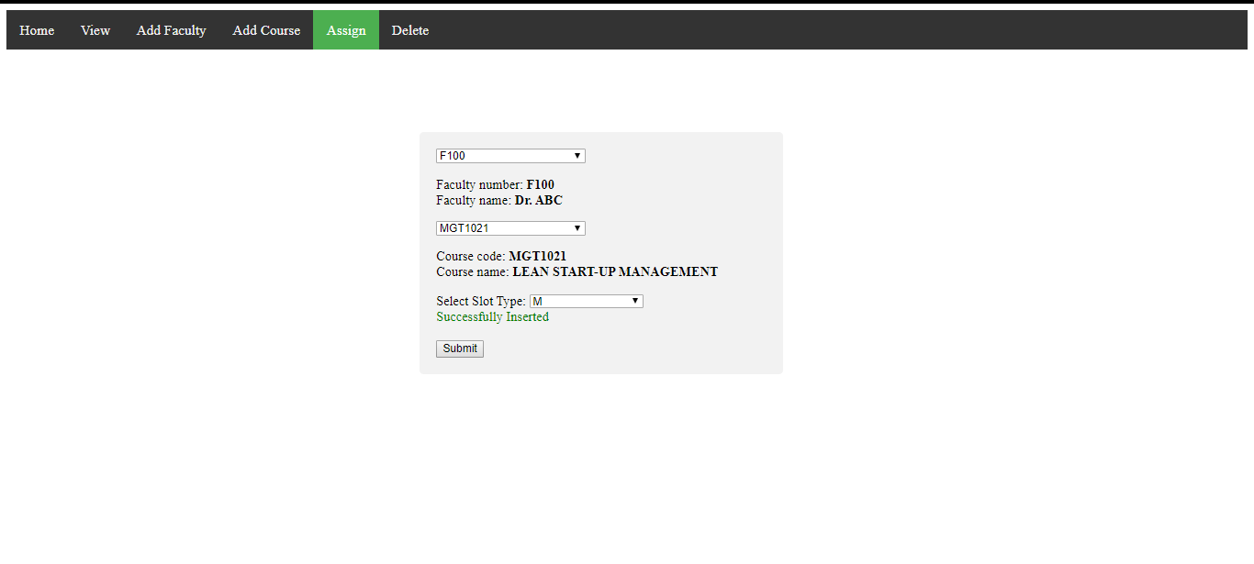

**10. Deletion.**

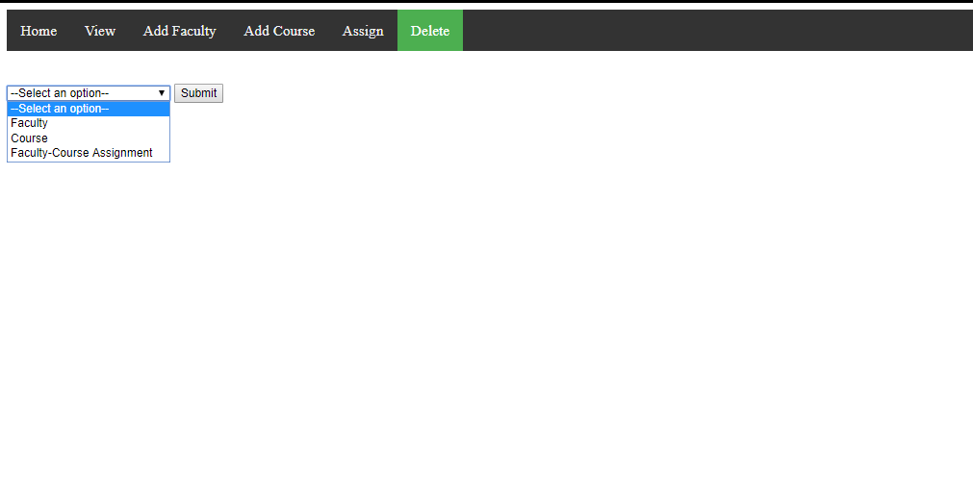

**I) Deleting Faculty-Course Assignment.**

**Before,**

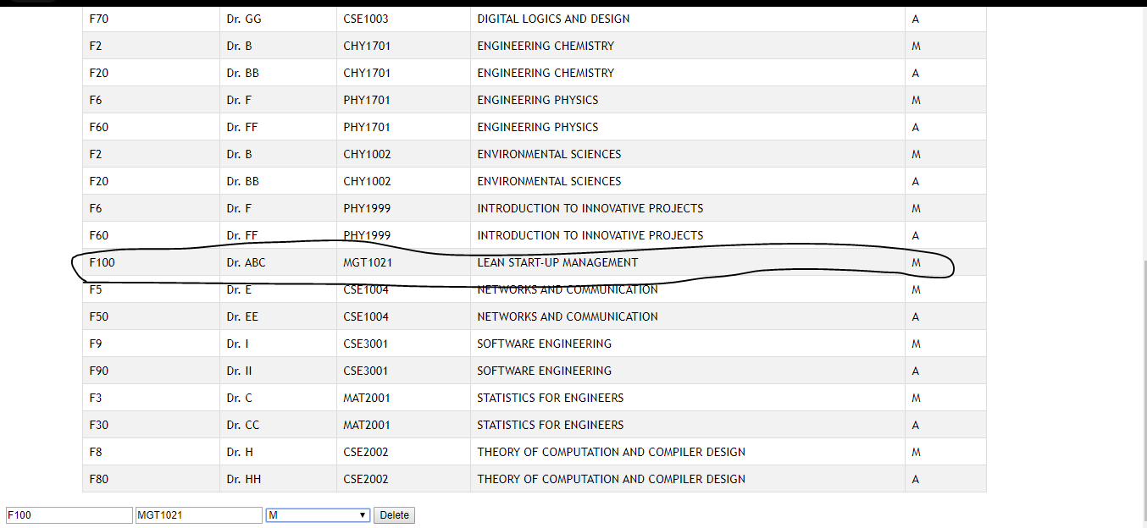

**After,**

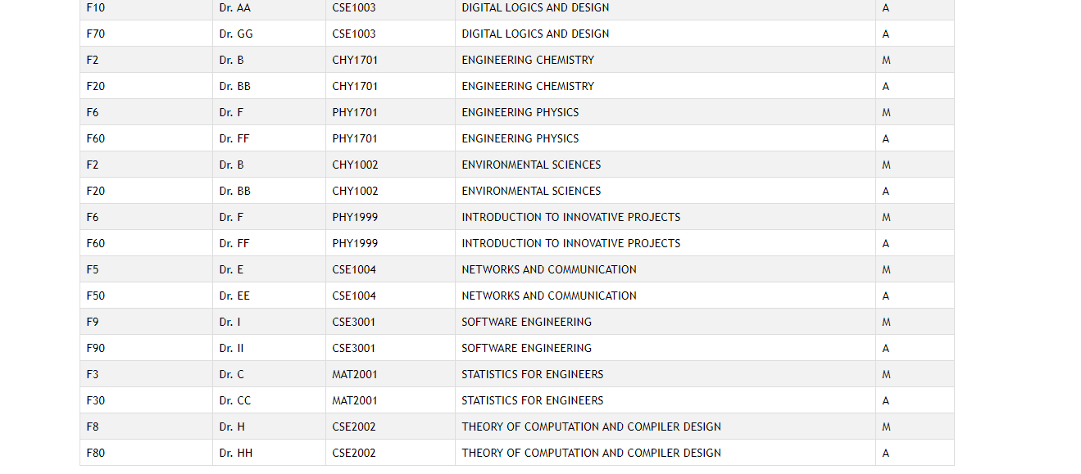

**Similarly,**

**II) Deleting Course.**

**Before,**

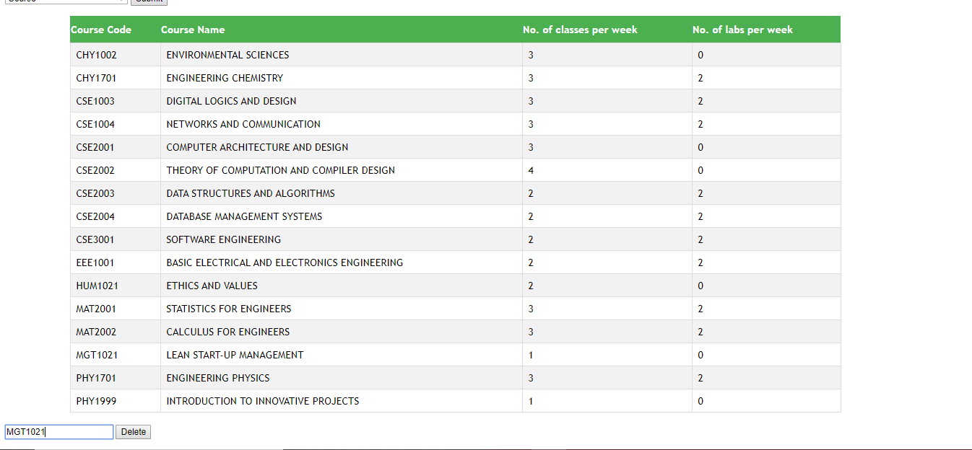

**After,**

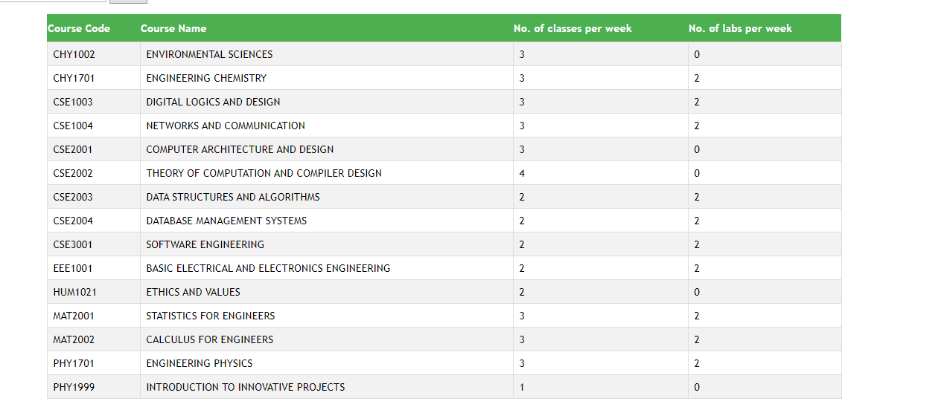

**III) Deleting Faculty.**

**Before,**

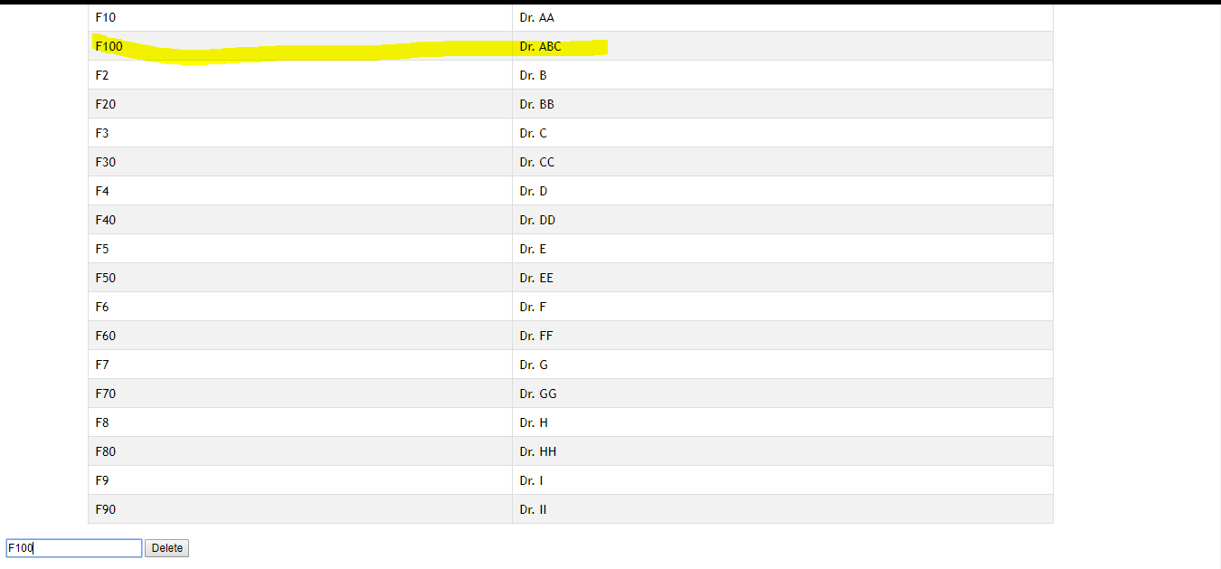

**After,**

