**Write a program to implement word count using Pig.**

**INPUT FILE:**

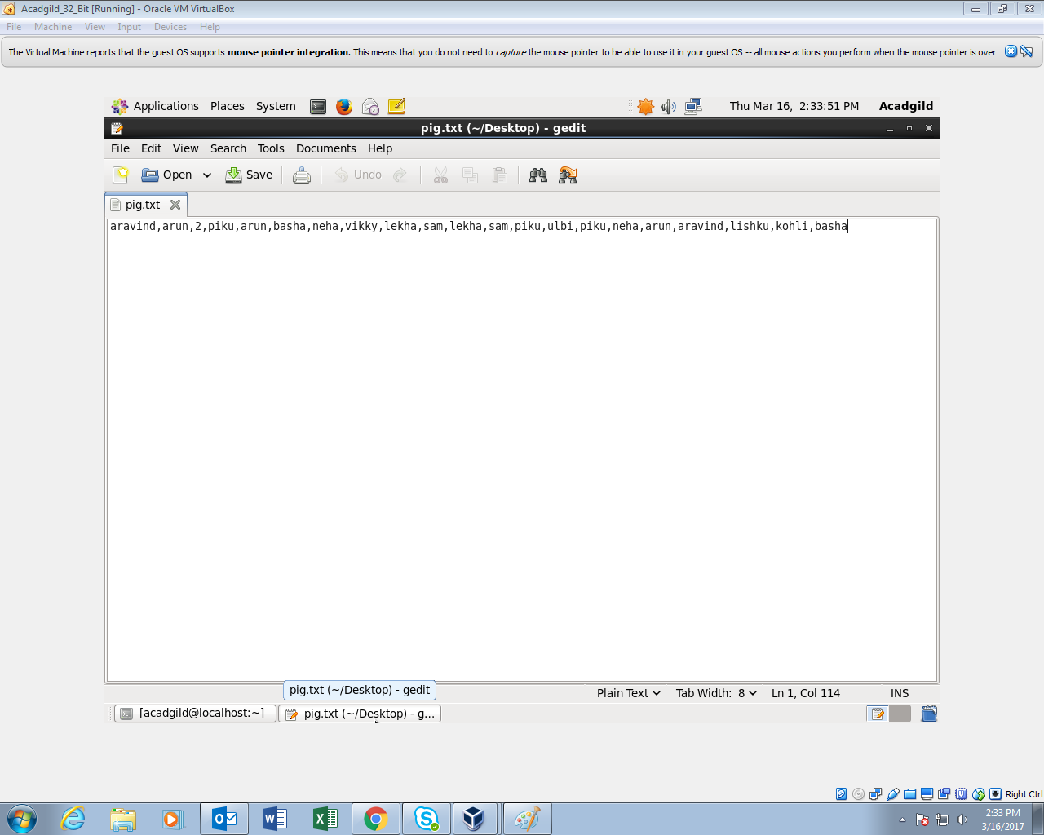

**COMMANDS USED:**

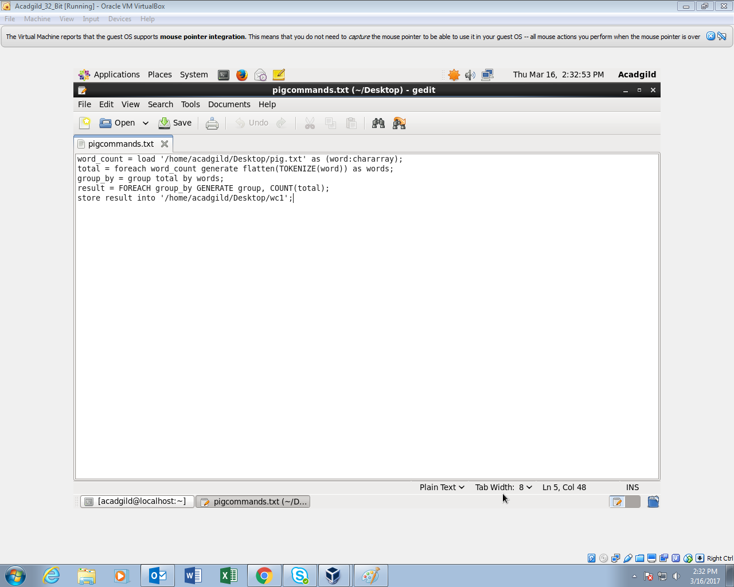

1. **The File for which the word count has to be performed is fed into the pig shell with the help of LOAD COMMAND**
2. **Flatten command is used to convert bag in to tuples.**
3. **Group by command groups similar words**
4. **Count command counts the grouped words**
5. **Store command stores the processed o/p as a text file.**

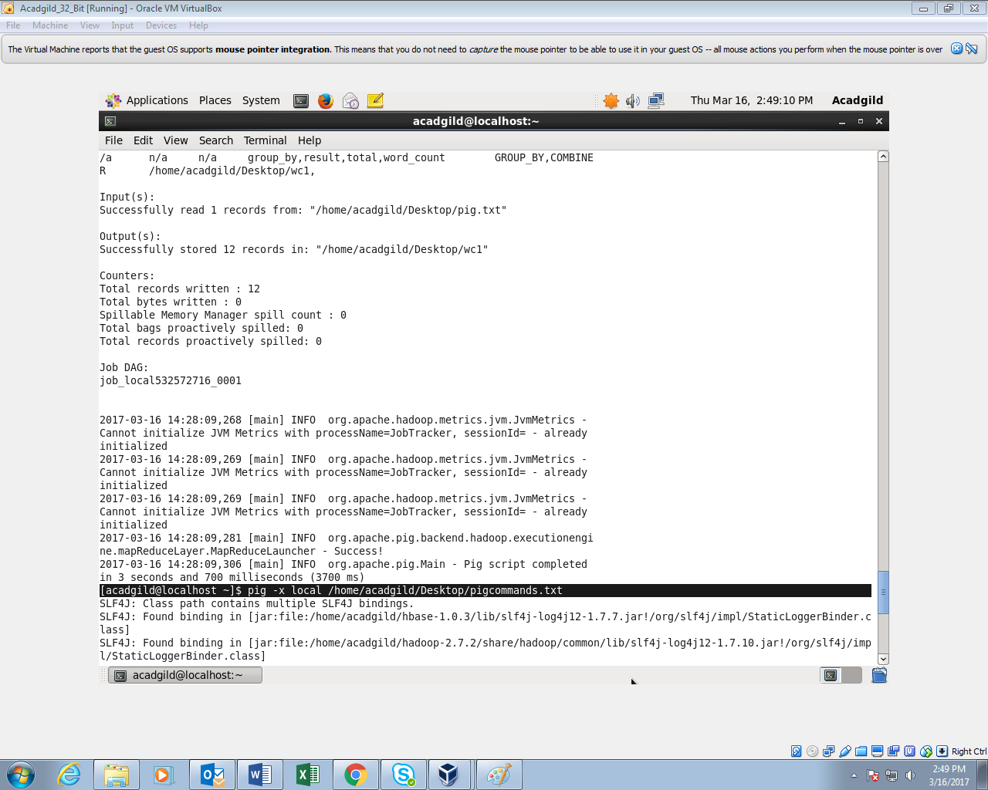

**OUTPUT FILE :**

