**10.4.1:**

**Write a pig script find the average age of male and female persons died in the titanic tragedy**

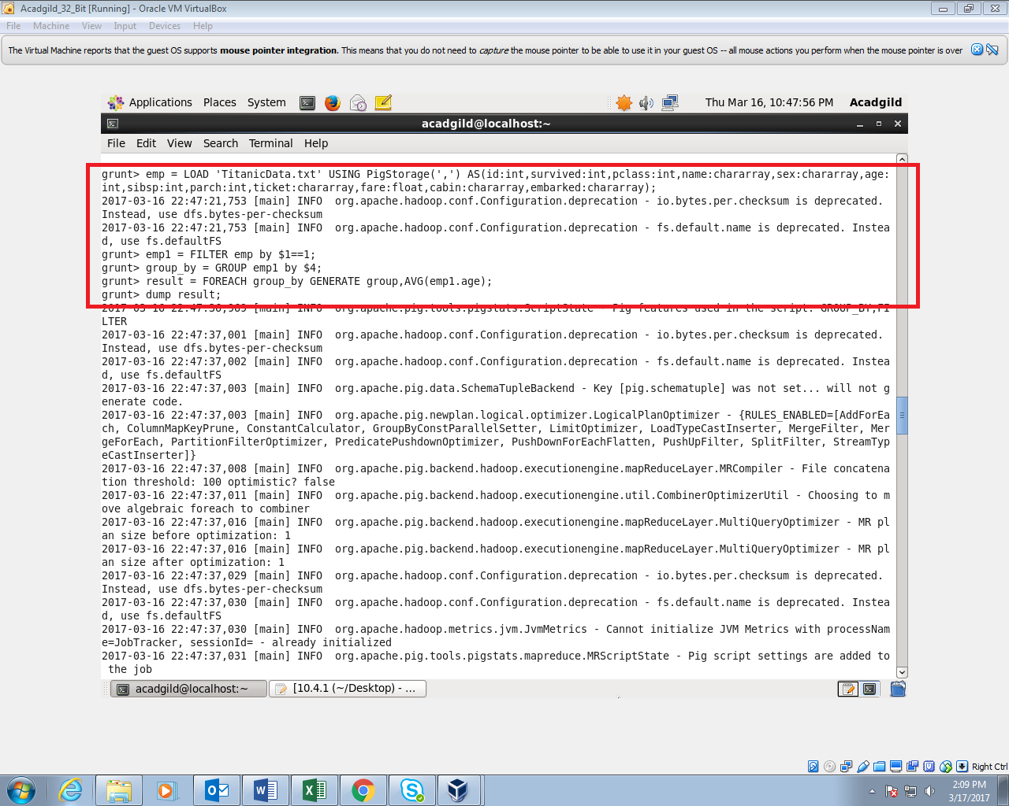

**OUTPUT:**

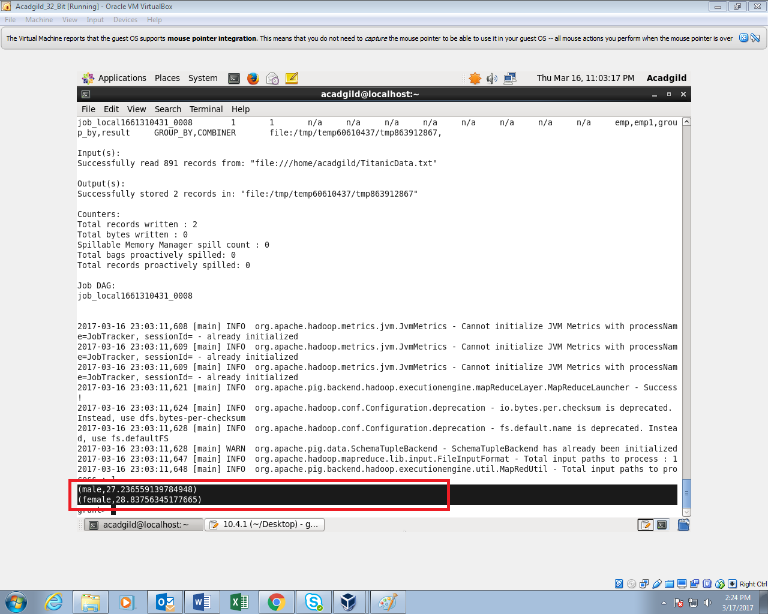

**10.4.2:**

**Write a pig script to find the number of people died and survived in each class.**

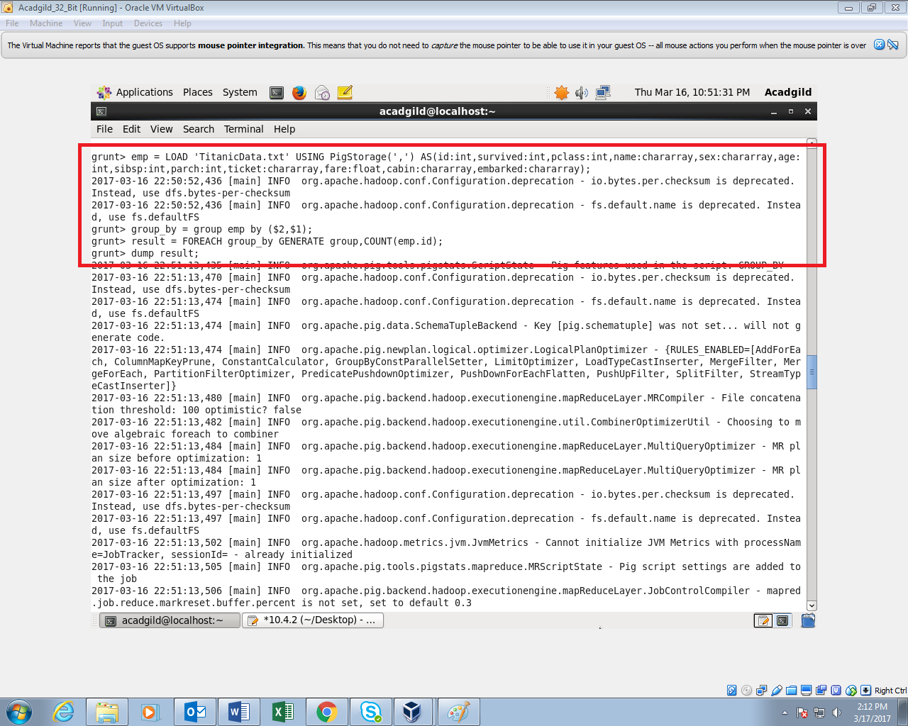

**OUTPUT:**

