1. **What is the total amount of petrol in volume sold by every distributor?**

**Grouping by Distributor name using group by cmd.**

**Summing the out volumes using sum cmd.**

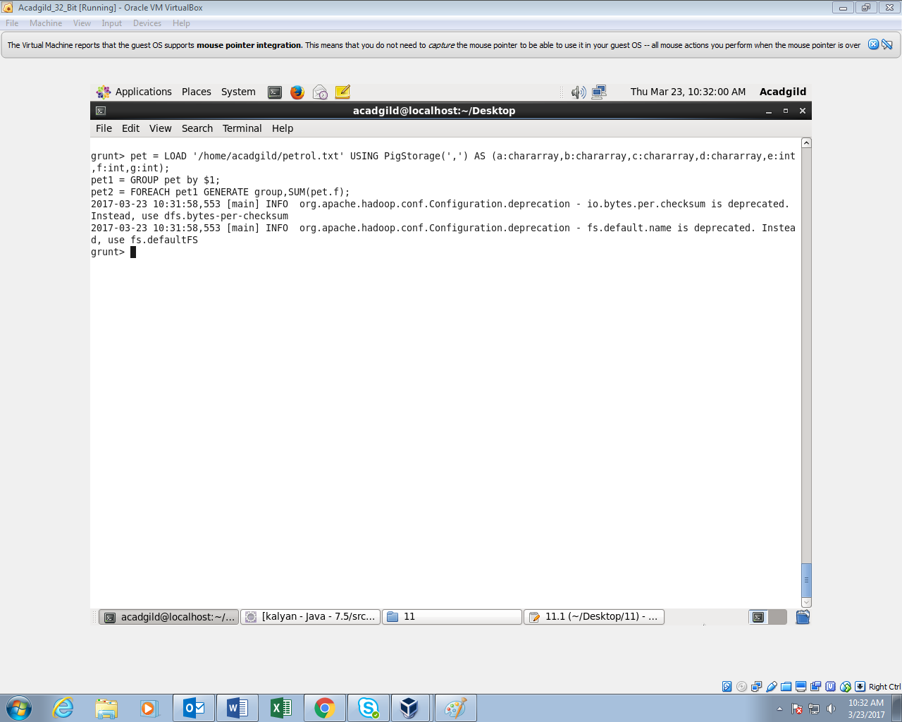

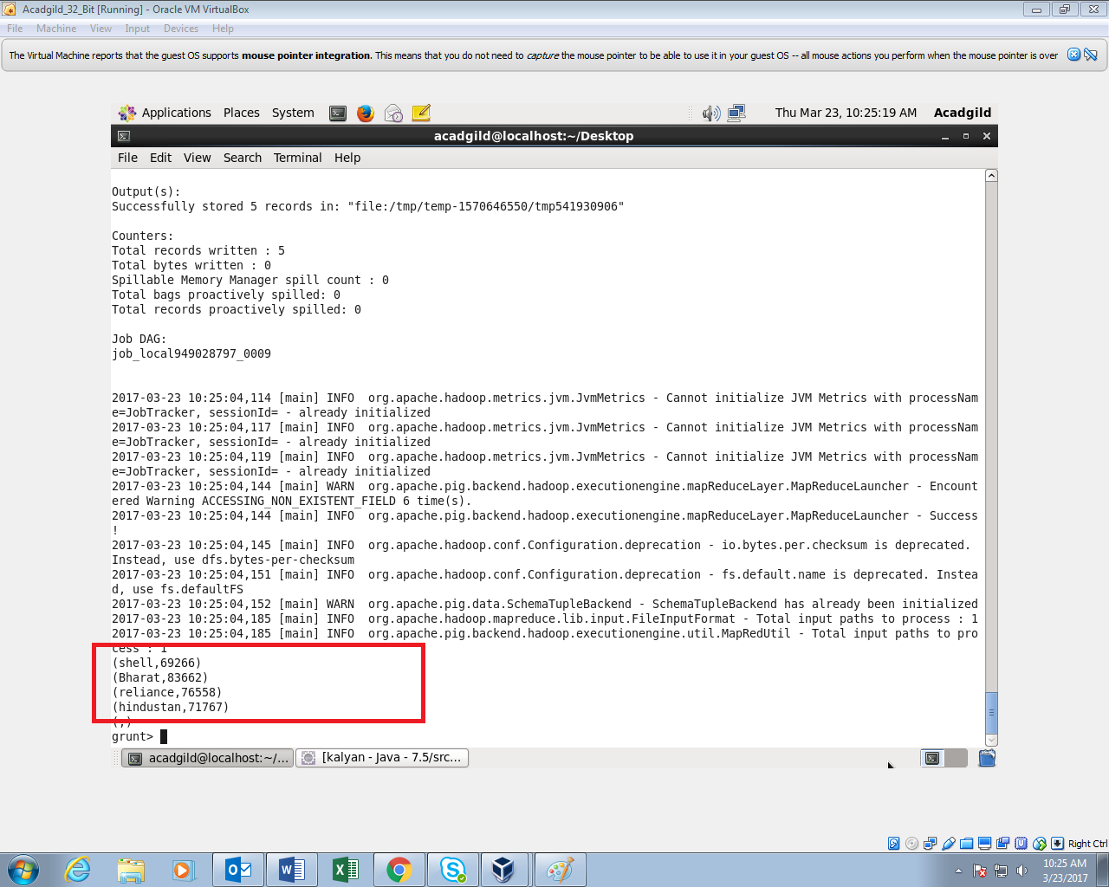

1. **Which are the top 10 distributors ID's for selling petrol? Also display the amount of petrol sold in volume.**

**Grouping by distributor id**

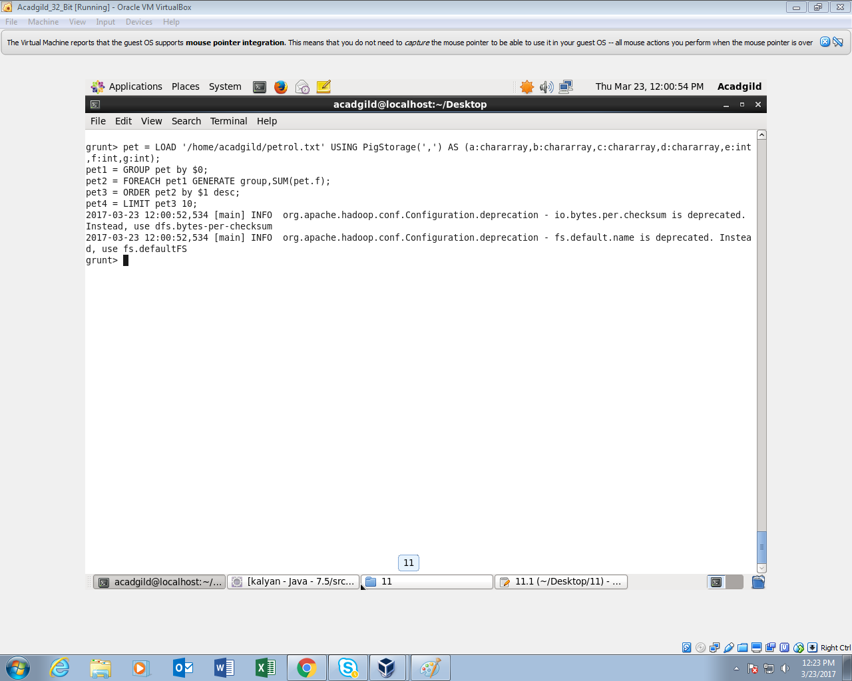

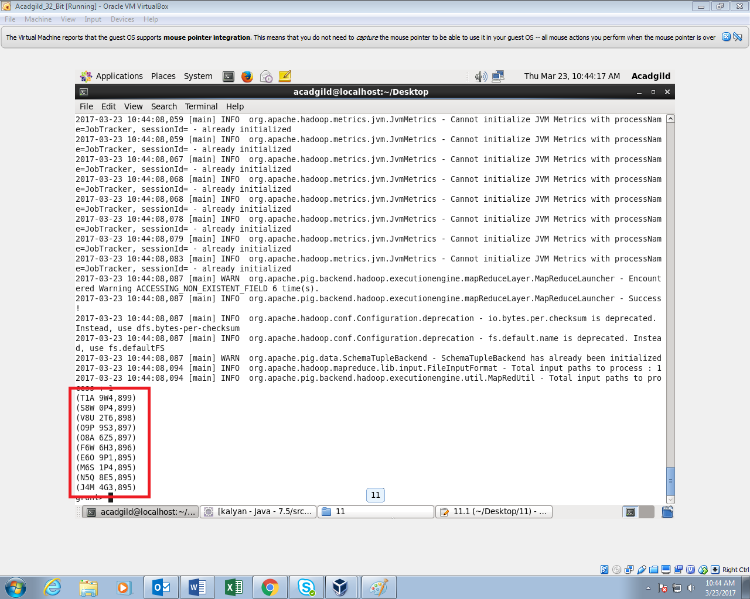

1. **List 10 years where consumption of petrol is more with the distributer id who sold it.**

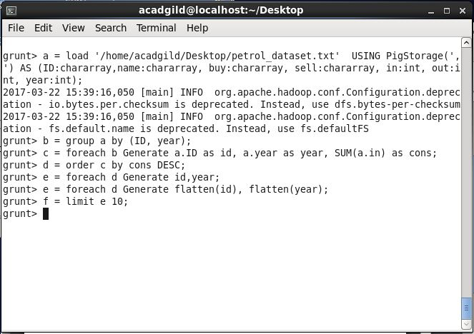

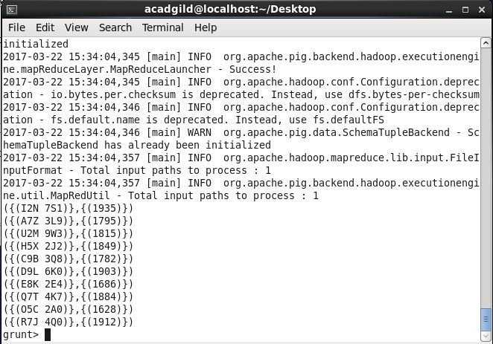

1. **Find the distributer name who sold petrol in least amount.**

