**Write a custom key to evaluate the number of people who died and the number of people who survived, along with their genders.**

**DRIVER CLASS:**

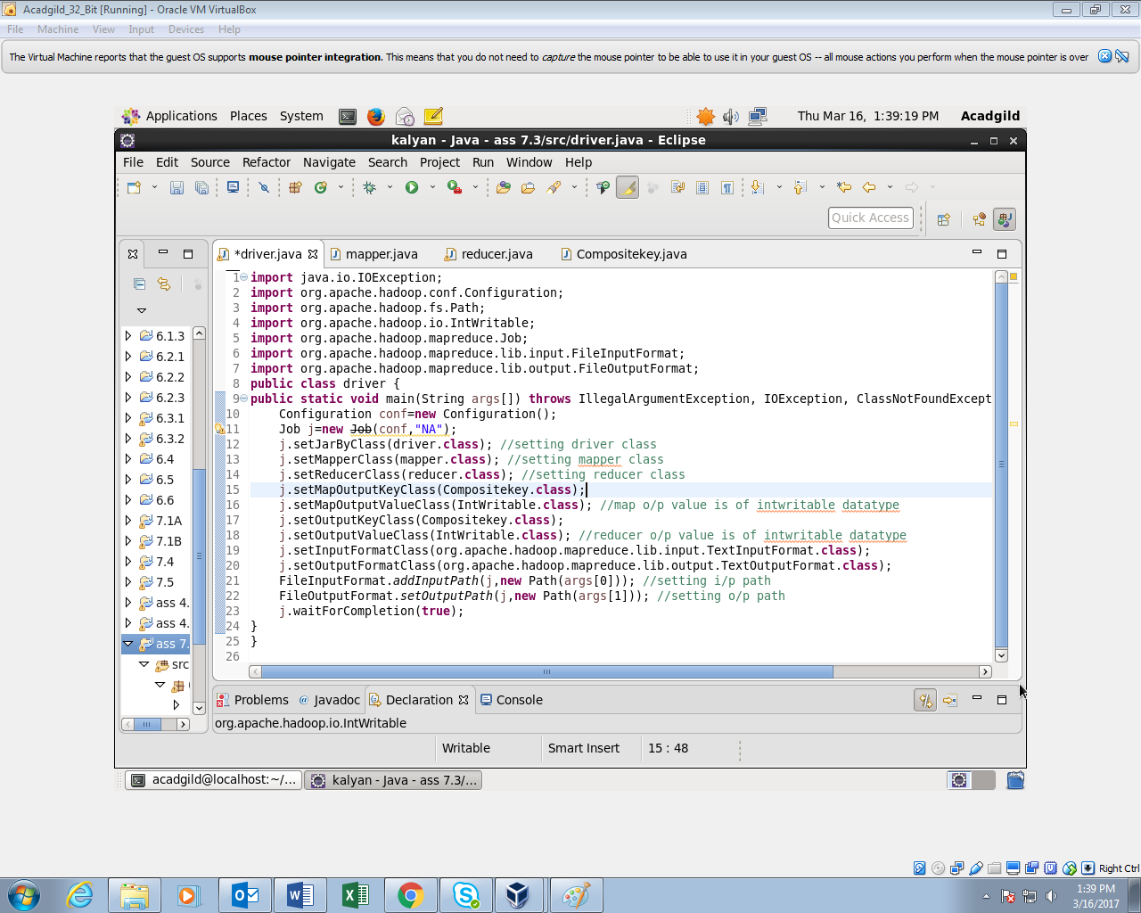

**MAPPER CLASS:**

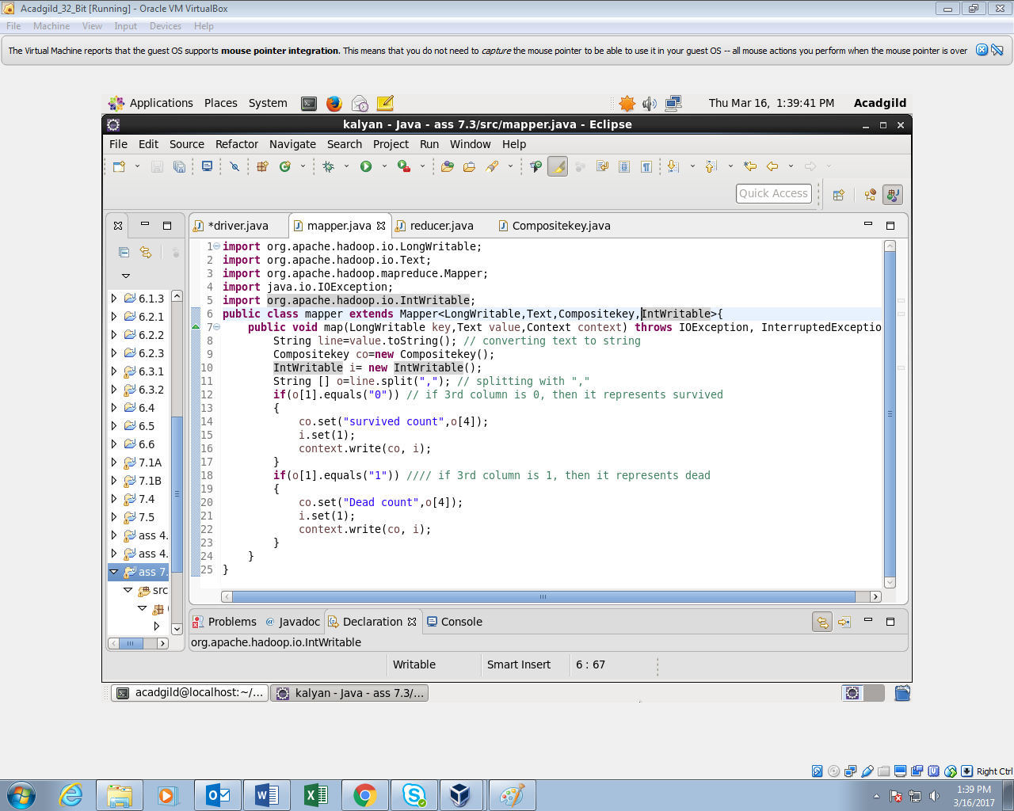

**COMPOSITE KEY:**

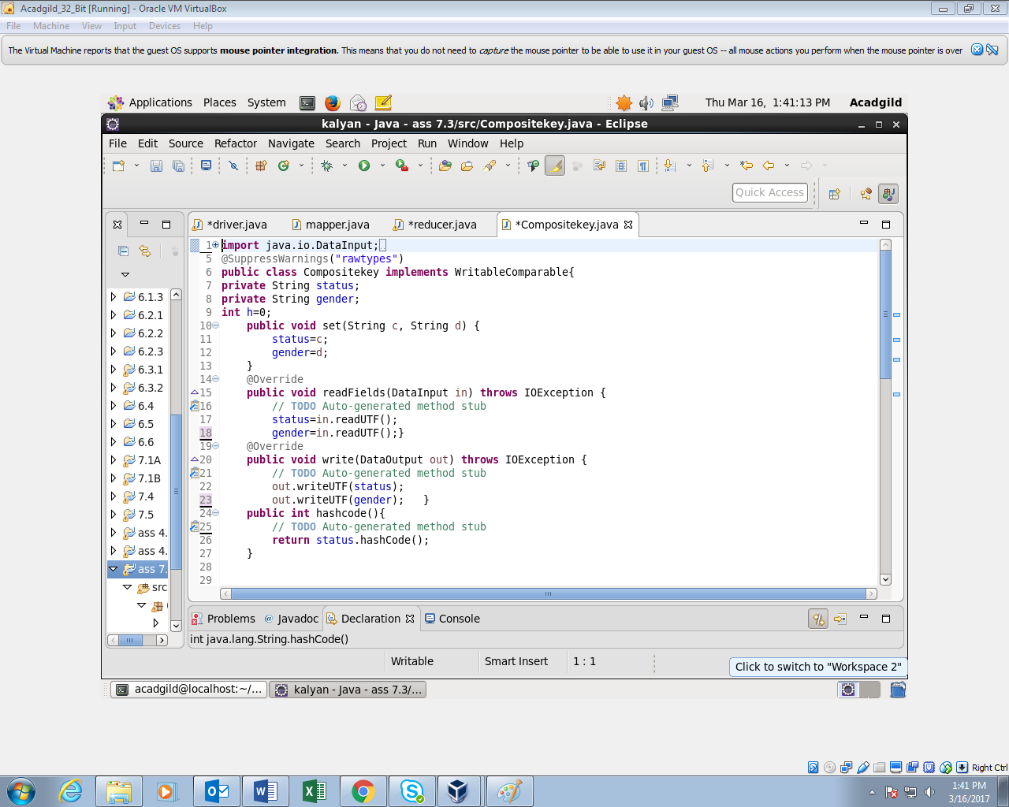

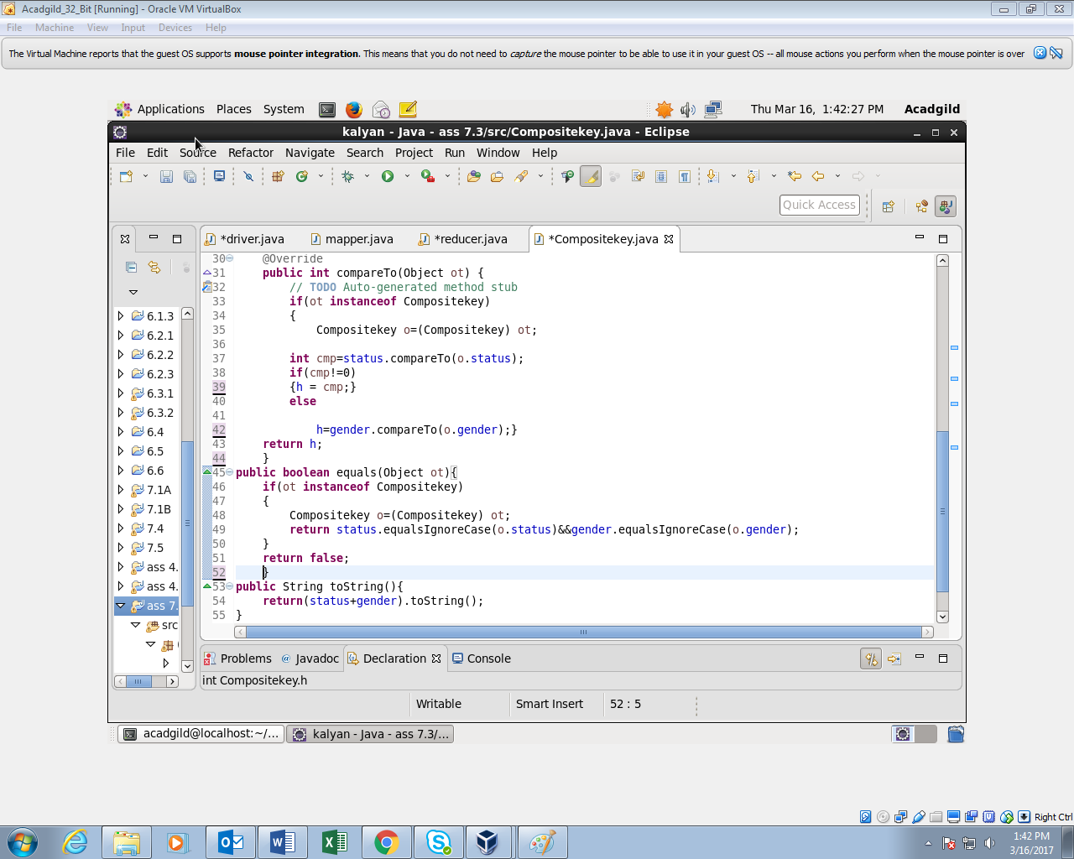

**REDUCER CLASS:**

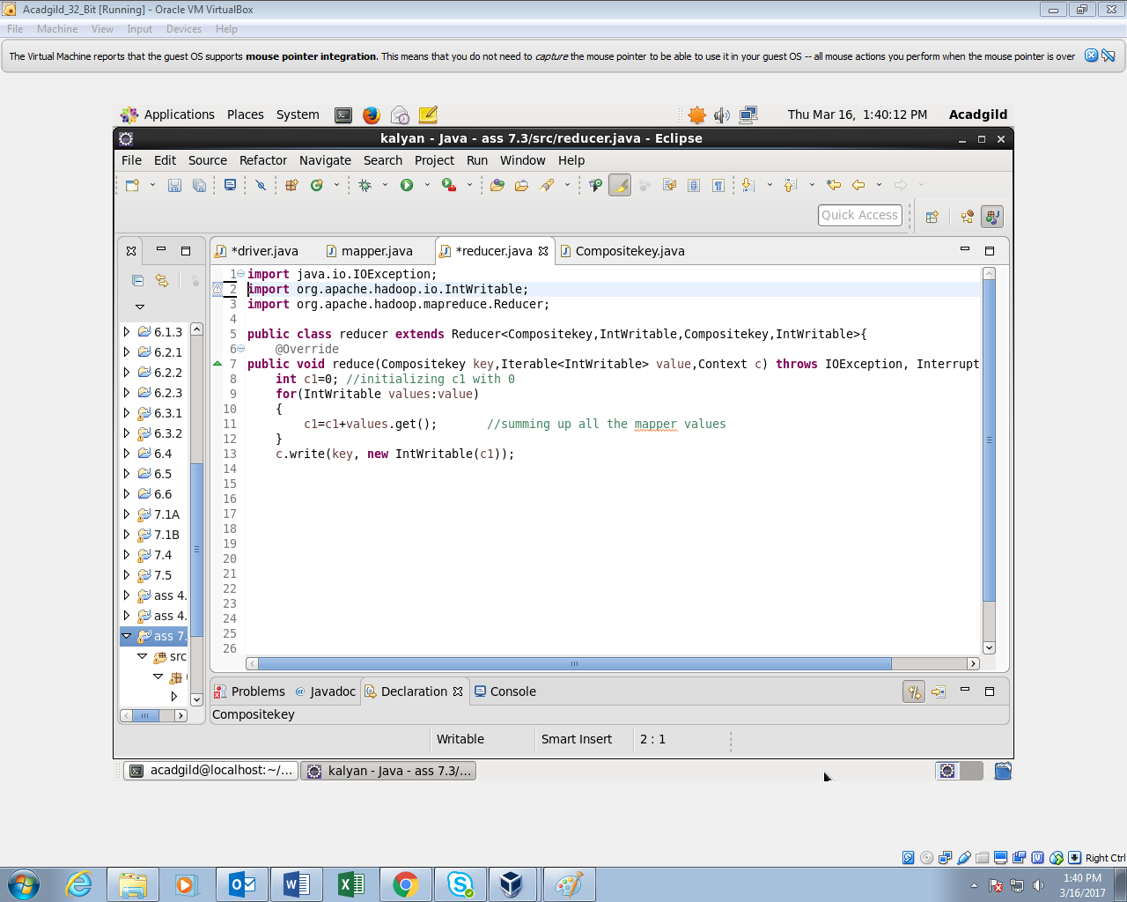

**OUTPUT:**

