**7.5 Write a map only job for the word count program and set the output format as sequence file.**

**DRIVER CLASS:**

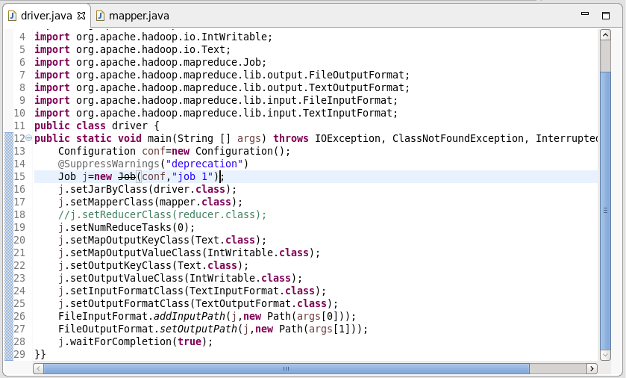

**MAPPER CLASS:**

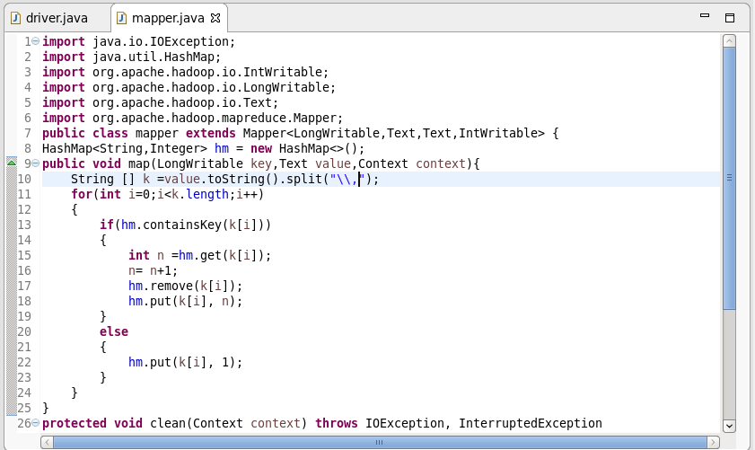

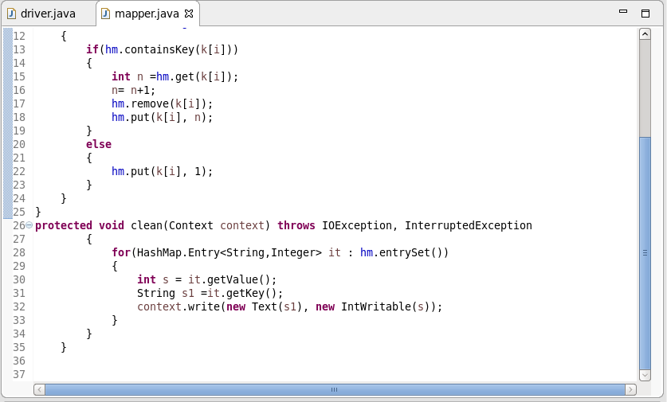

**OUTPUT:**

