**Write a map reduce program save the output of the word count program in XML format. You need to write a custom writable to save the output in XML format.**

**DRIVER CLASS:**

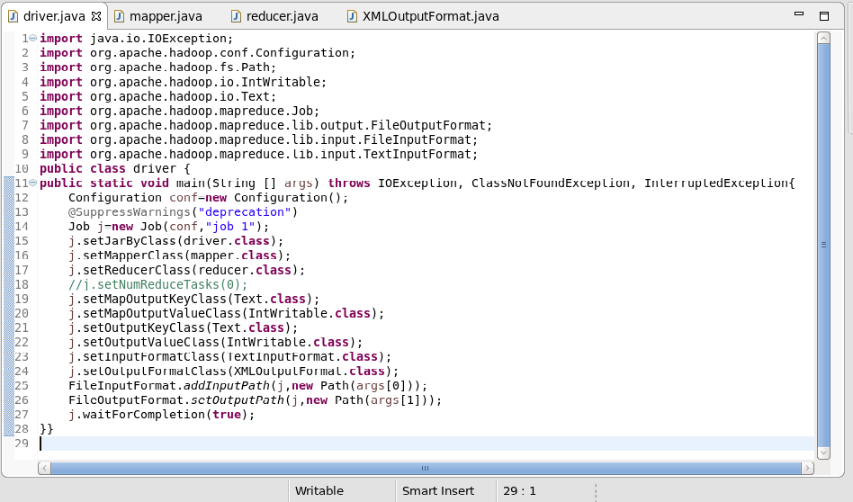

**MAPPER CLASS:**

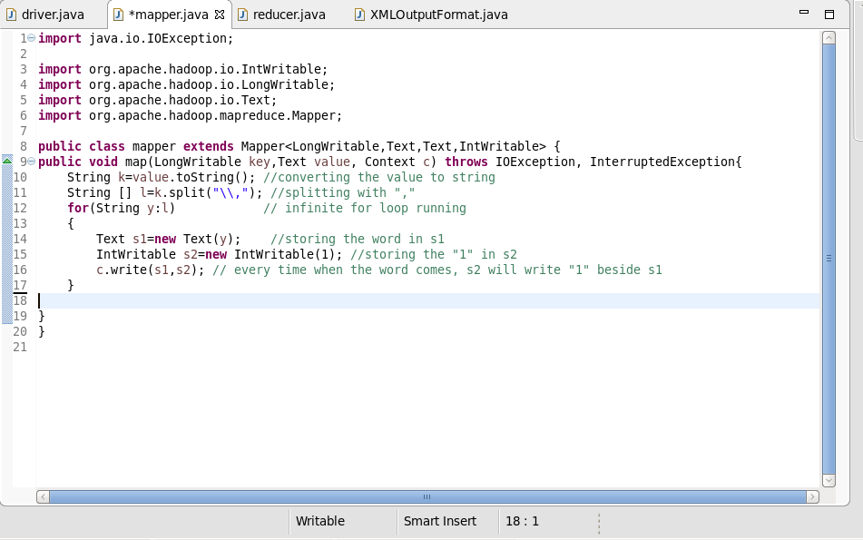

**REDUCER CLASS:**

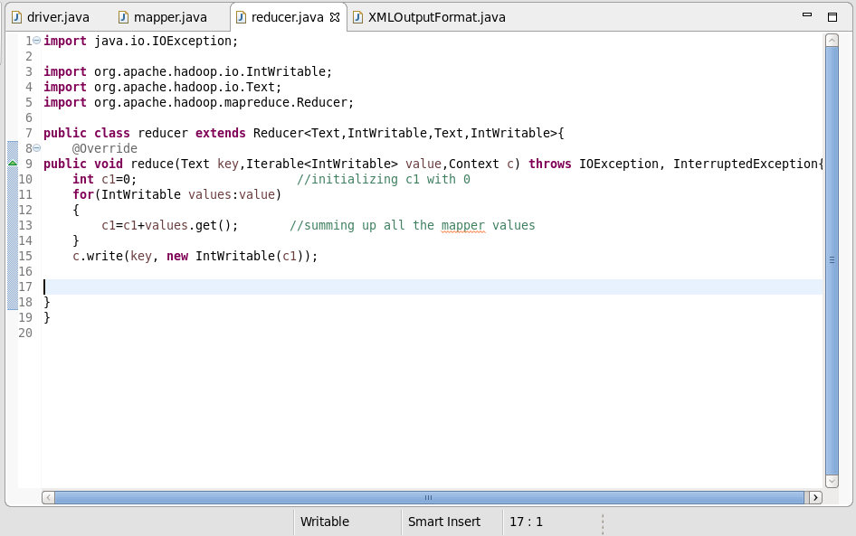

**XML CLASS:**

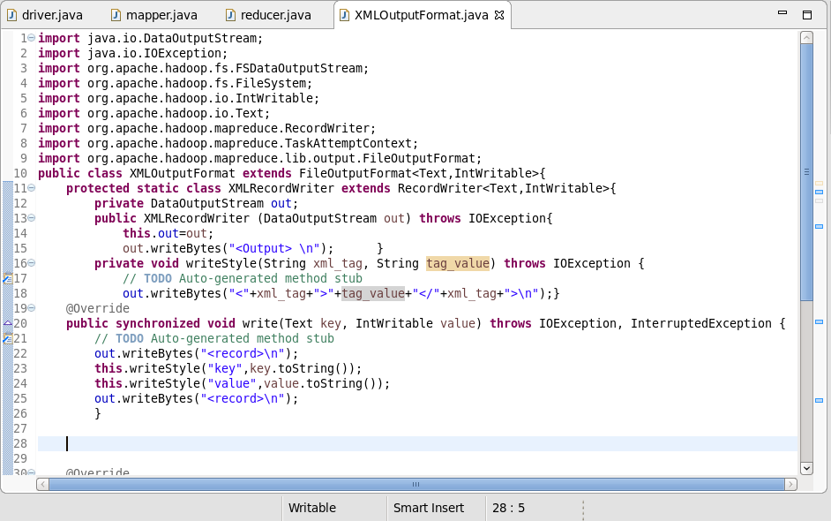

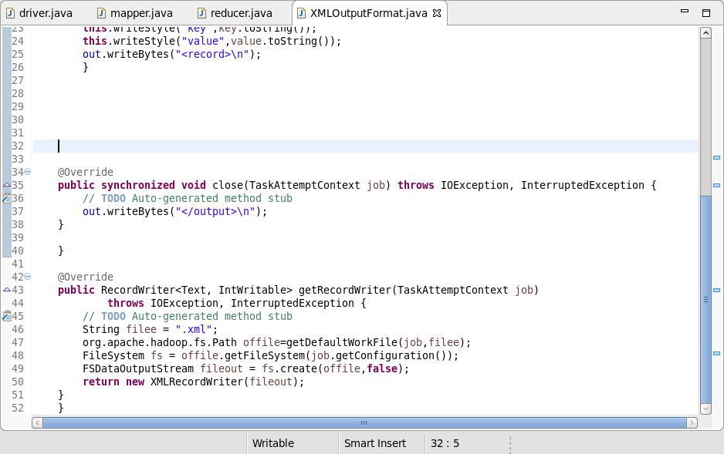

**OUTPUT:**

