**8.1.1 Write a mapreduce program to find the total amount of petrol in volume sold by every distributor.**

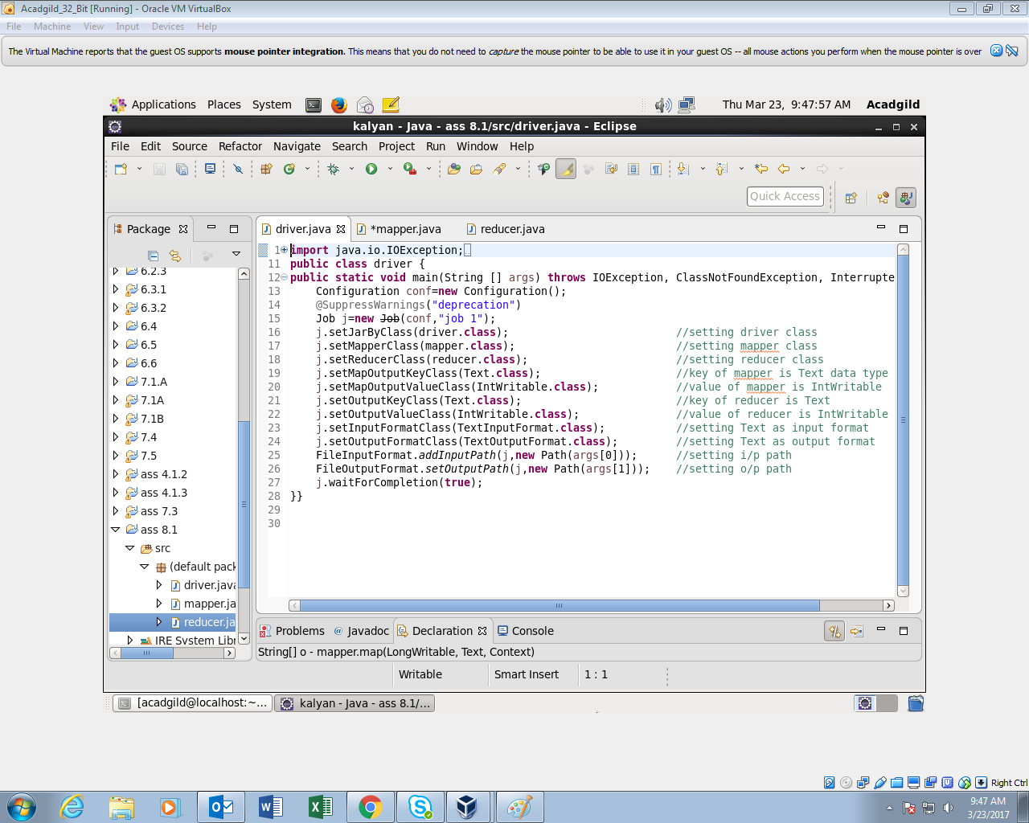

**MAPPER CLASS:**

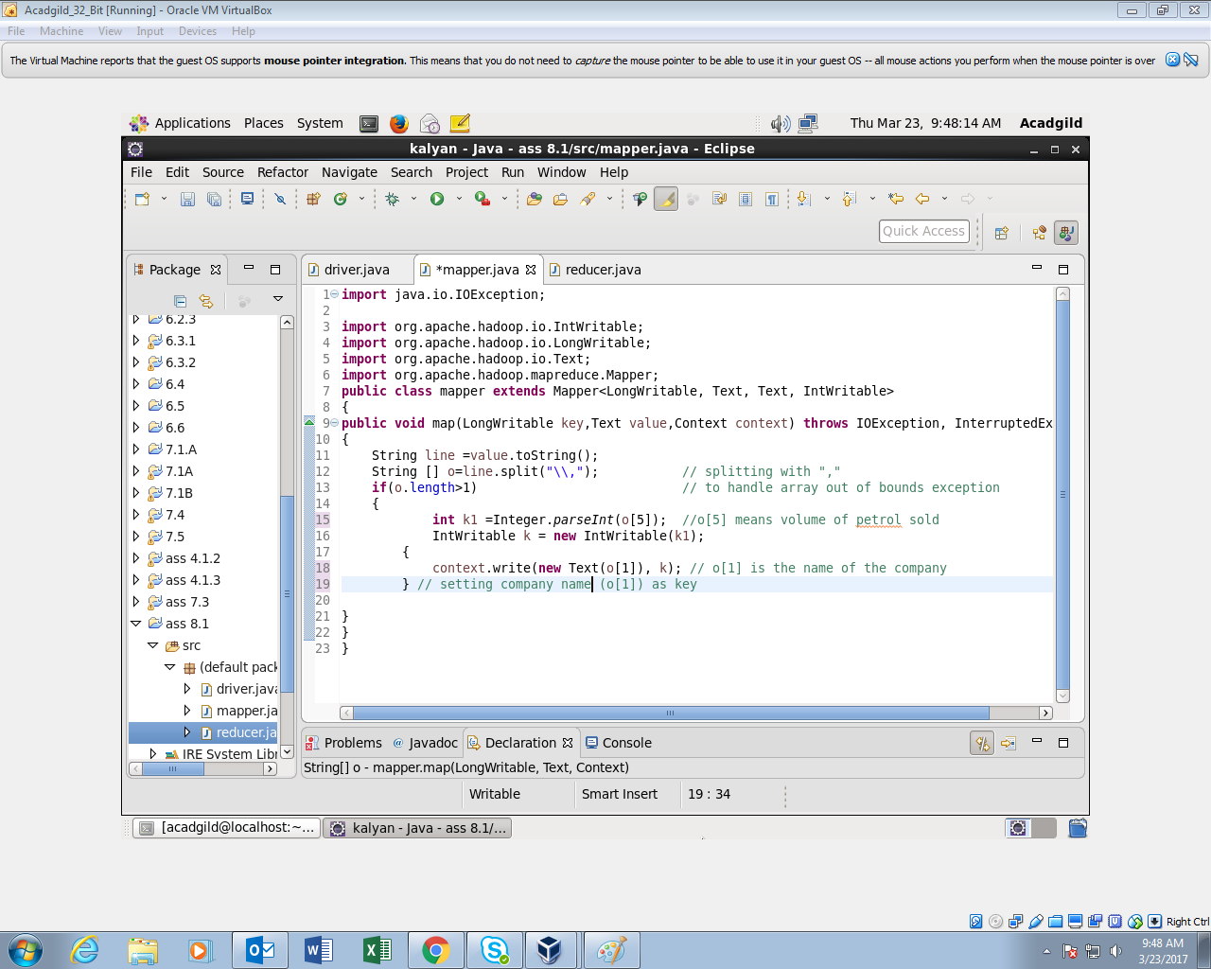

**REDUCER CLASS:**

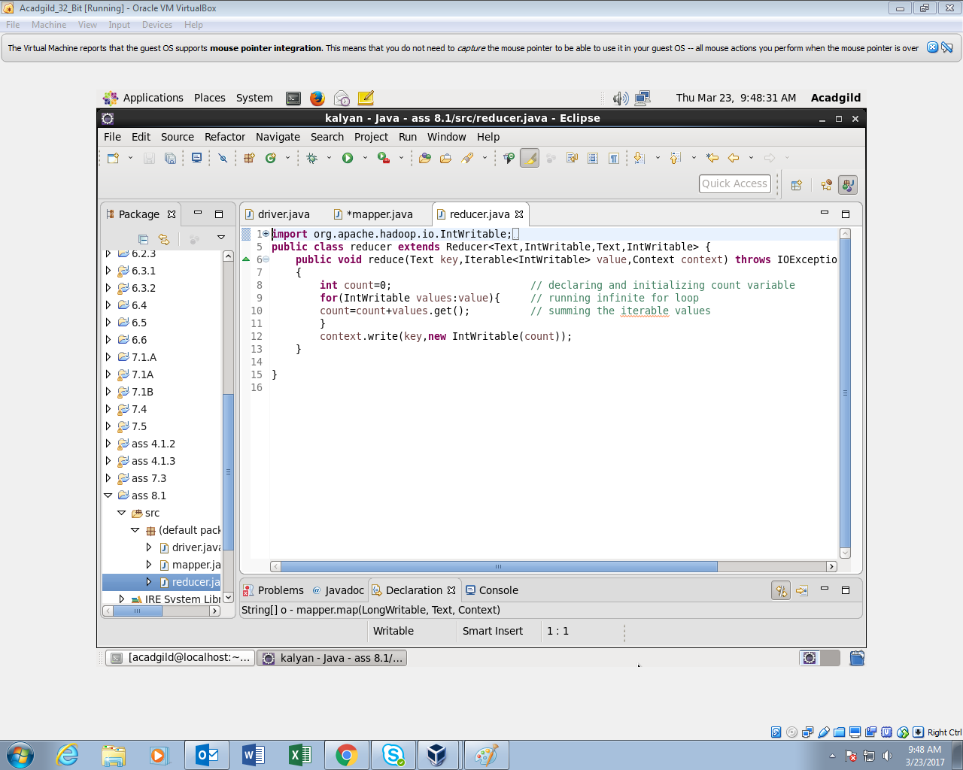

**OUTPUT:**

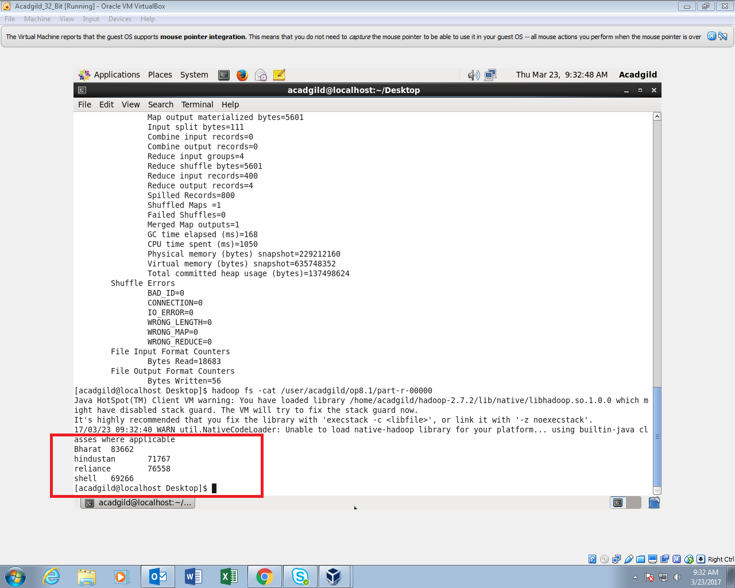

**8.1.2 Write a mapreduce program to find which are the top 10 distributors ID's for selling petrol and also display the amount of petrol sold in volume.**

**DRIVER CLASS:**

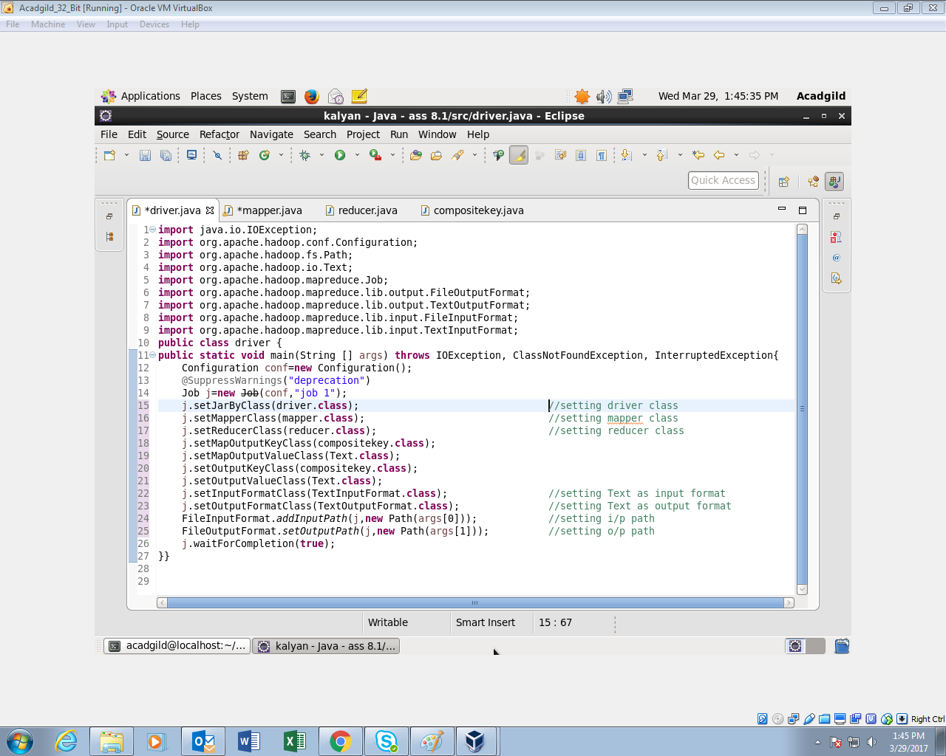

**MAPPER CLASS:**

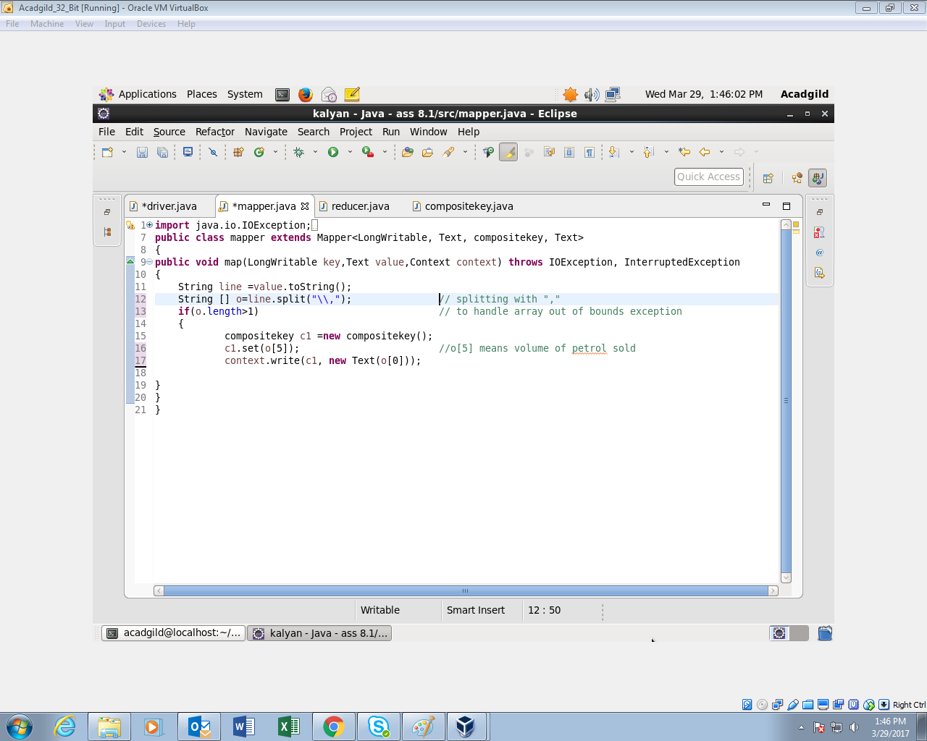

**COMPOSITE KEY CLASS:**

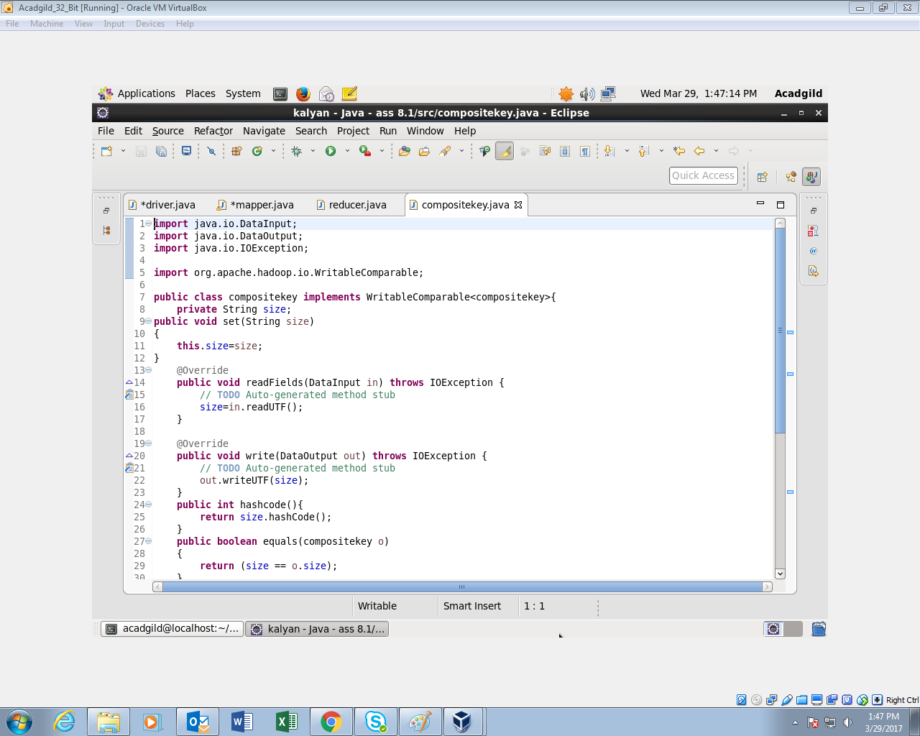

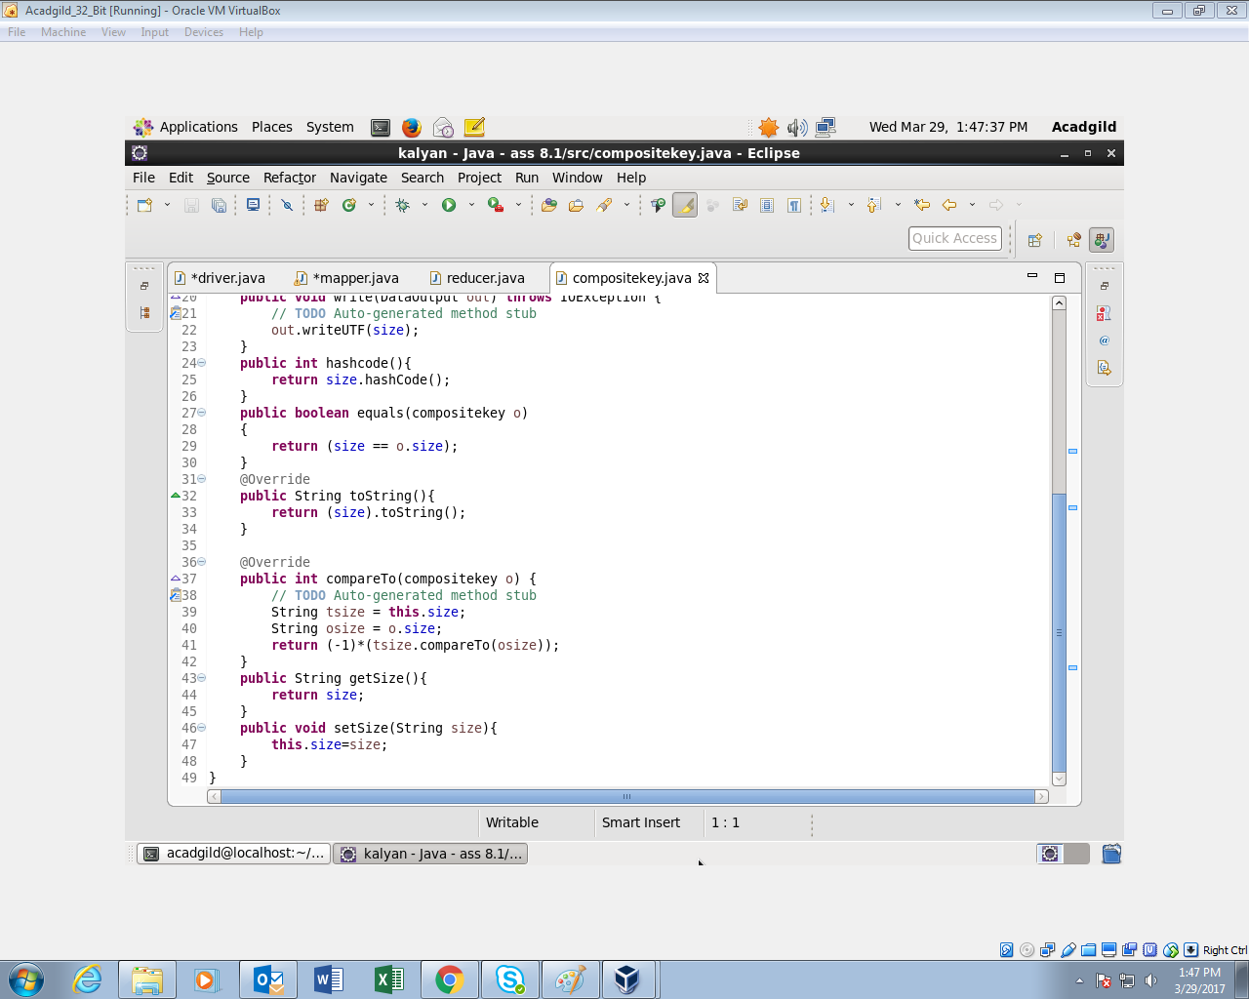

**REDUCER CLASS:**

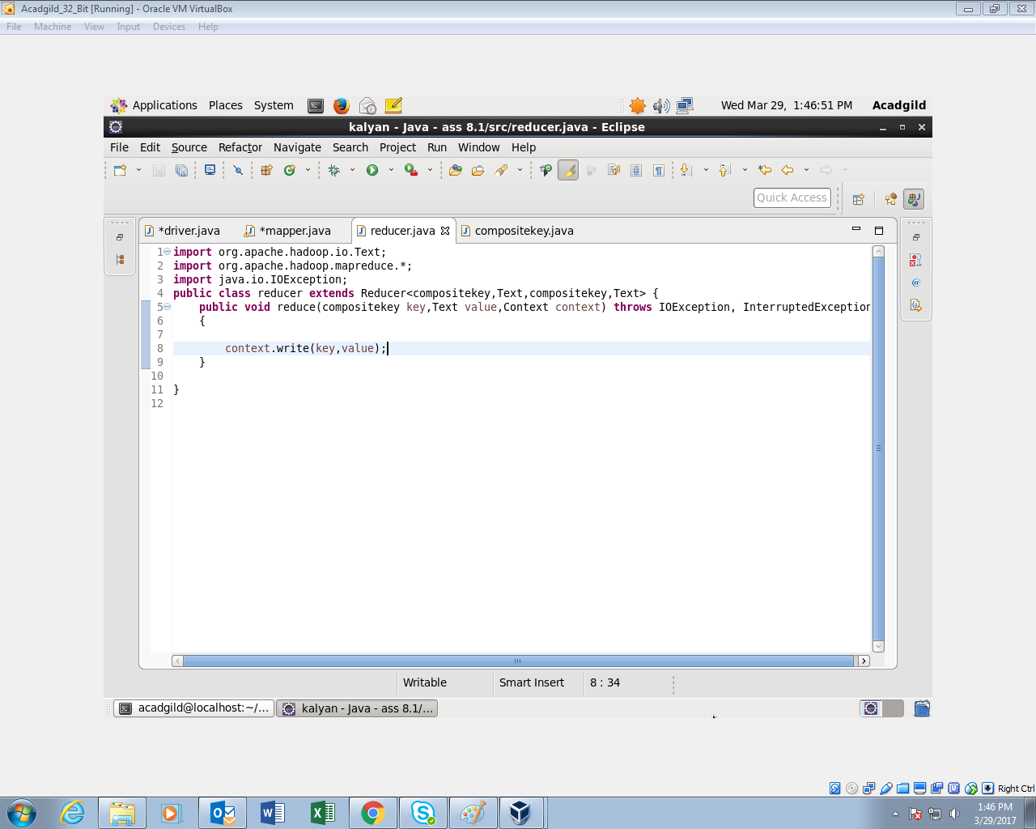

**OUTPUT:**

**USING HEAD –n10 to display only top 10 entries**

