**10.3.1 Top 5 employees (employee id and employee name) with highest rating. (In case two employees have same rating, employee with name coming first in dictionary should get preference).**

***Ordering employee by rating in descending order***

***Inorder to display only 5 ppl, limit cmd is used.***

***Then, generating only id and name using GENERATE cmd.***

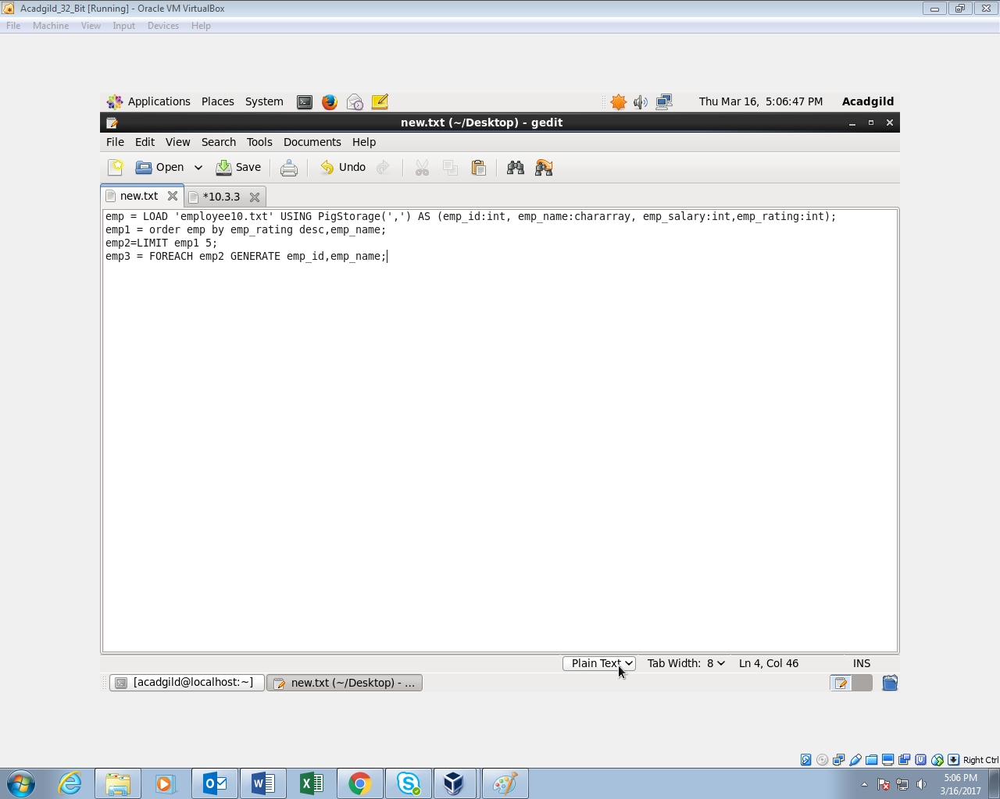

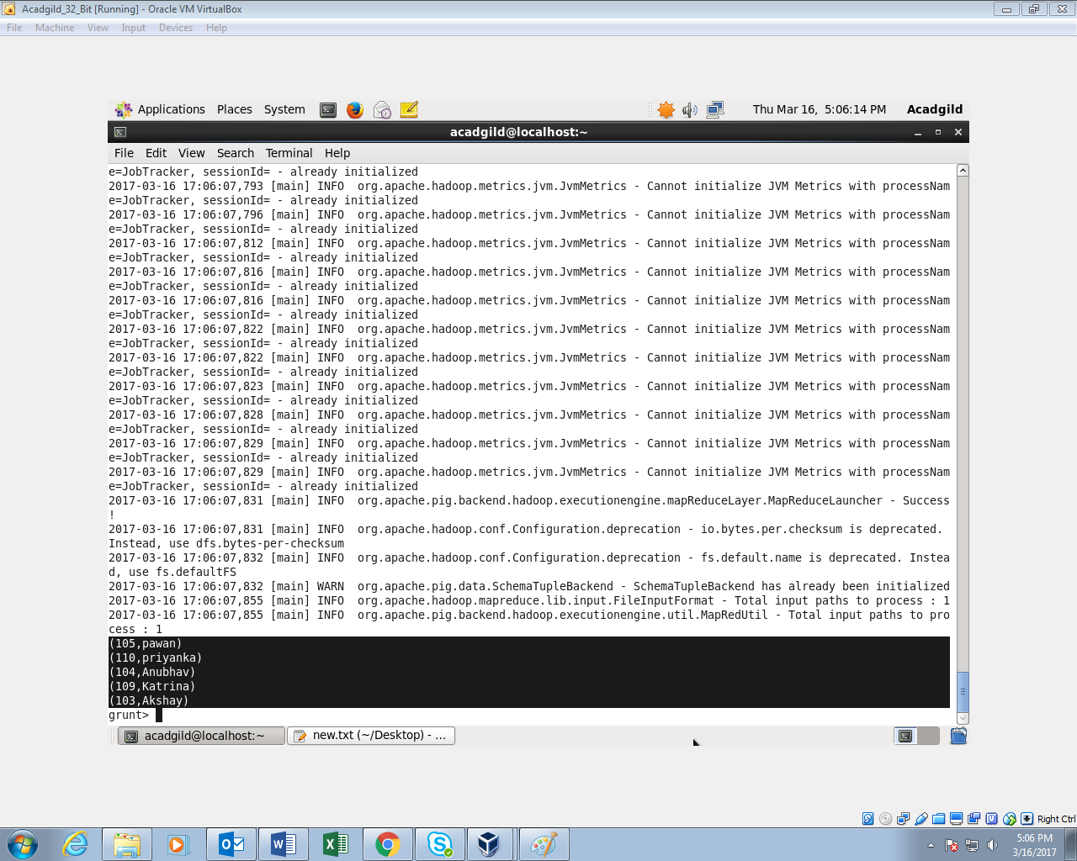

**10.3.2 Top 3 employees (employee id and employee name) with highest salary, whose employee id is an odd number. (In case two employees have same salary, employee with name coming first in dictionary should get preference).**

***Ordering salary in descending order***

***Filtering odd id’s from even id’s using filter cmd.***

***Displaying only top 3 employee using limit cmd.***

***Generating only id and name using generate cmd.***

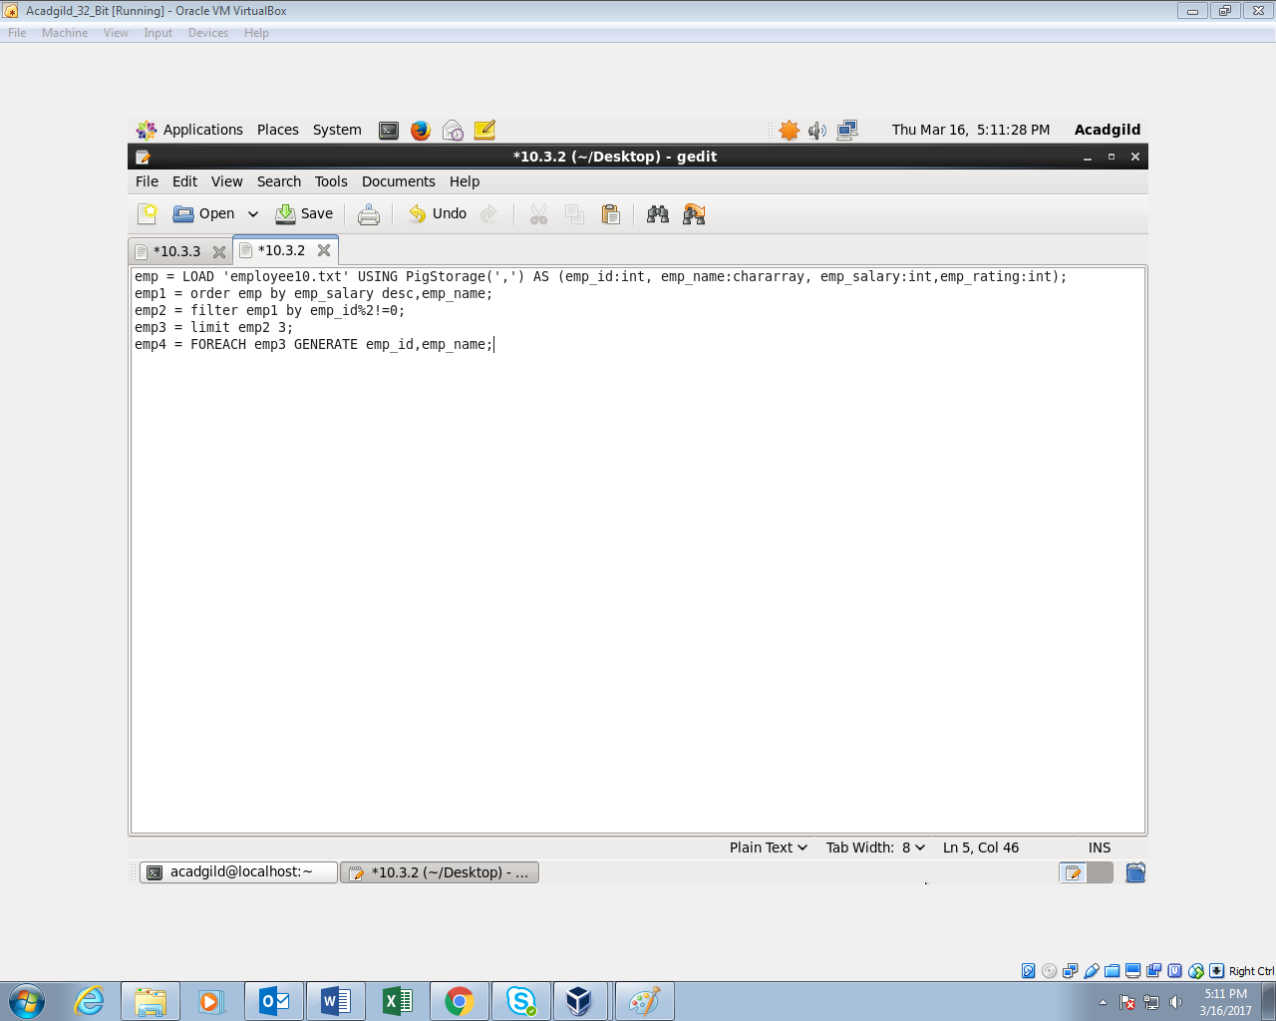

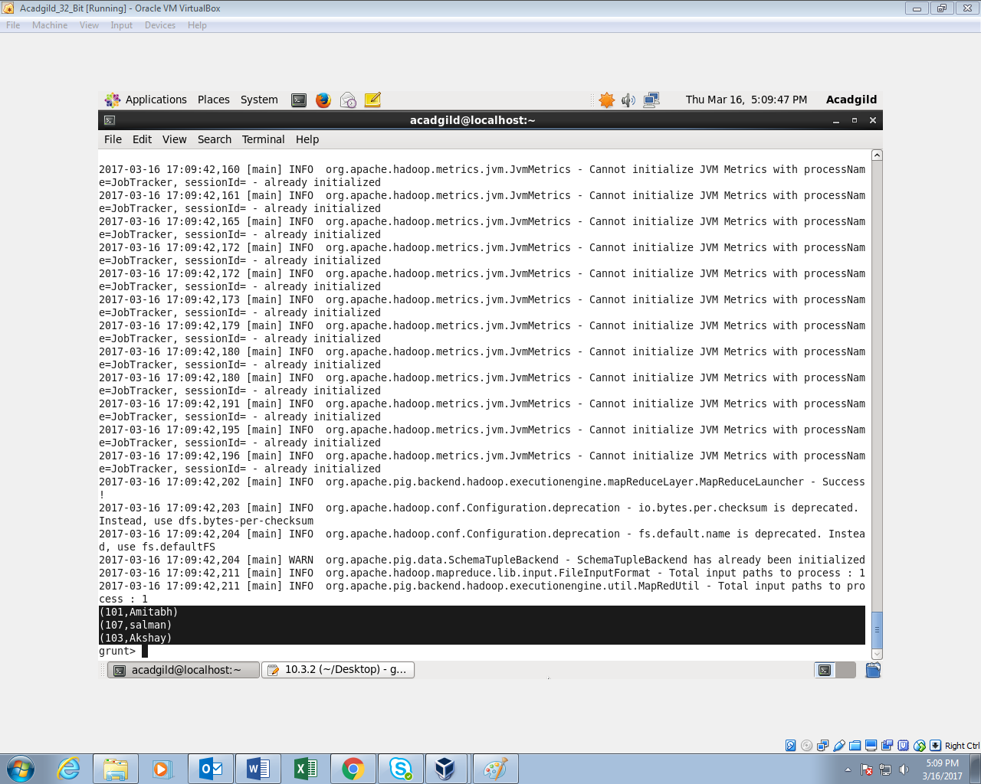

**10.3.3 Employee (employee id and employee name) with maximum expense (In case two employees have same expense, employee with name coming first in dictionary should get preference)**

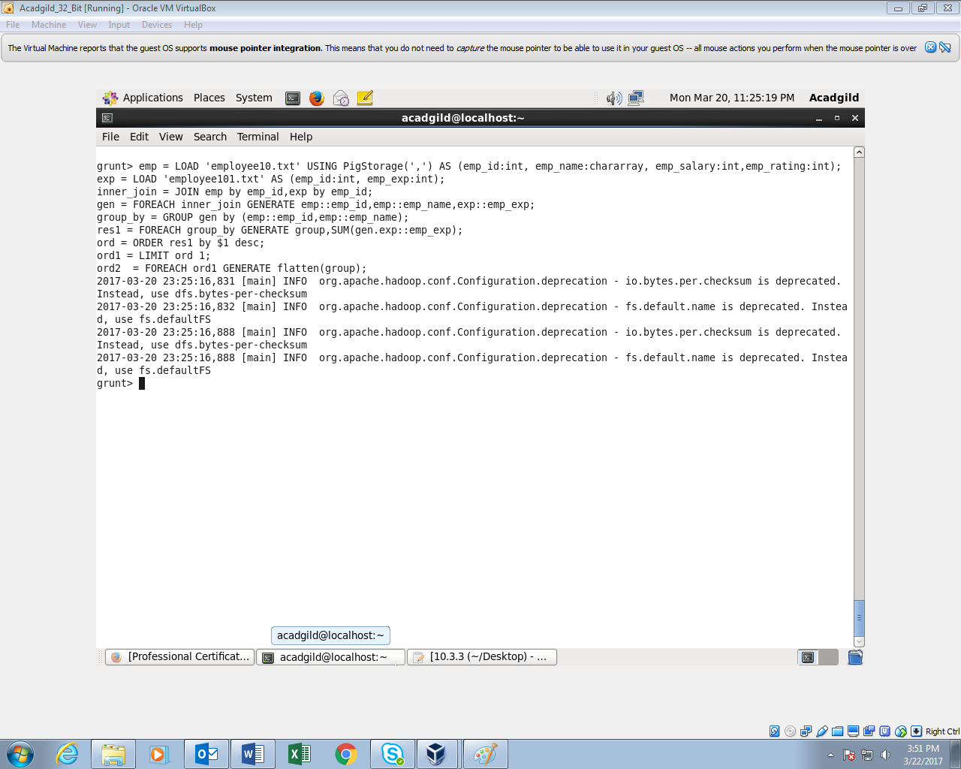

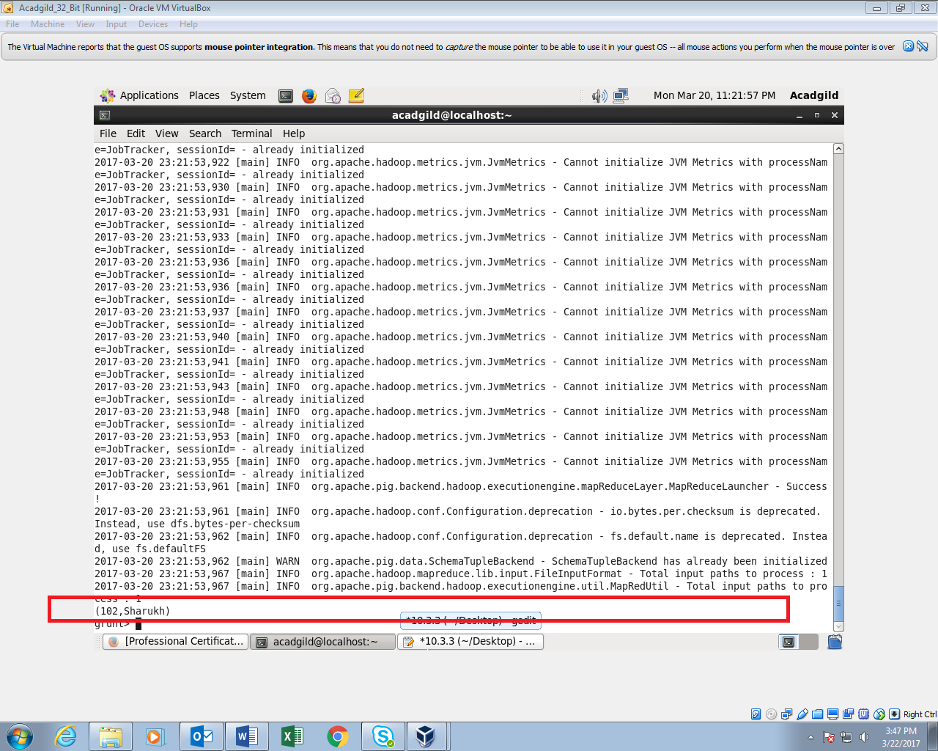

**10.3.4 List of employees (employee id and employee name) having entries in employee_expenses file.**

***Performing inner join for employee and expenses datasets***

***Generating only name and id using generate cmd.***

***Using distinct cmd to eliminate duplicates.***

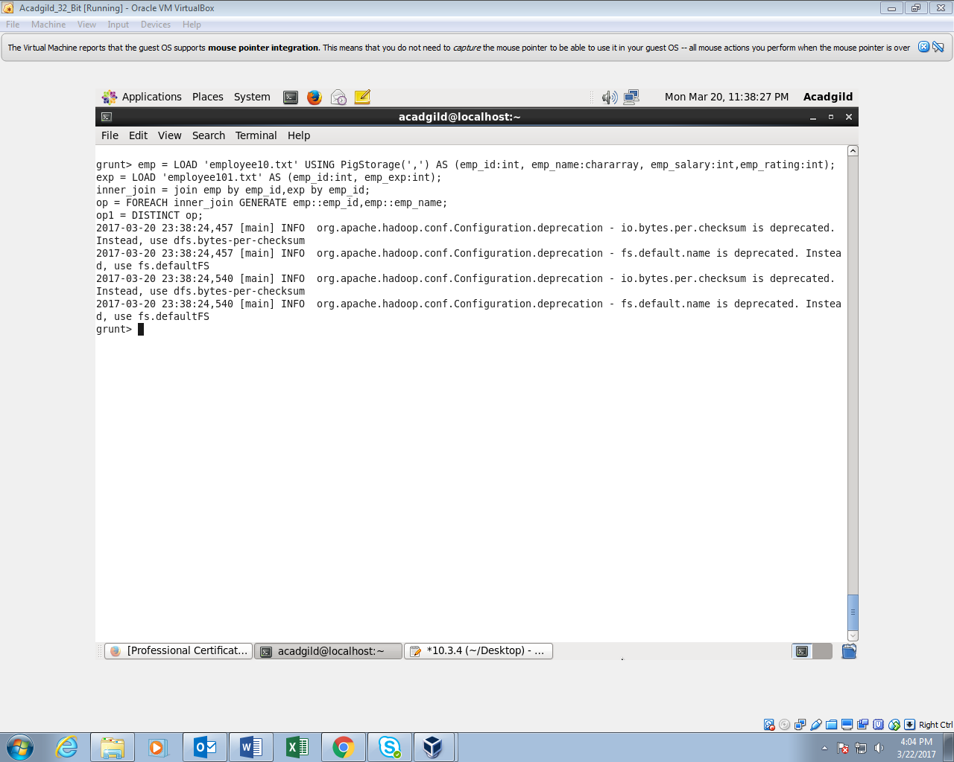

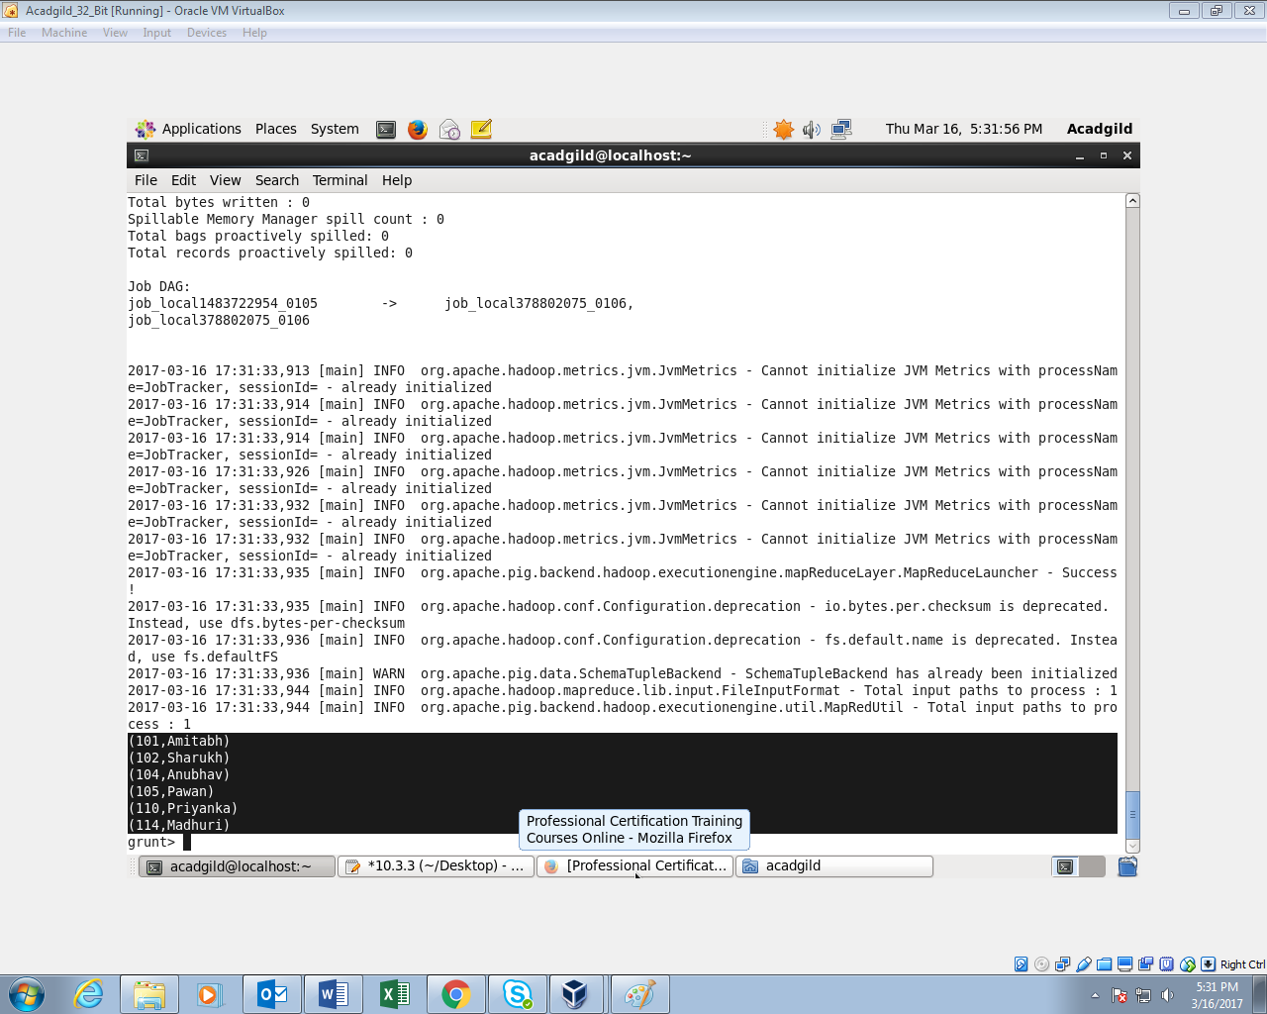

**10.3.5 List of employees (employee id and employee name) having no entry in employee_expenses file.**

*Performing left outer join for employee and expenses data sets.*

*Filtering using filter cmd.*

*Generating only name and id using generate cmd.*

