E-COMMERCE APPLICATION ON IBM CLOUD FOUNDRY
PROBLEM DEFINITION:
Most skilled craftsmen lack a platform to sell their products and showcase their skill. In order to make their product available to a larger audience, local artisans rely on a middleman which further reduces their margin of profit. Further problems include the authenticity of a design or a product since it is not being registered. Lack of publicity automatically yields low demand. Low quality makers are trumping skilled craftsmen due their vastly superior presence in the market. An online web application for selling handicrafts online can be used to tackle these problems.
IMPORTANCE OF THE PROJECT:
E-commerce business is very scarcely focused on the handicrafts industry which constitutes as the second biggest employing industry in India. This creates a sort of niche for providing the artisans and handicrafts sellers with a digital platform to help with their sales and growth. With the recent switch of emphasis of make in India products, the platform would be fruitful for helping the local artisans. Also, since individual artisans will be applying directly to sell their products they can benefit directly in terms of finance.
OBJECTIVE AND SCOPE OF THE PROJECT:
Scope of this project directly revolves around welfare of individual artisans.
Few of them are:-
- This can be used by and for various individual artisans throughout the country.
- Can be used anywhere any time as it is a web based application (user Location doesn’t matter).
IMPLEMENTATION:
- Determine what kind of artisan products you want to sell.
- Identify your target audience and market.
- Research your target audience's preferences and needs.
- Choose a domain name that reflects your brand.
- Create an appealing and user-friendly website design.
- Incorporate your artisan brand's identity into the design.
- Ensure the website is mobile-responsive.
- Add high-quality images and descriptions for each artisan product.
- Organize products into categories and use tags for easy navigation.
- Set up a secure and easy-to-use shopping cart system.
- Implement a secure payment gateway for transactions.
- Offer various shipping options and clearly state shipping costs.
- Integrate shipping carriers for real-time shipping rates.
- Automate order fulfillment processes.
- Regularly update your E-Commerce platform and plugins for security.
- Provide clear contact information and customer support channels.
- Consider adding a live chat feature.
- Once everything is ready, launch your E-Commerce website.
- Promote it through various channels to attract customers.
- Continuously monitor your website's performance and gather customer feedback.
- Make improvements and updates as needed to enhance the user experience.

BENEFITS OF E-COMMERCE:
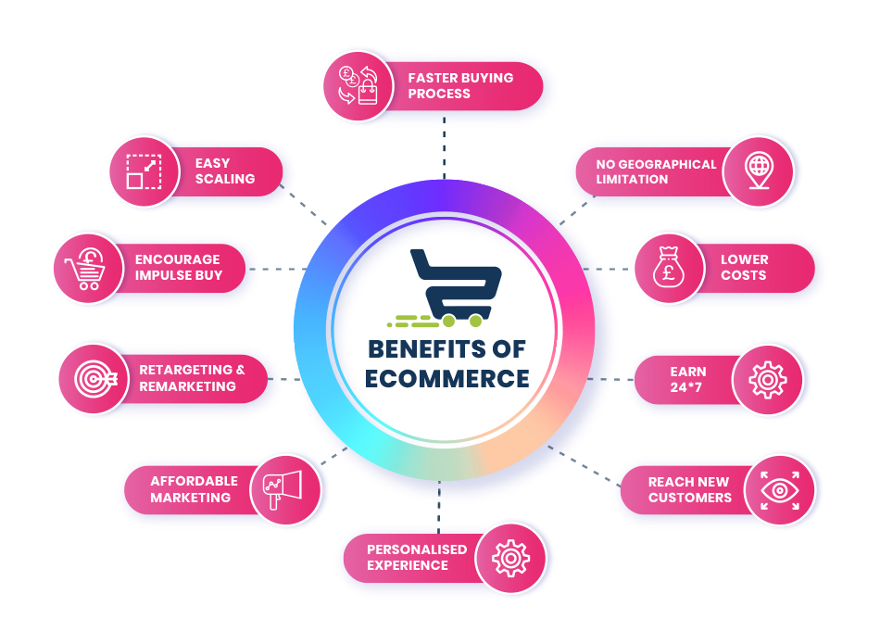
CONCLUSION:
- Online Handicrafts store will be an ease of access for everyone, i.e, customers as well as the artisans.
- Due to the pandemic, it is highly risky to go out for anything but with this e-commerce website people can admire and buy the fine work of the local craftsmen sitting at home.
- It will help the local craftsmen reach out to a wider audience who admire the real art. It will help them reach out to those people who respect the artwork but live far away and can’t travel to shop for them

