Phase:2 Innovation
e-commerce application on ibm cloud foundry
Our innovation ideas for creating website for artisans and some features we want to apply in our application.
An E-Commerce website for artisans operates much like any other online store but with a focus on handmade or artisanal products. Here's a simplified overview of how it works:
- Product Listings: Artisans create accounts and list their handmade products on the website. Each product typically includes detailed descriptions, high-quality images, prices, and possibly customization options.
- Online Catalog: Shoppers browse the website's catalog, searching for unique handmade items they're interested in purchasing.
- Shopping Cart: When a shopper finds a product they want to buy, they can add it to their shopping cart, where they can review and modify their selections.
- Checkout: After selecting their desired items, shoppers proceed to the checkout page. Here, they provide shipping and payment information, and they confirm their order.
- Payment Processing: The website securely processes the payment, often through various payment gateways like credit/debit cards, digital wallets, or other methods.
- Order Confirmation: Shoppers receive an order confirmation email with details of their purchase, including an estimated delivery date.
- Order Fulfillment: The artisan receives the order details and prepares the handmade item for shipment. This may involve crafting the product, packaging it, and generating a shipping label.
- Shipping: The artisan ships the product to the customer using a chosen shipping method. The website may integrate with shipping carriers to provide tracking information.
- Delivery: The customer receives the product and can leave reviews or ratings based on their experience.
- Seller Payout: Once the transaction is complete, the artisan may receive the payment for their product, minus any applicable fees or commissions taken by the E-Commerce platform.
- Customer Support: The website typically offers customer support to handle inquiries, returns, or issues related to the order.
- Marketing and Promotion: To attract more customers, the E-Commerce platform may run marketing campaigns, offer discounts, and use various strategies to promote artisans' products.
- Maintenance and Updates: Regular maintenance is required to keep the website running smoothly. Updates and improvements to the platform may also be necessary to enhance the user experience.
- Feedback and Reviews: Customers' feedback and reviews play a crucial role in building trust and reputation for both the artisans and the E-Commerce website.
Overall, an E-Commerce website for artisans connects skilled creators with a global audience, providing a platform for them to showcase and sell their unique, handcrafted products.

FLOW CHART:
SELLER WEB PAGE DESIGN:
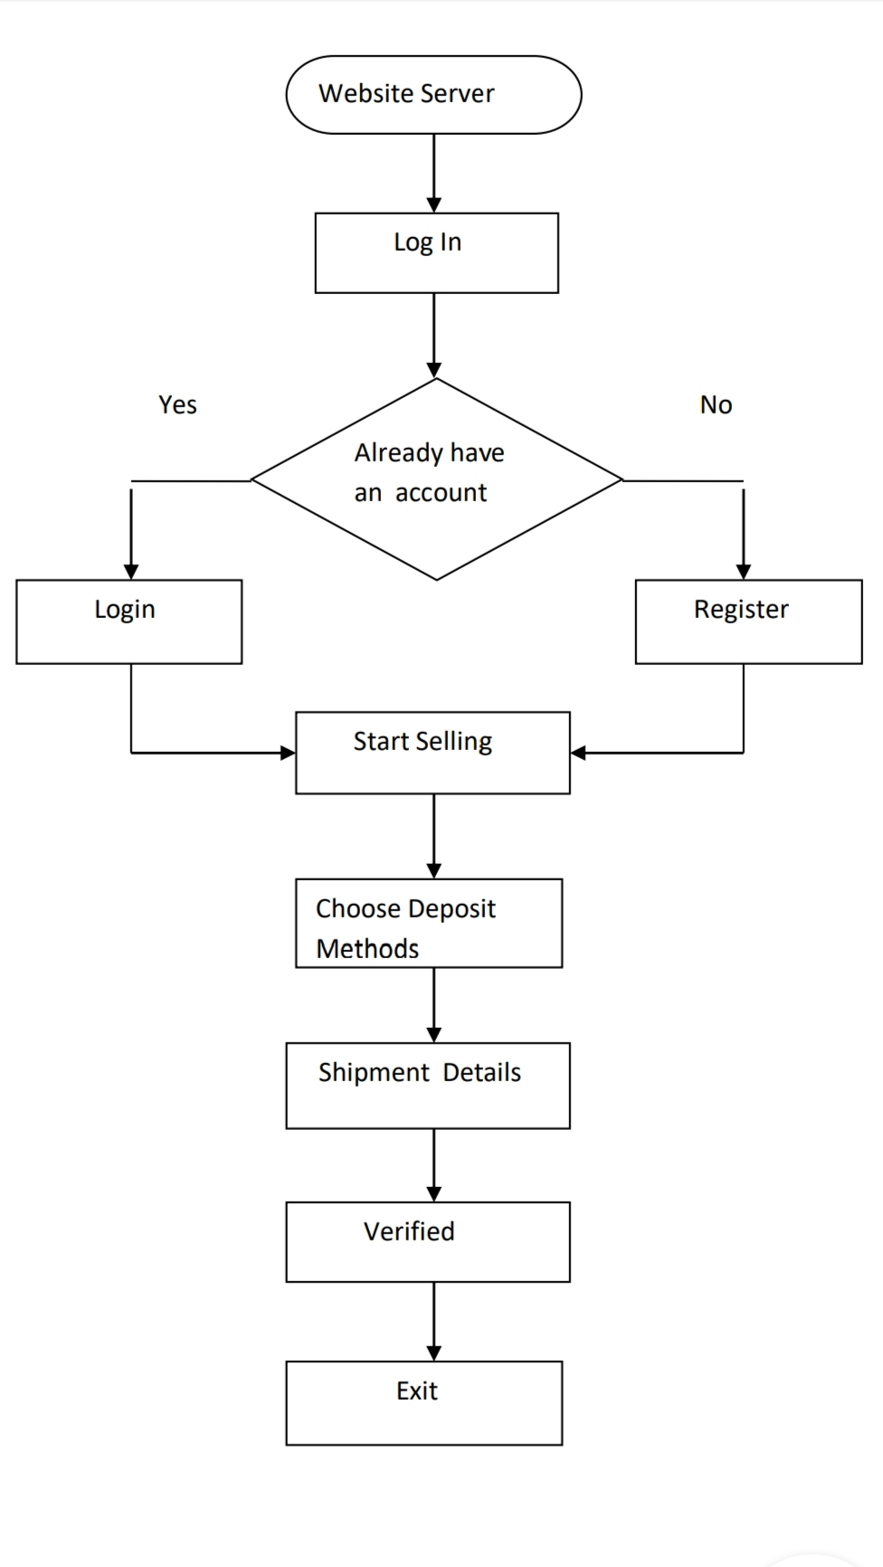

BUYER WEB PAGE DESIGN:
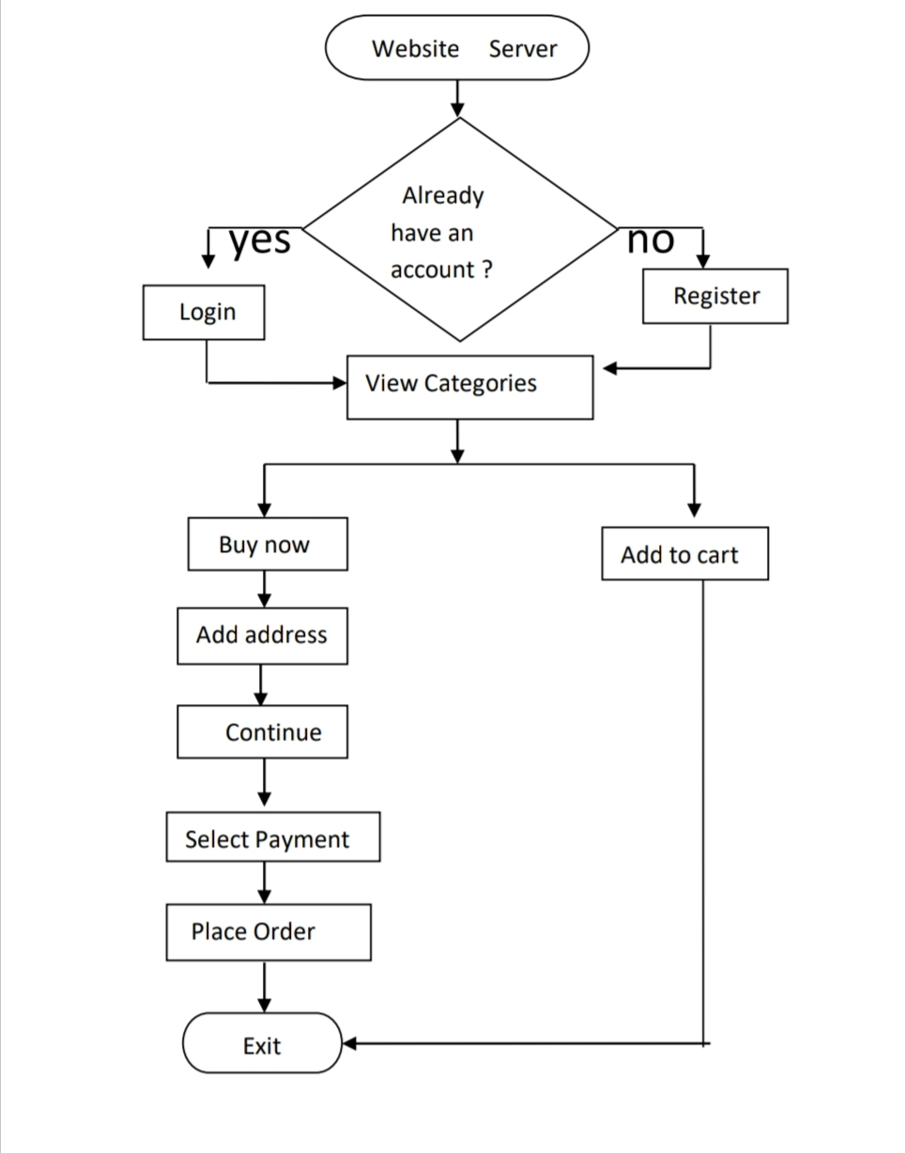

These are some of our innovation ideas for creating E-Commerce application on IBM Cloud Foundry.

