Java Script:

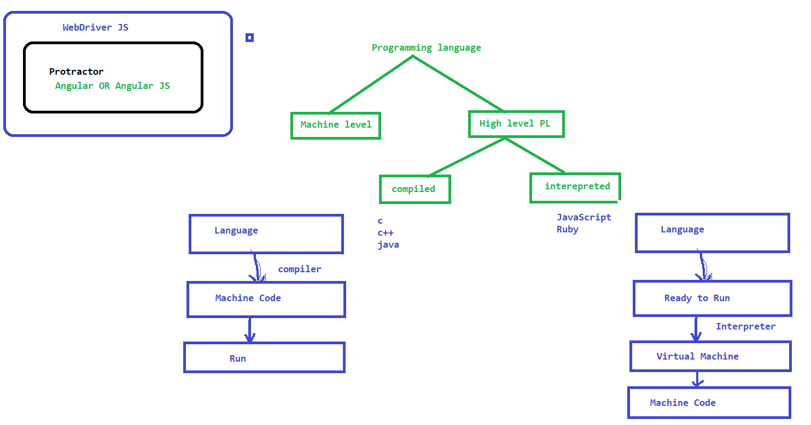

Download and install Visual Studio Code:

1. <https://code.visualstudio.com/download>
2. Download the software – follow the instructions by double clicking on the downloaded sw

Variables in JS:

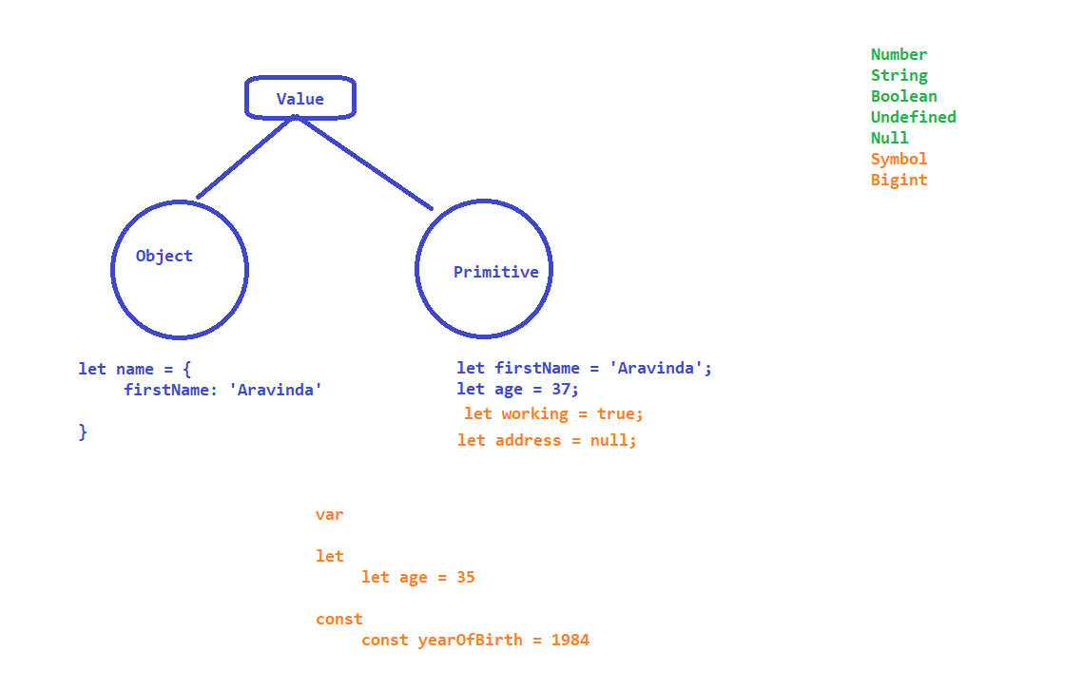

Operators: It’s a Symbol usually represents an Action or process

* Arithmetic Operator
  + + : Addition
  + - : Substration
  + * : Multiplication
  + / : Division
  + % : Module
  + ** : Exponential
  + ++ : Increment
* Assignment Operator
  + = : Assign : x=y
  + += : Add and Assign : x+=y : x= x + y
  + -= : Subtract and Assign : x-=y : x= x - y
  + *= : Multiply and Assign : x*=y : x= x * y
  + /= Divide and assign : x/=y : x= x / y
  + %= Module and assign : x%=y : x= x % y
  + **= Exponential and assign: x**=y : x= x ** y
* Comparison Operators
  + == : equal to
  + === : equal value and equal type
  + != : not equalto
  + !== : not equal value and type
  + > : greater than
  + < : lessthan
  + >= : greater than or equal
  + <= : less than or equal
  + ? : : (a>b)? first : second
* Logical Operators
  + &&
  + ||
  + !
* Type Operators
  + typeof
  + instanceof
* BitWise Operators

Conditional Statements :

1. if
2. if.. else
3. if..elseif..else
4. switch

Looping Statements:

1. for

for( let index = 0 ; index<10 ; index++ )

{

==========

}

1. for-in
2. for-of
3. for-each

Arrays:

* push
* pop
* shift
* unshift
* concat
* splice
* slice

Functions

* Norman function
* Function Expressions
* Arrow Functions
* Overloading in JS!!!

OOPS

* Class
* Object
* Abstraction
* Encapsulation
* polymorphism
* Inheritance
* Constructors

Protractor

Angular and AngularJS

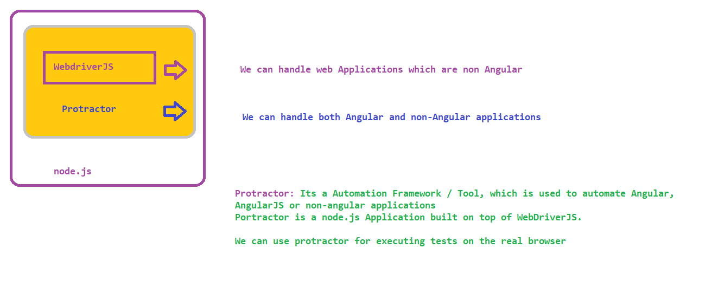

Advantages of Protractor:

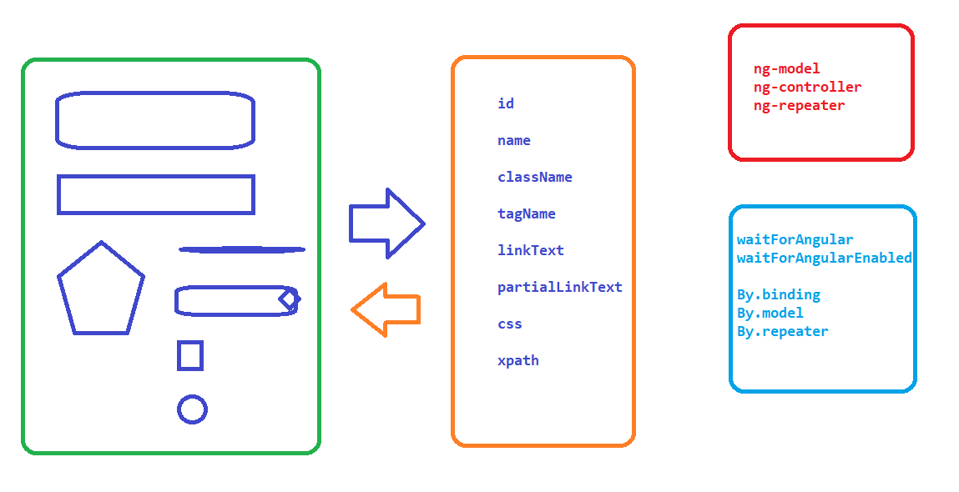

Synchronous and Asynchronous Programming:

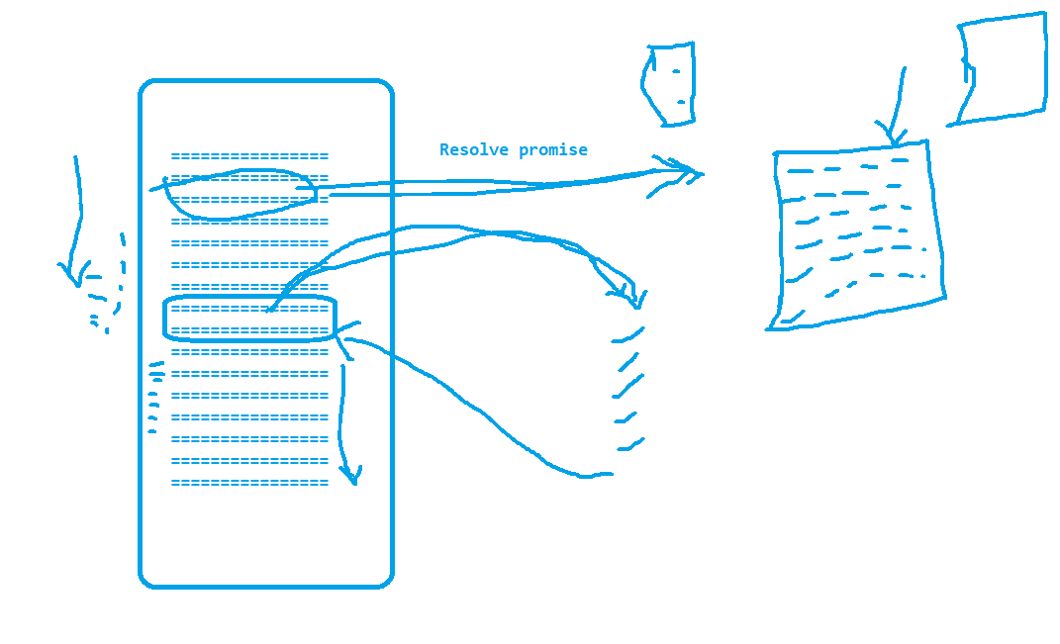

How Protractor Works:

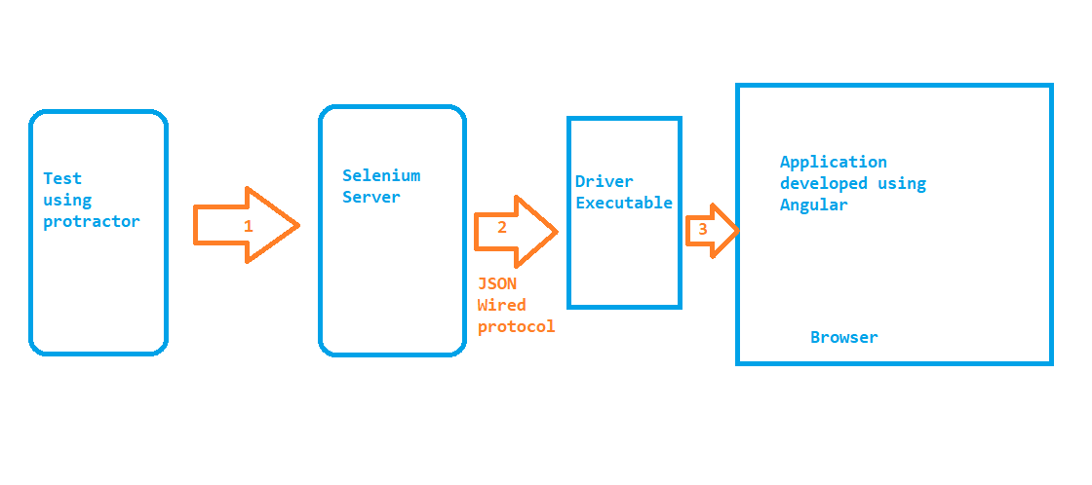

Setup Protractor:

1. Install node.js - <https://nodejs.org/en/download/>

2. Install Protractor

1. npm install –g protractor
2. webdriver-manager update

OR

1. webdriver-manager update --versions.chrome <<VersionNum>>

Popular plugins:

1. Code Runner
2. Run Protractor
3. Protractor Snippets
4. Jasmine code snippets

Installation :

**Promise : Result of the step or Current state of the step**

**1. Pending**

**2. Resolved**

**3. Rejected**

**Most of the protractor functions will not move to the next step until promise is resolved!!!**

**Ex - type click etc**

**But whatever we read from the application like getText(), getAttribute() . we have to resolve the promise**

Running Test:

protractor .\conf.js

NOTE: if any error is thrown execute the below command from the same terminal and try again

Set-ExecutionPolicy RemoteSigned -Scope CurrentUser

Executing Test on Different browser

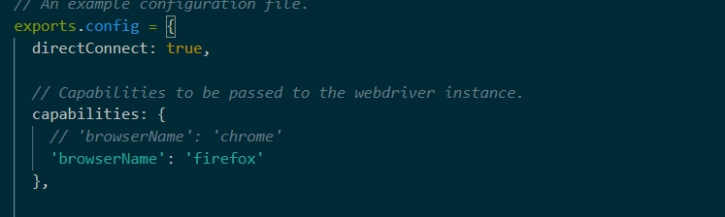

Direct Connect is true only for FF and chrome, if you want to execute other than FF and Chrome then,

1. Download the driver executable for the corresponding browser
   1. Webdriver-manager update –ie

Capturing screenshots :

- install npm package protractor-jasmine2-screenshot-reporter

- update conf.js as per the documentation.

HTML Reports:

* Allure Reports
  + <https://www.npmjs.com/package/jasmine-allure-reporter>
  + update conf.js as per instructions
* Getting HTML Reports from allure xml
  + search for allure-commandline in npm library
    - <https://www.npmjs.com/package/allure-commandline>
    - install allure command line
    - allure serve <<location of xml files>>

Automating Non-Angular Applications in Protractor:

set  browser.waitForAngularEnabled(false);

Explicit Wait in protractor:

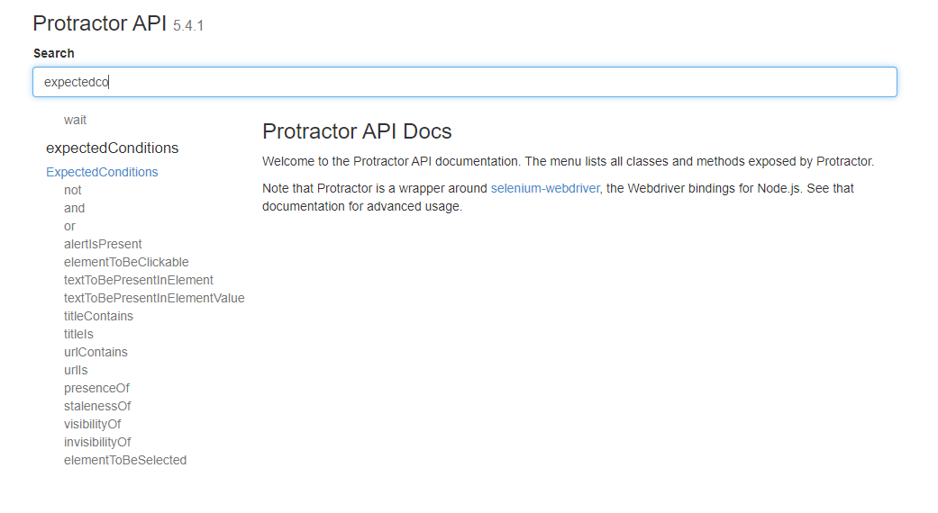

Performing Exact KB and Mouse operations in protractor:

we can use actions to perform KB and Mouse operations

Browser operations

SwitchTo()

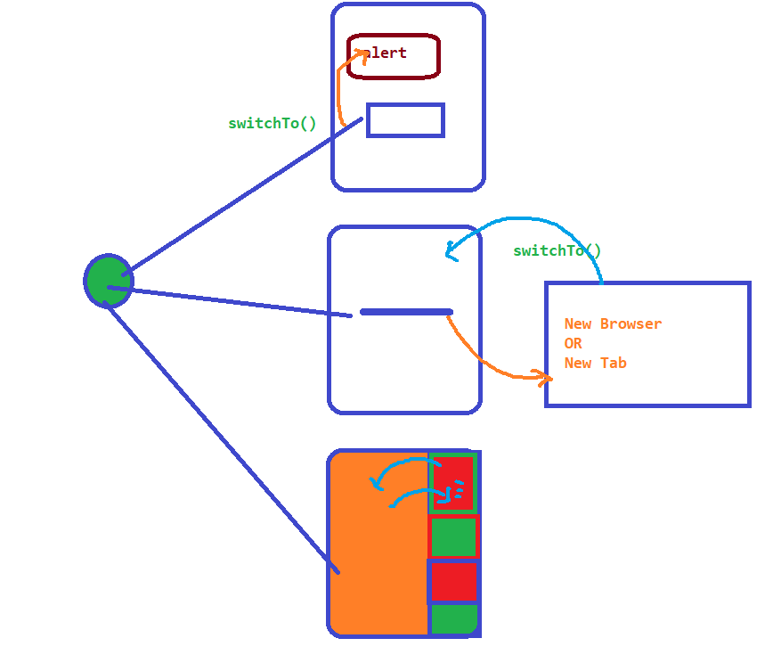

Before Each and AfterEach

onPrepare and onComplete

Data driven testing with

- JSON

- Data provider

POM