**How to run the apps:**

**Step 1:**

Open the Android Virtual Device (AVD).

**My AVD Name**: Pixel_3a_API_34_extension_level_7_x86_64

**Image**: Android API 34 X86_64

**Step 2:**

Open the project in Visual Studio Code

**Step 3:**

Open a new terminal and run “**npm run android**”

**GitHub link of the two Applications**

https://github.com/AravindaWijesekara122/ReactNative_Assignment.git

**Assignment 1**

**Assumptions**:

* Each entry in Budget Listing Screen has the Delete option.
* An Alert of validation error will be popped up when the fields are empty, or data type is invalid.

**Assignment 2**

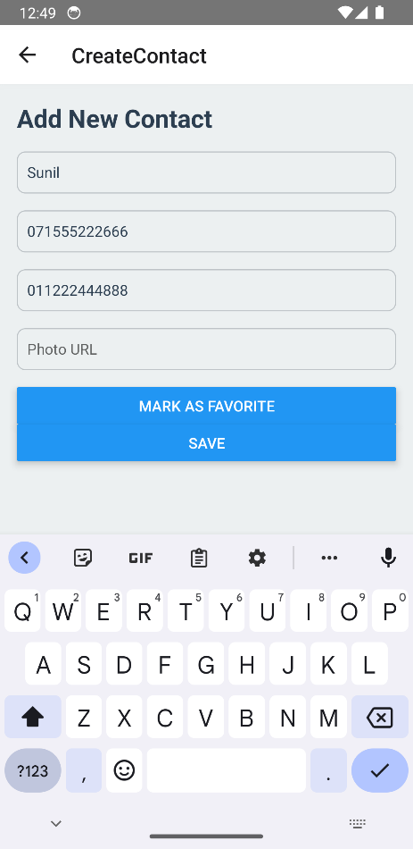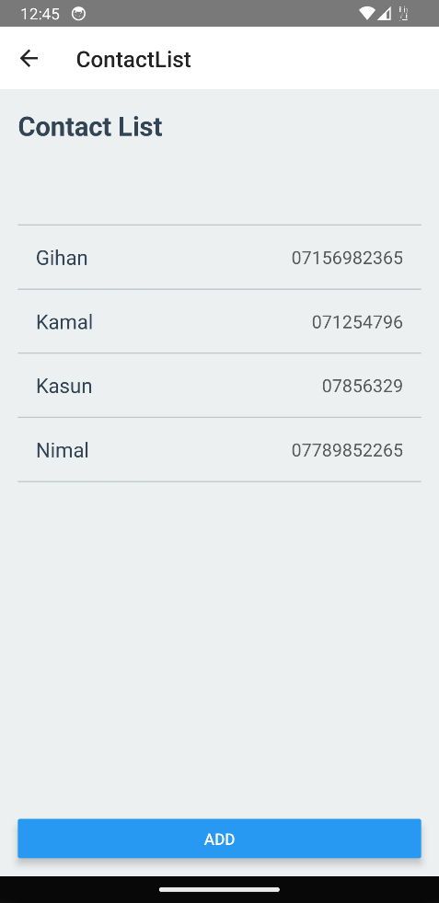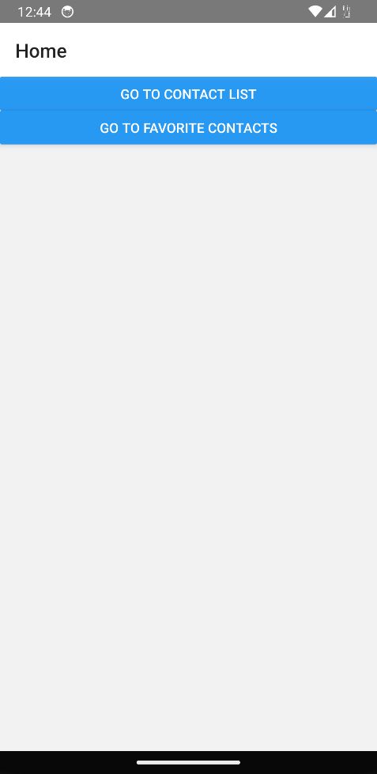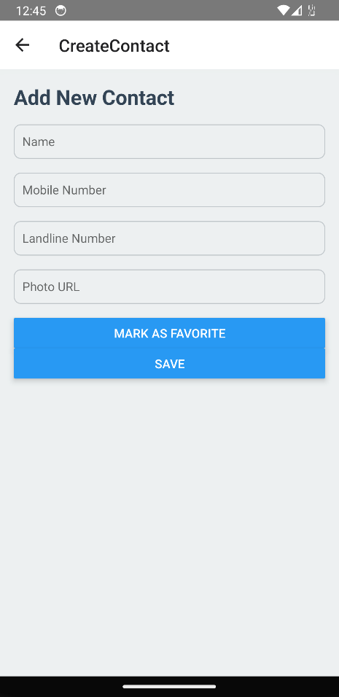

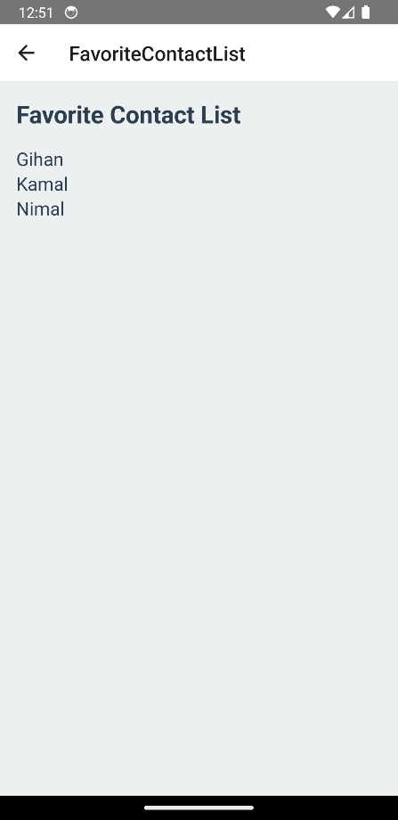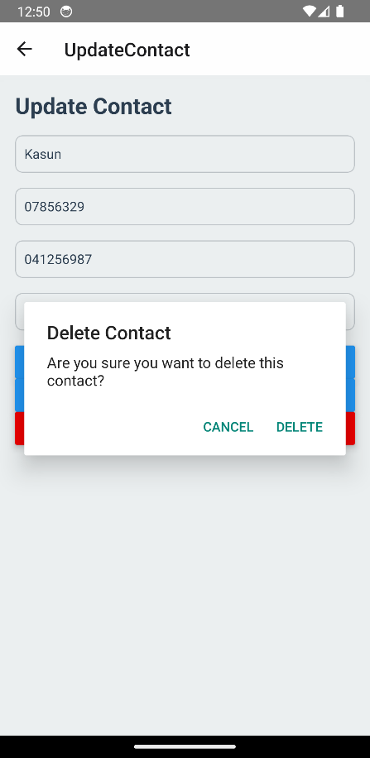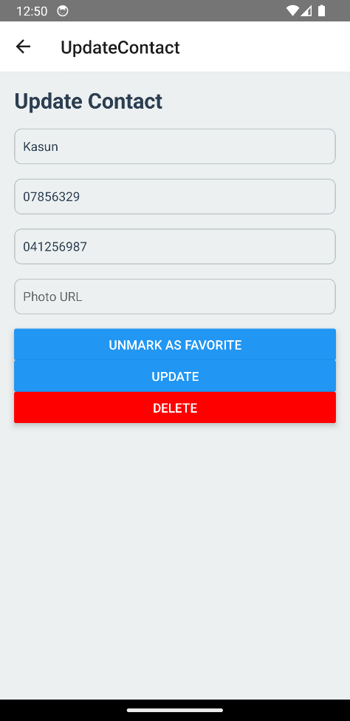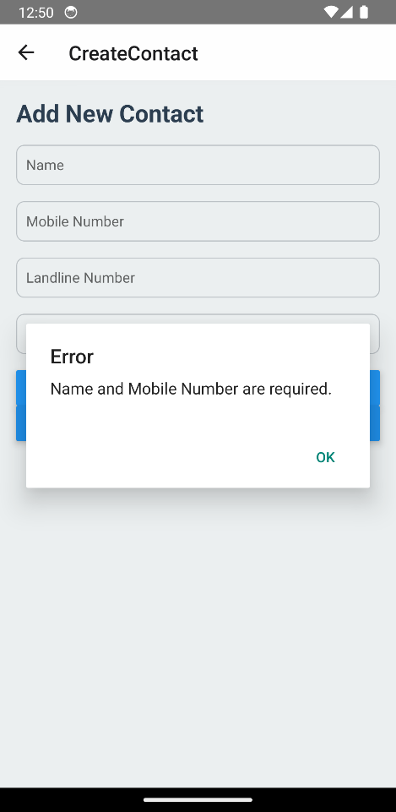

**Assumptions**:

* An Alert of validation error will be popped up when the fields are empty, or data type is invalid.
* Redux has not been used in this assignment. After add, delete or update will have to reload the app to see changes in contact listing screen.