Customer Review Scraping and Sentiment Analysis: Apple AirPods 4 at Best Buy Canada
HanuAi ML Assessment - Task 1 report | 127 public reviews, one product (SKU 18470962) | collected 23 Oct 2026

1. Executive summary
127 | 64 / 63 | 86% | 36%
public reviews collected (the page header shows 139) | reviews with text / star-only reviews | agreement of the open-source LLM sentiment label with star ratings | of text reviews talk about the shopping experience, not only the product

We collected the public customer reviews of one product with well over the required 50 reviews, extracted the required fields for each (primary key, title, text, date as YYYY-MM-DD, rating out of 5, source, reviewer name, plus helpfulness, sub-ratings and ranking under each sort filter), scored sentiment with a lexicon and with an open-source LLM, and tagged each review with aspect-level sentiment in the format of the brief (e.g. ['Fit & Comfort (Neg)']).

What the reviews say
- Polarised, and better than it looks - until you read the words. The average is 4.04 stars (74% would recommend), driven by many 5-star ratings, but reviews that contain text average only 3.6 stars versus 4.5 for star-only reviews: 30% of text reviews are 1-2 stars compared with 8% of star-only ones. Unhappy customers write; happy ones tap five stars.
- Sound and fit decide the verdict - and divide opinion. They are the two most-mentioned aspects and both are praised and criticised (sound: 17 positive vs 12 negative reviews; fit: 13 vs 12). With only 24 negative reviews the two are statistically tied as the top complaint themes (46% and 42% of negative reviews).
- The retailer is part of the product experience. 36% of text reviews discuss delivery, staff or returns. Delivery and pickup is the strongest positive (8 of 11 mentions positive); returns and store policies is the most negative (7 of 10 negative), with reviewers citing the open-box 'hygiene' policy for earbuds.
- One review in five is mixed (13 of 64 text reviews praise one aspect and criticise another), which a single star rating cannot express.
- Half the reviews carry no reasons: 63 of 127 are star-only, so the 'why' is missing for half the customers.

What we recommend (details in section 6)
- Investigate sound defects and fit together (unit-level issues such as one bud quieter or louder, static, cracking; ear-fit guidance and a short fit-exchange window).
- Revisit the open-box 'hygiene' return policy for earbuds, which converts product problems into store grievances.
- State what is not included (no ANC, no cable, limited non-Apple features) on the product page, and keep the strong delivery/pickup experience.
- Collect reasons, not just stars, and track aspect sentiment rather than star averages.
Important: how this data was obtained
The brief asks for a scraper and for compliance with site policy. Best Buy's robots.txt allows product pages, but its Conditions of Use (section 7) prohibit scraping. The requester was told and chose a small, polite, one-product collection. The Selenium scraper was blocked on its first request ('Access Denied') and stopped, as agreed; the same public pages were then read through an unmodified browser session with the same selectors and limits (28 'Show More' clicks). For production use, the right route is a data licence or official API. Details in sections 2 and 7.

2. Approach, policy checks and what actually happened
Step | What was done
Product choice | Apple AirPods 4 In-Ear True Wireless Earbuds with USB-C Charging Case: 139 ratings (>50 required), so a capped scrape still captures essentially all of them
robots.txt | /en-ca/product/ is explicitly Allowed; the reviews page lives under it; /search, /account, /basket, /checkout, /create-review are Disallowed and were never visited
Terms of use | Conditions of Use section 7 prohibits scraping/data-mining 'in any form and by any means'. The user was informed and explicitly chose to proceed with a small, polite collection; this is disclosed in the report
Limits agreed | one product; public pages only (no login, no /search); throttled with 2.5-5 s random delays; stop on any block or CAPTCHA; about 15-30 page actions (hard budget in code: 60)
Attempt 1: Selenium + headless Chrome | Blocked - 'Access Denied' on the first page load. Scraper stopped immediately (no retry, no spoofed user-agent, no proxy, no CAPTCHA handling)
Attempt 2: unmodified browser session | Same public pages, same CSS selectors, parsing rules, sort filters, delays and click budget; 28 'Show More' clicks; stopped when the button disappeared
Filters applied | Sort: Newest (paged to exhaustion), Most Helpful, Most Relevant, Highest Rating, Lowest Rating, Oldest (first ~20 each); 'Verified Buyers Only' (the site reports no verified-buyer reviews for this product)
Integrity | Data moved from the page to disk in four slices, each verified against a checksum computed in the page

The scraper
The reviews are on a dedicated page that loads 10 reviews per 'Show More' click, with a sort drop-down and a verified-buyers switch. The notebook contains the full, commented Selenium + BeautifulSoup scraper:
Design principle | How it is implemented
Pagination and filters | click_show_more() pages until the button disappears; apply_sort() drives the drop-down; set_verified_only() toggles the switch; each waits for the list to re-render
Public data only | No login; reviewer names are the display names shown by the site
Respect robots.txt | robots_allows() is checked before anything is opened
Be gentle | Randomised 2.5-5 s pauses; hard budgets on 'Show More' clicks (60) and on unique reviews (200)
Be resilient | with_retries(): exponential back-off with jitter for transient errors (demonstrated in the notebook)
Stop, don't fight | A block or CAPTCHA raises BlockedError and the run ends
Testable | The parser is unit-tested offline on an HTML fixture that mirrors one review

3. The data collected
Required field | Source on the page | Notes
Primary key | derived | The page exposes no review id, so a stable id is hashed from the review's content (BB18470962-<hash>); verified unique
Title / Review text | h3 / review content block | 63 reviews have neither (star-only)
Date (YYYY-MM-DD) | ISO data-date attribute | 2024-09-28 to 2026-10-03
Rating (out of 5) | screen-reader text 'N out of 5 stars'
Source | constant | Best Buy Canada (bestbuy.ca)
Reviewer name | 'Reviewed by NAME' | Public display name; 6 reviews are 'Anonymous reviewer'
Extras | buttons, sub-ratings, sort ranks | Helpful / not-helpful votes, would-recommend, Quality / Value / Ease-of-use sub-ratings, rank under each sort

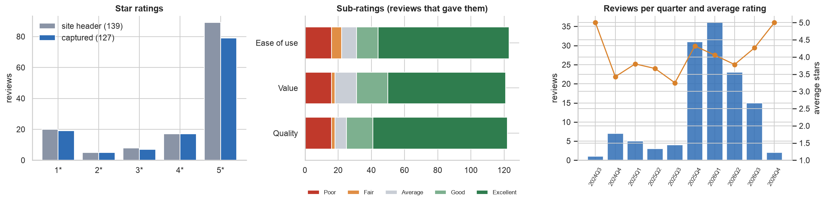
Figure 1. Star ratings (captured vs the site's own breakdown), sub-ratings, and reviews per quarter with average rating.
The captured rating distribution matches the site's: average 4.04 against the site's 4.08. The list ends 12 reviews short of the 139 shown in the header (10 five-star, 1 three-star, 1 one-star), probably reviews in another language or hidden by the site; they are not recoverable from the public list.

Data-quality observations
- Half the reviews are star-only (63): a star rating, three sub-ratings and a recommend answer, but no words. They cannot be scored on text, so their sentiment is derived from the stars and labelled as such.
- An off-topic review: one review under the AirPods is about an iPad Pro; it is detected and flagged (Off-topic).
- Retail feedback is mixed in with product feedback, so each review is also classified as Product / Retail experience / Both.
- No verified-buyer reviews exist for this product according to the site, so that field is False throughout.
- Duplicates: none - the primary key is unique; the same review surfaced under several sorts is merged, keeping its rank under each.

4. Sentiment analysis

Method
Preprocessing: title and body are joined (the title often carries the verdict), typographic quotes and whitespace are normalised and URLs are removed; punctuation and capitalisation are kept because both models use them. Only the 64 reviews with words are scored on text.
 | VADER (lexicon) | FLAN-T5 (zero-shot LLM)
Type | Lexicon + rules (negation, intensifiers, punctuation) | Open-source instruction-tuned LLM (google/flan-t5-base, 250M parameters), prompted to answer positive / neutral / negative
Accuracy vs star-derived label | 78.1% | 85.9%
Macro-F1 | 0.53 | 0.59
Positive-vs-negative accuracy (3-star excluded) | 86.2% | 94.8%

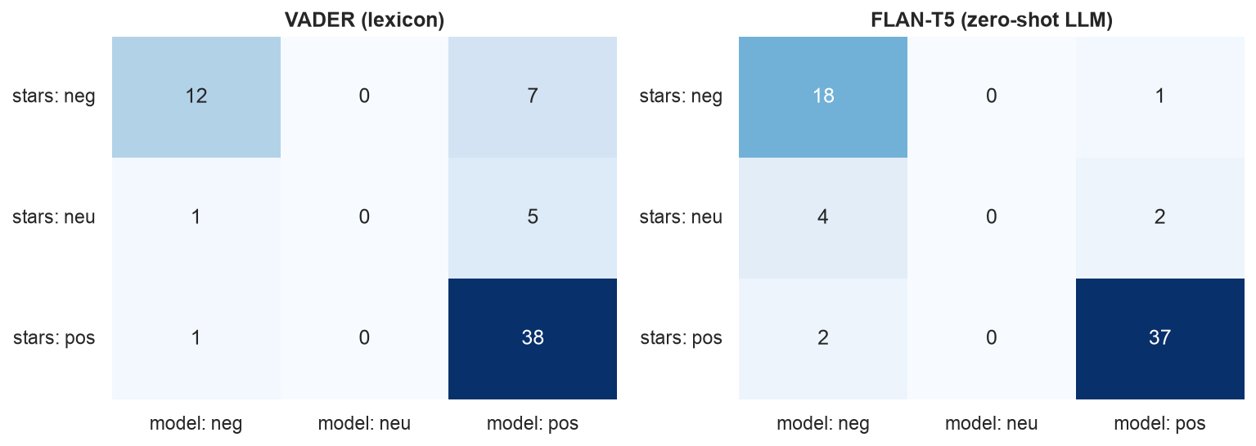
Figure 2. Confusion matrices against the star-derived label (1-2 negative, 3 neutral, 4-5 positive).
How to read these scores
n = 64 text reviews, and star ratings are an imperfect yardstick (a 3-star review is genuinely mixed; a 5-star review can still contain a complaint), so the scores are indicative. The LLM tracks the stars better than the lexicon, but never outputs 'neutral' - it picks a side. For that reason a separate Mixed flag is derived from the aspect tags (a review with at least one praised and one criticised aspect).

Aspect-based tags in the format of the brief
Each text review is split into sentences; a keyword lexicon (sound, fit, battery, price, connectivity, features, build/defects, delivery/pickup, store staff, returns/policies) finds the aspects each sentence discusses, and the LLM scores the sentence for that aspect ("What is the sentiment toward the fit and comfort in this sentence?"). Sentence scores are averaged per review and aspect, giving tags such as ['Sound Quality (Pos)', 'Fit & Comfort (Neg)']. Star-only reviews are tagged from the site's Quality / Value / Ease-of-use sub-ratings.
ID | TITLE | REVIEW (shortened) | SENTIMENT
BB18470962-A9E9632DCA | Purchase if AirPods | What made this transaction so pleasant was dealing with your sales representative, Jessica | ['Store Service & Staff (Pos)']
BB18470962-041E2D0EE6 | Works as expected. | Happy with purchase, was for my son. He loves them. | ['Overall Satisfaction (Pos)']
BB18470962-3A24FAAD65 | Product now working properly | Left ear bud is defective and couldn’t return or exchange | ['Build Quality & Defects (Neg)', 'Returns & Policies (Neg)']
BB18470962-3AD357F120 | Great | Air pods 4 are great for my daughter she loves them !! | ['Overall Satisfaction (Pos)']
BB18470962-C22D599D93 | Fast and easy | came faster than the expected date, clean and safely packaged no damages. | ['Delivery & Pickup (Pos)']

Accuracy of the aspect tags
The aspect tags have not been checked against independent human labels. An informal read of about 60 sampled mentions (two samples) found roughly 83% matched a reader's judgement; the misses are ambiguous context ('I spoke to chat support' scored positive), weak cue words, and one-sentence reviews that mix aspects. That read was done by the analyst/assistant, so a 50-100 review hand-labelled sample by a person is the sensible next step. The audit sample is printed in the notebook (section 6) for anyone to check.

5. Insights for stakeholders
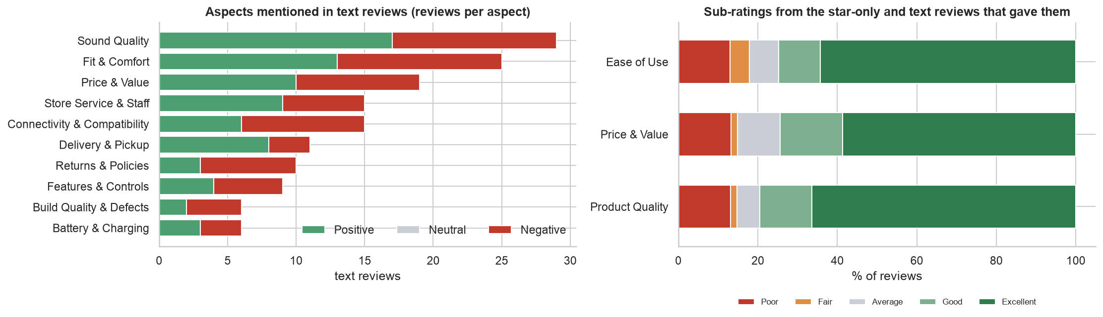
Figure 3. Aspects mentioned in text reviews and how they are judged (left); sub-ratings from the reviews that gave them (right).
Aspect | Type | % of 24 negative reviews citing it negatively | % of 40 positive reviews praising it | Reviews mentioning it
Sound Quality | product | 46% | 42% | 29
Fit & Comfort | product | 42% | 30% | 25
Connectivity & Compatibility | product | 33% | 15% | 15
Price & Value | product | 25% | 22% | 19
Returns & Policies | retail | 25% | 5% | 10
Store Service & Staff | retail | 21% | 20% | 15
Features & Controls | product | 17% | 10% | 9
Battery & Charging | product | 8% | 5% | 6
Build Quality & Defects | product | 8% | 5% | 6
Delivery & Pickup | retail | 4% | 20% | 11

Drivers of satisfaction
- Sound is the most-praised aspect (42% of positive reviews), then fit and comfort (30%) and price and value (22%).
- The buying experience: delivery and pickup is praised in 20% of positive reviews and is positive in 8 of 11 mentions; store staff are praised and criticised in similar measure.
- Strong word signals in positive reviews: amazing, comfortable, great, perfect, fast, gen, they're, noise (smoothed log-odds; small sample, a pointer not proof).

Drivers of dissatisfaction
- Sound problems and fit top the list (46% and 42% of negative reviews; statistically tied with 24 negative reviews). Many negative sound comments describe unit-level defects (one bud quieter or louder, static, cracking); negative fit comments describe buds that fall out or hurt.
- Connectivity and compatibility (33% of negative reviews): disconnects, and weaker experience with non-Apple devices.
- Returns and store policies (7 of 10 mentions negative; 25% of negative reviews vs 5% of positive ones): reviewers who could not return ill-fitting or defective units describe the open-box 'hygiene' rule as the last straw.
- Expectation gaps: missing active noise cancelling, no charging cable in the box, price relative to older models.

Other patterns
- Stars versus words. Only 2 high-star reviews have negative text (for example a 5-star review complaining about store staff), and 1 low-star review has positive text - a mismatch worth reading, not a pattern.
- Mixed reviews: 13 of 64 (20%) praise some aspects and criticise others; they appear at every star level, including 5 stars with a complaint.
- Sub-ratings are polarised: quality 4.2, value 4.0, ease of use 4.1 on average, but each has a block of 'Poor' ratings (about 13%) next to a majority of 'Excellent'.
- Helpfulness: readers vote for balanced and negative reviews as readily as positive ones (average 1.7 helpful votes on negative vs 1.5 on positive text reviews).

6. Recommendations
# | Recommendation | Evidence
1 | Investigate sound defects and fit together. Sound is both the most-praised and a top-complained aspect, so complaints look like unit-level quality or firmware variation (one bud quieter/louder, static, cracking) - escalate to the vendor and publish known fixes. For fit, add guidance and try-on advice to the listing and offer a short fit-exchange window. | Sound cited negatively in 46% and fit in 42% of negative reviews
2 | Review the open-box 'hygiene' return policy for earbuds. It converts product problems into store grievances. | Returns & policies negative in 7 of 10 mentions
3 | State what is not included - no active noise cancelling, no charging cable, limited features with non-Apple devices - on the product page. | Expectation-gap complaints in several negative reviews
4 | Keep the delivery and pickup experience - the retailer's most consistently praised strength. | Positive in 8 of 11 mentions
5 | Collect reasons, not just stars (a one-tap 'what did you like / dislike' chooser) and keep reviews on-topic. | 63 star-only reviews; 1 off-topic review
6 | Do not read star averages alone. Track aspect-level sentiment from text as an early warning. | Text reviews average 3.6 stars vs 4.5 for star-only

7. Solutions for scraping challenges
What was encountered here. The site's bot protection returned 'Access Denied' to headless Chrome driven by Selenium on the first request, while an ordinary browser session loaded the same page without issue. Typical triggers are the automation flag (navigator.webdriver), a HeadlessChrome user-agent, missing browser-fingerprint details and automated traffic patterns.
Challenge | Technique | Used here? | Notes
IP blocking / rate limits | Throttle and randomise requests; rotate residential or datacentre proxies; spread work over time; cache so nothing is fetched twice | Throttling: yes. Proxies: supported (ScrapeConfig.proxy), not used | Rotation hides volume, so use it only where the volume itself is permitted
Bot detection / fingerprinting | Headed browser, realistic viewport/locale and consistent headers; 'stealth' patches for navigator.webdriver; undetected-chromedriver | No | These work by disguising automation; using them after a block would circumvent the site's decision, which was not agreed
CAPTCHA | Avoid triggering it with human-like pacing; human-in-the-loop solving; third-party solving services | No - the scraper stops | Automated CAPTCHA bypass defeats a control designed to stop automation
Transient errors (timeouts, stale elements, 5xx) | Retry with exponential back-off and jitter | Yes - with_retries() | Demonstrated in the notebook (2 retries, then success); a block is never retried
Dynamic JavaScript pages | Real-browser automation with explicit waits on elements, not fixed sleeps | Yes | WebDriverWait plus list-growth checks after each click
Layout changes | Prefer stable hooks (data-automation) over generated class names; keep an offline fixture test | Yes | The parser test runs offline
Terms of use / legality | Check robots.txt and the terms; prefer an official API, partner feed or licensed data | Checked; terms prohibit scraping | The right long-term answer for production: ask Best Buy for a data licence or API access

8. Limitations and next steps
- One product, 127 listed reviews (64 with text). Findings describe this product at this retailer; with 24 negative reviews, differences between aspect percentages (for example sound versus fit) are within noise.
- Collection route. The Selenium scraper was blocked; data came from an unmodified browser session using the same selectors and limits, and the site's terms prohibit scraping. This was disclosed to and accepted by the requester; production use needs a licence or API.
- Validation. Sentiment is validated against star ratings (imperfect); aspect tags only by an informal read (about 83% of ~60 mentions) - not against independent human labels.
- Next steps: hand-label 50-100 reviews and fine-tune a small classifier; extract aspects with an LLM instead of a lexicon; handle other languages (the site's own summary notes multilingual reviews); track aspect sentiment over time once volume allows; pursue a data-licence route for continuous monitoring.

Appendix - deliverables
- Task1_Scraping_Sentiment.ipynb - annotated notebook: policy checks, Selenium + BeautifulSoup scraper, offline parser test, data validation, EDA, sentiment (VADER + FLAN-T5), aspect tags, insights, scraping-challenge demonstration, export.
- task1_reviews_sentiment.csv / .xlsx - 127 reviews; required fields first (Primary Key, Title, Review Text, Date, Rating, Source, Reviewer Name), then the SENTIMENT aspect tags, overall sentiment and scores, mixed flag, sub-ratings, helpfulness, ranks; workbook adds the example layout, aspect summary, model evaluation, collection log and data dictionary.
- outputs/scrape_log.json and outputs/aspect_mentions.csv - the collection log and every aspect mention with its score.

