Infotainment Warranty Claims: Text Mining and Root-Cause Analysis
HanuAi ML Assessment - Task 2 stakeholder report | 1,000 warranty claims, MY2020 build cohort (Aug-Sep 2019), claims Aug-2019 to Jun-2021

1. Executive summary
88% | 46% | 11-12% | 3
of claims end with the radio replaced, whatever the symptom | replace the radio with no documented physical cause | of 2021 claims: radio stays on / drains the battery (0-5% per quarter before) | model lines over-represented in camera / video complaints

We analysed 1,000 warranty claims for one vehicle cohort whose infotainment system (radio / head unit, display, camera, satellite radio, Bluetooth, OnStar) is the subject of every claim. Three free-text narratives per claim (customer concern, technician diagnosis, repair performed) were converted into structured tags, the claims were grouped by type of issue, and the results were tested statistically so that only patterns that survive multiple-testing correction are reported as findings.

What the data says
- The radio is the hub. 88% of claims end with the radio replaced - 80-94% in every symptom cluster, including camera, phone, satellite-radio and screen complaints. Customers describe many different symptoms; the repair is almost always the same.
- Diagnosis is not converging. 46% of claims replace the radio without documenting a physical cause; 33% are escalated to technical assistance (TAC), and 92% of those end in replacement. Only 31% explicitly document an internal radio fault and just 2% show an external wiring/electrical cause.
- One trend is statistically real. Of 32 categories tested for change over time, only one survives correction: claims where the radio stays on after the vehicle is switched off / drains the battery (46 claims) rose from 4.0% early on and 2.2% in mid-2020 to 11.1% in 2021 (adjusted p < 0.001).
- Camera / video complaints concentrate in specific models - FusionNova (18 vs 7 expected), HyperFury X (30 vs 17 expected), StellarGlide (16 vs 7 expected) - and this is confirmed independently by the semantic clusters and by the repair-narrative topics. Plants show no significant concentration.
- The structured codes mislead. The coded cause barely changes what technicians found or fixed, and the coded complaint 'Communication' is mostly audio drop-outs and screen blanking, not connectivity.
- Early-life failures matter: 21% of claims arrive within 90 days of the vehicle entering service, and 76 claims are dated before the in-service date.

What we recommend (details in section 6)
- Failure-analyse returned radios with the supplier (documented-fault, undocumented, camera-complaint and stays-on samples) - the single largest cost driver.
- Software-first, verify-before-replace workflow and a mandatory evidence standard (fault codes, circuit tests, failure code) before a radio is authorised for replacement.
- Contain the emerging 'stays on / battery drain' issue now: check against software releases, measure key-off current draw, add a power-down test to software validation.
- Investigate the camera/video signal path on the over-represented model lines before it spreads.
- Fix data capture (structured fields, clean labels, keep DTC/part numbers) and run this text-mining pipeline weekly as an early-warning system.
Reading note
All figures are claim counts, not failure rates: the dataset has no production volumes, so a model or plant with more claims may simply have built more vehicles. The dollar figures in section 6 are illustrative assumptions, not values from the data.

2. Understanding the data
Each row is one warranty event: identifiers and dates, vehicle attributes (build plant, make, model), two coded fields (complaint, cause) and three free-text narratives. Six columns (Trigger, Failure Component, Failure Condition, Additional Context, Fix Component, Fix Condition) were provided empty except for five worked examples, which define the target tag schema. All 1,000 vehicles are model year 2020 and were built within five weeks (Aug-Sep 2019), so calendar time and vehicle age move together and the data behaves like a single cohort ageing through its warranty.
Claims ramp up over the first five months in service, plateau at about 58 a month through 2020 and decline during 2021. The median claim arrives 227 days (about 7.5 months) after the vehicle enters service; 43% arrive within 180 days and 75% within a year.
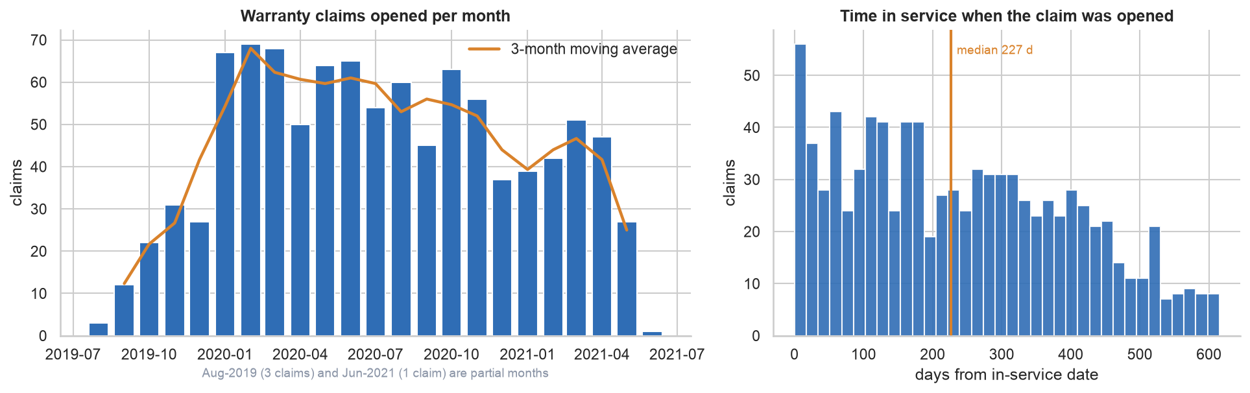
Figure 1. Claims per month (left) and time in service at claim (right).

Data-quality audit and what was done about it
Issue | Column(s) | Rows | Action
Missing coded cause | CAUSAL_CD_DESC | 3 | Kept as its own category 'Not Coded' (mode-imputing would invent a cause)
Missing diagnosis narrative | CAUSAL_VERBATIM | 1 | Set to empty text and flagged (causal_missing); mining falls back to the other narratives
Missing in-service date | IN_USE_DATE | 1 | Imputed as BUILD_DATE + median build->service lag; flagged (in_use_imputed) and excluded from time-in-service statistics
Entity-tag columns ~99.5% empty | Trigger ... Fix Condition | 995 | Not missing data: only 5 worked examples were supplied. Populated for all rows by text mining (section 4)
Placeholder instead of a complaint | CUSTOMER_VERBATIM | 8 | Text is just the coded category ('Audio Entertainment Navigation Other issues'). Flagged customer_placeholder; symptom mining falls back to the diagnosis text
Repeated customer concern text | CUSTOMER_VERBATIM | 10 | Kept - same short phrase on different vehicles/dates/plants, with different diagnoses. No true duplicate records exist
Hidden whitespace (non-breaking spaces) in labels | COMPLAINT_CD_DESC | 11 | Normalised. The 'Abnormal Noise' complaint label used non-breaking spaces, so it had been silently counted as a different category from its normal spelling
Mixed date formats | Opened date vs BUILD_DATE / IN_USE_DATE | 1000 | Opened date is M/D/YYYY text; build/in-use are ISO timestamps. All parsed to a single datetime type
Claim opened before in-service date | Opened date / IN_USE_DATE | 76 | Kept (possible pre-delivery repair or date-entry error) but flagged tis_negative and excluded from time-in-service statistics
Constant column | MODLYR | 1000 | Excluded from analysis (all 2020)
Redundant column | PLANT | 1000 | Excluded; BUILD_PLANT_DESC used (1-to-1 with the code)
Very rare models | MODEL | 26 | 7 models with <10 claims grouped as 'Other (<10 claims)' for charts/tests
Noisy free text | CUSTOMER/CAUSAL/CORRECTION_VERBATIM | 1000 | Export removed line-breaks and numbers: glued and split words, mixed case, boiler-plate. Handled by normalisation + corpus-driven fragment repair + substring-tolerant matching (section 4)
Non-English narratives (Spanish / French) | free text | 17 | Kept; Spanish/French cues are included in the lexicons (e.g. 'pantalla negra', 'ecran noir')

Two defects are worth highlighting because they are invisible to the eye: a complaint label spelled with non-breaking spaces (silently a separate category from its normal spelling), and placeholder text pasted into the customer-concern field in place of a real complaint. Free text also has glued words ('atradiothat'), split words ('RE PLACED') and stripped numbers because the export removed line-breaks and digits - which is why the text-mining step uses substring-tolerant matching and a corpus-driven fragment repair.

3. From free text to structured tags
The three narratives were treated as one story: the customer's symptom, the technician's diagnosis, and the repair. A transparent lexicon with clause-level pairing produces the same six tag columns as the examples for all claims. Components and conditions are aligned lists (the i-th component pairs with the i-th condition), exactly as in the provided examples, and the label vocabulary reuses theirs (Black Screen, Controls Irresponsive, Inoperative, No Sound, Internal Fault, Malfunction, Replaced, Programmed ...) and extends it with entities seen in the data.
Option considered | Verdict
Generic named-entity recognition | Not suitable: 'radio', 'TCICM', 'SPS' are not person/organisation/place entities
Fine-tuned model | Not possible: only five labelled rows
Open-source LLM, zero/few-shot | Viable but slow on CPU for long narratives, less auditable, non-deterministic - proposed as a next step
Domain lexicon + clause pairing (used) | Fast, deterministic, auditable, multilingual by adding cues; errors are fixed by editing a dictionary

Coverage: 99.6% of claims received at least one failure component/condition pair and 97.9% a fix pair. Triggers (22%) and additional context (35%) are legitimately sparse; claims without one receive the same default labels the examples use. Spanish (4) and French (13) narratives are handled with multilingual cues but excluded from clustering.
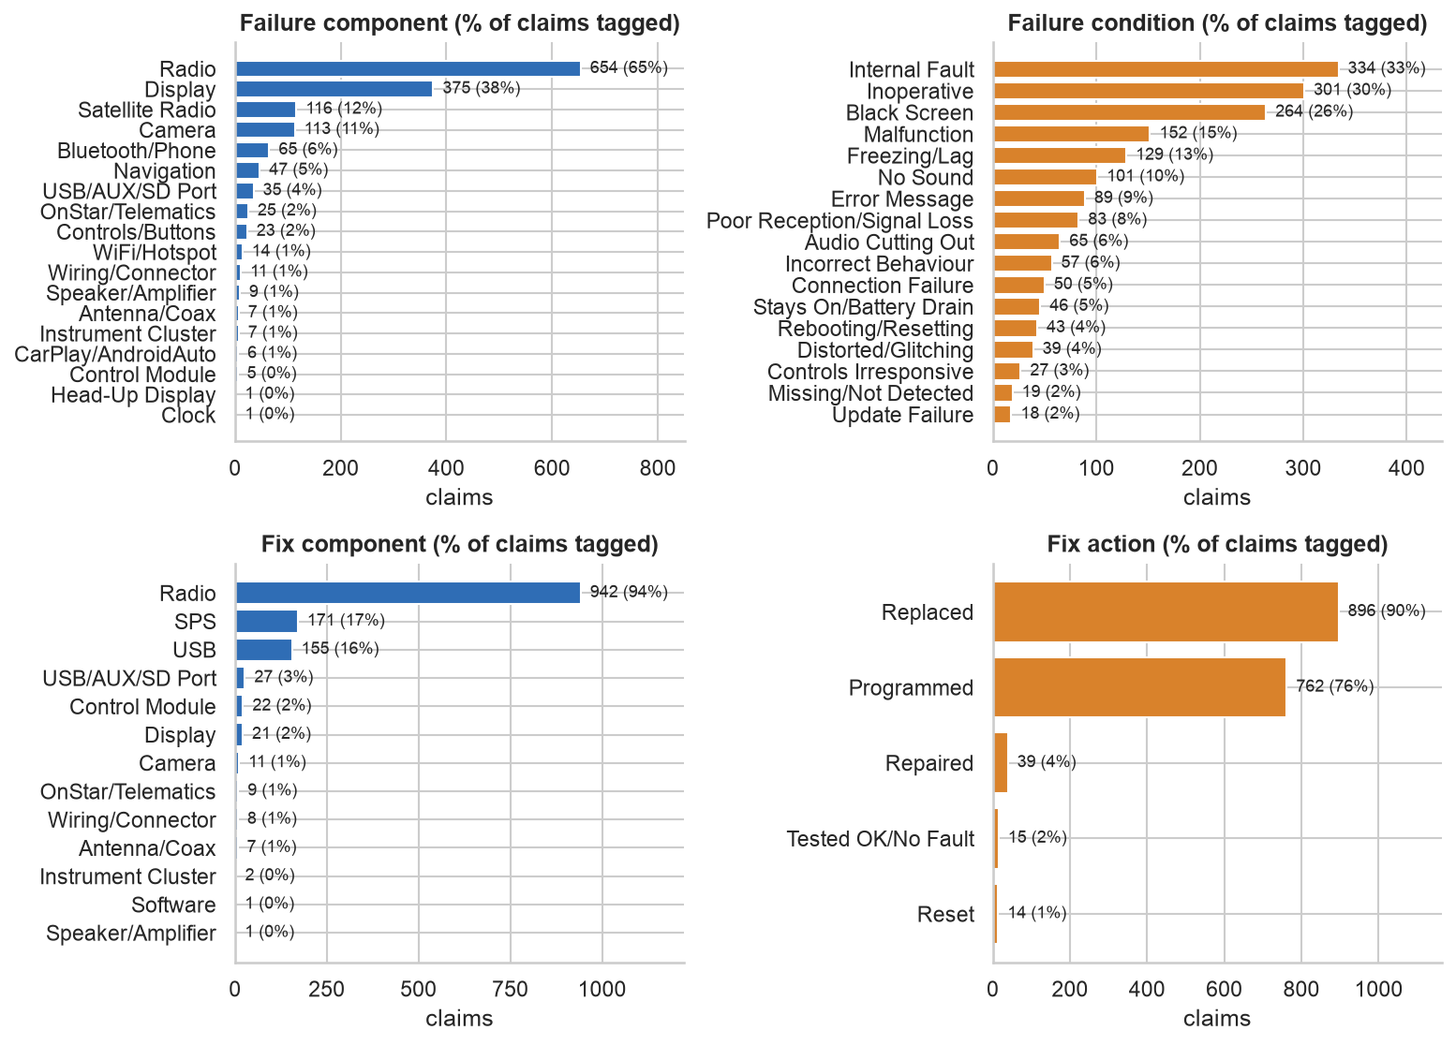
Figure 2. Extracted tag vocabularies (share of claims carrying each tag).

How accurate are the tags? (honest answer)
Tag column | Precision | Recall | F1
Failure Component | 0.90 | 1.00 | 0.95
Failure Condition | 0.56 | 0.56 | 0.56
Trigger | 1.00 | 1.00 | 1.00
Additional Context | 0.60 | 0.60 | 0.60
Fix Component | 0.67 | 0.75 | 0.71
Fix Condition | 0.78 | 0.88 | 0.82

Validation is thin by necessity
Only five labelled rows exist, so these scores are indicative, not an accuracy estimate - and the example labels are themselves subjective (e.g. 'Controls Irresponsive' vs 'Inoperative'). Component tagging agrees well with the examples; condition tagging is the weakest part. A second check against the coded complaint shows Navigation: 56% of 32 claims carry a matching component; Video: 81% of 103 claims carry a matching component. A human spot-check sample is included in the notebook (section 4.11c) and should be read by a domain expert before the tags drive decisions.

4. What fails, and what technicians do about it

4.1 Failure modes
Display black screen is the most-reported failure mode (22% of claims), followed by an inoperative radio (13%), generic radio malfunction, freezing/lag and no sound. The technician's own diagnosis names an internal fault in 33% of claims. By what the customer notices, the radio in general and the display dominate, with camera/video and satellite-radio reception next.
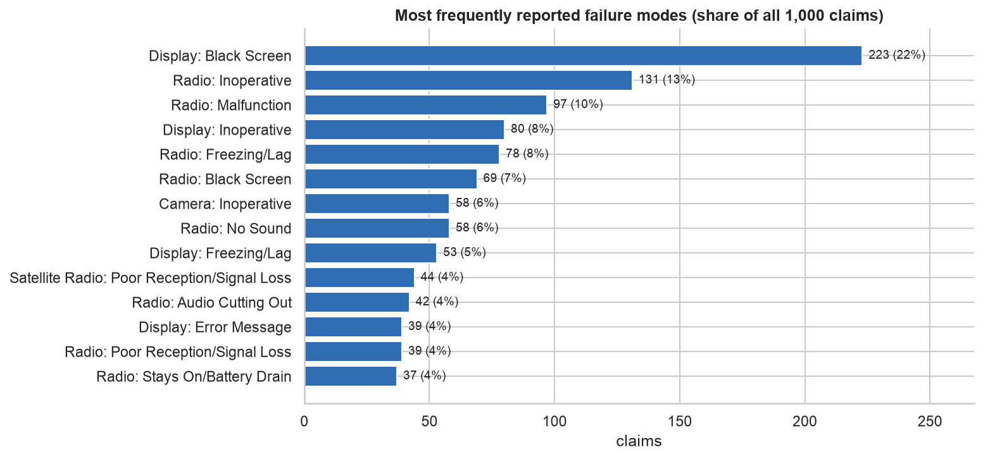
Figure 3. Most frequently reported failure modes (share of all claims; a claim can show several).

4.2 One repair fits (almost) every symptom
88.3% of claims end with the radio replaced and 66.5% are replaced and reprogrammed; only 7.4% are resolved by reprogramming alone. The share is the same whatever the coded complaint (Audio, Communication, Navigation, Video: 88-91%) and whichever plant built the vehicle. This is why the radio/head-unit is the prime root-cause candidate (hypothesis H1) - and it is also why customer symptoms such as 'camera inoperative' are, for repair purposes, radio failures.

4.3 The type of issue
Type of issue (evidence-based) | Claims | Share | What it means
Radio Replaced - Cause Not Documented | 456 | 46% | Radio replaced; the narrative states no physical cause (typically 'per TAC')
Radio Hardware Failure | 306 | 31% | Explicit internal fault / short / defective / failed radio documented
Software / Programming Issue | 103 | 10% | Software or update cause cited, or reprogramming alone resolved it
Communication / Network Fault | 83 | 8% | Documented loss of communication / data-bus fault, no stronger cause
Electrical / Wiring / Power Fault | 23 | 2% | Wiring, connector or coax repaired/replaced; corrosion, chafing, open/short, battery drain
Other / Unclassified | 15 | 2% | None of the above
Peripheral / Accessory Failure | 14 | 1% | A non-radio part (camera, antenna, USB port, display) replaced and the radio kept

The structured coded cause does not predict what technicians found. Among the 237 claims coded 'Module/Component-Shorted', 42% document a radio hardware failure, 41% document no cause and only 3% show electrical evidence. The same near-uniform mix appears under every other coded cause (Figure 4).
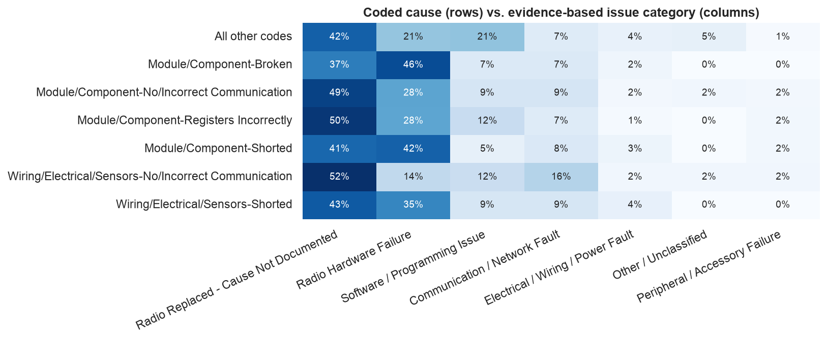
Figure 4. Coded cause (rows) versus evidence-based issue category (columns); rows sum to 100%.

5. Patterns, trends and significant changes

5.1 Volume over time
With the 2020 mean of 58 claims/month as the baseline (Poisson 3-sigma limits 35-81), the only months outside the limits are the ramp-up months (Sep 2019, Oct 2019, Nov 2019, Dec 2019) and May 2021. No month is unusually high: there is no spike, but a gradual age-related rise and fall.
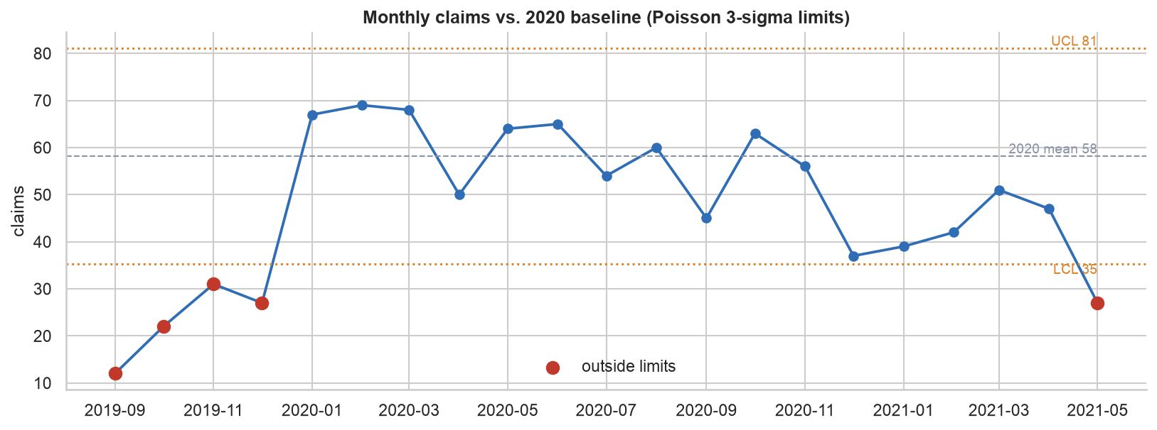
Figure 5. Monthly claims against 2020 baseline limits.

5.2 What is changing - after correcting for multiple testing
We compared the early period (Aug-19 to Mar-20), mid period (Apr-Dec 2020) and 2021 for 32 categories (affected functions, issue types, every failure condition and update-related wording) and corrected for the number of tests (Benjamini-Hochberg). Only one change is significant: Stays On/Battery Drain - 4.0% -> 2.2% -> 11.1% (adjusted p < 0.001). Every other apparent shift is not significant after correction (the next-best has an adjusted p of 0.06); these include the rise of the generic 'radio' share and complaints that mention a software update.
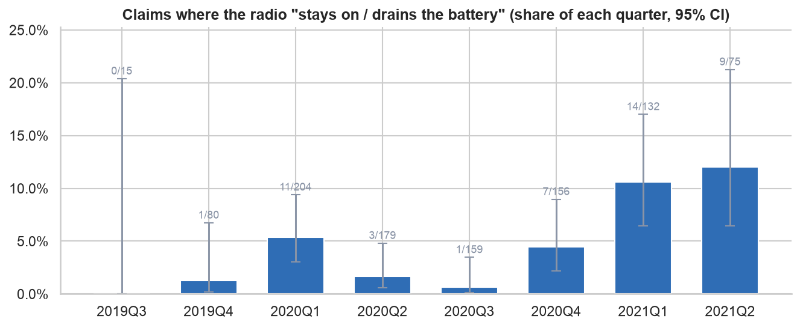
Figure 6. Share of each quarter's claims where the radio stays on / drains the battery (95% confidence intervals).
These 46 claims are mostly triggered after ignition-off (57%), arrive later in the vehicle's life (median 309 vs 226 days), are escalated to TAC far less often (13% vs 34%) and are fixed by reprogramming alone more often (11% vs 7%) - a profile consistent with a power-management / sleep-mode software behaviour rather than a hardware failure (hypothesis H7; to be confirmed against software release dates).

5.3 Where and when
- Plants: no significant association between build plant and affected function (p = 0.57) or issue category (p = 0.67). The radio-replacement rate ranges 83%-94% across plants (p = 0.07, not significant).
- Models: affected function differs by model (p = 1.2e-05). The strongly over-represented cells that survive a Bonferroni correction are all camera/video: FusionNova 18 claims vs 7 expected (z = 4.8); HyperFury X 30 claims vs 17 expected (z = 3.7); StellarGlide 16 claims vs 7 expected (z = 3.7). At make level, NebulaCruiser is over-represented as well.
- Time in service does not differ significantly by issue category (Kruskal-Wallis p = 0.12) or function (p = 0.40). 21% of claims occur within 90 days; 76 claims precede the in-service date.

5.4 Clusters, topics and likely root causes
Two unsupervised views complement the rules. Symptom clusters group the customer's wording (K-Means on TF-IDF/LSA, k = 10; and K-Means on all-MiniLM-L6-v2 sentence embeddings, k = 10). Repair topics (NMF) group the technician narratives. Cluster separation is weak - silhouette 0.10 (TF-IDF), and the TF-IDF solution is only moderately stable across restarts (ARI 0.49) - as is typical for short text, so clusters are used as a lens, and findings are reported only where independent views agree. The embedding clusters match the rule-based functions better (NMI 0.35 vs 0.19 for TF-IDF).
Embedding (semantic) cluster | Claims | Dominant function share | Radio replaced | TAC escalated
E0: Display / Screen | 91 | 60% | 80% | 35%
E1: Radio (General) | 50 | 44% | 94% | 44%
E2: Display / Screen | 136 | 74% | 90% | 30%
E3: Radio (General) | 95 | 73% | 89% | 25%
E4: Radio (General) | 185 | 53% | 90% | 37%
E5: Satellite Radio / Reception | 90 | 84% | 91% | 38%
E6: Radio (General) | 91 | 53% | 85% | 24%
E7: Phone / Connectivity | 46 | 91% | 89% | 30%
E8: Camera / Video | 103 | 92% | 89% | 24%
E9: Radio (General) | 96 | 43% | 88% | 51%

Repair-narrative topic (NMF) | Share of claims | Radio replaced | TAC escalated
Programming path (USB file transfer / SPS) | 15% | 75% | 39%
Documented internal failure -> replaced | 8% | 93% | 22%
Internal fault found by scan -> replaced | 8% | 93% | 22%
TAC-directed replacement (communication / short) | 14% | 96% | 46%
Power / ground / data circuits tested OK -> replaced | 18% | 90% | 23%
Replace + program (claim documentation) | 13% | 96% | 37%
Display / camera / coax diagnostics | 23% | 84% | 35%

Reading the topics: roughly one narrative in five records a programming path (USB file transfer / SPS) - and that topic has the lowest radio-replacement rate (75%); another fifth documents that power, ground and data circuits tested fine before the radio was replaced (consistent with an internal radio fault); the TAC-directed replacement topic has the highest escalation rate (46%); and the display / camera / coax diagnostics topic is the largest and is over-represented in FusionNova.

Root-cause hypotheses
# | Hypothesis | Evidence from the data | Confidence
H1 | The radio / head-unit is the common failure point (a hub), not the individual symptoms | 88% of claims end with the radio replaced - 80-94% in every symptom cluster (TF-IDF and embedding views), incl. camera, phone, satellite and display complaints; 31% of claims explicitly document an internal radio fault; only 2% show an external wiring/electrical cause | High that the radio is the remedy; medium on the failure mechanism (narratives rarely state it)
H2 | Software / firmware robustness (programming and update) contributes materially | 10% are classed software/programming; 7% were resolved by reprogramming WITHOUT replacing the radio; a USB/SPS programming topic covers 15% of narratives; complaints that mention a software update are 3% of claims in Apr-Dec 2020 and 8% in 2021 (exploratory: p=0.007 unadjusted, 0.073 after correction - not significant) | Medium for a software contribution; the 2021 update-wording rise does not survive correction
H3 | The video / rear-camera signal path on specific model lines is weaker than on others | Camera/video complaints are over-represented in: FusionNova (18 claims vs 7 expected), HyperFury X (30 claims vs 17 expected), StellarGlide (16 claims vs 7 expected). In the independent repair text, FusionNova is over-represented in the repair topic 'Display / camera / coax diagnostics' (28 vs 14 expected). Yet 93% of camera claims are still fixed by replacing the radio | Medium - convergent (symptom + repair text), but counts not rates
H4 | Diagnosis is not converging: radios are replaced on TAC advice without a documented cause | 46% of claims replace the radio with no documented physical cause; 33% escalate to TAC/Techline and 92% of those end in replacement; 16% replace the radio while recording no fault codes | High that documentation is thin; unknown how many replaced radios were truly faulty
H5 | Early-life (infant-mortality) failures escape end-of-line / dealer PDI testing | 21% of claims occur within 90 days of the vehicle entering service; 76 claims are even dated BEFORE the in-service date (pre-delivery repairs?) | Medium
H6 | Structured claim coding hides the real failure picture | The coded cause barely changes the repair or the evidence found (fig 5); coded complaint 'Communication' is mostly audio drop-outs and screen blanking, not connectivity; a hidden non-breaking-space defect split one complaint label in two | High
H7 | An emerging power-management / sleep-mode problem: the radio fails to shut down after ignition-off and drains the battery | The ONLY change in event frequency that survives multiple-testing correction: 'stays on / battery drain' claims rise from 1% (2020Q3) to 11-12% (2021). They are 57% 'after ignition off', arrive later in life (median 309 vs 226 days), are fixed by reprogramming alone more often (11% vs 7%) and are escalated less (13% vs 34%) | Medium-high that the increase is real; the mechanism (software sleep-mode vs hardware) is a hypothesis to test

6. Actionable recommendations and business impact
# | Action | Evidence | Business impact | Priority
R1 | Failure-analyse returned radios with the supplier (stratified sample: documented-fault, undocumented, camera, stays-on); open an 8D on the head unit | H1, H4 | Largest cost driver: radio replacement is ~9 in 10 claims. Every 10% cut removes ~9 replacements per 100 claims | 1
R2 | Software-first, verify-before-replace: guided recovery/reflash path and a re-test after reprogramming before a unit swap is authorised | H2, H4 | ~7% of claims are already fixed by programming alone; converting some 'cause not documented' claims avoids hardware and labour | 1
R3 | Standardise diagnostic evidence: require fault codes, circuit-test results and a supplier failure code on every replacement; give TAC a decision tree | H4 | Enables supplier chargebacks (recovery needs documented failure), cuts 'no fault found' returns, sharpens the next analysis | 1
R4 | Contain the 'radio stays on / battery drain' issue: compare with software-release/bulletin dates, measure key-off current draw, add a power-down/sleep test to software validation | H7 | The one statistically real trend (about 11% of 2021 claims); flat batteries are a high-visibility failure | 1
R5 | Investigate the camera/video path on the over-represented models (video-processing module, coax/LVDS harness, radio part numbers vs unaffected models) | H3 | Contains a model-specific defect before it spreads; cheaper than a fleet-wide action | 2
R6 | Strengthen end-of-line / PDI functional tests for display, camera, Bluetooth pairing, satellite radio and update-readiness | H5 | 21% of claims occur within 90 days - the largest age band | 2
R7 | Fix data capture and add monitoring: structured fields, clean labels, keep DTC/part numbers (stripped in this export); run this pipeline weekly with the control chart and tag-share alerts | H6 | Turns the NLP into a continuous early-warning loop - it would have flagged H7 as it began | 2
R8 | Customer experience: stock radios at dealers for high-volume models, offer loaners when parts are on order, escalate repeat visits | Repair path | 9% of claims are repeat visits and 8% wait for parts: lower repeat-repair cost, better satisfaction | 3

Sizing the prize
The data has no cost fields, so impact is expressed first in replacements avoided: the baseline is about 883 radio replacements per 1,000 claims. The dollar columns below use illustrative assumptions for average cost per replacement (parts + labour) - substitute your own figure.
Reduction in radio replacements | Avoided per 1,000 claims | Saving @ $500 each | Saving @ $800 each | Saving @ $1,200 each
5% | 44 | $22,075 | $35,320 | $52,980
10% | 88 | $44,150 | $70,640 | $105,960
20% | 177 | $88,300 | $141,280 | $211,920

7. Key learnings, limitations and further improvements

What worked
- Reading the five worked examples carefully defined a usable tag vocabulary; a transparent lexicon with clause pairing reproduced the same six columns for every claim with fully auditable rules.
- Evidence beat codes. The structured complaint/cause fields did not predict findings or repairs; the narratives did.
- Statistical discipline kept the story honest. Most tempting patterns (plant differences, time trends, time-in-service by issue) vanished after correction; what remains (stays-on trend, camera/video concentration) is supported by independent views.
- Cross-method agreement (rules, TF-IDF, sentence embeddings, topic model) gave confidence in the camera/video finding and the radio-as-hub finding.

Limitations - read before acting
- No denominators: counts, not rates; no costs; no supplier/lot/part numbers; no returned-part teardown results.
- Tag accuracy is only lightly validated (five labelled rows plus consistency checks); condition tagging is the weakest component.
- Narratives are truncated and stripped of numbers, DTC codes and part numbers; 'cause not documented' describes the text, not necessarily what the technician knew.
- One production cohort (MY2020, five-week build window): findings may not generalise.
- Weak cluster structure: low silhouette scores and moderate stability; clusters are a lens, not hard classes. The software-update-wording rise (p = 0.007) did not survive correction and is exploratory only.

Further improvements
- Use an open-source LLM with the five examples as few-shot prompts to extract tags, then compare with the lexicon output and keep the union where they agree; use the lexicon output as silver labels.
- Have domain experts label 200-300 claims, fine-tune a token-classification model and report true precision/recall.
- Join production volumes, supplier lots and teardown results so rates, supplier effects and true root causes become measurable; add survival / Weibull analysis for warranty-exposure forecasting.
- Operationalise: run the pipeline weekly with control charts and alerts on tag shares.

Appendix - deliverables and tag vocabulary
- Task2_EDA_TextMining.ipynb - annotated notebook (EDA, text mining, issue classification, trends, clustering, export).
- task2_tagged_dataset.csv / .xlsx - every claim with the extracted tags highlighted, plus sheets for tag vocabulary, issue categories, clusters, validation, QA log and data dictionary.
Tag type | Most frequent labels (claims)
Failure Component | Radio (654); Display (375); Satellite Radio (116); Camera (113); Bluetooth/Phone (65); Navigation (47)
Failure Condition | Internal Fault (334); Inoperative (301); Black Screen (264); Malfunction (152); Freezing/Lag (129); No Sound (101)
Fix Component | Radio (942); SPS (171); USB (155); USB/AUX/SD Port (27); Control Module (22); Display (21)
Fix Condition | Replaced (896); Programmed (762); Repaired (39); Tested OK/No Fault (15); Reset (14)
Trigger | At Startup (101); After Ignition Off (49); When Reversing (41); Source/Station Change (31); After Software Update (16); During Phone Call (11)
Additional Context | Intermittent (239); Repeat Visit (92); While Driving (38); Remote Start (20); Cold/Hot Weather (5); Trailer Connected (4)

