PYTHON Assignment
Operators:
1. Write a python program to find average of 3 numbers
2. Python program to find the area of circle, square, triangle
3. Write a python program converting Centigrade to fahrenheit
4. Write a python program converting fahrenheit to centigrade
5. Write a python program calculating simple interest
6. Write a python program calculating compound interest
7. Write a python program swapping two number using temporary variable
8. Write a python program swapping two number without using temporary variable
9. Write a python program to find square root of number
10. Write a python program to display the last digit of a number.

Conditions (if, if else, if elif else):
1. Program to accept 2 numbers m and n where m>n, find the quotient remainder and print the result
2. Python program to get five marks and display the grade for the same
3. Python program to Checking positive or negative number, odd or even, pass or fail, leap year or not.
4. Python program to Check Vowels and Consonants
5. Python program to print max of three numbers and min of three numbers.

6. Write a python program to prints the season for that month and day
7. Python program to find number of days in a month
8. Write a python program to display “Hello” if a number entered by user is multiple of 5, otherwise print “Bye”.
9. Accept the temperature in degree Celsius of water and check whether it is boiling or not.
10. Accept the number of days from the user and calculate the charge for library according to the following:
Till 5 days: Rs 2/day.
6 to 10 days : Rs 3/day
11 to 15 days: Rs 4/day
After 15 days: Rs 5/day
11. Write a program for police work eligible
12. Write a program to give bonus to employee calculation
13. Write a program to accept the electric units from user and calculate the bills
14. Write a Python program to check the validity of password input by users

Loop (for, while):

1. Write a program in Python to display the Factorial of a number.

2. Print first 10 natural numbers by using for & while loop
3. Program to print sum of first 10 natural numbers

4. Write a program to print multiplication table of a given number

5. Write a program in Python to display the Fibonacci series

6. Write a program in Python to display the given number is palindrome or not.

7. Write a program in Python to display the given number is Armstrong or not.
8. Write a program to calculate HCF of Two given number.
9. Write a Python program which iterates the integers from 1 to 50. For multiples of three print "hi" instead of the number and for the multiples of five print "hello". For numbers which are multiples of both three and five print "hihello".
10. Write a python program to check given number is prime number or not.
11. Write a python program to print a prime number between 0 to 100, and print how many prime numbers are there.
12. Program to find all the positive divisors of the integer
13. Finding sum of first n odd & even numbers
14. Python program to print perfect square of the number

PATTERNS:
- To print the various below shown Pyramid pattern programs using stars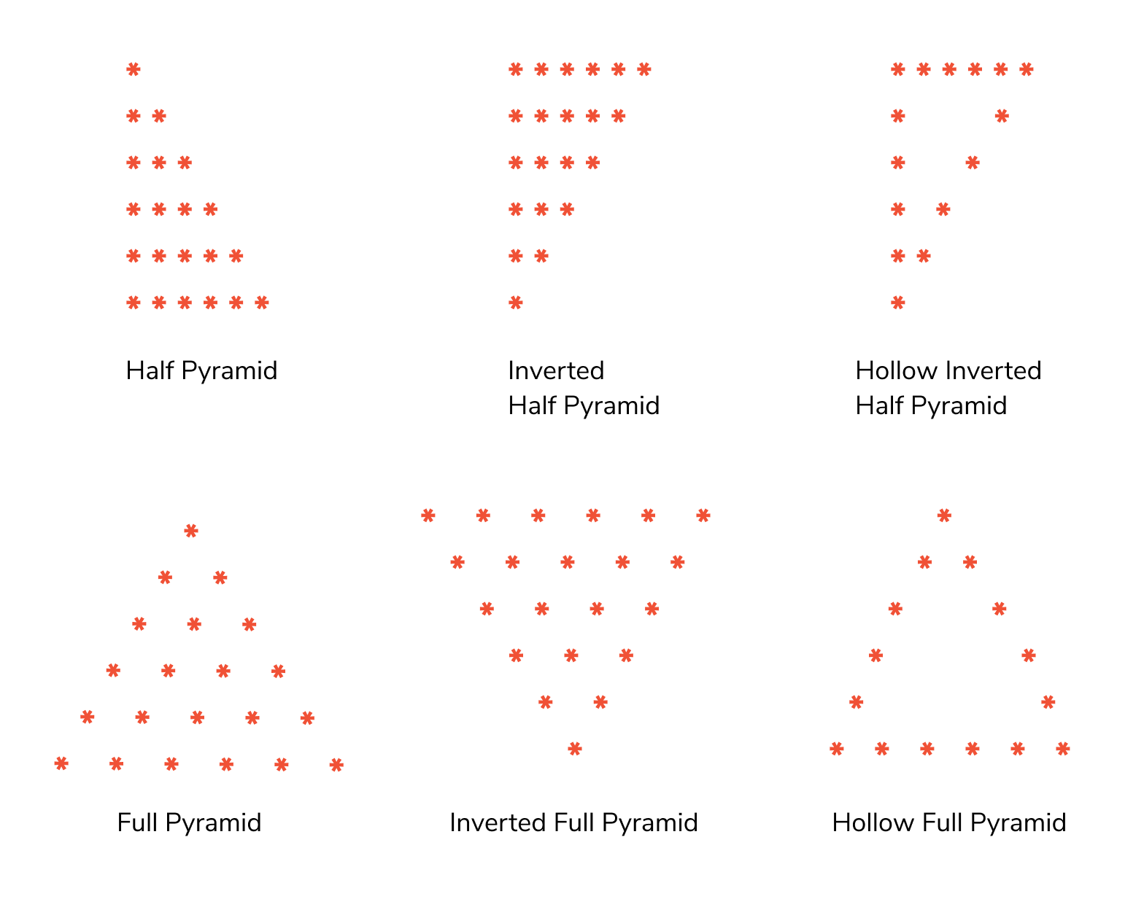
- To print the various below shown Pyramid pattern programs using numbers.
- 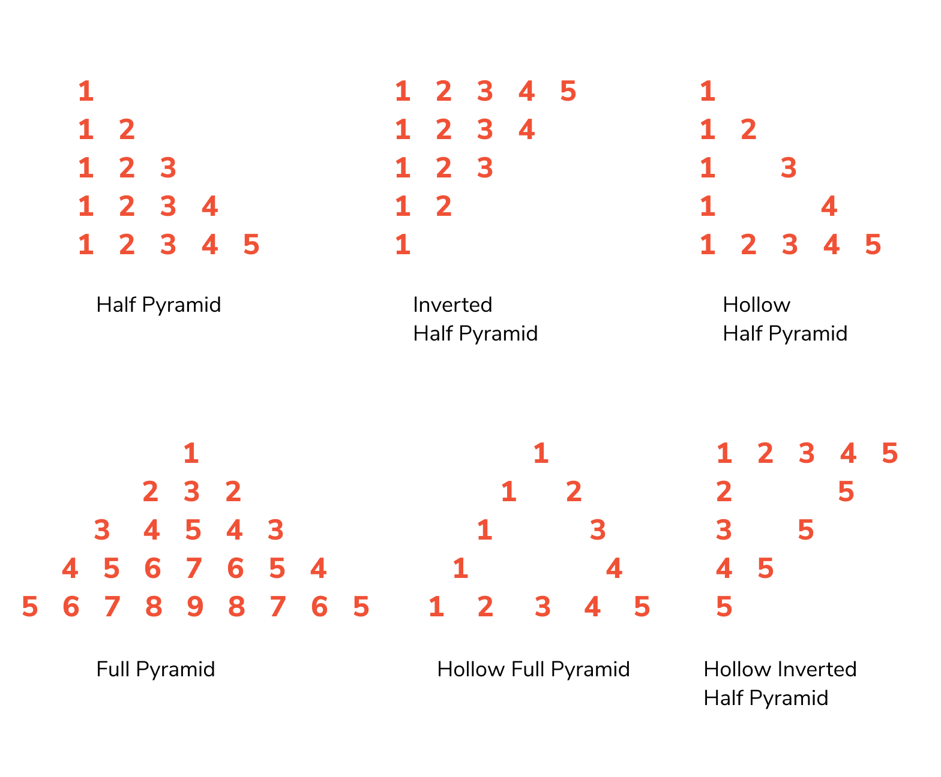
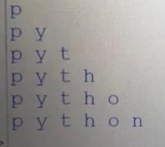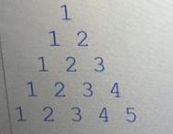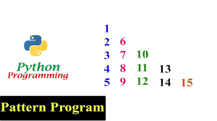
- Alphabetic pattern
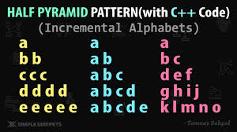
List:
- Write a Python program to sum all the items in a list.
- Write a Python program to get the largest number from a list.
- Write a Python program to get the smallest number from a list.
- Write a Python program to remove duplicates from a list.
- Write a Python program to clone or copy a list.
- Write a program to reverse a list in python
- Write a python program to create a list with random data types.
- Python program to remove an empty element from a list.
- Write a program to append data of the second list to the first list.
10. Write a python program to choose random item in a list.
11. Separate odd and even numbers in a list.
12. Sorting numbers in ascending order.

Tuple:
- Reverse the given tuple
- Access value 20 from the tuple
- Copy specific elements from one tuple to a new tuple
- Check if all items in the tuple are the same
- Create a tuple with single item 50
- Swap two tuples in python
- Unpack the tuple into 4 variables
Set & Dictionary:
- Get only unique items from two sets.
- Add a list of elements to a set
- Update the first set with items that don’t exist in the second set
- Return a new set of identical items from the two sets
- Searching:
  - Linear Search
  - Binary Search
- Sorting
  - Bubble sort
  - Selection sort
  - Insertion sort
  - Merge sort
  - Quick sort
- Creating a phone book and delete particular phone number using name (Dict)

