**MongoDB Task-2**

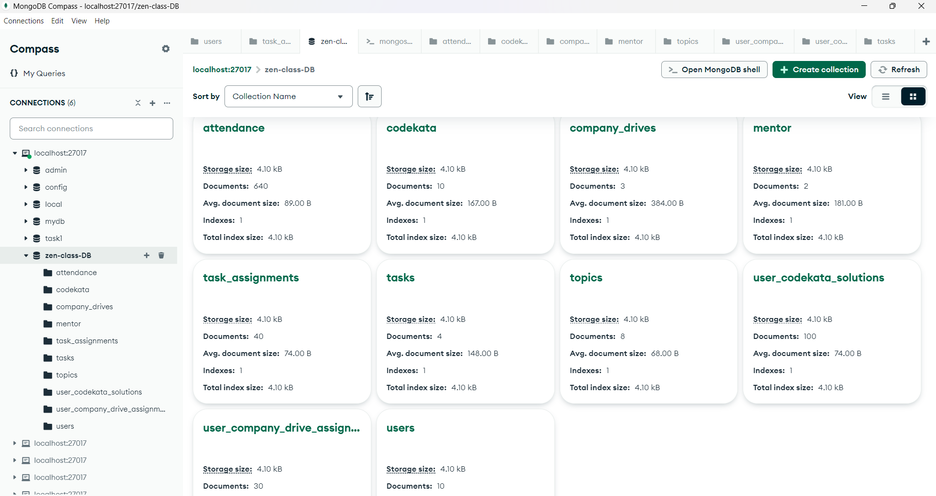

1. **Find all the topics and tasks which are thought in the month of October :**

**Query:**

|  |
| --- |
| **db.topics.find(** |
| **{ "date": { $gte: ISODate("2023-10-01T00:00:00Z"),** |
| **$lt: ISODate("2023-11-01T00:00:00Z") }** |
| **},** |
| **{ "_id": 0,** |
| **"title": 1,** |
| **"date":1 })** |

**Output:**

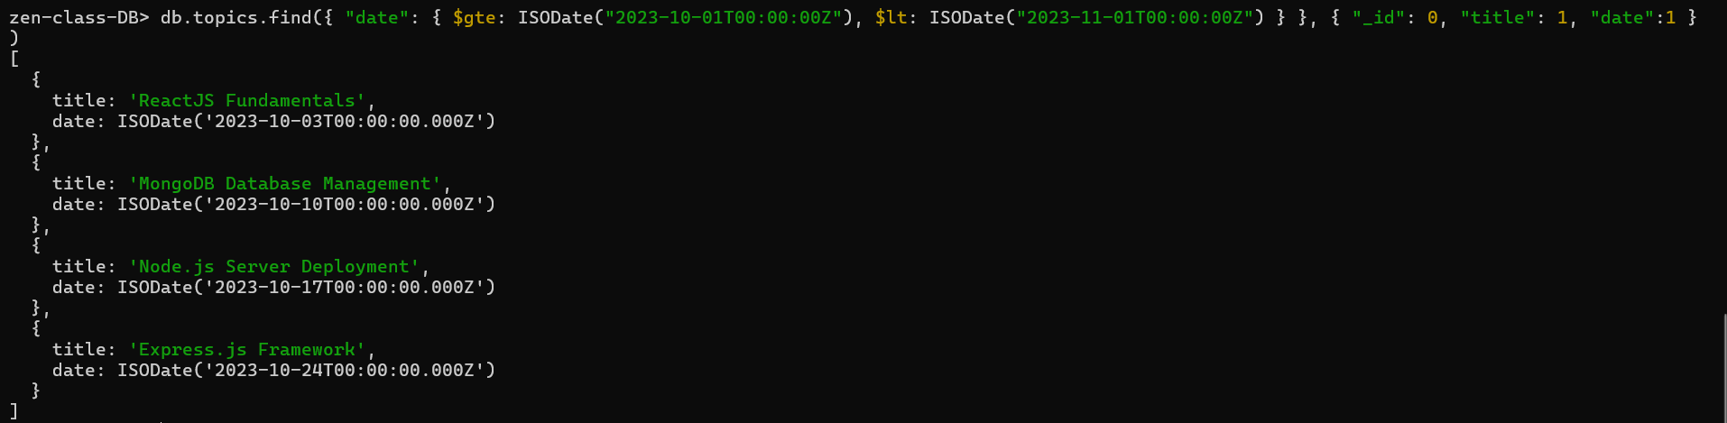

1. **2. Find all the company drives which appeared between 15 oct-2023 and 31-oct-2023:**

**Query:**

|  |
| --- |
| **db.company_drives.find(** |
| **{"driveDate":** |
| **{ $gte: ISODate("2023-10-15T00:00:00.000Z"),** |
| **$lte: ISODate("2023-10-31T23:59:59.999Z") }** |
| **})** |

**Output:**

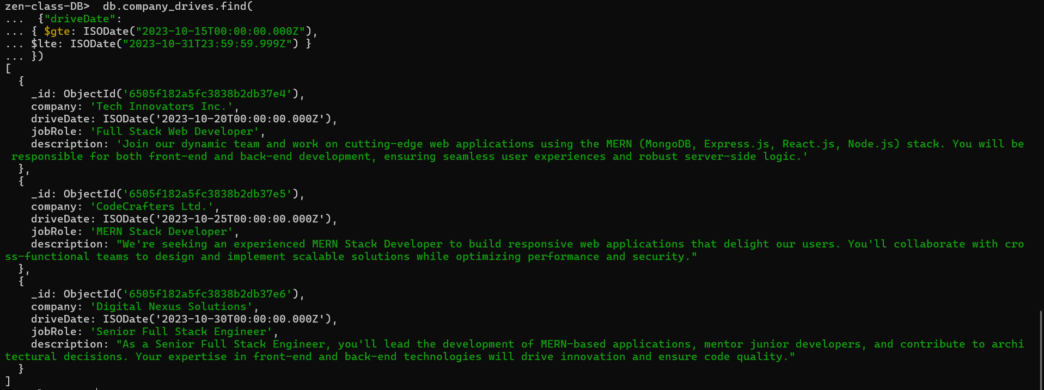

**3.Find all the company drives and students who are appeared for the placement :**

**Query:**

|  |
| --- |
| **db.user_company_drive_assignments.aggregate([** |
| **{** |
| **$match: {** |
| **attended: true** |
| **}** |
| **},** |
| **{** |
| **$lookup: {** |
| **from: "company_drives",** |
| **localField: "company",** |
| **foreignField: "company",** |
| **as: "drive"** |
| **}** |
| **},** |
| **{** |
| **$lookup: {** |
| **from: "users",** |
| **localField: "userId",** |
| **foreignField: "_id",** |
| **as: "student"** |
| **}** |
| **},** |
| **{** |
| **$unwind: "$drive"** |
| **},** |
| **{** |
| **$unwind: "$student"** |
| **},** |
| **{** |
| **$project: {** |
| **_id: 0,** |
| **"drive.company": 1,** |
| **"drive.jobRole": 1,** |
| **"student.name": 1** |
| **}** |
| **}** |
| **])** |

**Output:**

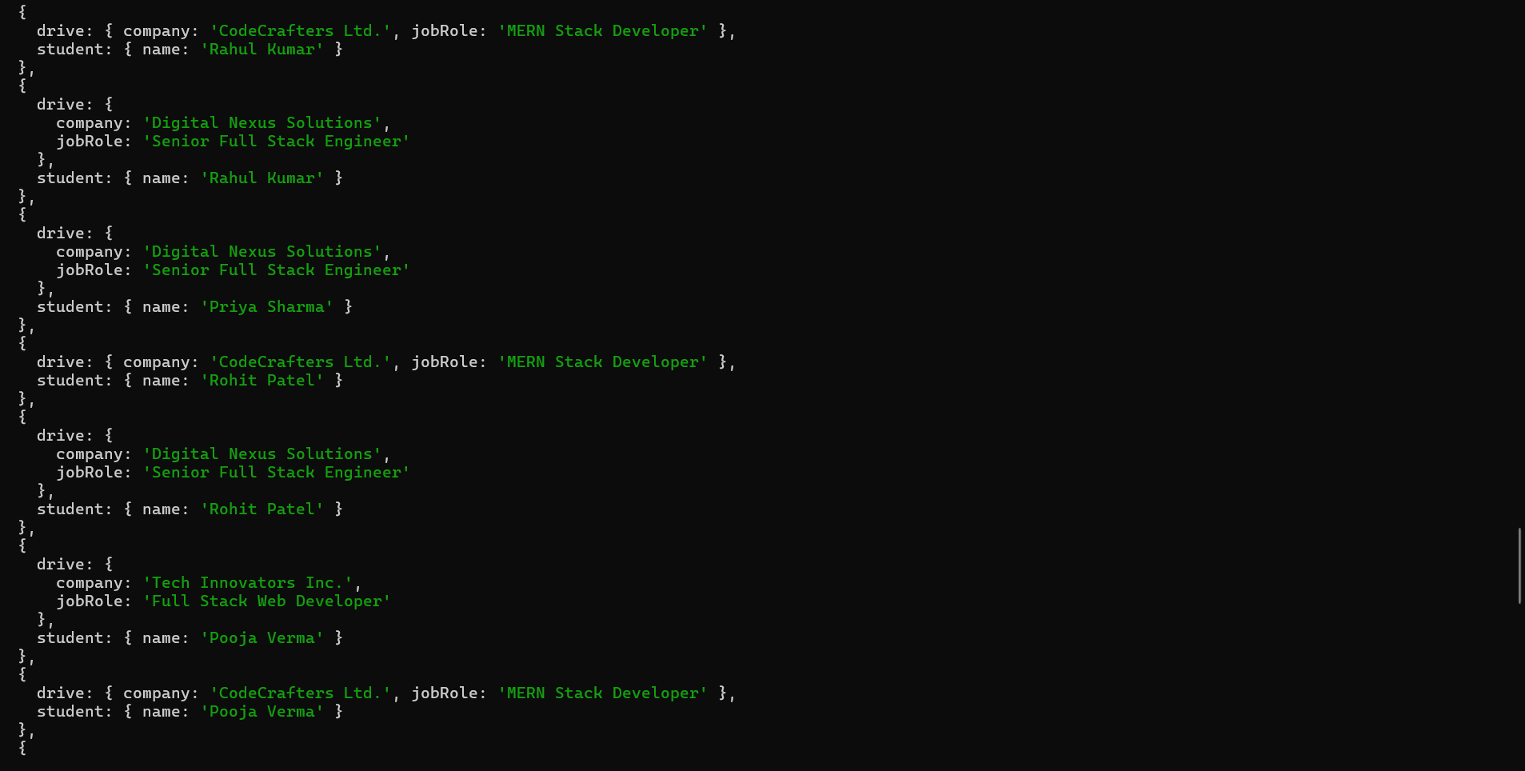

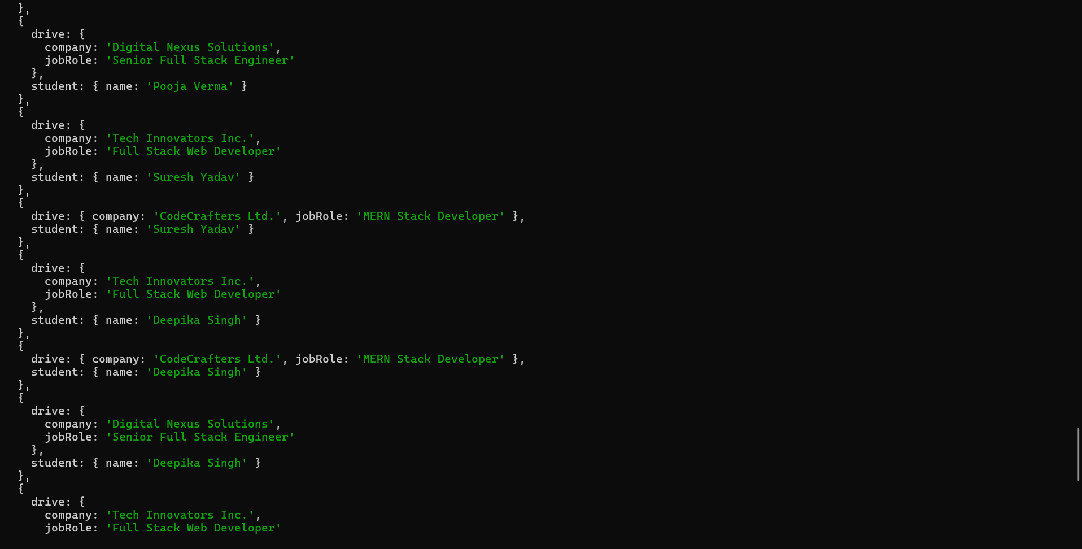



**4.Find the number of problems solved by the user in codekata :**

**Query:**

|  |
| --- |
| **db.user_codekata_solutions.aggregate([** |
| **{** |
| **$group: {** |
| **_id: "$userId",** |
| **totalSolved: { $sum: { $cond: { if: "$solved",** |
| **then: 1, else: 0 } } }** |
| **}** |
| **},** |
| **{** |
| **$lookup: {** |
| **from: "users",** |
| **localField: "_id",** |
| **foreignField: "_id",** |
| **as: "userDetails"** |
| **}** |
| **},** |
| **{** |
| **$unwind: "$userDetails"** |
| **},** |
| **{** |
| **$project: {** |
| **_id: 0,** |
| **userName: "$userDetails.name",** |
| **totalSolved: 1** |
| **}** |
| **}** |
| **])** |

**Output:**

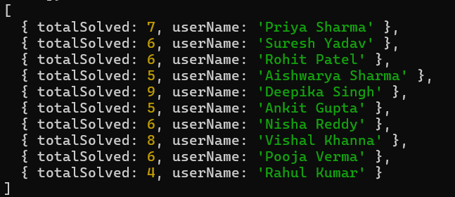

**5.Find all the mentors with who has the mentee's count more than 15 :**

**Query:**

|  |
| --- |
| **db.mentors.aggregate([** |
| **{** |
| **$match: {** |
| **menteecount: { $gt: 15 }** |
| **}** |
| **},** |
| **{** |
| **$project: {** |
| **_id: 0,** |
| **mentorName: "$name",** |
| **menteecount: 1** |
| **}** |
| **}** |
| **])** |

**Output:**

**6. Find the number of users who are absent and task is not submitted  between 15 oct-2023 and 31-oct-2023 :**

**Query:**

**db.attendance.aggregate([**

**{**

**$match:**

**{**

**date:**

**{**

**$gte: ISODate("2023-10-15T00:00:00.000Z"),**

**$lte: ISODate("2023-10-31T23:59:59.999Z")**

**},**

**isPresent: false**

**}**

**},**

**{**

**$lookup:**

**{**

**from: "task_assignments",**

**localField: "userId",**

**foreignField: "userId",**

**as: "tasks"**

**}**

**},**

**{**

**$match: {**

**"tasks.completed": false**

**}**

**},**

**{**

**$group: {**

**_id: "$userId", count: { $sum: 1 }**

**}**

**},**

**{**

**$group:**

**{**

**_id: null, totalCount: { $sum: 1 }**

**}**

**}**

**]);**

**Output:**

