**Nodejs Assigning Mentor/Students**

**Create mentor:**

POST-Create Mentor:-

[**https://node-js-3-w39e.onrender.com/api/createMentor**](https://node-js-3-w39e.onrender.com/api/createMentor)

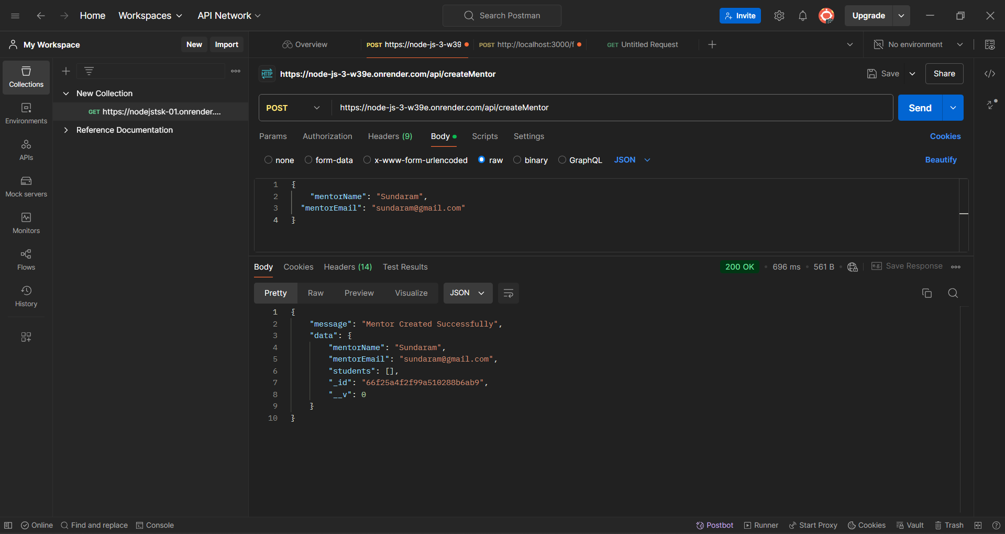

**Get All Mentors:**

GET-Get All Mentors:-

[**https://node-js-3-w39e.onrender.com/api/getAllMentors**](https://node-js-3-w39e.onrender.com/api/getAllMentors)

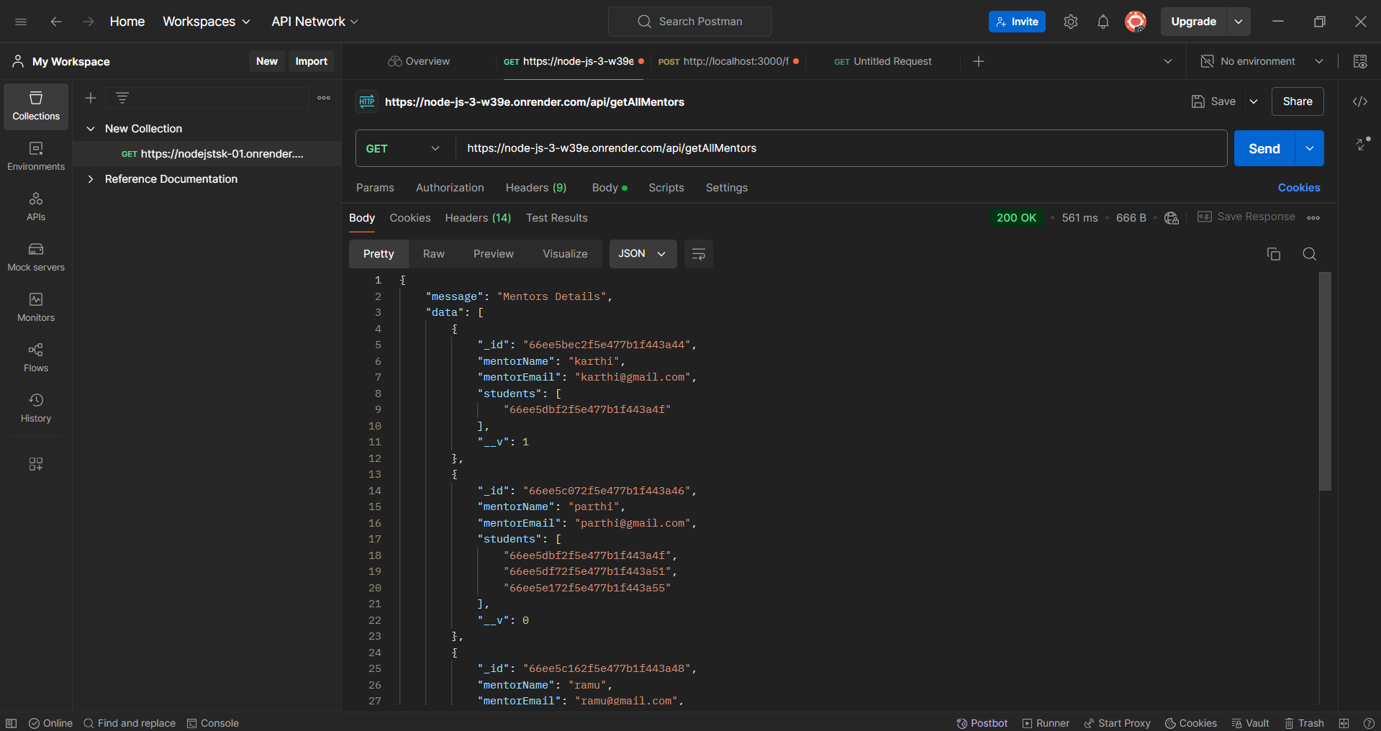

**Create Student:**

POST- Create Student:-

[**https://node-js-3-w39e.onrender.com/api/createStudent**](https://node-js-3-w39e.onrender.com/api/createStudent)

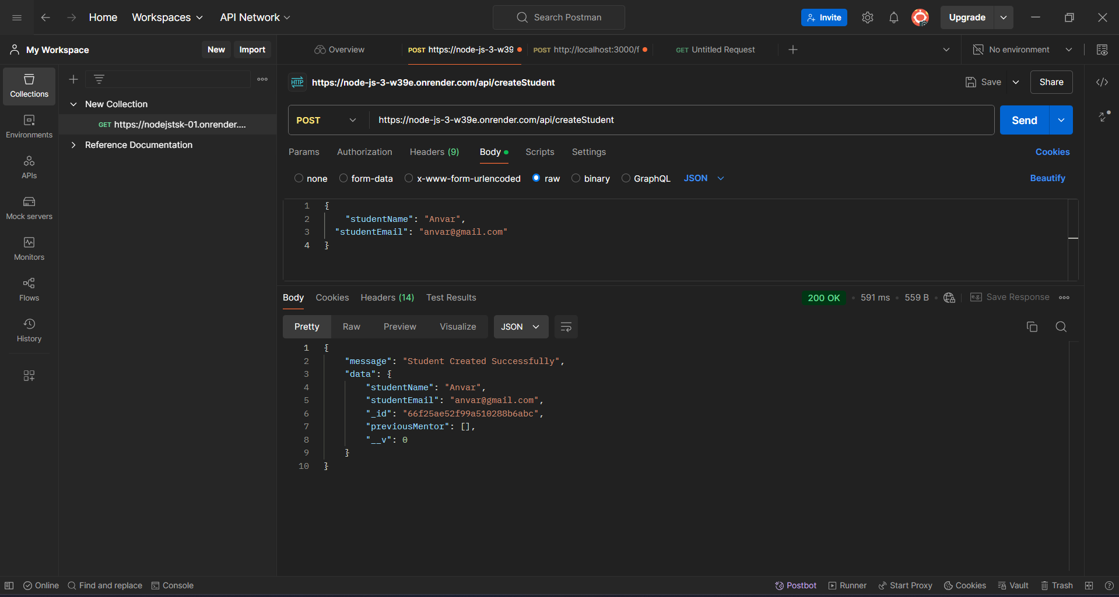

**Get All Students:**

GET- All Students:-

[**https://node-js-3-w39e.onrender.com/api/getAllStudents**](https://node-js-3-w39e.onrender.com/api/getAllStudents)

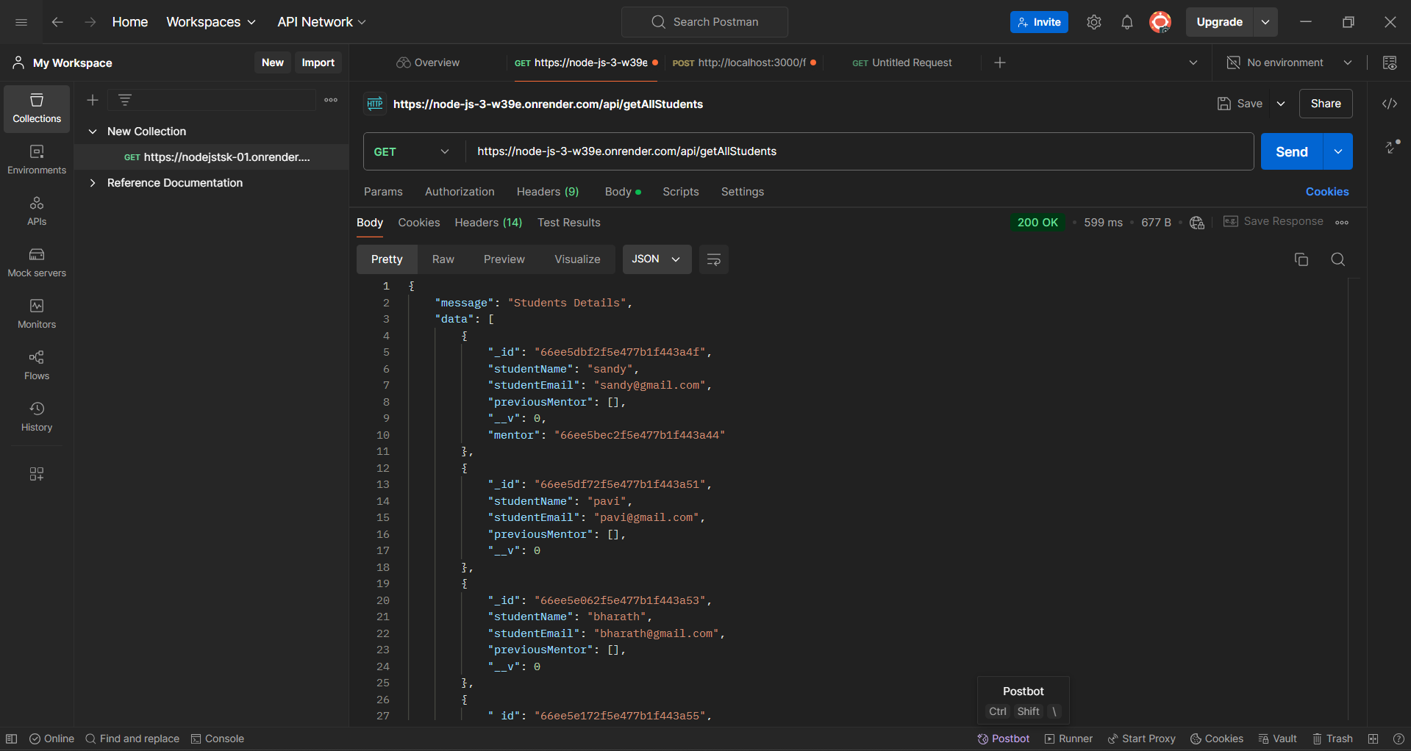

**Assign Students To Mentor:**

**PUT**- Assign Students To Mentor:-

[**https://node-js-3-w39e.onrender.com/api/assignStudentsToMentor/66ee5c242f5e477b1f443a4a**](https://node-js-3-w39e.onrender.com/api/assignStudentsToMentor/66ee5c242f5e477b1f443a4a)

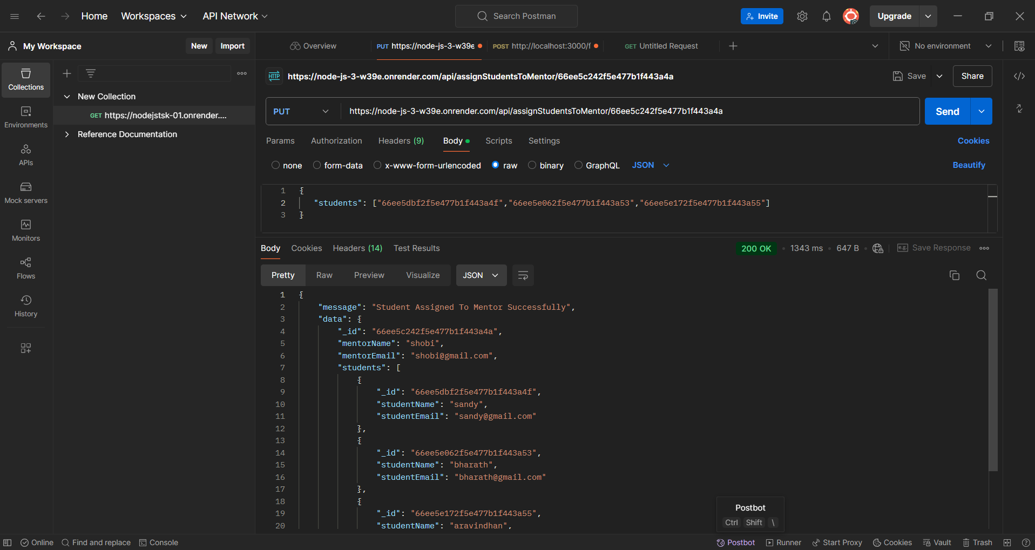

**Assign Mentor To Student:**

**PUT**- Assign Mentor To Student:-

[**https://node-js-3-w39e.onrender.com/api/assignMentorToStudent/66ee5e062f5e477b1f443a53**](https://node-js-3-w39e.onrender.com/api/assignMentorToStudent/66ee5e062f5e477b1f443a53)

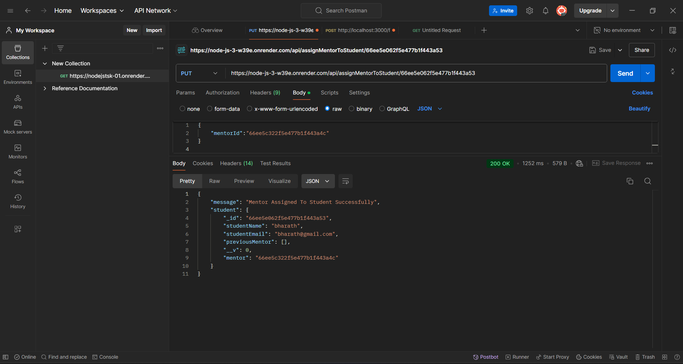

**Get All Mentors With Students:**

**GET** - Get All Mentors With Students:-

[**https://node-js-3-w39e.onrender.com/api/getAllMentorsWithStudents**](https://node-js-3-w39e.onrender.com/api/getAllMentorsWithStudents)

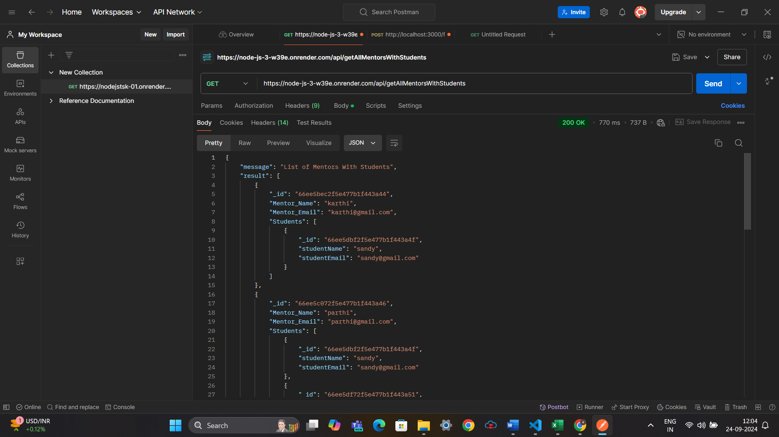

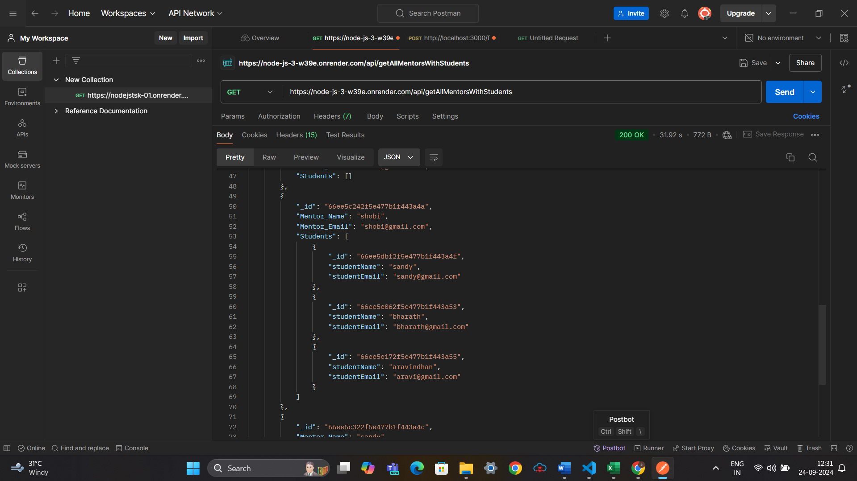

**Change Mentor For Particular Student:**

**PUT** - Change Mentor for Particular Student:-

[**https://node-js-3-w39e.onrender.com/api/changeMentor/66ee5e172f5e477b1f443a55**](https://node-js-3-w39e.onrender.com/api/changeMentor/66ee5e172f5e477b1f443a55)

