* + 1. Search RAN Duplicates by Batch Number

Provides the facility to get RAN duplicates details for a specified batch number. Output is displayed in a spreadsheet.

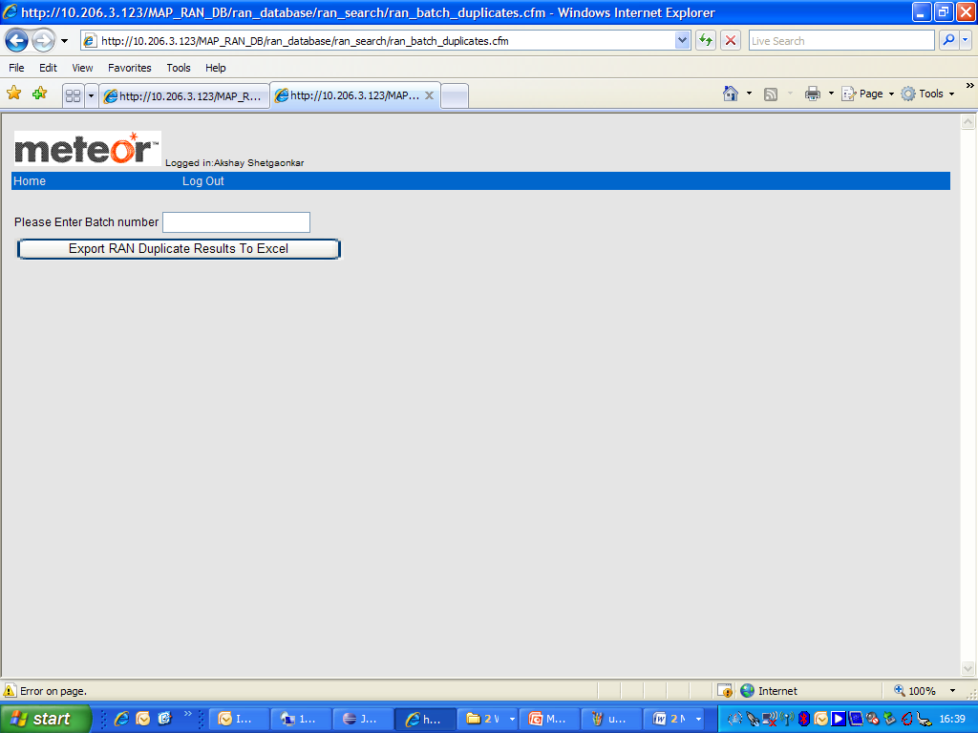

**Process**:

1. User enters batch number and press ‘Search’ button
2. If no details found ‘No RAN details for batch number: <batch number>’ message is displayed.
3. Otherwise all batch details are displayed in a spreadsheet.

Note: Supplier Id is decoded to supplier name using Supplier table

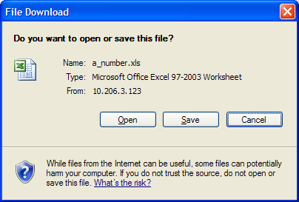

* + 1. Search RAN/RAN Duplicates by Batch Number

**ran_database/ran_home.cfm**



1. Displays text box for the user to enter the batch number.
2. Displays "Export RAN Results To Excel“ button that calls "ran_batch_results.cfm“.

**ran_database\ran_search\ran_batch.cfm**

1. Get records from the ran table with the matching batch number.
2. Set content type to excel and file name to a_number.xls.
3. Loop through the result set of query 1 and display data.

**ran_database\ran_search\ran_batch_results.cfm**



1. Displays text box for the user to enter the batch number.
2. Displays "Export RAN Duplicate Results To Excel“ button that calls "ran_batch_duplicate_results.cfm“.

**ran_database\ran_search\ran_batch_duplicates.cfm**

1. Get records from the ran_duplicates table with the matching batch number.
2. Set content type to excel and file name to a_number.xls.
3. Loop through the result set of query 1 and display data.

**ran_database\ran_search\ran_batch_duplicate_results.cfm**

**Search RAN/RAN Duplicates by Batch Number code flow**