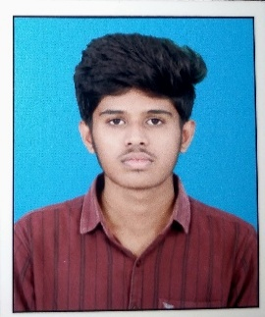
Aravindhan G
- garavind171204@gmail.com
- +91 – 9600609689
- linkedin.com/in/aravindhan-g-060533277

Objective

Passionate engineering student with hands-on web development experience from an internship at Airports Authority of India, contributing to a ticket-raising and management portal. Skilled in problem-solving and teamwork, with foundational knowledge in software development, and eager to enhance skills through industry-focused training at Deloitte.

Skills and interests
Programming Language Python
Frontend Technologies HTML, CSS
Database MySQL
Soft Skills Problem-solving, Teamwork, and Adaptability
EDUCATION
SRM Easwari Engineering College 2022 – Ongoing
- B.E - Computer Science and Engineering (Cyber Security)
- CGPA – 8.3 (Upto 7th Semester)

Adhiyaman Public School 2021 - 2022
- Higher Secondary
- Percentage: 92.4

Adhiyaman Public School 2019 - 2020
- Senior Secondary
- Percentage: 89.6
ExPERIENCE
Web Developer Intern | Airports Authority of India Mar 2025 - April 2025

Designed and developed a ticket management portal for Airports Authority of India, enhancing issue resolution efficiency.

Built response interfaces using HTML, CSS, and JavaScript for effective tracking of operational tickets.

Streamlined issue reporting processes to improve operational workflows for airport staff.

Certifications
- Python Programming, Spoken Tutorial, IIT Bombay
- SQL Injection Attacks, EC Council
- Generative AI (Level 3), Arcade (Level 3) - Google Developer Student Club, EEC

Projects
Ticket Raising and Management Portal
- Designed and developed a web-based portal to manage and track internal IT support requests efficiently.
- Implemented ticket creation, status tracking, and role-based access control to streamline workflows.
- Technologies used: HTML, CSS, JavaScript, Node.js, Express.js, SQL, REST APIs.

PoSITION OF RESPONSIBILITv

Student Welfare Head – Department of Cyber Security | Easwari Engineering College

Served as a key point of contact between students and faculty, addressing student concerns and supporting academic and personal well-being. Coordinated and organized departmental activities, workshops, and student initiatives, fostering a collaborative environment while strengthening leadership, communication, and team management skills.

Languages known
- English
- Tamil

