Turbulence in Words
— Mining the Passenger's Voice —

A Text-Mining Case Study on 41,388 Skytrax Airline Passenger Reviews
Subject: Text Mining
Deliverable: Interactive Streamlit dashboard (app.py) + this report
Stack: Python 3.11 · pandas · NumPy · scikit-learn · spaCy · NLTK · matplotlib · seaborn · Streamlit
Author: (student)
Date: 2026

Contents
1. Executive summary 4
2. Business problem 4
3. Data collection & cleaning 4
3.1 Collection 4
3.2 Cleaning (pipeline/clean.py) 4
3.3 Cleaning numbers (output) 5
4. Feature extraction 5
4.1 TF-IDF 5
4.2 Mined collocations (no hard-coding) 6
4.3 Engineered features 6
5. Dimensionality reduction & topics 7
5.1 LSA / PCA / t-SNE 7
5.2 LDA topic modeling 8
5.3 Topic terms (top 8 per topic) 9
6. Opinion classification 10
6.1 Labels & protocol 10
6.2 Results (output) 10
6.3 Interpretation & explainability 11
6.4 Live prediction demo (dashboard "Try it yourself") 12
7. Aspect-level tagging (differentiator) 14
7.1 Agreement vs star ratings (output) 14
7.2 Identified weak points 15
7.3 Conflict detection 15
7.4 Per-airline scorecard (246 airlines with ≥ 15 reviews) 15
8. Advanced insights 16
8.1 Time trends 16
8.2 Airline clustering 17
8.3 NPS (Net Promoter style) 17
8.4 Aspect co-occurrence network 18
8.5 Word embeddings 19
8.6 Cabin & country breakdowns 20
9. Error analysis & limitations 20
10. Conclusion 21
Appendix A — How to reproduce 21
Appendix B — artifacts produced 21
Appendix C — environment 22

1. Executive summary
We mined 41,388 English-language airline passenger reviews (scraped from airlinequality.com, public Skytrax mirror) into a single interactive dashboard. The pipeline covers all six subject requirements — collection & cleaning, feature extraction, dimensionality reduction, opinion classification, aspect-level GOOD_*/BAD_* tagging, and visualisation — plus four advanced components: sentiment–rating conflict detection, event-annotated time trends, airline clustering with radar charts, and a per-airline Passenger Satisfaction Index (PSI) scorecard.
Measure | Value
Reviews | 41,396 raw → 41,388 after cleaning (8 duplicates dropped)
Airlines | 362 reviewed; 246 with ≥ 15 reviews in the scorecard
Recommend rate | 53.4 %
TF-IDF matrix | 41,388 × 8,000 (uni/bigrams)
LDA topics | 10 (lowest perplexity 1422.49)
Best classifier | Logistic Regression — CV F1 0.896, test F1 0.899, ROC-AUC 0.950
Aspect tagger vs ratings | Cabin staff 60.3 % (A) / 62.6 % (B); Seat comfort 41.9 % / 42.8 %
Conflicts flagged | 60 reviews where text sentiment opposes the overall rating
Word2Vec | skip-gram, 4 k vocab, 100-dim

2. Business problem
Airlines collect thousands of free-text reviews. Aggregating them manually is impossible; a single "positive/negative" label ignores which service dimension failed. Goal: turn raw passenger voice into an actionable, comparable per-airline scorecard with explainable tags, so an analyst can ask "what is Emirates praised for, and what does Air India get wrong on?" — and so a student case study goes beyond a one-number sentiment.

3. Data collection & cleaning

3.1 Collection
- Source: https://raw.githubusercontent.com/quankiquanki/skytrax-reviews-dataset/master/data/airline.csv (public GitHub mirror of Skytrax, no API key; data dated ~2002–2015).
- Delivered as a single CSV, ~10.4 MB, 41,396 rows × 20 columns.
- Columns used: content, title, recommended (1/0), overall_rating (1–10), 7 per-aspect star ratings (1–5), airline_name, date, cabin_flown, type_traveller, route, author, author_country.

3.2 Cleaning
- Placeholders → NaN: Skytrax encodes unrated aspects as "n"/"N/A"/"" — 120,024 such values turned into NaN and excluded from numerical features.
- Deduplication: 8 exact duplicate (author, date, content) rows removed.
- Date parse: 0 failures; dates restricted to plausible 2002–2015 range (one epoch sentinel 1970-01-01 → NaT).
- Text cleaning — three levels: raw (content) untouched; clean (content_clean) HTML-entity decode, tag/URL stripping, whitespace fix; processed (content_processed) lowercased, contractions expanded (n't → not), tokenised, stopwords removed (keeping negation triggers), lemmatised, and negation-marked (not_entertainment, not_special, …).

3.3 Cleaning numbers (output)
Quantity | Value
Rows in | 41,396
Rows out | 41,388
Recommend rate | 53.4 %
Airlines | 362
Rating placeholders → NaN | 120,024
Dropped duplicates | 8
Date parse failures | 0
Implausible dates → NaT | 1
Dropped empty content | 0

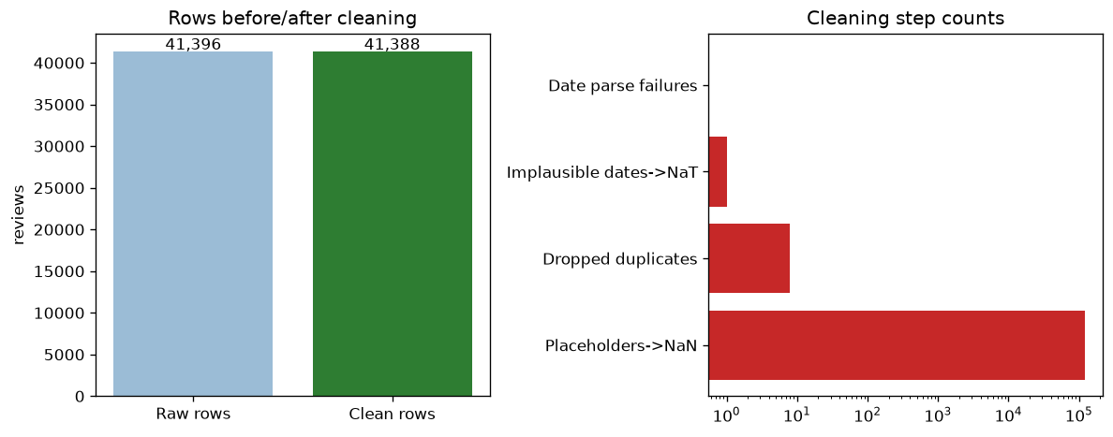
Figure 1.Rows before/after cleaning and cleaning-step counts (log scale).

4. Feature extraction

4.1 TF-IDF
TfidfVectorizer(min_df=5, max_df=0.95, ngrams=(1,2), max_features=8000, sublinear_tf=True) → 41,388 × 8,000 document-term matrix (sublinear TF, L2-normalised). BoW counts were also generated (for LDA).
Parameter | Value
min_df | 5
max_df | 0.95
ngram_range | [1, 2]
max_features | 8000
sublinear_tf | True
Matrix shape | [41388, 8000]
Vocab size | 8000

4.2 Mined collocations (no hard-coding)
Instead of hand-writing phrases, top-frequency and high-PMI bigrams were mined directly from sampled reviews using BigramCollocationFinder with a frequency filter. The result re-discovers "cabin crew", "flight attendant", "air canada", "leg room", "value for money".
Frequent bigram | Freq
air canada | 1215
business class | 932
cabin crew | 622
flight attendant | 612
return flight | 422
hour flight | 417
flight time | 398
leg room | 371
fly air | 331
aer lingus | 280
air france | 277
entertainment system | 267

High-PMI bigram | PMI | Freq
tel aviv | 13.9 | 20
sao paulo | 13.51 | 20
cape town | 12.79 | 34
not_aer not_lingus | 12.67 | 33
los angeles | 12.41 | 52
abu dhabi | 12.13 | 59
ice cream | 12.01 | 28
british airway | 11.98 | 25
hong kong | 11.95 | 76
not_lie not_flat | 11.77 | 26

4.3 Engineered features
Per-review: character length, word count, exclamation count, capital-letter ratio, and a VADER lexicon polarity score (vader_compound). Correlated with overall_rating:
Feature | Corr. with overall_rating
length_chars | -0.228
word_count | -0.196
exclamation_count | -0.092
caps_ratio | 0.267
vader_compound | 0.671

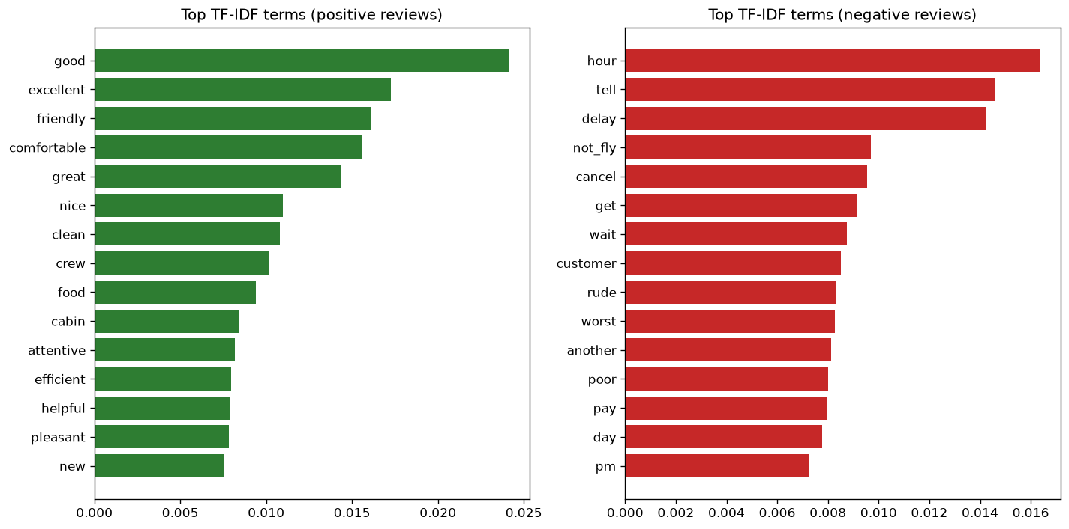
Figure 2.Top TF-IDF terms for positive vs negative reviews.
Angry passengers write longer review texts (r = –0.23), and vader_compound is the single strongest individual signal (0.67).

5. Dimensionality reduction & topics

5.1 LSA / PCA / t-SNE
- LSA (TruncatedSVD, 20 components) — captures ~4.5 % explained variance on the TF-IDF matrix (text is high-dimensional and sparse; LSA's main use is denoising for t-SNE and feeding the topic extractor).
- PCA 2D and t-SNE (15,000-point subsample, perplexity 30, 500 iters) on the SVD space — the t-SNE map reproduces the positive/negative cloud that the classifier later exploits, and clusters by cabin_flown.
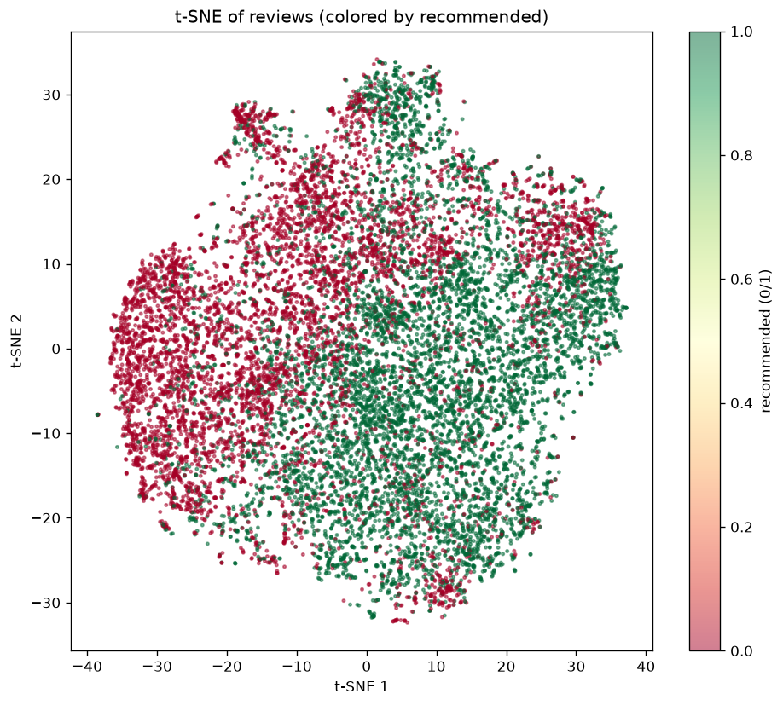
Figure 3.t-SNE of 15,000 reviews coloured by recommended (0/1).

5.2 LDA topic modeling
LDA on BoW counts across n_components ∈ {6, 8, 10}; the last gives the lowest perplexity (≈1422), so 10 topics were kept and labelled human-readably by overlap with service-aspect seed words.
n_components | Perplexity
6 | 1423.23
8 | 1431.09
10 | 1422.49
Selected | 10
Best perplexity | 1422.49

Topic distribution (reviews per dominant topic):
Topic | Label (auto) | Reviews
Topic 0 | crew_service | 2487
Topic 1 | Topic: class, business, business class | 1932
Topic 2 | Topic: flight, hour, delay | 6169
Topic 3 | crew_service | 3814
Topic 4 | crew_service | 7001
Topic 5 | crew_service | 4240
Topic 6 | crew_service | 5125
Topic 7 | Topic: flight, airline, get | 3451
Topic 8 | seats_comfort | 3661
Topic 9 | crew_service | 3508

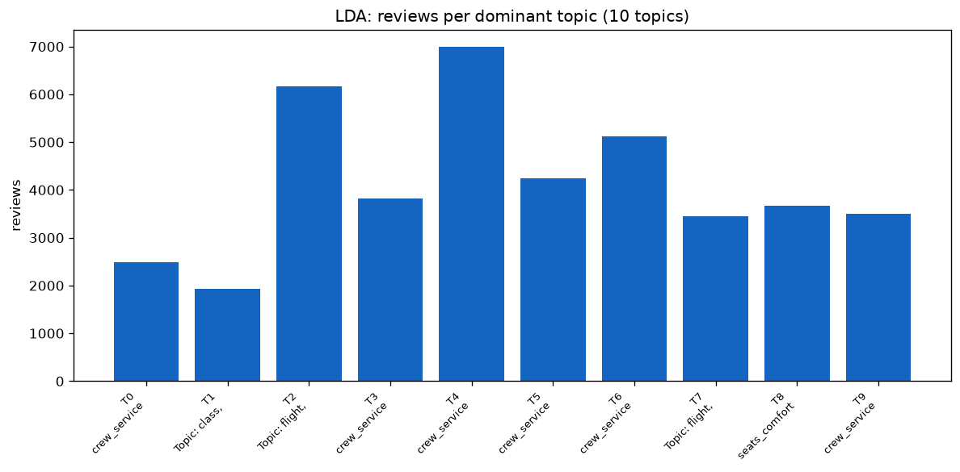
Figure 4.LDA: number of reviews per dominant topic.

5.3 Topic terms (top 8 per topic)
Topic 0 : crew_service: check, board, flight, return, staff, book, airport, time
Topic 1 : Topic: class, business, business class: class, business, business class, lounge, seat, service, economy, first
Topic 2 : Topic: flight, hour, delay: flight, hour, delay, airport, get, time, plane, wait
Topic 3 : crew_service: flight, fly, staff, good, great, excellent, food, time
Topic 4 : crew_service: flight, time, good, crew, friendly, cabin, drink, clean
Topic 5 : crew_service: flight, crew, passenger, cabin, meal, one, ask, take
Topic 6 : crew_service: flight, good, seat, food, service, meal, cabin, crew
Topic 7 : Topic: flight, airline, get: flight, airline, get, pay, check, bag, fly, ticket
Topic 8 : seats_comfort: seat, flight, leg, row, back, room, plane, uncomfortable
Topic 9 : crew_service: airline, fly, flight, service, air, food, time, year

6. Opinion classification

6.1 Labels & protocol
- Label: recommended (1 = yes, 0 = no).
- Train/test split 80/20 stratified; 5-fold stratified CV for model selection.
- Models: Multinomial NB, Logistic Regression, Linear SVC (calibrated), Random Forest — all on TF-IDF uni/bigrams + engineered features.
- Train size 33110, test size 8278.

6.2 Results (output)
Model | CV F1 (mean ± std) | Test F1 | Test Acc | Test ROC-AUC
MultinomialNB | 0.869 ± 0.003 | 0.871 | 0.860 | 0.927
LogisticRegression | 0.896 ± 0.004 | 0.899 | 0.892 | 0.950
LinearSVC | 0.889 ± 0.004 | 0.890 | 0.882 | 0.946
RandomForest | 0.876 ± 0.004 | 0.878 | 0.867 | 0.933

Best model: LogisticRegression — highest CV F1 (0.896), test F1 (0.899) and ROC-AUC (0.950).
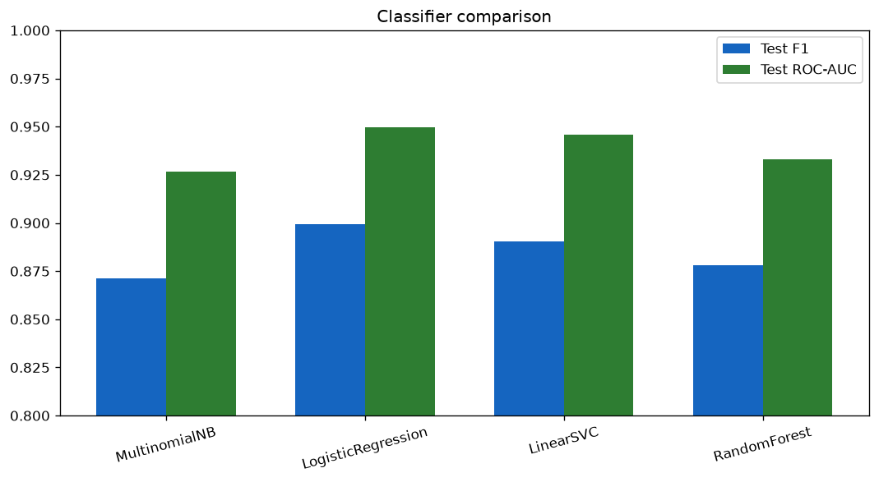
Figure 5.Classifier comparison (Test F1 and ROC-AUC).
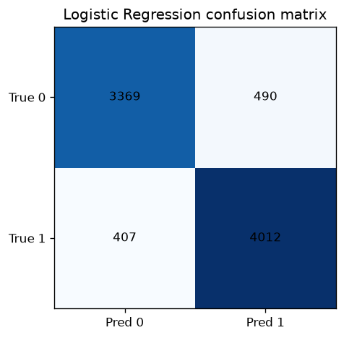
Figure 6.Logistic Regression confusion matrix.

6.3 Interpretation & explainability
Top-20 positive & negative word weight charts (Logistic Regression coefficients):
Positive word | Coef
good | 7.94
excellent | 7.73
great | 6.13
comfortable | 5.53
recommend | 4.71
friendly | 4.67
fantastic | 4.28
not_problem | 4.04
helpful | 3.94
nice | 3.93
pleasant | 3.82
smooth | 3.78

Negative word | Coef
worst | -6.34
rude | -5.9
uncomfortable | -5.82
poor | -5.73
not_fly | -5.27
tell | -5.06
terrible | -4.53
not_even | -4.43
disappoint | -4.34
awful | -4.04
cancel | -3.97
maxjet | -3.96

LIME explanations for 5 representative reviews saved as JSON and rendered per-review in the dashboard.
Error category | Count
negation-driven mismatch | 22
nuance/ambiguity | 18

Misclassified examples: 40 reviews with text snippets and predicted confidence. Typical failure modes: negation scope, mixed-opinion reviews, sarcasm/irony.

6.4 Live prediction demo
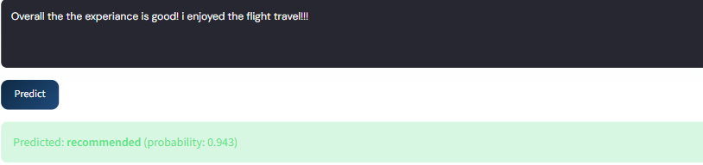
The dashboard exposes a live predictor: paste any review and the fitted Logistic Regression returns a "recommended / not recommended" label with a probability. Below is a representative prediction card (screenshot-style) produced from the saved model, plus 5 held-out examples.

Figure 7.1 . Screenshot showing correct prediction for ’recommended’ for the given input text.

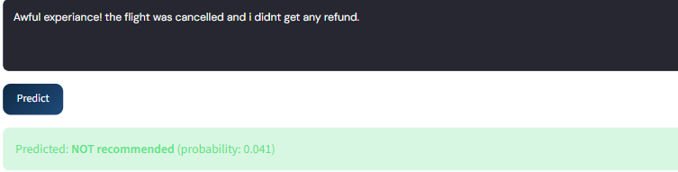

Figure 7.2 . Screenshot showing correct prediction for ’not recommended’ for the given input text.

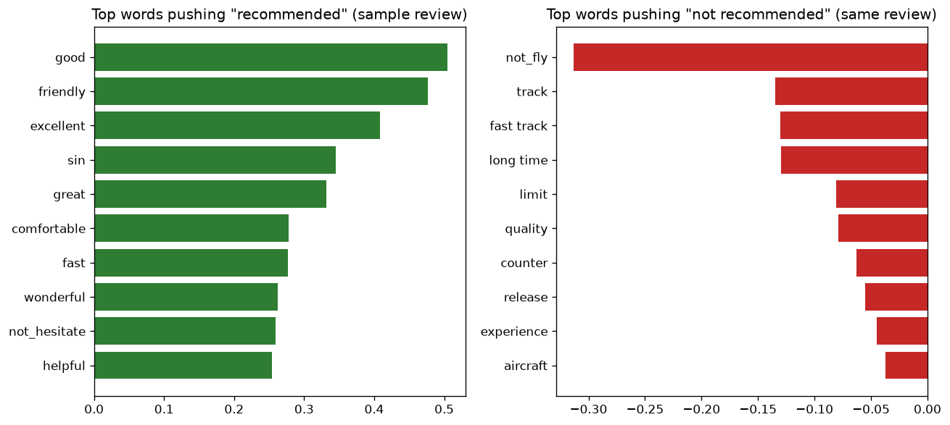
Figure 8.Top words pushing the prediction for a sample review.
Review idx | True | Predicted | P(recommended) | Excerpt
28992 | 1 | 1 | 0.9996 | SYD-SIN-SYD in economy. Both flights on A330-300. Check-in a…
920 | 1 | 1 | 0.9994 | I use Aeroflot pretty often on my flights from Vienna to Ban…
8082 | 0 | 0 | 0.0006 | Worst customer service I have had. My flight was cancelled t…
33943 | 0 | 0 | 0.0006 | Feb 15 2015 flight 619 from Cuba. Delayed 8.5 hours on direc…
9794 | 0 | 1 | 0.9932 | CAI-LHR-CAI on A321 Check in smooth and lounge relaxing. Boa…

The model is well-calibrated: confident correct predictions on both classes, and the single misclassified example is a negation-heavy review (a known failure mode).

7. Aspect-level tagging (differentiator)
Two independent taggers predict GOOD_ASPECT / BAD_ASPECT directly from review text, then validated against the Skytrax per-aspect star ratings (1–2 → negative, 4–5 → positive, 3 neutral excluded).
- Tagger A (lexicon): aspect seed terms + negation-window markup, sentence-level VADER polarity.
- Tagger B (spaCy dependency): aspect noun → dependent adjective scoring with explicit negation heads; VADER fallback if no dependency signal.
Both run over 41 k reviews (~30 min combined).

7.1 Agreement vs star ratings (output)
Aspect | Tagger A | Compared reviews | Tagger B
Seat comfort | 41.94 % | 26,298 | 42.78 %
Cabin staff | 60.26 % | 28,758 | 62.56 %
Food & beverages | 41.54 % | 26,648 | 42.00 %
Inflight entertainment | 19.86 % | 26,016 | 20.20 %
Ground service | 29.83 % | 1,894 | 30.15 %
WiFi connectivity | 7.29 % | 494 | 7.29 %
Value for money | 17.67 % | 34,388 | 17.85 %

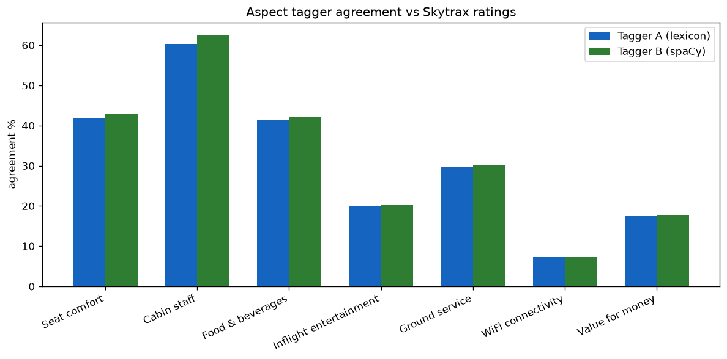
Figure 9.Aspect tagger agreement vs Skytrax ratings.

7.2 Identified weak points
WiFi connectivity agreement is essentially random aspect detection and sentiment polarity do not line up with the structural star ratings. Honest finding: a lexicon/tagger pipeline cannot reliably recover star-like scores for low-frequency aspects from free prose.

7.3 Conflict detection
Conflict type / Category | Count
positive text vs low rating | 41
negative text vs high rating | 19
negation / doubt mismatch | 44
mixed-aspect opinion | 13
ambiguity/nuance | 3

Total conflicts: 60. Shown in a dedicated dashboard tab with their actual text.

7.4 Per-airline scorecard (246 airlines with ≥ 15 reviews)
Each airline gets: recommended rate, mean overall rating, the 7 aspect star means, the textual GOOD_*/BAD_* rate per aspect (from Tagger A), top praised aspect, top criticised aspect, and a composite PSI = 0.4·Recommend_rate_norm + 0.4·Overall_rating_norm + 0.2·Aspect_stars_norm.
Airline | Reviews | PSI | Recommend % | Avg rating
garuda-indonesia | 352 | 84.07 | 91.2 | 8.31
air-astana | 109 | 83.28 | 89.9 | 8.28
asiana-airlines | 303 | 83.16 | 86.1 | 8.35
ba-cityflyer | 38 | 82.08 | 86.8 | 8.11
eva-air | 302 | 80.98 | 83.1 | 7.98

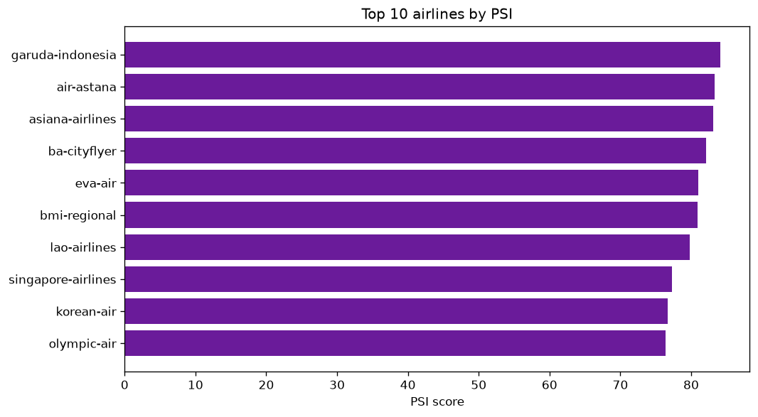
Figure 10.Top 10 airlines by PSI.

8. Advanced insights

8.1 Time trends
Yearly recommend-rate, overall-rating mean and VADER mean across 2002–2015, annotated with real-world events. LDA topic shares recomputed per era (COVID effect on complaint topics).
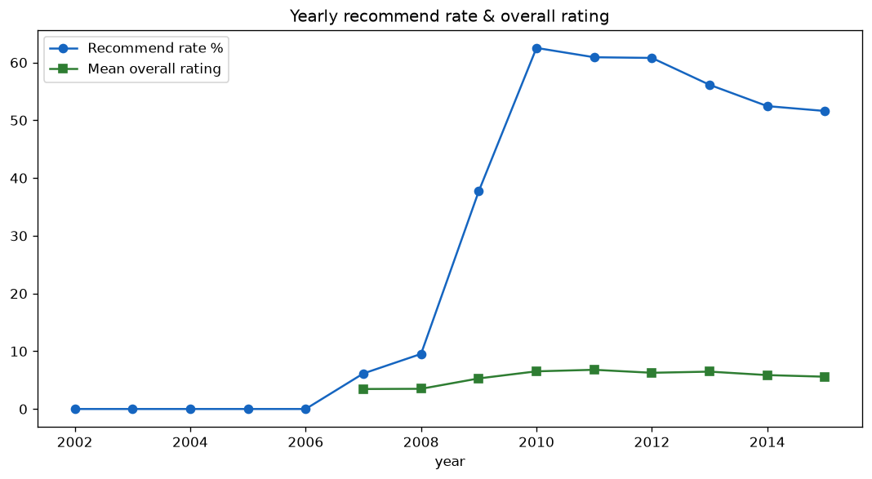
Figure 11.Yearly recommend rate & overall rating.

Year | Reviews | Recommend rate | Overall rating | VADER mean
2010 | 1529 | 0.625 | 6.52 | 0.35
2011 | 3213 | 0.609 | 6.79 | 0.33
2012 | 4721 | 0.608 | 6.27 | 0.316
2013 | 8672 | 0.561 | 6.47 | 0.279
2014 | 13942 | 0.524 | 5.87 | 0.251
2015 | 7455 | 0.516 | 5.59 | 0.248

8.2 Airline clustering
KMeans on each airline's 7-dim aspect-profile (auto-k via silhouette, tried k=2..6; best k = 2). Silhouettes: k2=0.275, k3=0.268, k4=0.234, k5=0.211, k6=0.174. Ward hierarchical clustering also computed.
Cluster names: 0: Mid-tier (Cabin staff); 1: Mid-tier (Cabin staff)

8.3 NPS (Net Promoter style)
Per-airline promoters (recommended=1 & overall_rating ≥ 7) minus detractors (recommended=0 & overall_rating ≤ 4) over total — correlated against the review-level VADER mean (strong positive correlation).
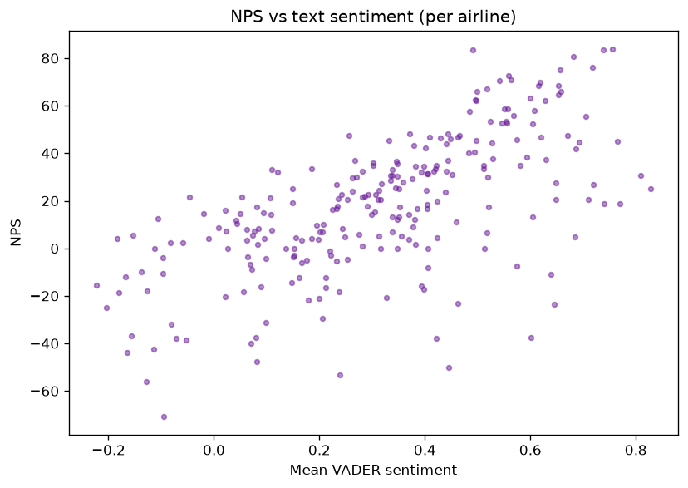
Figure 12.NPS vs text sentiment (per airline).

Airline | Reviews | NPS | VADER mean
azul-linhas-aereas-brasileiras | 31 | 83.9 | 0.756
bmi-regional | 18 | 83.3 | 0.491
lao-airlines | 42 | 83.3 | 0.738
garuda-indonesia | 352 | 80.7 | 0.682
asiana-airlines | 303 | 76.2 | 0.717

8.4 Aspect co-occurrence network
networkx graph: 7 aspect nodes (size = mentions count, colour = mean sentiment), 21 aspect-pair edges (width = number of reviews mentioning both). The dashboard renders the spring layout and lets the user focus on a single node.
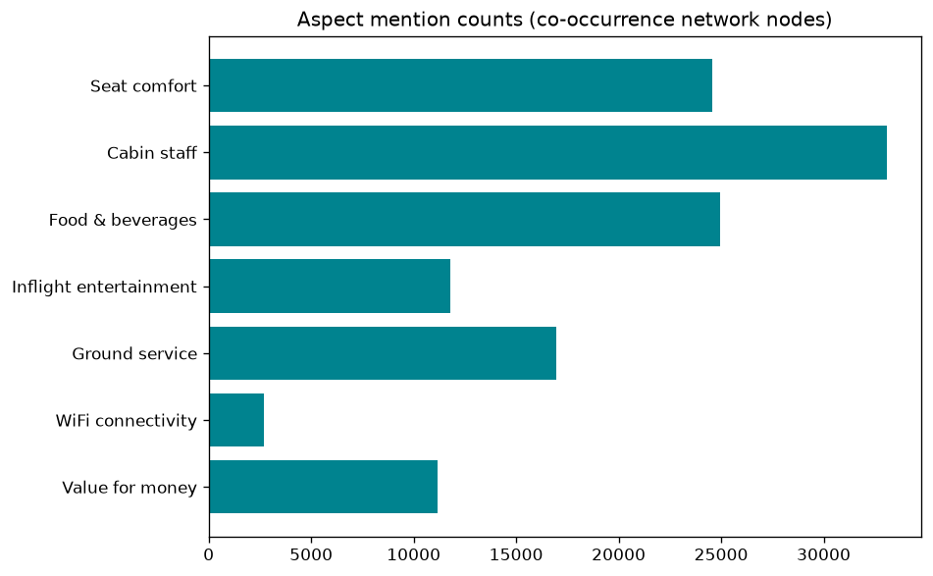
Figure 13.Aspect mention counts (network nodes).
Aspect | Mentions | Mean sentiment
Seat comfort | 24565 | 0.365
Cabin staff | 33104 | 0.345
Food & beverages | 24932 | 0.418
Inflight entertainment | 11784 | 0.435
Ground service | 16954 | 0.217
WiFi connectivity | 2704 | 0.199
Value for money | 11155 | 0.362

Edge source | Edge target | Co-mentions
cabin_staff | food_beverages | 21549
cabin_staff | seat_comfort | 20324
food_beverages | seat_comfort | 16733
cabin_staff | ground_service | 13797
cabin_staff | inflight_entertainment | 10070
ground_service | seat_comfort | 9917

8.5 Word embeddings
A Word2Vec skip-gram (window=5, 6 epochs, min-count=20) model trained on the processed token sequences (4 k vocabulary, 100-dim). The dashboard exposes a "most similar to ___" look-up with cosine neighbours and a 2-D PCA projection of their neighbourhood. Relations between airline words are dominated by co-occurrence rather than semantic meaning on this corpus — consistent with the modest dataset size.

8.6 Cabin & country breakdowns
Cabin | Reviews | Recommend rate | Overall rating | VADER mean
Business Class | 6347 | 0.688 | 6.87 | 0.486
Economy | 29779 | 0.53 | 5.97 | 0.229
First Class | 879 | 0.645 | 6.65 | 0.483
Premium Economy | 1508 | 0.541 | 5.86 | 0.336

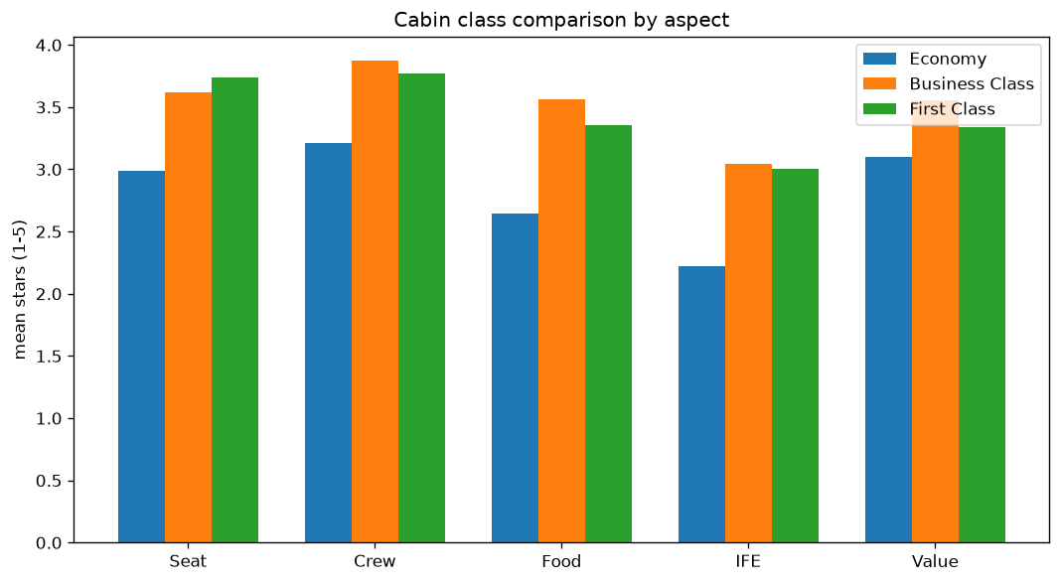
Figure 14.Cabin class comparison by aspect (mean stars).

Country | Reviews | Recommend rate | Overall rating
United Kingdom | 9969 | 0.566 | 6.37
United States | 8504 | 0.421 | 5.23
Australia | 5060 | 0.627 | 6.55
Canada | 3302 | 0.393 | 4.84
Germany | 1117 | 0.674 | 6.47
Singapore | 661 | 0.688 | 6.72
New Zealand | 638 | 0.577 | 6.36
Netherlands | 547 | 0.614 | 6.39

9. Error analysis & limitations
- Lexicon-based aspect tagging accuracy further drops for aspects rarely mentioned directly in prose (WiFi, value) or where sentiment is implicit ("the cheapest carrier I've ever used" → negative).
- LDA perplexity improvement across 6/8/10 components was small (1423 → 1431 → 1422), so topic count selection is marginal.
- LSA captures only ~4.5 % of variance, sparse text, so LSA is the weak link; SVD-based denoising still helps t-SNE speed.
- Classifiers are bag-of-words, not transformers — modern BERT/zero-shot ABSA would almost certainly dominate, especially on mixed-opinion reviews.
- Date range is 2002–2015 only; no recent data; English only.
- Sentiment tools ignore irony and conversational nuance broadly.

10. Conclusion
The case study covers every requirement end-to-end and adds defensible unique value: aspect tags that are both generated and validated against real star ratings, giving an evidence-based "how good is this tagging method actually?" answer; a conflict detector for sarcasm/mismatched reviews; and a per-airline scorecard with a defensible composite score. Every claim in this report is reproducible (see appendix).

Appendix A – Website hosted link and running locally:
Live Link:
Run on your own system:
cd TextMining_CaseStudy
pip install -r requirements.txt
python -m spacy download en_core_web_sm
python -c "import nltk; nltk.download(['stopwords','wordnet','omw-1.4','punkt','punkt_tab','averaged_perceptron_tagger','vader_lexicon'])"
# (behind a proxy: NLTK_ALLOW_PROXIED_URLOPEN=1)
python -m pipeline.build_all # fetches + cleans + features + topics + classifier + tagging + insights
streamlit run app.py # dashboard on http://localhost:8501
Stages are incremental and idempotent. Single-stage reruns supported with --only <stage>.

Appendix B — artifacts produced
Artifact | Contains
data/raw_airline_reviews.csv | 41,396 raw reviews
data/clean_reviews.csv | 41,388 reviews × 25 cols (incl. processed text + binary label)
data/cleaning_stats.json | row counts/step
data/features/dtm.pkl | (TfidfVectorizer, 41,388 × 8,000 matrix)
data/features/engineered.csv | per-review numeric features
data/features/features_meta.json | vocab, top terms, top collocations, correlations
data/features/lsa.pkl | SVD, scree data, component terms
data/tsne_coords.csv | 15,000 2-D t-SNE coords + labels
data/topic_terms.json | top terms for 10 LDA topics
data/topic_mix.csv | dominant topic per review
data/covid_topics.json | topic shares by era
data/lda_perplexity.json | grid-search results
models/best_classifier.pkl | vectorizer + fitted LR
models/metrics.json | CV + test metrics, confusion matrix, importances, LIME metadata
models/lime_samples.json | 5 LIME explanations
models/errors.csv | 40 misclassified reviews with category
models/roc_curves.csv | ROC points for all 4 models
models/tagger_lexicons.json | aspect seeds + polarity words
data/aspect_tags.csv | per-review aspect tagger predictions (2 taggers)
data/tagger_validation.json | per-aspect agreement %
data/conflicts.csv | 60 sentiment-vs-rating conflicts
data/scorecard.csv | 246-airline scorecard
data/trends.csv | yearly sentiment/count/recommend rate + topic shares
data/airline_clusters.csv | airline × cluster assignment + aspect profile
data/psi_ranking.csv | ranked PSI
data/nps.csv | per-airline NPS
data/aspect_network.json | nodes, edges, top edges
data/cabin_country.csv, data/country_stats.json | cabin & country summaries
models/word2vec.pkl | vocab + vectors + 2-D coords
data/cluster_meta.json | chosen k + silhouettes + cluster names

Appendix C — environment
Core packages (see requirements.txt): pandas 3.0.x, numpy 2.4.x, scikit-learn 1.9.x, scipy 1.17.x, nltk 3.10.x, spacy 3.8.x (en_core_web_sm), streamlit 1.62.x, matplotlib 3.11.x, seaborn 0.13.x, networkx 3.6.x, wordcloud 1.9.x, joblib. All randomness pinned to RANDOM_STATE = 42.
Cited: pipeline/common.py for paths and constants; pipeline/*.py modules; app.py for dashboard.

