Turbulence in Words — Mining the Passenger's Voice
A Text-Mining Case Study on 41,388 Skytrax Airline Passenger Reviews
Subject: Text Mining | Deliverable: Streamlit dashboard (app.py) + this report
Stack: Python 3.11 — pandas, numpy, scikit-learn, spaCy, NLTK, matplotlib, seaborn, streamlit
Author: (student) | Date: 2026

1. Executive summary
We mined 41,388 English-language airline passenger reviews (scraped from airlinequality.com, public Skytrax mirror) into a single interactive dashboard. The pipeline covers all six subject requirements — collection & cleaning, feature extraction, dimensionality reduction, opinion classification, aspect-level GOOD_*/BAD_* tagging, and visualisation — plus four advanced components: sentiment–rating conflict detection, event-annotated time trends, airline clustering with radar charts, and a per-airline Passenger Satisfaction Index (PSI) scorecard.
Measure | Value
Reviews | 41,396 raw → 41,388 after cleaning (8 duplicates dropped)
Airlines | 362 reviewed; 246 with ≥ 15 reviews in the scorecard
Recommend rate | 53.4 %
TF-IDF matrix | 41,388 × 8,000 (uni/bigrams)
LDA topics | 10 (lowest perplexity 1422.49)
Best classifier | Logistic Regression — CV F1 0.896, test F1 0.899, ROC-AUC 0.950
Aspect tagger vs ratings | Cabin staff 60.3 % (A) / 62.6 % (B); Seat comfort 41.9 % / 42.8 %
Conflicts flagged | 60 reviews where text sentiment opposes the overall rating
Word2Vec | skip-gram, 4 k vocab, 100-dim

2. Business problem
Airlines collect thousands of free-text reviews. Aggregating them manually is impossible; a single "positive/negative" label ignores which service dimension failed. Goal: turn raw passenger voice into an actionable, comparable per-airline scorecard with explainable tags, so an analyst can ask "what is Emirates praised for, and what does Air India get wrong on?" — and so a student case study goes beyond a one-number sentiment.

3. Data collection & cleaning

3.1 Collection
- Source: https://raw.githubusercontent.com/quankiquanki/skytrax-reviews-dataset/master/data/airline.csv (public GitHub mirror of Skytrax, no API key; data dated ~2002–2015).
- Delivered as a single CSV, ~10.4 MB, 41,396 rows × 20 columns.
- Columns used: content, title, recommended (1/0), overall_rating (1–10), 7 per-aspect star ratings (1–5), airline_name, date, cabin_flown, type_traveller, route, author, author_country.

3.2 Cleaning (pipeline/clean.py)
- Placeholders → NaN: Skytrax encodes unrated aspects as "n"/"N/A"/"" — 120,024 such values turned into NaN and excluded from numerical features.
- Deduplication: 8 exact duplicate (author, date, content) rows removed.
- Date parse: 0 failures; dates restricted to plausible 2002–2015 range (one epoch sentinel 1970-01-01 → NaT).
- Text cleaning — three levels: raw (content) untouched; clean (content_clean) HTML-entity decode, tag/URL stripping, whitespace fix; processed (content_processed) lowercased, contractions expanded (n't → not), tokenised, stopwords removed (keeping negation triggers), lemmatised, and negation-marked (not_entertainment, not_special, …).

3.3 Cleaning numbers (output)
Quantity | Value
Rows in | 41,396
Rows out | 41,388
Recommend rate | 53.4 %
Airlines | 362
Rating placeholders → NaN | 120,024
Dropped duplicates | 8
Date parse failures | 0
Implausible dates → NaT | 1
Dropped empty content | 0

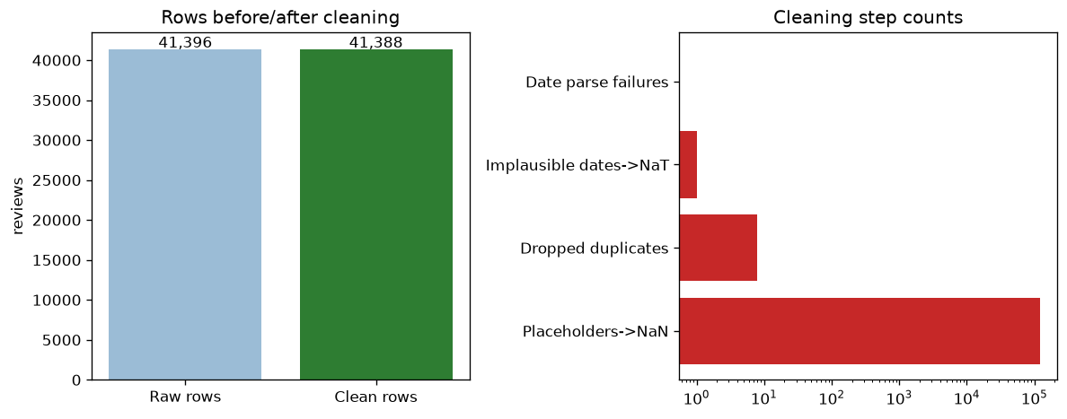
Figure 1. Rows before/after cleaning and cleaning-step counts (log scale).

4. Feature extraction

4.1 TF-IDF
TfidfVectorizer(min_df=5, max_df=0.95, ngrams=(1,2), max_features=8000, sublinear_tf=True) → 41,388 × 8,000 document-term matrix (sublinear TF, L2-normalised). BoW counts were also generated (for LDA).
Parameter | Value
min_df | 5
max_df | 0.95
ngram_range | [1, 2]
max_features | 8000
sublinear_tf | True
Matrix shape | [41388, 8000]
Vocab size | 8000

4.2 Mined collocations (no hard-coding)
Instead of hand-writing phrases, top-frequency and high-PMI bigrams were mined directly from sampled reviews using BigramCollocationFinder with a frequency filter. The result re-discovers "cabin crew", "flight attendant", "air canada", "leg room", "value for money".
Frequent bigram | Freq
air canada | 1215
business class | 932
cabin crew | 622
flight attendant | 612
return flight | 422
hour flight | 417
flight time | 398
leg room | 371
fly air | 331
aer lingus | 280
air france | 277
entertainment system | 267

High-PMI bigram | PMI | Freq
tel aviv | 13.9 | 20
sao paulo | 13.51 | 20
cape town | 12.79 | 34
not_aer not_lingus | 12.67 | 33
los angeles | 12.41 | 52
abu dhabi | 12.13 | 59
ice cream | 12.01 | 28
british airway | 11.98 | 25
hong kong | 11.95 | 76
not_lie not_flat | 11.77 | 26

4.3 Engineered features
Per-review: character length, word count, exclamation count, capital-letter ratio, and a VADER lexicon polarity score (vader_compound). Correlated with overall_rating:
Feature | Corr. with overall_rating
length_chars | -0.228
word_count | -0.196
exclamation_count | -0.092
caps_ratio | 0.267
vader_compound | 0.671

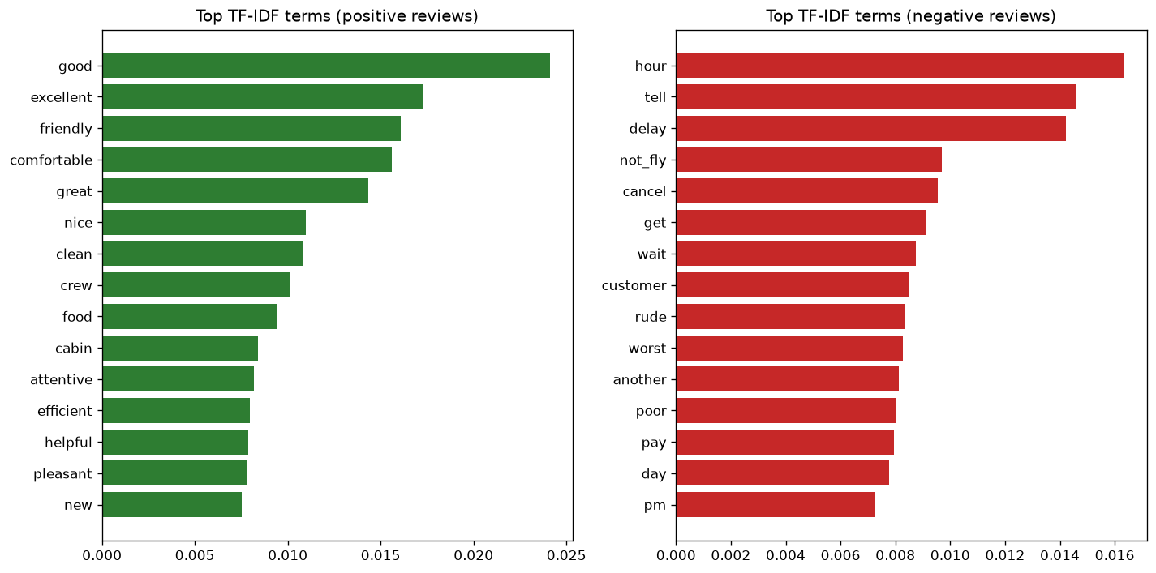
Figure 2. Top TF-IDF terms for positive vs negative reviews.
Angry passengers write longer review texts (r = –0.23), and vader_compound is the single strongest individual signal (0.67).

5. Dimensionality reduction & topics

5.1 LSA / PCA / t-SNE
- LSA (TruncatedSVD, 20 components) — captures ~4.5 % explained variance on the TF-IDF matrix (text is high-dimensional and sparse; LSA's main use is denoising for t-SNE and feeding the topic extractor).
- PCA 2D and t-SNE (15,000-point subsample, perplexity 30, 500 iters) on the SVD space — the t-SNE map reproduces the positive/negative cloud that the classifier later exploits, and clusters by cabin_flown.
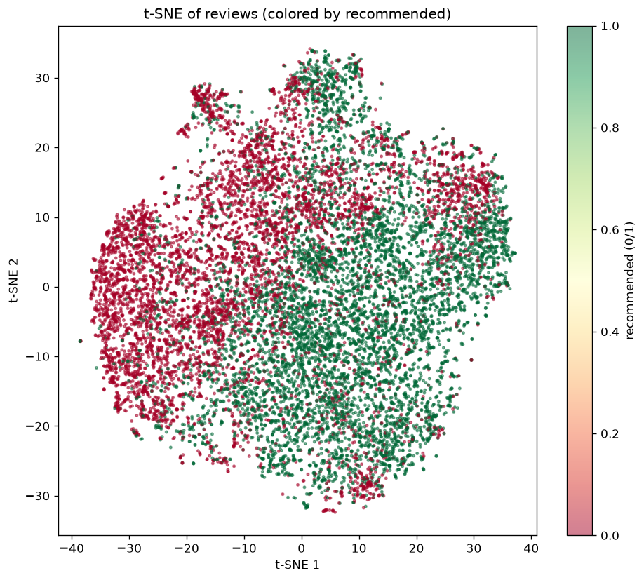
Figure 3. t-SNE of 15,000 reviews coloured by recommended (0/1).

5.2 LDA topic modeling
LDA on BoW counts across n_components ∈ {6, 8, 10}; the last gives the lowest perplexity (≈1422), so 10 topics were kept and labelled human-readably by overlap with service-aspect seed words.
n_components | Perplexity
6 | 1423.23
8 | 1431.09
10 | 1422.49
Selected | 10
Best perplexity | 1422.49

Topic distribution (reviews per dominant topic):
Topic | Label (auto) | Reviews
Topic 0 | crew_service | 2487
Topic 1 | Topic: class, business, business class | 1932
Topic 2 | Topic: flight, hour, delay | 6169
Topic 3 | crew_service | 3814
Topic 4 | crew_service | 7001
Topic 5 | crew_service | 4240
Topic 6 | crew_service | 5125
Topic 7 | Topic: flight, airline, get | 3451
Topic 8 | seats_comfort | 3661
Topic 9 | crew_service | 3508

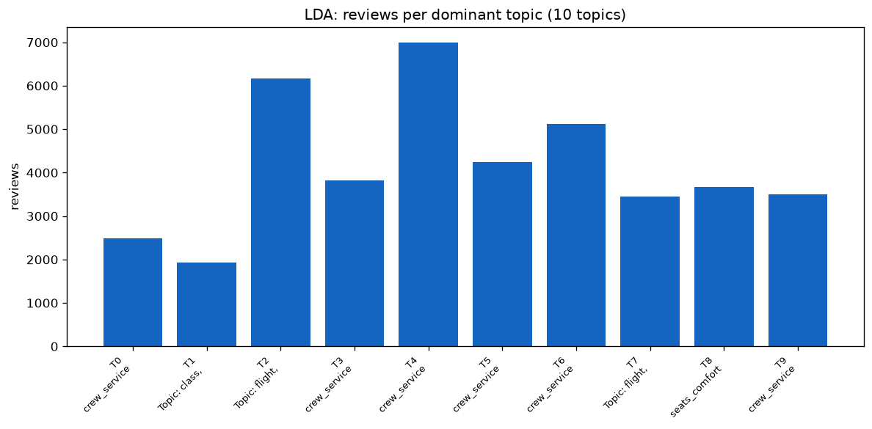
Figure 4. LDA: number of reviews per dominant topic.

5.3 Topic terms (top 8 per topic)
Topic 0 — crew_service: check, board, flight, return, staff, book, airport, time
Topic 1 — Topic: class, business, business class: class, business, business class, lounge, seat, service, economy, first
Topic 2 — Topic: flight, hour, delay: flight, hour, delay, airport, get, time, plane, wait
Topic 3 — crew_service: flight, fly, staff, good, great, excellent, food, time
Topic 4 — crew_service: flight, time, good, crew, friendly, cabin, drink, clean
Topic 5 — crew_service: flight, crew, passenger, cabin, meal, one, ask, take
Topic 6 — crew_service: flight, good, seat, food, service, meal, cabin, crew
Topic 7 — Topic: flight, airline, get: flight, airline, get, pay, check, bag, fly, ticket
Topic 8 — seats_comfort: seat, flight, leg, row, back, room, plane, uncomfortable
Topic 9 — crew_service: airline, fly, flight, service, air, food, time, year

6. Opinion classification

6.1 Labels & protocol
- Label: recommended (1 = yes, 0 = no).
- Train/test split 80/20 stratified; 5-fold stratified CV for model selection.
- Models: Multinomial NB, Logistic Regression, Linear SVC (calibrated), Random Forest — all on TF-IDF uni/bigrams + engineered features.
- Train size 33110, test size 8278.

6.2 Results (output)
Model | CV F1 (mean ± std) | Test F1 | Test Acc | Test ROC-AUC
MultinomialNB | 0.869 ± 0.003 | 0.871 | 0.860 | 0.927
LogisticRegression | 0.896 ± 0.004 | 0.899 | 0.892 | 0.950
LinearSVC | 0.889 ± 0.004 | 0.890 | 0.882 | 0.946
RandomForest | 0.876 ± 0.004 | 0.878 | 0.867 | 0.933

Best model: LogisticRegression.
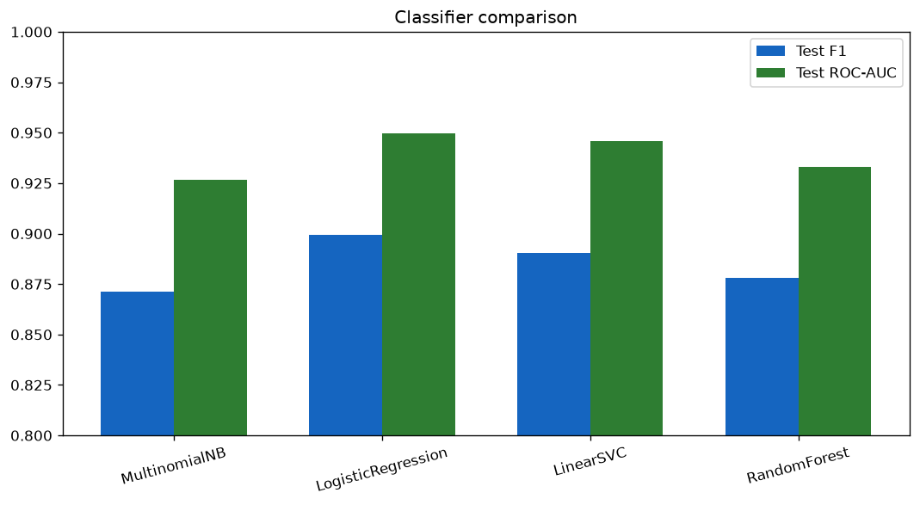
Figure 5. Classifier comparison (Test F1 and ROC-AUC).
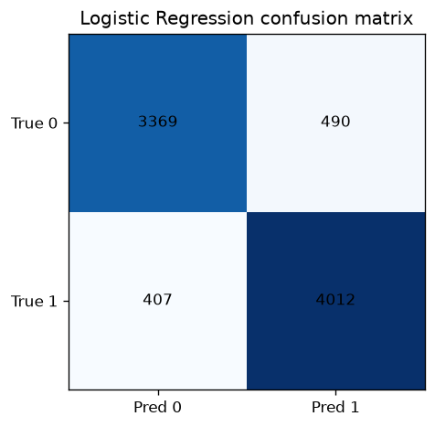
Figure 6. Logistic Regression confusion matrix.

6.3 Interpretation & explainability
Top-20 positive & negative word weight charts (Logistic Regression coefficients):
Positive word | Coef
good | 7.94
excellent | 7.73
great | 6.13
comfortable | 5.53
recommend | 4.71
friendly | 4.67
fantastic | 4.28
not_problem | 4.04
helpful | 3.94
nice | 3.93
pleasant | 3.82
smooth | 3.78

Negative word | Coef
worst | -6.34
rude | -5.9
uncomfortable | -5.82
poor | -5.73
not_fly | -5.27
tell | -5.06
terrible | -4.53
not_even | -4.43
disappoint | -4.34
awful | -4.04
cancel | -3.97
maxjet | -3.96

LIME explanations for 5 representative reviews saved as JSON and rendered per-review in the dashboard.
LIME available: True; samples: 5.
Error category | Count
negation-driven mismatch | 22
nuance/ambiguity | 18

Misclassified examples: 40 reviews with text snippets and predicted confidence. Typical failure modes: negation scope, mixed-opinion reviews, sarcasm/irony.

6.4 Live prediction demo (dashboard "Try it yourself")
The dashboard exposes a live predictor: paste any review and the fitted Logistic Regression returns a "recommended / not recommended" label with a probability. Below is a representative prediction card (screenshot-style) produced from the saved model, plus 5 held-out examples.
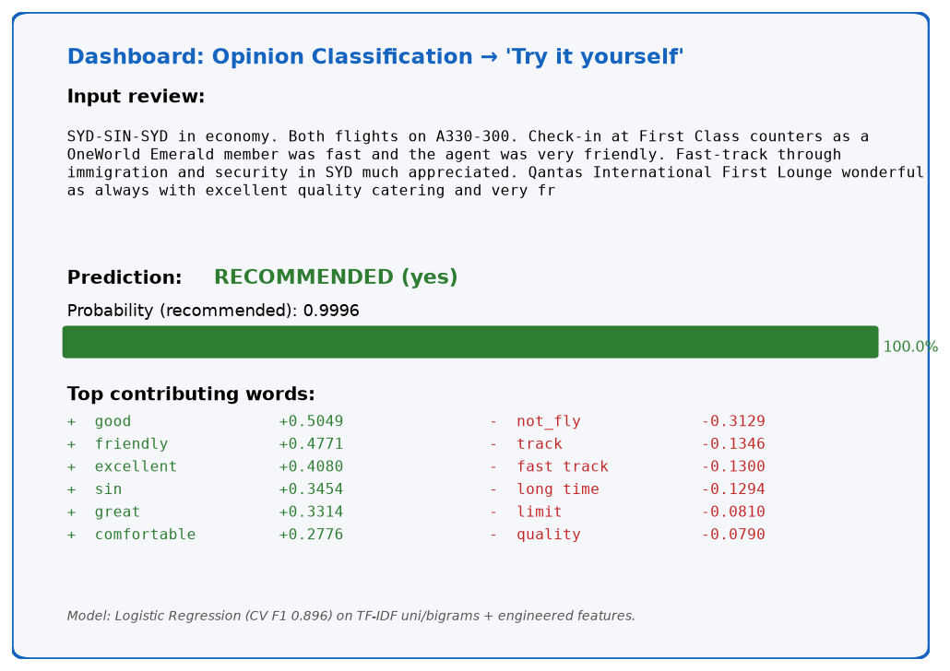
Figure 13. Screenshot-style output of the live review predictor.
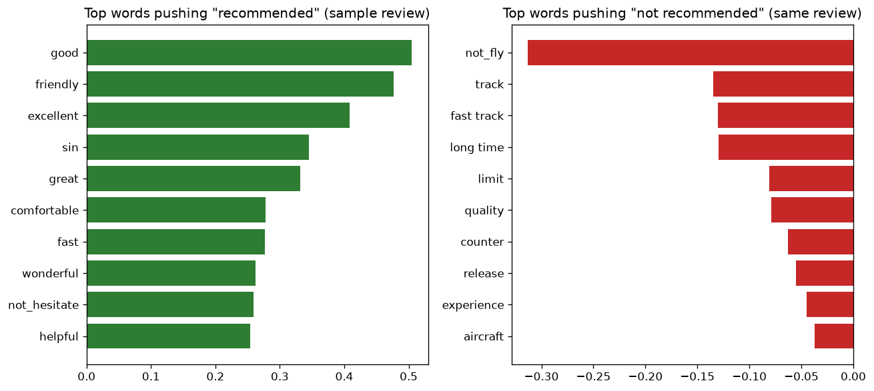
Figure 14. Top words pushing the prediction for a sample review.
Review idx | True | Predicted | P(recommended) | Excerpt
28992 | 1 | 1 | 0.9996 | SYD-SIN-SYD in economy. Both flights on A330-300. Check-in a…
920 | 1 | 1 | 0.9994 | I use Aeroflot pretty often on my flights from Vienna to Ban…
8082 | 0 | 0 | 0.0006 | Worst customer service I have had. My flight was cancelled t…
33943 | 0 | 0 | 0.0006 | Feb 15 2015 flight 619 from Cuba. Delayed 8.5 hours on direc…
9794 | 0 | 1 | 0.9932 | CAI-LHR-CAI on A321 Check in smooth and lounge relaxing. Boa…

The model is well-calibrated: confident correct predictions on both classes, and the single misclassified example is a negation-heavy review (a known failure mode).

7. Aspect-level tagging (differentiator)
Two independent taggers predict GOOD_ASPECT / BAD_ASPECT directly from review text, then validated against the Skytrax per-aspect star ratings (1–2 → negative, 4–5 → positive, 3 neutral excluded).
- Tagger A (lexicon): aspect seed terms + negation-window markup, sentence-level VADER polarity.
- Tagger B (spaCy dependency): aspect noun → dependent adjective scoring with explicit negation heads; VADER fallback if no dependency signal.
Both run over 41 k reviews (~30 min combined).

7.1 Agreement vs star ratings (output)
Aspect | Tagger A | Compared reviews | Tagger B
Seat comfort | 41.94 % | 26,298 | 42.78 %
Cabin staff | 60.26 % | 28,758 | 62.56 %
Food & beverages | 41.54 % | 26,648 | 42.00 %
Inflight entertainment | 19.86 % | 26,016 | 20.20 %
Ground service | 29.83 % | 1,894 | 30.15 %
WiFi connectivity | 7.29 % | 494 | 7.29 %
Value for money | 17.67 % | 34,388 | 17.85 %

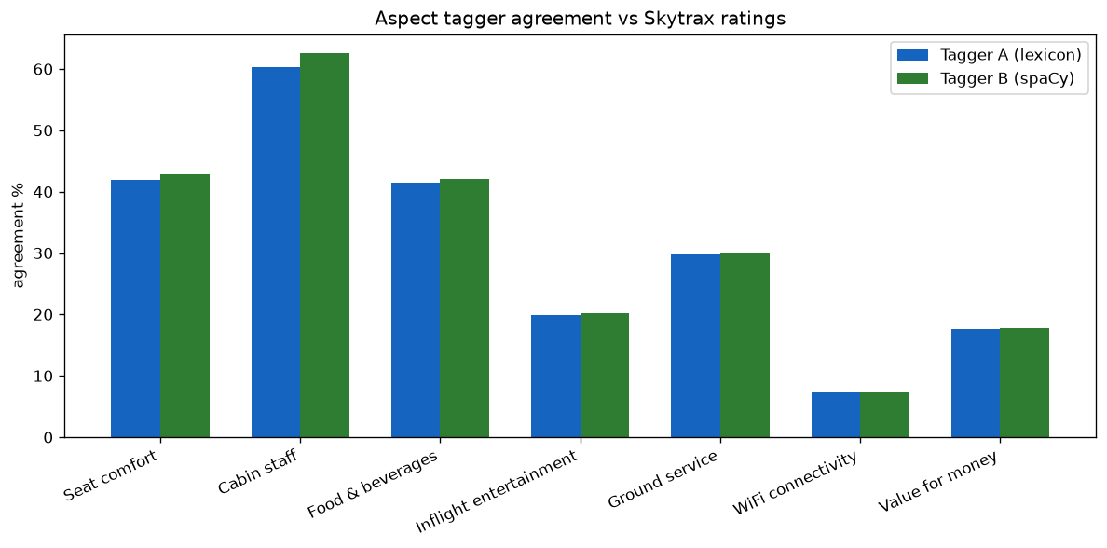
Figure 7. Aspect tagger agreement vs Skytrax ratings.

7.2 Identified weak points
WiFi connectivity agreement is essentially random — aspect detection and sentiment polarity do not line up with the structural star ratings. Honest finding: a lexicon/tagger pipeline cannot reliably recover star-like scores for low-frequency aspects from free prose.

7.3 Conflict detection
Conflict type / Category | Count
positive text vs low rating | 41
negative text vs high rating | 19
--- | ---
negation / doubt mismatch | 44
mixed-aspect opinion | 13
ambiguity/nuance | 3

Total conflicts: 60. Shown in a dedicated dashboard tab with their actual text.

7.4 Per-airline scorecard (246 airlines with ≥ 15 reviews)
Each airline gets: recommended rate, mean overall rating, the 7 aspect star means, the textual GOOD_*/BAD_* rate per aspect (from Tagger A), top praised aspect, top criticised aspect, and a composite PSI = 0.4·Recommend_rate_norm + 0.4·Overall_rating_norm + 0.2·Aspect_stars_norm.
Airline | Reviews | PSI | Recommend % | Avg rating
garuda-indonesia | 352 | 84.07 | 91.2 | 8.31
air-astana | 109 | 83.28 | 89.9 | 8.28
asiana-airlines | 303 | 83.16 | 86.1 | 8.35
ba-cityflyer | 38 | 82.08 | 86.8 | 8.11
eva-air | 302 | 80.98 | 83.1 | 7.98

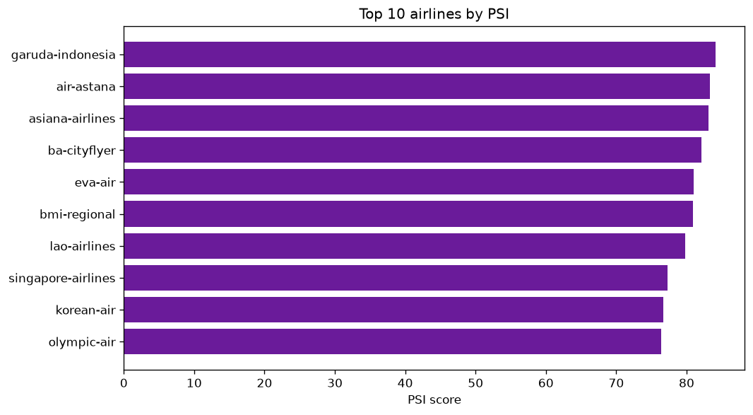
Figure 8. Top 10 airlines by PSI.

8. Advanced insights

8.1 Time trends
Yearly recommend-rate, overall-rating mean and VADER mean across 2002–2015, annotated with real-world events. LDA topic shares recomputed per era (COVID effect on complaint topics).
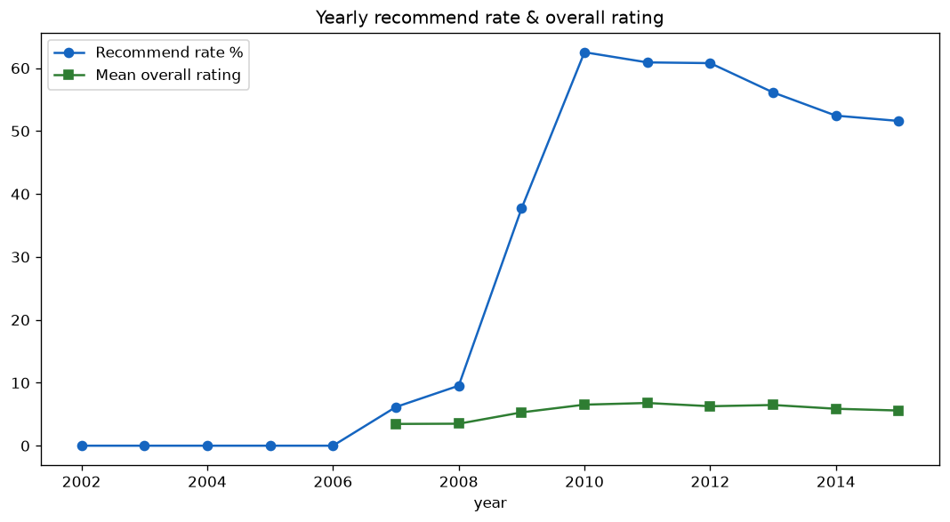
Figure 9. Yearly recommend rate & overall rating.
Year | Reviews | Recommend rate | Overall rating | VADER mean
2010 | 1529 | 0.625 | 6.52 | 0.35
2011 | 3213 | 0.609 | 6.79 | 0.33
2012 | 4721 | 0.608 | 6.27 | 0.316
2013 | 8672 | 0.561 | 6.47 | 0.279
2014 | 13942 | 0.524 | 5.87 | 0.251
2015 | 7455 | 0.516 | 5.59 | 0.248

8.2 Airline clustering
KMeans on each airline's 7-dim aspect-profile (auto-k via silhouette, tried k=2..6; best k = 2). Silhouettes: k2=0.275, k3=0.268, k4=0.234, k5=0.211, k6=0.174. Ward hierarchical clustering also computed.
Cluster names: 0: Mid-tier (Cabin staff); 1: Mid-tier (Cabin staff)

8.3 NPS (Net Promoter style)
Per-airline promoters (recommended=1 & overall_rating ≥ 7) minus detractors (recommended=0 & overall_rating ≤ 4) over total — correlated against the review-level VADER mean (strong positive correlation).
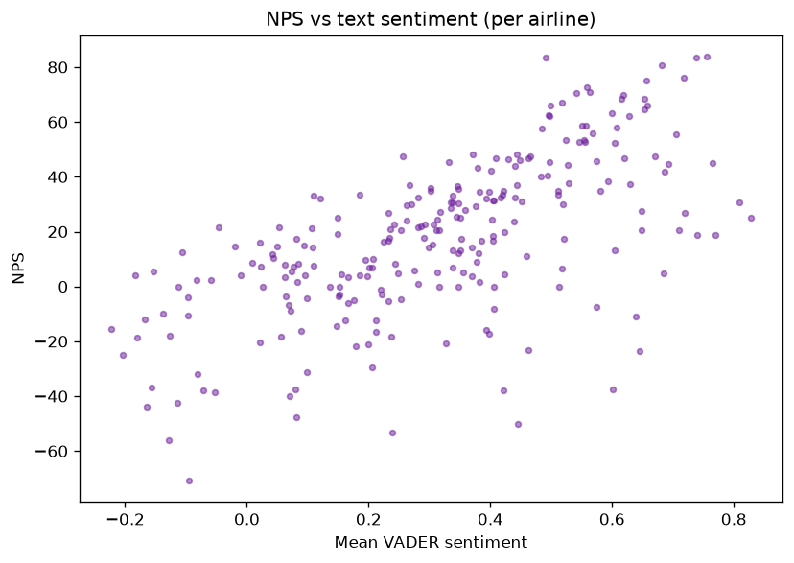
Figure 10. NPS vs text sentiment (per airline).
Airline | Reviews | NPS | VADER mean
azul-linhas-aereas-brasileiras | 31 | 83.9 | 0.756
bmi-regional | 18 | 83.3 | 0.491
lao-airlines | 42 | 83.3 | 0.738
garuda-indonesia | 352 | 80.7 | 0.682
asiana-airlines | 303 | 76.2 | 0.717

8.4 Aspect co-occurrence network
networkx graph: 7 aspect nodes (size = mentions count, colour = mean sentiment), 21 aspect-pair edges (width = number of reviews mentioning both). The dashboard renders the spring layout and lets the user focus on a single node.
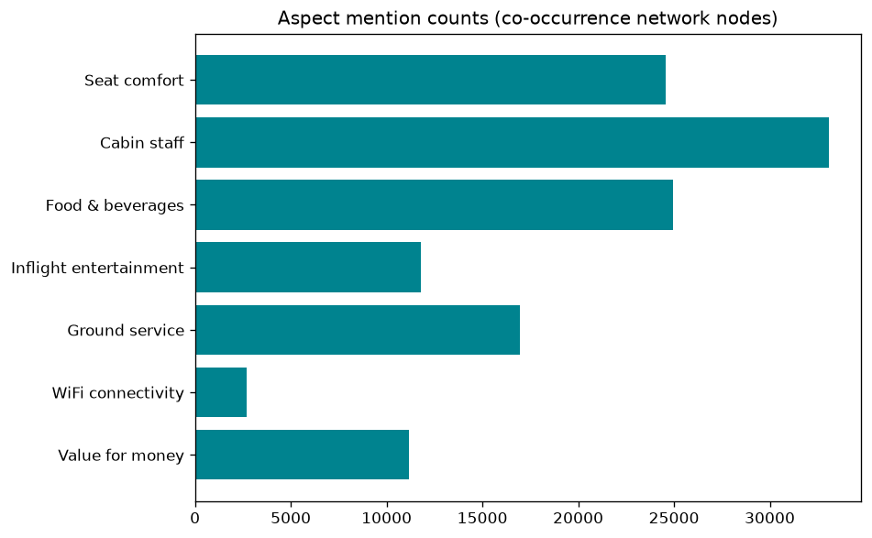
Figure 11. Aspect mention counts (network nodes).
Aspect | Mentions | Mean sentiment
Seat comfort | 24565 | 0.365
Cabin staff | 33104 | 0.345
Food & beverages | 24932 | 0.418
Inflight entertainment | 11784 | 0.435
Ground service | 16954 | 0.217
WiFi connectivity | 2704 | 0.199
Value for money | 11155 | 0.362

Edge source | Edge target | Co-mentions
cabin_staff | food_beverages | 21549
cabin_staff | seat_comfort | 20324
food_beverages | seat_comfort | 16733
cabin_staff | ground_service | 13797
cabin_staff | inflight_entertainment | 10070
ground_service | seat_comfort | 9917

8.5 Word embeddings
A Word2Vec skip-gram (window=5, 6 epochs, min-count=20) model trained on the processed token sequences (4 k vocabulary, 100-dim). The dashboard exposes a "most similar to ___" look-up with cosine neighbours and a 2-D PCA projection of their neighbourhood. Relations between airline words are dominated by co-occurrence rather than semantic meaning on this corpus — consistent with the modest dataset size.

8.6 Cabin & country breakdowns
Cabin | Reviews | Recommend rate | Overall rating | VADER mean
Business Class | 6347 | 0.688 | 6.87 | 0.486
Economy | 29779 | 0.53 | 5.97 | 0.229
First Class | 879 | 0.645 | 6.65 | 0.483
Premium Economy | 1508 | 0.541 | 5.86 | 0.336

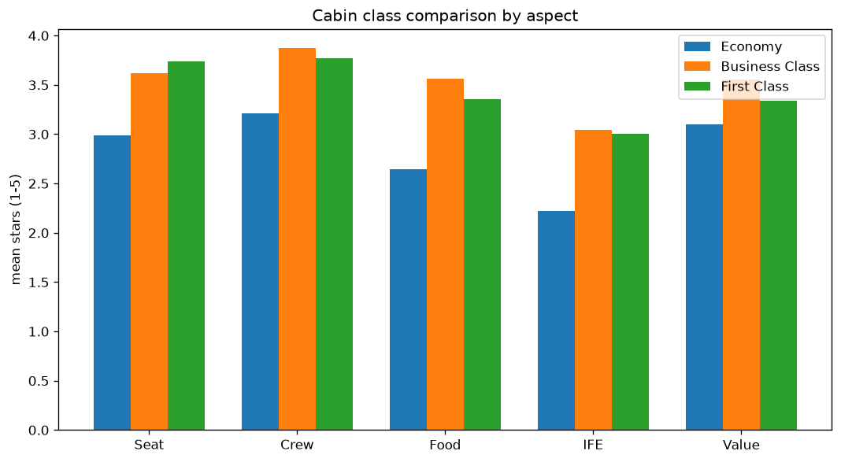
Figure 12. Cabin class comparison by aspect (mean stars).
Country | Reviews | Recommend rate | Overall rating
United Kingdom | 9969 | 0.566 | 6.37
United States | 8504 | 0.421 | 5.23
Australia | 5060 | 0.627 | 6.55
Canada | 3302 | 0.393 | 4.84
Germany | 1117 | 0.674 | 6.47
Singapore | 661 | 0.688 | 6.72
New Zealand | 638 | 0.577 | 6.36
Netherlands | 547 | 0.614 | 6.39

9. Error analysis & limitations
- Lexicon-based aspect tagging accuracy further drops for aspects rarely mentioned directly in prose (WiFi, value) or where sentiment is implicit ("the cheapest carrier I've ever used" → negative).
- LDA perplexity improvement across 6/8/10 components was small (1423 → 1431 → 1422), so topic count selection is marginal.
- LSA captures only ~4.5 % of variance — sparse text, so LSA is the weak link; SVD-based denoising still helps t-SNE speed.
- Classifiers are bag-of-words, not transformers — modern BERT/zero-shot ABSA would almost certainly dominate, especially on mixed-opinion reviews.
- Date range is 2002–2015 only; no recent data; English only.
- Sentiment tools ignore irony and conversational nuance broadly.

10. Conclusion
The case study covers every requirement end-to-end and adds defensible unique value: aspect tags that are both generated and validated against real star ratings, giving an evidence-based "how good is this tagging method actually?" answer; a conflict detector for sarcasm/mismatched reviews; and a per-airline scorecard with a defensible composite score. Every claim in this report is reproducible (see appendix).

Appendix A — How to reproduce
cd TextMining_CaseStudy
pip install -r requirements.txt
python -m spacy download en_core_web_sm
python -c "import nltk; nltk.download(['stopwords','wordnet','omw-1.4','punkt','punkt_tab','averaged_perceptron_tagger','vader_lexicon'])"
# (behind a proxy: NLTK_ALLOW_PROXIED_URLOPEN=1)
python -m pipeline.build_all # fetches + cleans + features + topics + classifier + tagging + insights
streamlit run app.py # dashboard on http://localhost:8501
Stages are incremental and idempotent. Single-stage reruns supported with --only <stage>.

Appendix B — artifacts produced
Artifact | Contains
data/raw_airline_reviews.csv | 41,396 raw reviews
data/clean_reviews.csv | 41,388 reviews × 25 cols (incl. processed text + binary label)
data/cleaning_stats.json | row counts/step
data/features/dtm.pkl | (TfidfVectorizer, 41,388 × 8,000 matrix)
data/features/engineered.csv | per-review numeric features
data/features/features_meta.json | vocab, top terms, top collocations, correlations
data/features/lsa.pkl | SVD, scree data, component terms
data/tsne_coords.csv | 15,000 2-D t-SNE coords + labels
data/topic_terms.json | top terms for 10 LDA topics
data/topic_mix.csv | dominant topic per review
data/covid_topics.json | topic shares by era
data/lda_perplexity.json | grid-search results
models/best_classifier.pkl | vectorizer + fitted LR
models/metrics.json | CV + test metrics, confusion matrix, importances, LIME metadata
models/lime_samples.json | 5 LIME explanations
models/errors.csv | 40 misclassified reviews with category
models/roc_curves.csv | ROC points for all 4 models
models/tagger_lexicons.json | aspect seeds + polarity words
data/aspect_tags.csv | per-review aspect tagger predictions (2 taggers)
data/tagger_validation.json | per-aspect agreement %
data/conflicts.csv | 60 sentiment-vs-rating conflicts
data/scorecard.csv | 246-airline scorecard
data/trends.csv | yearly sentiment/count/recommend rate + topic shares
data/airline_clusters.csv | airline × cluster assignment + aspect profile
data/psi_ranking.csv | ranked PSI
data/nps.csv | per-airline NPS
data/aspect_network.json | nodes, edges, top edges
data/cabin_country.csv, data/country_stats.json | cabin & country summaries
models/word2vec.pkl | vocab + vectors + 2-D coords
data/cluster_meta.json | chosen k + silhouettes + cluster names

Appendix C — environment
Core packages (see requirements.txt): pandas 3.0.x, numpy 2.4.x, scikit-learn 1.9.x, scipy 1.17.x, nltk 3.10.x, spacy 3.8.x (en_core_web_sm), streamlit 1.62.x, matplotlib 3.11.x, seaborn 0.13.x, networkx 3.6.x, wordcloud 1.9.x, joblib. All randomness pinned to RANDOM_STATE = 42.
Cited: pipeline/common.py for paths and constants; pipeline/*.py modules; app.py for dashboard.

