**Name:** Aravind Kumar Kaspe **Banner ID:** 001291145

**ASSIGNMENT 1**

**CSCI 5930 – Homework 1: Statistical values**

1. **Find the mean, median, Variance and standard deviation of A.**

**A = {2,4,1,6,7,9,2,1,5,3}**

**Mean:** Mean or average is calculated as the sum of all values divided by the total number of values.

Mean= Sum of values

Total number of values

Mean= (2+4+1+6+7+9+2+1+5+3)

10

Mean= 40

10

Mean= 4

**Median:** To find the median, you first need to sort the data and then find the middle value. If the number of observations is even, take the average of the two middle values.

Sorted A = {1, 1, 2, 2, 3, 4, 5, 6, 7, 9}

Median= (3+4)

2

Median= 7/2

Median= 3.5

**Standard deviation:** The standard deviation measures the amount of variation or dispersion from the mean in a set of values.

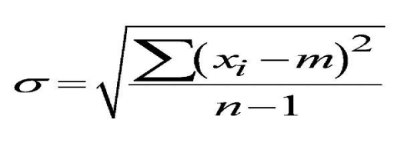

Where σ is the standard deviation

m is mean

n is the total number of values in the data

Standard deviation is calculated the following way:

Step1: Calculating mean

Mean=(2+4+1+6+7+9+2+1+5+3)

10

Step2: finding deviation from the mean for every value of the data A

(2 - 4) = -2

(4 - 4) = 0

(1 - 4) = -3

(6 - 4) = 2

(7 - 4) = 3

(9 - 4) = 5

(2 - 4) = -2

(1 - 4) = -3

(5 - 4) = 1

(3 - 4) = -1

Step3: Square of each deviation from the mean

(-2)² = 4

(0)² = 0

(-3)² = 9

(2)² = 4

(3)² = 9

(5)² = 25

(-2)² = 4

(-3)² = 9

(1)² = 1

(-1)² = 1

Step4: Calculating the mean of individual standard deviations

= (4+0+9+4+9+25+4+9+1+1)

10-1

= (66)

9

= 7.333333

Step5: Take the square root of the mean of individual standard deviations

√7.33 =2.7080128

So, the standard deviation of the above data A = **{**2,4,1,6,7,9,2,1,5,3} is approximately 2.7

**Variance:** Variance is the square of standard deviation. Variance is expectation of the squared deviation from mean value.

Variance= (Standard deviation)^2

Variance = (2.7)^2

Variance = 7.33

**2. Write a code in Python:**

**a) Enter vector A of question 1 in Python. Copy the code. (Hint: A<- c(2,4,...))**

Creating a vector using a NumPy array:

Python code:

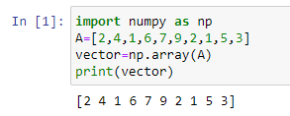

The above python code converts the array to a vector and prints the vector A of the above-given data.

**b) Find the mean and standard deviation of A. Copy the code.**

As we consider standard deviation for a sample, we consider it as sample standard deviation. If we have considered the total population, we would take sample_std = np. std(vector) instead of sample_std = np.std(vector, ddof=1)in the below Python code.

Python code to calculate mean and standard deviation:

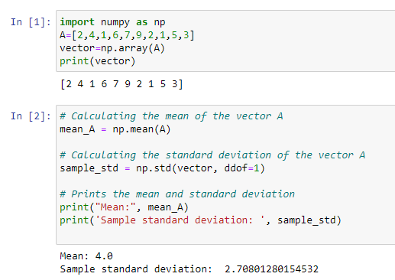

**c) Do your results match question 1?**

Yes, the results of question 1 match the result of the above Python code.