**Name:** Aravind Kumar Kaspe **Banner ID:** 001291145

**ASSIGNMENT 4**

**CSCI 5930 – Homework 4: Regression**

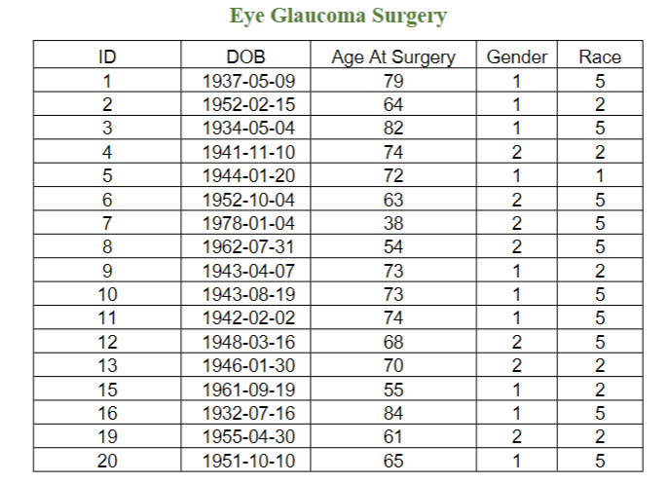

1. **Plot the linear regression of Age vs Race. Plt.line**

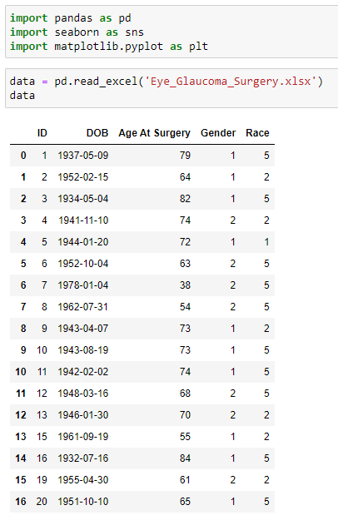

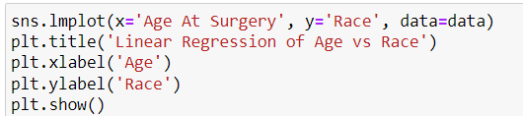

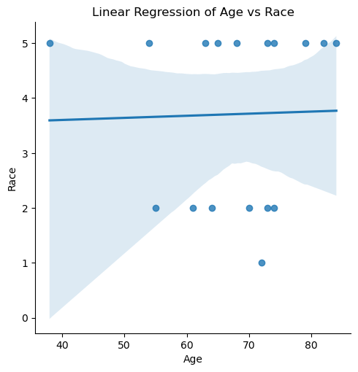

1. **Find the linear regression equation.**

Race = slope * Age + intercept.

Slope - It represents the coefficient for Age

Intercept - It represents the intercept of the regression line with the y-axis.

1. **Find the scatter plot matrix of eye data for columns Age, Gender, and Race. What attributes have any kind of correlation?**

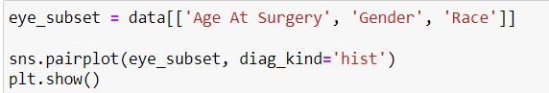

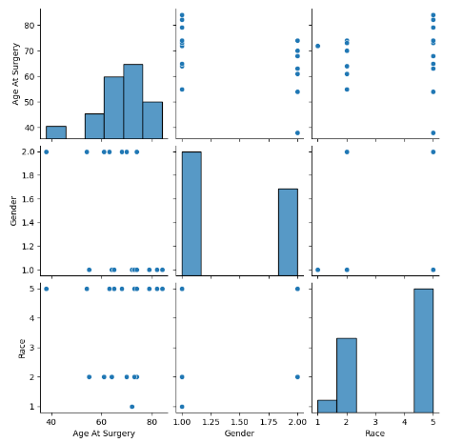

There is NO correlation between "Race" and "Gender". The correlation between "Race" and "Age At Surgery" is almost negligible. There is a Negative correlation between "Gender" and "Age At Surgery". Specifically, as the value of one variable (gender) increases (for example, from female to male), the value of the other variable (age at surgery) tends to decrease. Therefore, there is a moderate negative association between gender and the age at which individuals undergo surgery.

1. **Classify data with logistic regression for X: age and y: Gender. Copy the code and results and interpret the results.**

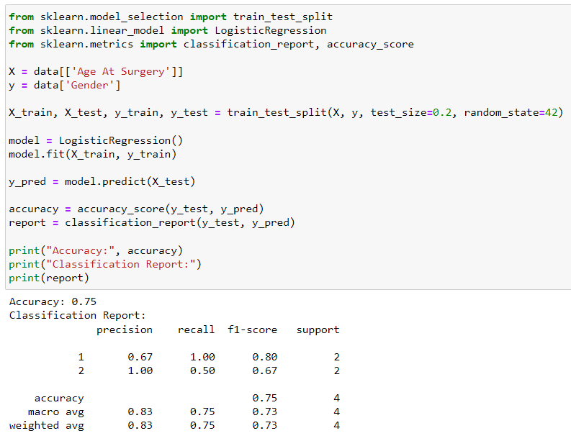

The accuracy of the model is reported as 75%, indicating that it correctly classified 75% of the instances in the test set. Precision measures the proportion of true positive predictions out of all positive predictions, with values of 67% and 100% for “Age At Surgery” and “Gender” respectively. Recall, or sensitivity, assesses the ability of the model to correctly identify all positive instances, where “Age At Surgery” achieved perfect recall while “Gender” achieved 50%. The F1 score, which combines precision and recall into a single metric, is 80% for “Age At Surgery” and 67% for “Gender”. Support indicates the number of instances in each column. Overall, the model performs reasonably well, especially for “Age At Surgery”, while “Gender” could benefit from improved recall.