**Name:** Aravind Kumar Kaspe **Banner ID:** 001291145

**ASSIGNMENT 7**

**CSCI 5930 – Homework 7: SVM Graphs**

1. **For data of frequent names in NY:  
   a) X1: CNT, X2: RNK  
   b) Make the graph of SVM with 4 kernels.  
   c) Find the accuracy. Which kernel classifies data better?  
   d) Copy the graphs.  
   e) Interpret the graphs.**

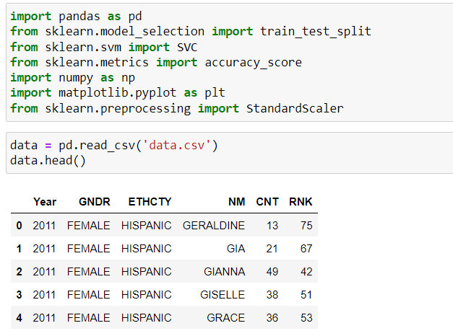

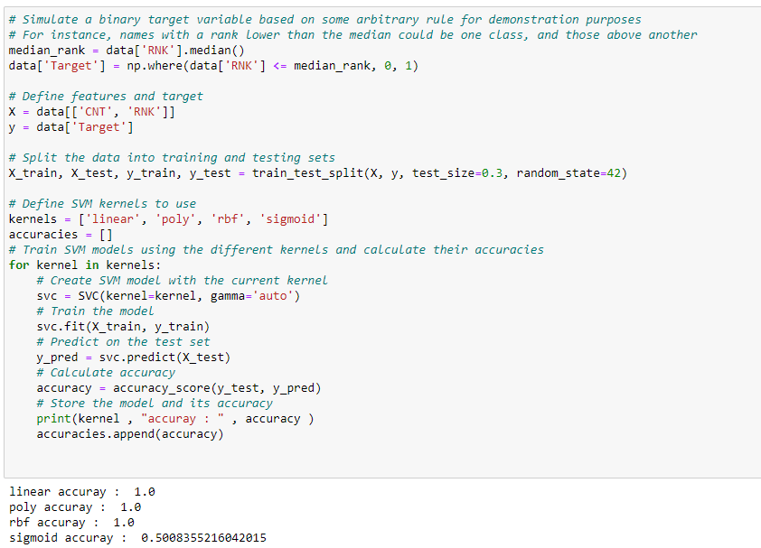

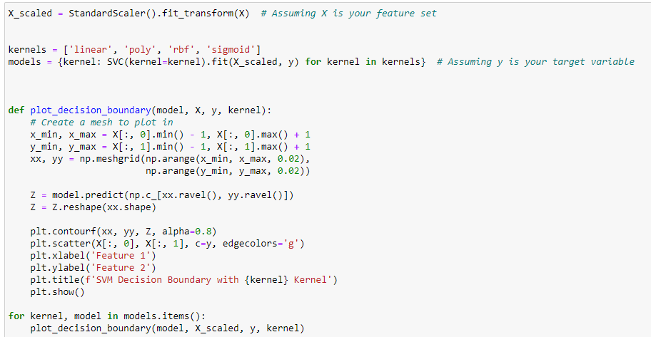

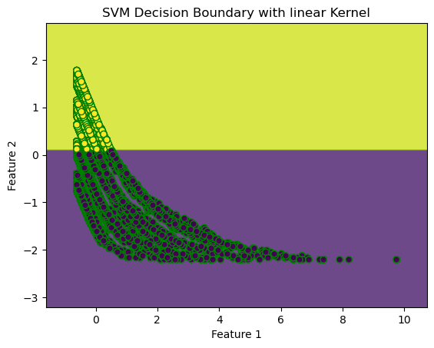

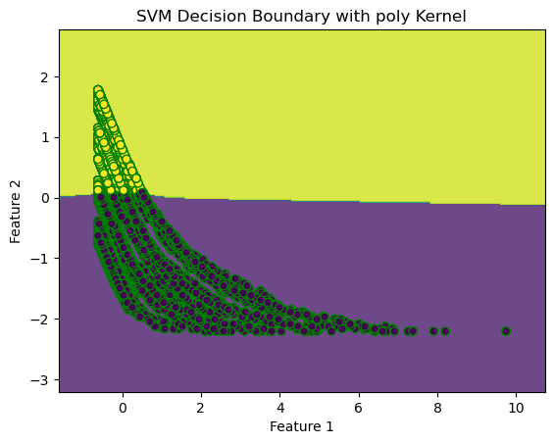

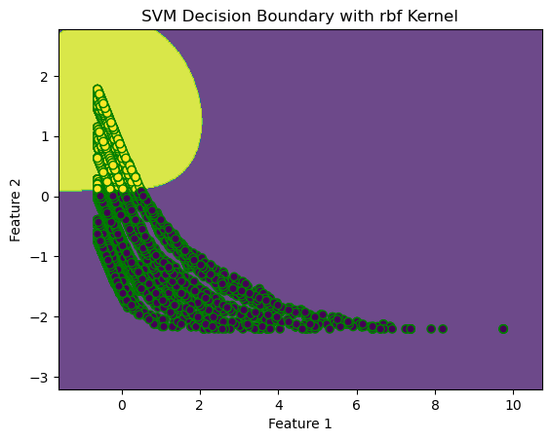

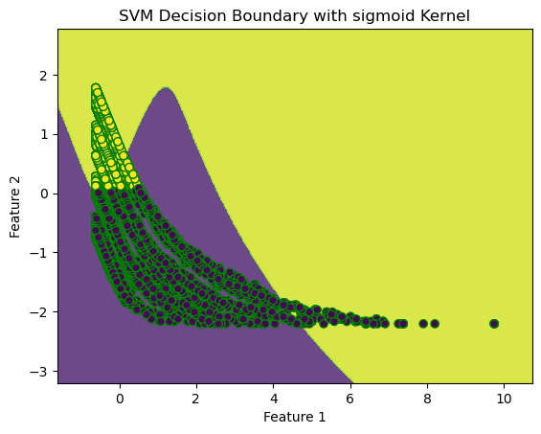

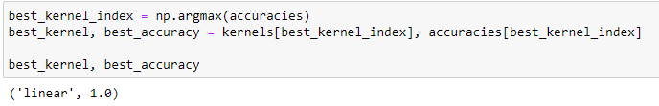

**Interpretation:**

Different kernels of the SVM show up various features of the classifiers related to the dataset with regard of claimed accuracies. The linear, polynomial, and RBF kits had a 100% track record, indicating that they classifed the data in errorless manner in this particular case. The linear kernels performance points considering a chance of straightforward separation of data with linear hyperplane. This simple and effectivness property, alongside the natural versatility to apply on datasets not requiring non-trivial decision boundaries, makes it a robust and reliable option when dealing with this type of data. The polynomial kernel can once again prove to be effective. This might suggest the data to be complex and as such containing something more than the conventional straight line can capture, but still being organized around an ordered pattern that the polynomial transformation is able to appropriately model. The RBF (Radial Basis Function) kernel's perfect score shows that the kernel has the most versatility and is able to deal with complex non-linear dependencies that are often observed in real life circumstances. It adjusts the decision boundary to allow for a good fit to the input data.  
  
However, the Sigmoid function's attainment of such a low level of accuracy at half the average finds widespread deficiencies in its fitting capability. A frequently found evidence of this behavior suggest that the kernel, often producing complex and varied decision boundaries, may not have the ability to suit the data structure, resulting in overfitting and/or a failure to properly capture the distribution of classes.  
  
The expression of performance by kernel sigmoid is not observed in the others confirming the critical point of the use of the kernel that is dependent on the features of data. As employed in the traditional SVM with the linear and the RBF kernels, the linear and the RBF kernels show strength in robustness and flexibility, effectively handling both simple and complex patterns. But, the very limitation of the sigmoid kernel element directs to the fact that it is limited to the cases it can handle and for that the kernel selection is critical in the SVM.