Command 1 : Git –version

Description: It is used to know the git version on our machine.

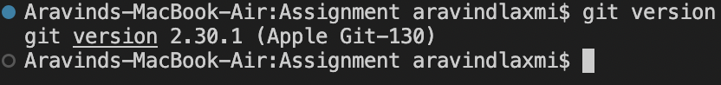

Command 2 : git init

Description : Initialize the git to create a new git repository.



Command 3 : git config --global user.name “User_name”

git config –global user.email ”[email@.com](mailto:email@.com)”

Description : To configure git with user name or email

Command 3 : git status

Description : To check what are the files are in vs code to load in git hub.(This is untracked file)

Command 4 : git add README.md (or) git add “file name”

Description : used to add particular file

Command 5 : git add .

Description : used to add all files in github

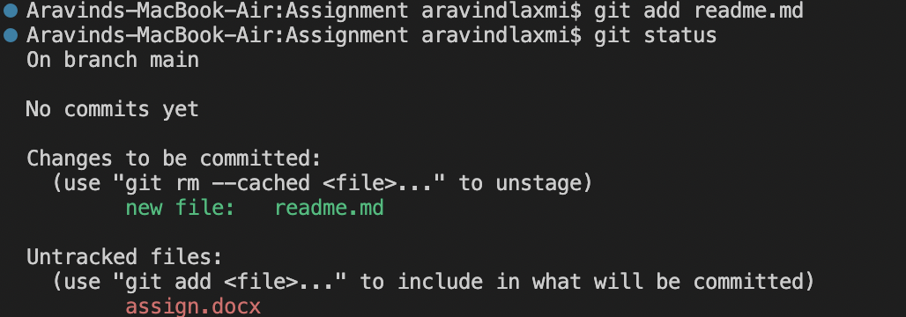

Command 6 : git restore --staged

Description : To do unstage.

Command 7 : git commit -m “changes/commits done”

Description : commit a snapshot all changes in a directory.

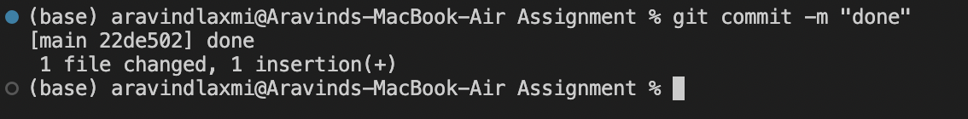

Command 8 : git branch

Description : git branch let us to create list, rename and delete branches.

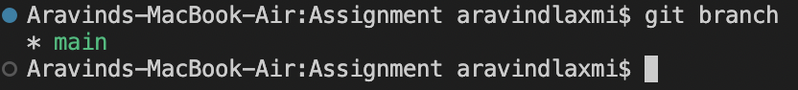

Command 9 : git remote add origin “ link here”

Description : Obtain the git remote add URL for the remote repository and add. Push if already added.



Command 10 : git push -u origin main (or) git push origin main

Description : To push the new branch into git.

Command 11 : git remote add origin “ link here”

Description : Obtain the git remote add URL for the remote repository and add

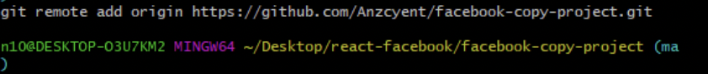

Command 12 : git remote add origin “ link here”

Description : Obtain the git remote add URL for the remote repository and add

Command 13 : git branch developer1

Description : used to add a new branch with the name of developer and add multiple with names.



Command 14 : git checkout developer1

Description: switch to branch developer1.



Command 15 : git clone “link to clone repo”

Description : To clone the git hub repository.

Command 16 : git remote -v

Description : It refers to a remote repository.

Command 17 : git remote remove origin

Description : It removes the remote repository

