CSA4707 - DEEP LEARNING
Name: K Aravind Kumar Reddy
Reg No:192324225

Experiment 1:
Aim: To demonstrate confusion matrix using python

Program:
import numpy as np
from sklearn.metrics import confusion_matrix import seaborn as sns
import matplotlib.pyplot as plt actual = np.array(
['Dog','Dog','Dog','Not Dog','Dog','Not Dog','Dog','Dog','Not Dog','Not Dog']) predicted = np.array(
['Dog','Not Dog','Dog','Not Dog','Dog','Dog','Dog','Dog','Not Dog','Not Dog']) conf_matrix=confusion_matrix(actual,predicted)
sns.heatmap(conf_matrix,annot=True,fmt='g',xticklabels=['Dog','Not Dog'],yticklabels=['Dog','Not Dog'],cmap='RdPu')
plt.ylabel("prediction",fontsize=16) plt.xlabel("actual",fontsize=16) plt.title("confusion matrix",fontsize=20) plt.show()

Output:
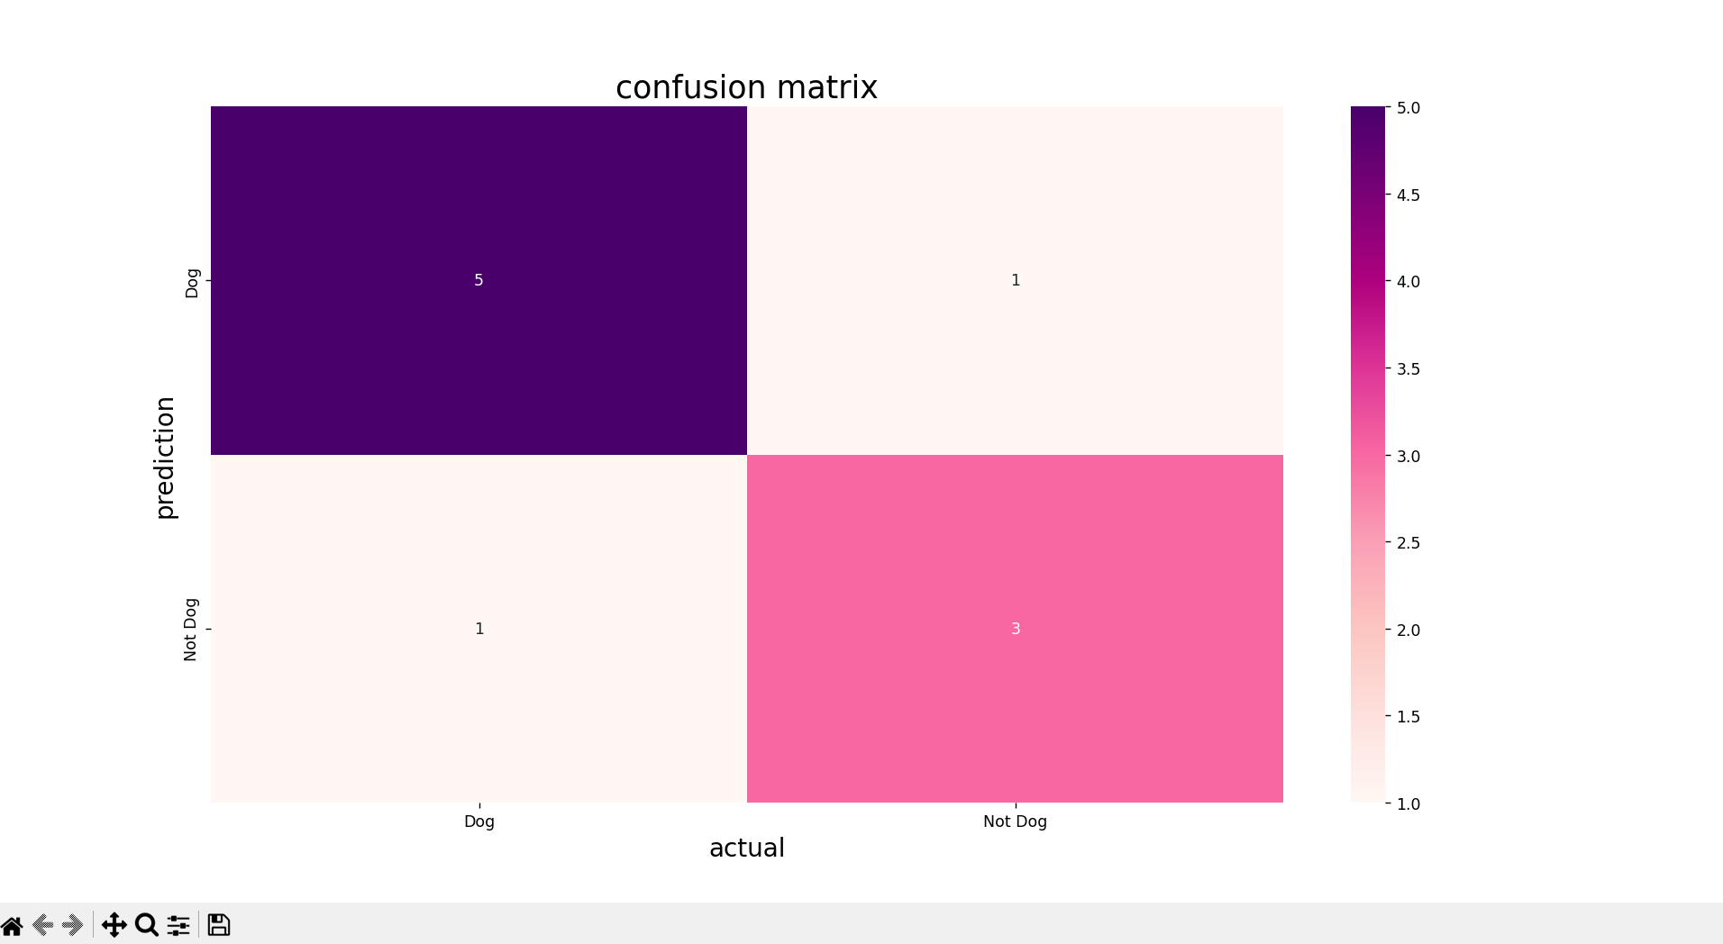

Experiment 2:
Aim: To demonstrate 2 class confusion matrix using python

Program:
import pandas as pd
import matplotlib.pyplot as plt import seaborn as sns
from sklearn.datasets import load_wine
from sklearn.model_selection import train_test_split from sklearn.tree import DecisionTreeClassifier from sklearn.metrics import
accuracy_score,f1_score,precision_score,recall_score,classification_report,conf usion_matrix
wine=load_wine() data=pd.DataFrame(data=wine.data,columns=wine.feature_names) data['Target']=wine.target

data=data[data['Target']!=2] x=data.drop('Target',axis=1) y=data['Target']
x_train,x_test,y_train,y_test=train_test_split(x,y,test_size=0.3,random_state=1) model=DecisionTreeClassifier(random_state=1)
model.fit(x_train,y_train) y_pred=model.predict(x_test) accuracy=accuracy_score(y_test,y_pred) print("accuracy:",accuracy)
class_report = classification_report(y_test, y_pred, target_names=wine.target_names[:2])
print("Classification Report:\n", class_report) precision = precision_score(y_test, y_pred) recall = recall_score(y_test, y_pred)
f1 = f1_score(y_test, y_pred) print(f"Precision: {precision:.2f}") print(f"Recall: {recall:.2f}")
print(f"F1 Score: {f1:.2f}") conf_matrix=confusion_matrix(y_test,y_pred) plt.figure(figsize=(8,6))
sns.heatmap(conf_matrix,annot=True,fmt='d',cmap='PuBuGn',xticklabels=wine. target_names[:2],yticklabels=wine.target_names[:2])
plt.xlabel("predicted label") plt.ylabel("true label") plt.title("confusion matrix") plt.show()

Output:

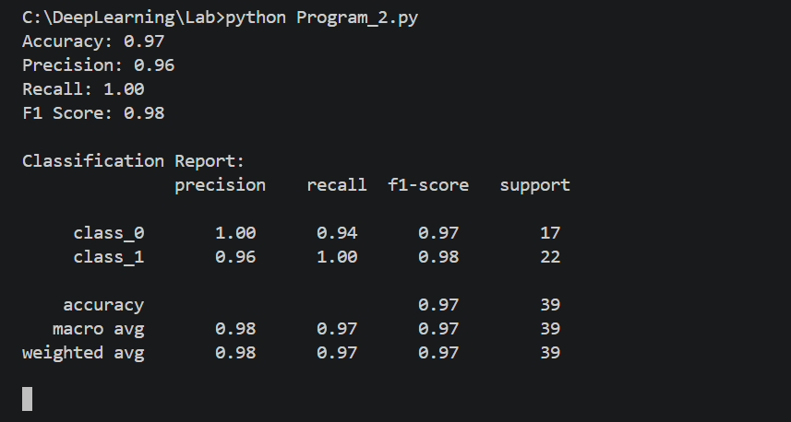

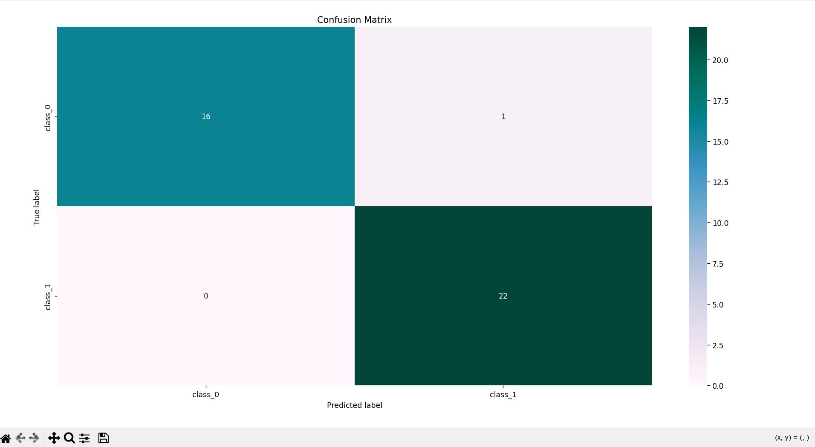

Experiment 3:
Aim: To analyse the performance of a multi class confusion matrix by using choosen database with python code

Program:
from sklearn.datasets import load_digits
from sklearn.model_selection import train_test_split from sklearn.ensemble import RandomForestClassifier from sklearn.metrics import confusion_matrix
import seaborn as sns
import matplotlib.pyplot as plt
from sklearn.metrics import accuracy_score, precision_score, recall_score, f1_score
X, y= load_digits(return_X_y=True)
X_train, X_test, y_train, y_test = train_test_split(X, y,test_size=0.25) clf = RandomForestClassifier(random_state=23)
clf.fit(X_train, y_train) y_pred = clf.predict(X_test)
cm = confusion_matrix(y_test,y_pred) sns.heatmap(cm, annot=True,
fmt='g',cmap="winter") plt.ylabel('Prediction',fontsize=13) plt.xlabel('Actual',fontsize=13) plt.title('Confusion Matrix',fontsize=17) plt.show()
accuracy = accuracy_score(y_test, y_pred) print("Accuracy :", accuracy)

Output:
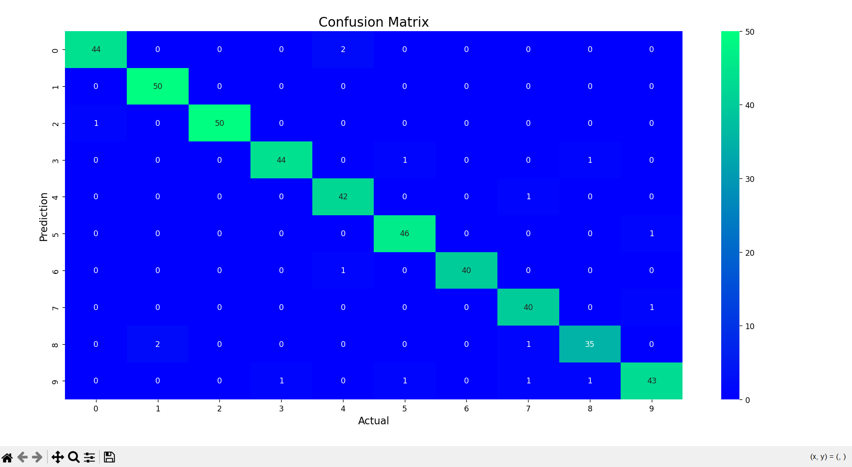

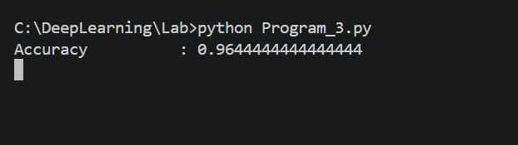

Experiment 4:
Aim: To analyse the performance of a over fitting by using choosen database with python code

Program:
import numpy as np
import matplotlib.pyplot as plt
from sklearn.pipeline import Pipeline
from sklearn.preprocessing import PolynomialFeatures from sklearn.linear_model import LinearRegression from sklearn.model_selection import cross_val_score

def true_fun(X):

return np.cos(1.5 * np.pi * X)

np.random.seed(0)

n_samples = 30
degrees = [1, 4, 15]

X = np.sort(np.random.rand(n_samples))
y = true_fun(X) + np.random.randn(n_samples) * 0.1

plt.figure(figsize=(14, 5)) for i in range(len(degrees)):
ax = plt.subplot(1, len(degrees), i + 1) plt.setp(ax, xticks=(), yticks=())

polynomial_features = PolynomialFeatures(degree=degrees[i], include_bias=False)
linear_regression = LinearRegression() pipeline = Pipeline(
[
("polynomial_features", polynomial_features), ("linear_regression", linear_regression),
]
)
pipeline.fit(X[:, np.newaxis], y) scores = cross_val_score(
pipeline, X[:, np.newaxis], y, scoring="neg_mean_squared_error", cv=10

)

X_test = np.linspace(0, 1, 100)
plt.plot(X_test, pipeline.predict(X_test[:, np.newaxis]), label="Model") plt.plot(X_test, true_fun(X_test), label="True function")
plt.scatter(X, y, edgecolor="y", s=20,marker="^", label="Samples") plt.xlabel("x")
plt.ylabel("y")
plt.xlim((0, 1))
plt.ylim((-2, 2)) plt.legend(loc="best") plt.title(
"Degree {}\nMSE = {:.2e}(+/- {:.2e})".format( degrees[i], -scores.mean(), scores.std()
)
)
plt.show()

Output:

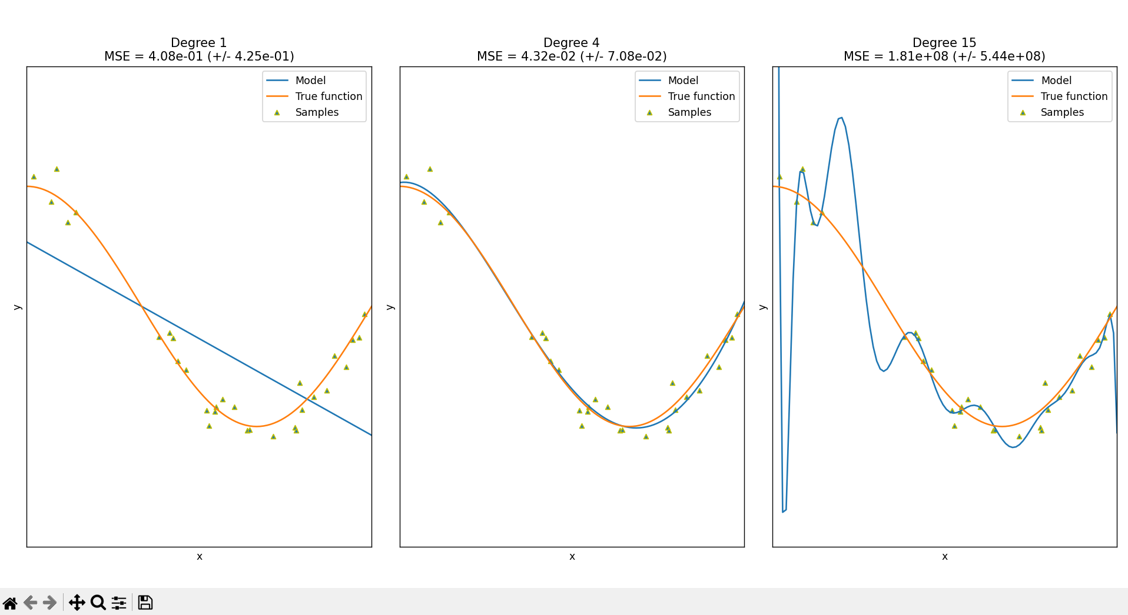

Experiment 5:
Aim: To demonstrate the performance of a linear regression by using choosen database with python code

Program:
import pandas as pd
import matplotlib.pyplot as plt
from sklearn.datasets import load_iris
from sklearn.model_selection import train_test_split from sklearn.linear_model import LinearRegression from sklearn.metrics import mean_squared_error iris = load_iris()
data = pd.DataFrame(data=iris.data, columns=iris.feature_names) data['species'] = iris.target
print(data.head())
X = data[['sepal length (cm)']] y = data['sepal width (cm)']
X_train, X_test, y_train, y_test = train_test_split(X, y, test_size=0.3, random_state=42)
model = LinearRegression() model.fit(X_train, y_train) y_pred = model.predict(X_test)
mse = mean_squared_error(y_test, y_pred) print(f'Mean Squared Error on test set: {mse:.2f}') plt.figure(figsize=(10, 6))
plt.scatter(X_test, y_test, color='r',marker='*', label='Actual') plt.plot(X_test, y_pred, color='y', linewidth=3, label='Predicted') plt.xlabel('Sepal Length (cm)')
plt.ylabel('Sepal Width (cm)')

plt.title('Linear Regression: Sepal Width vs Sepal Length') plt.legend()
plt.show()
new_sample = pd.DataFrame([[5]], columns=['sepal length (cm)']) predicted_width = model.predict(new_sample)
print(f'The predicted sepal width for sepal length {new_sample.values.tolist()} is {predicted_width[0]:.2f} cm')
Output: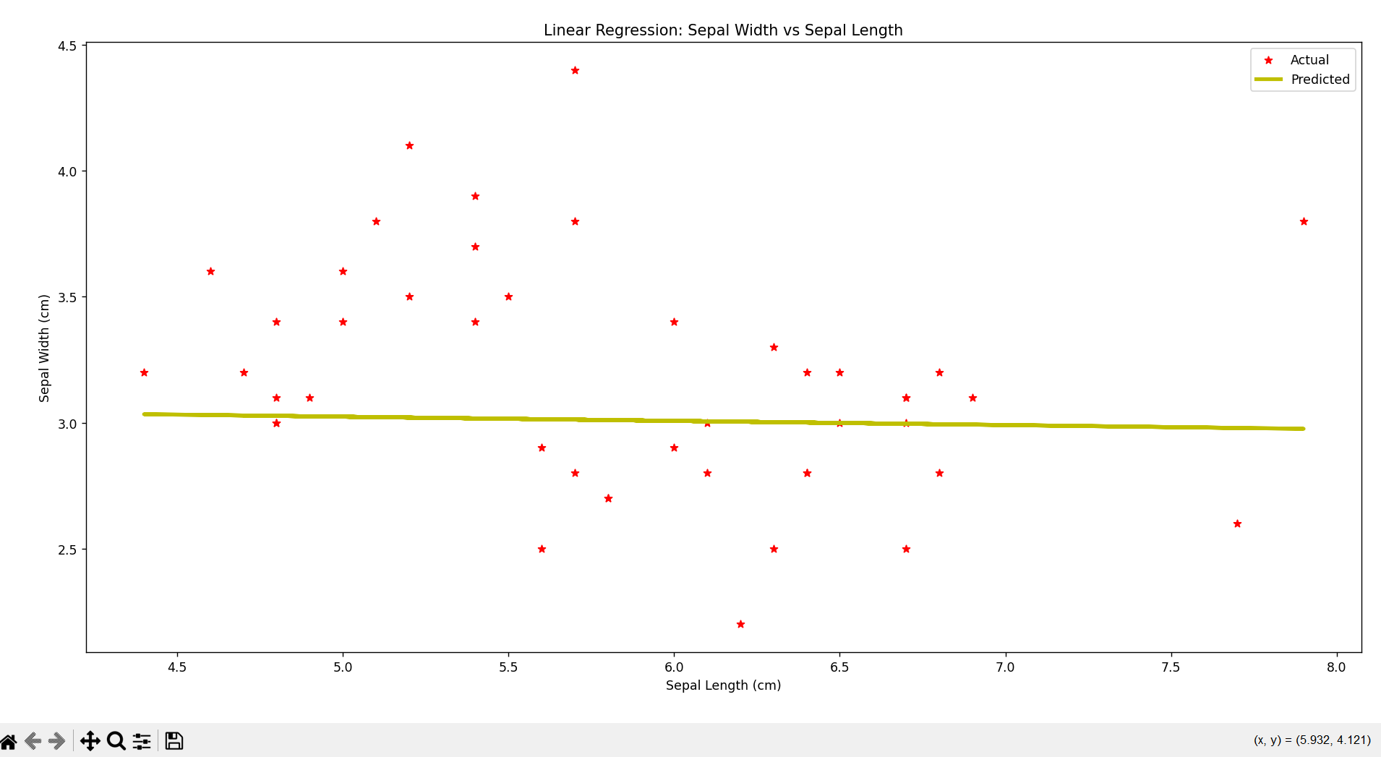

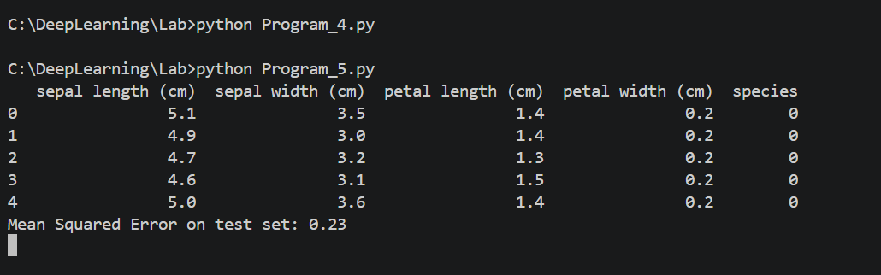

Experiment 6:
Aim: To demonstrate the performance of knn using wine dataset

Program:
import pandas as pd import pandas as pd
import matplotlib.pyplot as plt import seaborn as sns
from sklearn.datasets import load_wine
from sklearn.model_selection import train_test_split from sklearn.neighbors import KNeighborsClassifier
from sklearn.metrics import accuracy_score,confusion_matrix wine=load_wine() data=pd.DataFrame(data=wine.data,columns=wine.feature_names) data['Target']=wine.target
x=data.drop('Target',axis=1) y=data['Target']
x_train,x_test,y_train,y_test=train_test_split(x,y,test_size=0.3,random_state=1) model=KNeighborsClassifier(n_neighbors=5)
model.fit(x_train,y_train) y_pred=model.predict(x_test) accuracy=accuracy_score(y_test,y_pred) print("accuracy:",accuracy)
conf_matrix = confusion_matrix(y_test,y_pred) plt.figure(figsize=(8, 6))
sns.heatmap(conf_matrix, annot=True, fmt='d', cmap='summer', xticklabels=wine.target_names, yticklabels=wine.target_names)
plt.xlabel('Predicted Label') plt.ylabel('True Label')

plt.title('Confusion Matrix') plt.show()

Output:
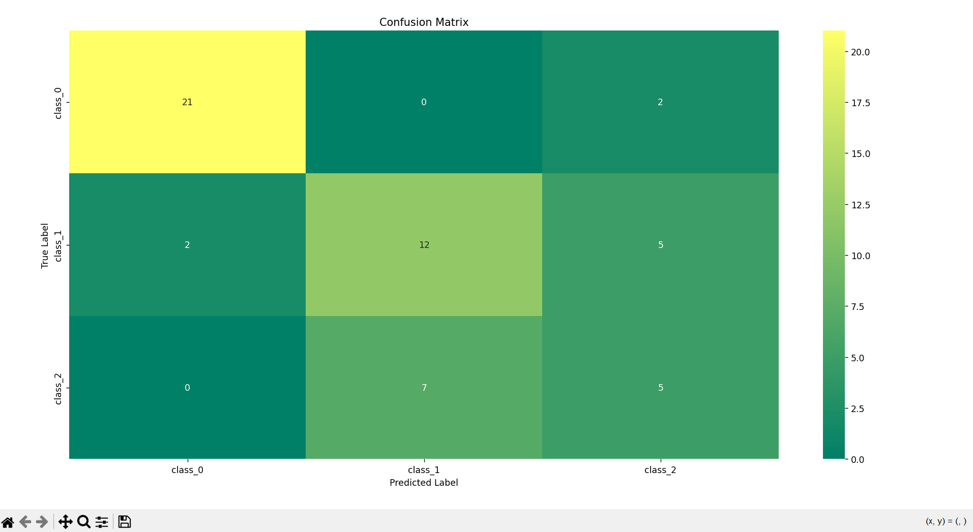
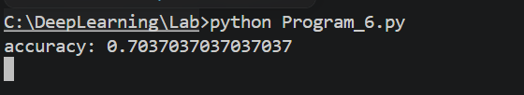

Experiment 7:
Aim: To demonstrate the performance of a logistic regression by using choosen database with python code.

Program:
import numpy as np
import matplotlib.pyplot as plt def sigmoid(z):
return 1 / (1 + np.exp( - z))
plt.plot(np.arange(-5, 5, 0.1), sigmoid(np.arange(-5, 5, 0.1)),color='pink') plt.title('Visualization of the Sigmoid Function')
plt.show()

Output:
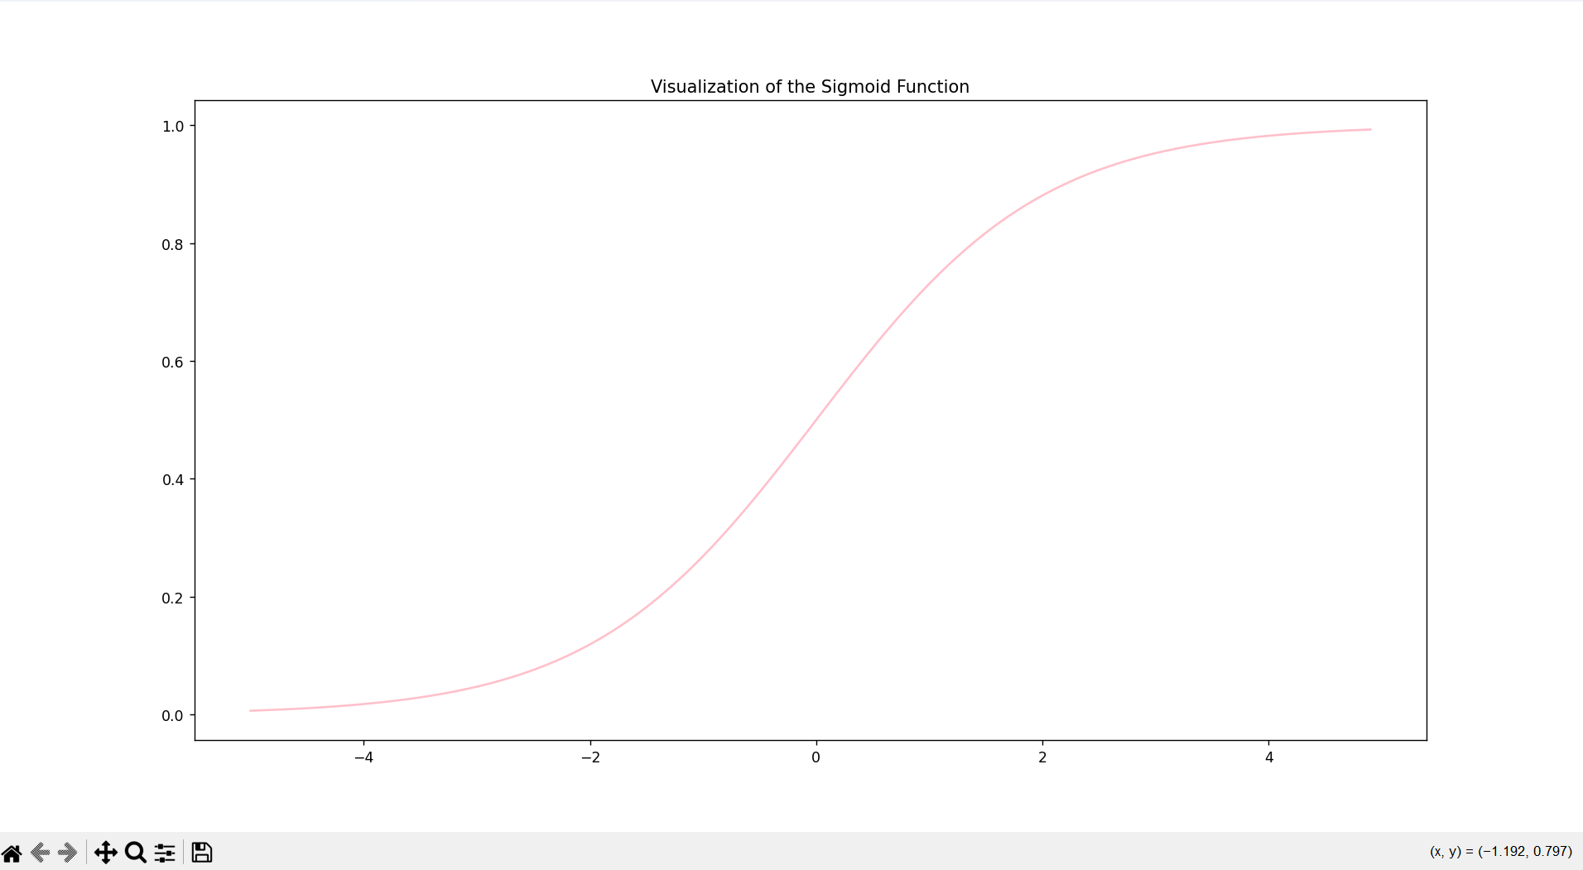

Experiment 8:
Aim: To demonstrate the performance of KNN algorithm by using iris dataset Program:
import pandas as pd
import matplotlib.pyplot as plt import seaborn as sns
from sklearn.datasets import load_iris
from sklearn.model_selection import train_test_split from sklearn.neighbors import KNeighborsClassifier
from sklearn.metrics import accuracy_score,confusion_matrix iris=load_iris() data=pd.DataFrame(data=iris.data,columns=iris.feature_names) data['Species']=iris.target
x=data.drop('Species',axis=1) y=data['Species']
x_train,x_test,y_train,y_test=train_test_split(x,y,test_size=0.3,random_state=1)

model=KNeighborsClassifier(n_neighbors=5) model.fit(x_train,y_train) y_pred=model.predict(x_test) accuracy=accuracy_score(y_test,y_pred) print("accuracy:",accuracy)
conf_matrix = confusion_matrix(y_test,y_pred) plt.figure(figsize=(8, 6))
sns.heatmap(conf_matrix, annot=True, fmt='d', cmap='pink', xticklabels=iris.target_names, yticklabels=iris.target_names)
plt.xlabel('Predicted Label') plt.ylabel('True Label') plt.title('Confusion Matrix') plt.show()

Output:

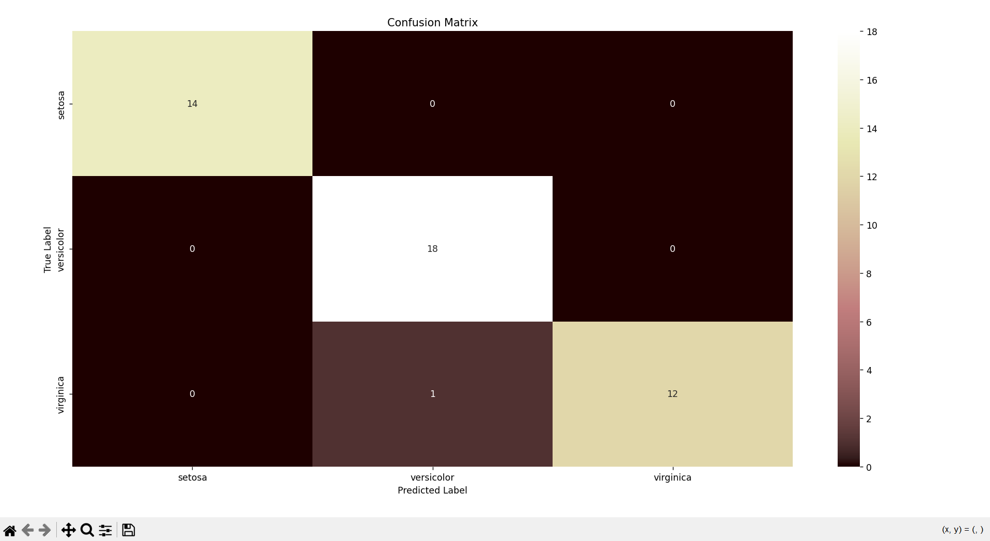

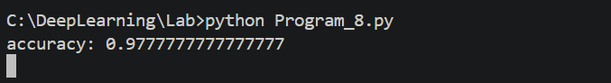

Experiment 9:
Aim: : To demonstrate the performance of Naïve Bayes algorithm by using iris dataset

Program:
#naive bayes iris import pandas as pd
import matplotlib.pyplot as plt import seaborn as sns
from sklearn.datasets import load_iris
from sklearn.model_selection import train_test_split from sklearn.naive_bayes import GaussianNB
from sklearn.metrics import accuracy_score,confusion_matrix iris = load_iris()
data = pd.DataFrame(data=iris.data, columns=iris.feature_names) data['species'] = iris.target
X = data.drop('species', axis=1) y = data['species']
X_train, X_test, y_train, y_test = train_test_split(X, y, test_size=0.3, random_state=42)
model = GaussianNB() model.fit(X_train, y_train) y_pred = model.predict(X_test)
accuracy = accuracy_score(y_test, y_pred) print("accuracy:",accuracy)
conf_matrix = confusion_matrix(y_test,y_pred) plt.figure(figsize=(8, 6))

sns.heatmap(conf_matrix, annot=True, fmt='d', cmap='vanimo', xticklabels=iris.target_names, yticklabels=iris.target_names)
plt.xlabel('Predicted Label') plt.ylabel('True Label') plt.title('Confusion Matrix') plt.show()

Output:
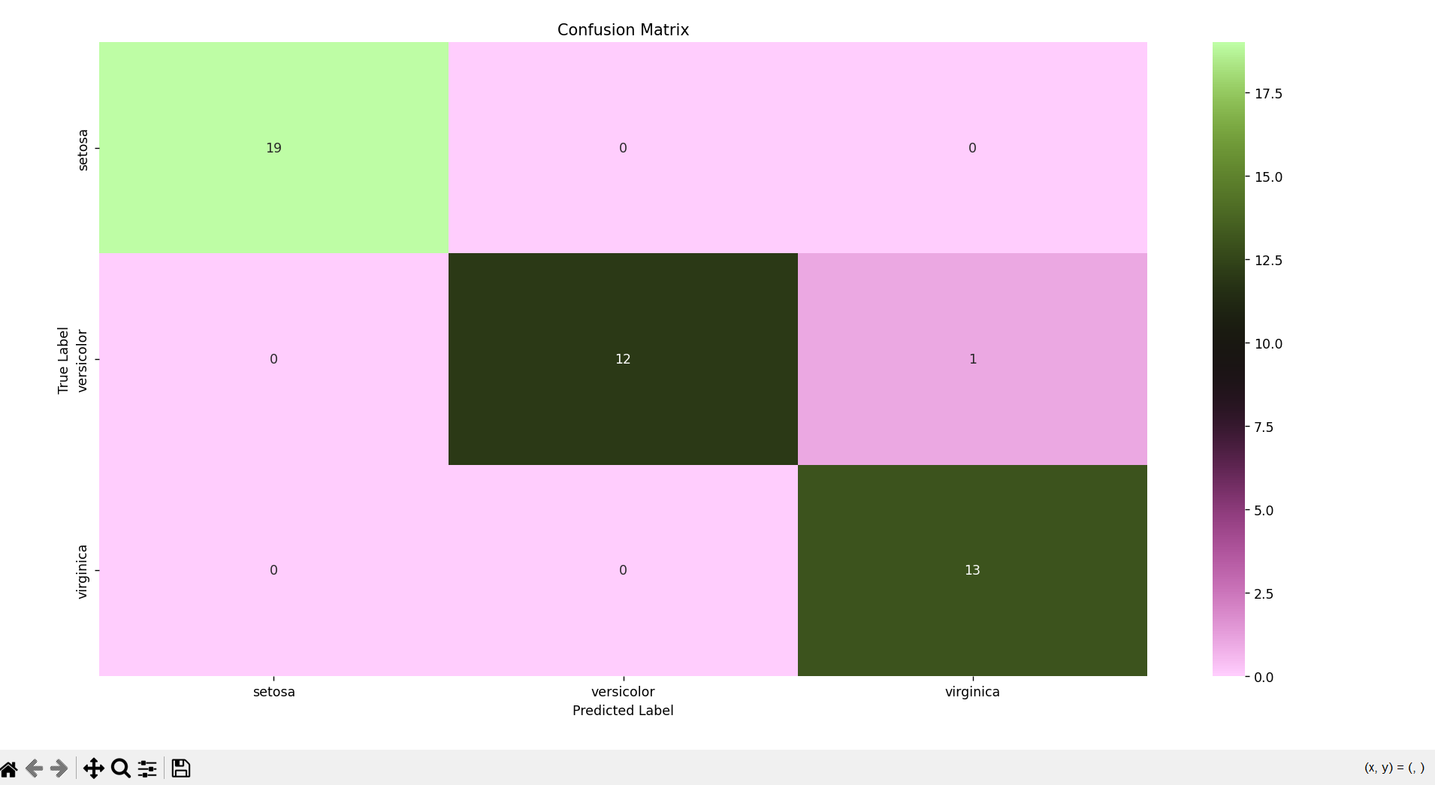

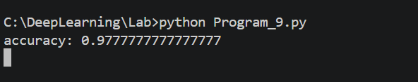

Experiment 10:
Aim: To demonstrate the performance of Logistic Regression using iris dataset Program:
import pandas as pd
import matplotlib.pyplot as plt import seaborn as sns

from sklearn.datasets import load_iris
from sklearn.model_selection import train_test_split from sklearn.linear_model import LogisticRegression
from sklearn.metrics import accuracy_score,confusion_matrix iris = load_iris()
data = pd.DataFrame(data=iris.data, columns=iris.feature_names) data['species'] = iris.target
X = data.drop('species', axis=1) y = data['species']
X_train, X_test, y_train, y_test = train_test_split(X, y, test_size=0.2, random_state=1)
model =LogisticRegression(max_iter=200) model.fit(X_train, y_train)
y_pred = model.predict(X_test)
accuracy = accuracy_score(y_test, y_pred) print("accuracy:",accuracy)
conf_matrix = confusion_matrix(y_test,y_pred) plt.figure(figsize=(8, 6))
sns.heatmap(conf_matrix, annot=True, fmt='d', cmap='berlin', xticklabels=iris.target_names, yticklabels=iris.target_names)
plt.xlabel('Predicted Label') plt.ylabel('True Label') plt.title('Confusion Matrix') plt.show()
Output:
