A Critical Review of Spatial Data analysis in the Banking Sector



**Prepared by**

Aravind Baskaran

Table of Contents

**1. ABSTRACT:** 3

**2. KEYWORDS:** 3

**3. ABBREVIATIONS:** 3

**4. INTRODUCTION:** 3

**5. METHODOLOGY:** 4

**6. MAIN ELEMENTS:** 6

6.1 Applications of Spatial data analysis on Banking Sector: 6

6.1.1) Finding New ATM Services: 6

6.1.2) Loan Sanction for Customers: 7

6.1.3) Customer Query Addressing: 7

6.2 Techniques of Spatial data in the Banking Sector: 8

6.2.1) AHP-GIS-HCLP Model: 8

6.2.2) Raster Weighted Model: 8

6.2.3) Getis-Ord, Kernel Density Mapping and Choropleth Mapping: 9

6.3 Hypothesis Testing of Spatial Data: 9

6.3.1) Italy: 9

6.3.2) China: 9

6.3.3) Unites States (US): 10

**7. DISCUSSION:** 10

**8. CONCLUSION:** 11

**9. REFERENCES:** 11

# **1. ABSTRACT:**

The banking industry is one of the most important businesses for a country, and it has a significant influence on economic growth. GIS is vital in making decisions. The use of spatial data has a significant influence on it since it allows for visualisation rather than charting and verifying. It also provides a clear image of the ATM's surrounding it, as well as the sort of bank and its size. The spatial data will assist us in determining the hotspot region surrounding any area. For example, a police station, a fire station, a subway station, and many others around a particular bank. So, in this study, we will review how the various research papers have used spatial data analysis techniques to perform significant advancements in the banking field like finding new place for ATM, Loan Sanction, Customer query addressing, locating branches and locating target customers as well.

# **2. KEYWORDS:**

GIS, New ATM points, Loan Sanction Bank patterns, Locate Branches, Customer Query.

# **3. ABBREVIATIONS:**

GIS – Geographic Information Systems, ATM – Automatic Teller Machine, AHP - Analytic Hierarchy Process, JTM - Jordanian Transverse Mercator MCLP - Maximal Covering Location Problem, OLS - Ordinary Least Squares and SE – Spatial Errors.

# **4. INTRODUCTION:**

GIS is one of the greatest tools in making the decision making in most of the industries. With respect to banking as well, the application of GIS is numerous. Banking is a knowledge driven application. It includes record keeping, data management, process monitoring, and business intelligence are critical for the banking industry because massive amounts of data are generated during daily financial activities. Linking data to space, like in a GIS, is a novel technique for banks or financial companies to better comprehend their data and clients. Competition in the banking business is increasing significantly as a result of the banking industry's globalisation. A product that conforms to this trend is the customer service centre. By collaborating with banks, the customer service centre provides consumers with easy and efficient services such as financial inquiries, operation questions, address inquiries, and other services. The quality of its service is closely related to the quality of the bank's service. According to data, around 40% of calls to bank customer care centres are connected to geographic information since the centre’s inception. Consultations include the location of the bank network and ATMs, as well as the travel path. Because there are so many bank branches, ATMs, and self-service banks, it is possible that clients' wait times will be extended by depending on service personnel's memory and inquiry files. As the service area of the customer support centre develops, offering convenient and quick geographic information enquiries becomes one of the most critical aspects affecting customer service quality. The bank customer care centre is considering adopting GIS to overcome the problem of unfamiliar geographical names in order to improve service quality.

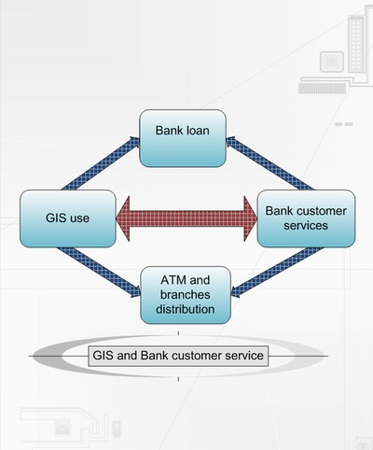

Source: Yang Fu Paper [6] – Chinese Bank Spatial Analysis

The following is the review paper's structure: The Abstract summarises the important topics, and the Introduction explains why the Banking application was chosen for review. The term methodology refers to the sort of approach employed for the review of data ecological aspects. The main aspects demonstrate the importance of geographical data analysis in the banking industry and the spatial techniques applied, and its many benefits and drawbacks. The discussion points out the gaps in the research articles, and the conclusion summarises the findings and future work.

# **5. METHODOLOGY:**

In this review, we are using the qualitative technique because we want to discover how GIS adds value to banks and persuade banks to embrace GIS in customer service management. Qualitative research is a collection of research methods used in marketing and the social sciences to investigate social and cultural phenomena. It looks at the whys and how’s of decision making. Qualitative research is likewise eclectic in that it employs a variety of methodologies and approaches. The qualitative data is normal comments and the reviews given by tiny amount of people. This distinguishes it from quantitative research, in which a large number of respondents submit statistically examined data. The framework of the design and data in qualitative research are not arranged in advance, but are formed as the empirical work progresses.

Figure 5.1 Overall Picture

**INTRODUCTION**

**METHODOLOGY**

**MAIN ELEMENTS**

**DISCUSSION**

**CONCLUSION**

**REFERENCES**

**SPATIAL DATA ANALYSIS ON BANKING SECTOR - APPLICATIONSTIAL**

1) FINDING NEW ATM SERVICES

2) LOAN SANCTION CUSTOMER IDENTIFICATION

3)CUSTOMER QUERY ADDRESSING

1) LOCATE BANK BRANCHES

2) PATTERNS IN BANK

3) ACCESS BANK FROM A POINT

**SPATIAL MODELS REVIEWED**

1) AHP

2) Kernel Density Mapping

3) HCLP

4) GETIS-ORD General Analysis

5) Chloropleth Mapping

In the above Figure 5.1, the overall picture of this critical review is drawn.

# **6. MAIN ELEMENTS:**

The main elements of this review for examination have been placed in the below sections in order to extract the hidden bits of spatial data analysis in banking.

1. Applications of Spatial data.
2. Techniques Used in Papers.

Let us have a look at the detailed explanation of the above sections and its subsections.

## 6.1 Applications of Spatial data analysis on Banking Sector:

The applications of the Spatial data analysis in the banking field are predicting the area of new ATM services that can be laid in a particular area by taking into account of the previous ATM services already installed in the previous locations. In addition to that, loan can be sanctioned to a customer based on their spatial information like the type of area they reside in and also the area of the house as well. Using spatial data, we can also address the customer query by assisting them with the ATM centres available in that area. Also, the retail and commercial banks available nearby in that area. Let us dive deep into the topics.

### 6.1.1) Finding New ATM Services:

Author Lamidi in paper [1] consolidates the factors that needs to be considered for finding new ATM services. They are as follows:

* Retail banks must consider many geographical concerns when offering an ATM machine to a specific location. For example, if an ATM is to be installed in a residential neighbourhood, the existing ATM centres in the region, as well as the density of ATMs, must be considered.
* Demography should be considered; for example, if an ATM is installed in a business area, the concentration should be considered.
* Area debit/credit card holders, money-transfer routes to ATMs, security centres also need to be considered. All Without a doubt, this can be accomplished with the assistance of geographical data

The same author has these factors considered, plotted them and was able to answer these questions like "Where is the ideal site for a new retail banking facility / ATM centre?" and "where is the nearest current bank branch/ATM centre?"

**Fig 6.1.1 – ATM in London Area**

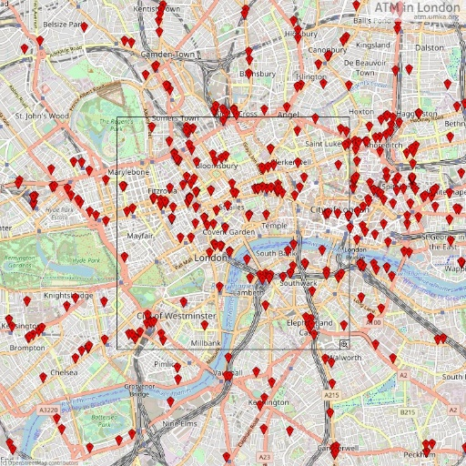

Source: ATM NatWest London

In Paper [6], the same thing has been achieved by using the SPOT image. SPOT can be assumed as a dictionary which contains the printed maps of visitors. The model used in that paper is the JTM.

Paper [9] has developed GIS data model that scans the registration and geodatabase creation. Also, Fianal map has been used. Decision support system and analysis has also been applied.

### 6.1.2) Loan Sanction for Customers:

Fu, Yang (2007) has considered that one of the most important services provided by the banking system is loan service to consumers, particularly real estate loans. Banks must consider credit risks when deciding whether or not to give real estate loans to its customers. Banks approve loans based on the value of the land, plot, or residence. Banks must examine the property or land as part of this procedure and also current land worth and dwelling size has been considered.

### 6.1.3) Customer Query Addressing:

Paper [6] has developed the system with a "customer focus" in mind and incorporates GIS. Designing The system is not only technological in nature, but it also meets the needs of the consumer.is regarded as an essential consideration. This system has further used. GIS, for example, may be used to respond to a consumer question from a bank.

## 6.2 Techniques of Spatial data in the Banking Sector:

In this section, the techniques of spatial data used in the Banking sector in various papers have been discussed in the below sections. In paper [3], the author Sonea have used global autocorrelation and spatial regression techniques. To find the correlation between the various phases of the banking sector, OLS and SE techniques are applied.

### 6.2.1) AHP-GIS-HCLP Model:

This model is used in the paper [7] to find **the access points** of bank. Please refer the abbreviation section to find the full form of each of them. AHP is used to find weights for the different regions. GIS data is used to identify new places and MCLP is used to find the best bank location. On combining all of them, the author has found the Bank’s location and the spread of them along with the type.

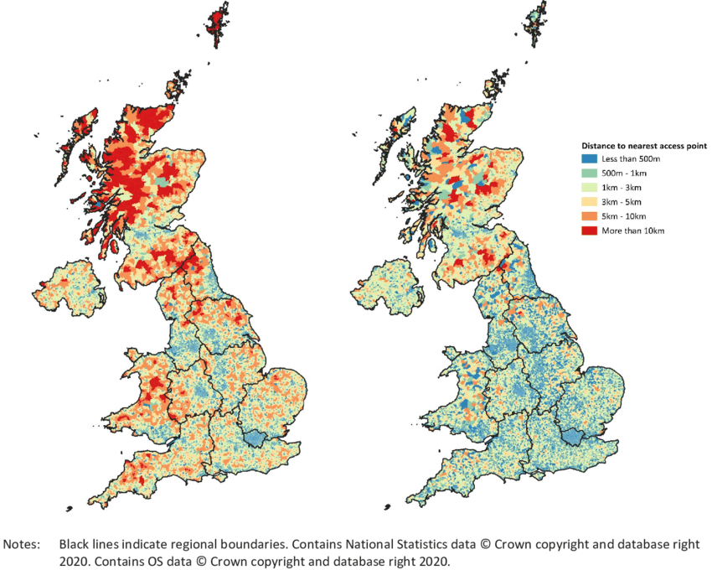 **Figure 6.2.1 Access Points of Bank Branches**

Source : National Statistics Data

### 6.2.2) Raster Weighted Model:

Author Todd in Paper [8] used this model to find the **Target Market customers.** This model and geographic data were applied to find the marketing areas. It was discovered that rich families having kids had the good power for managing clients to a large range of things such as bond saving, pension accounts, university funds, general accounts, and other deposits. The author also suggest that this algorithm may be reconstructed and applied in the near future to identify additional things.

### 6.2.3) Getis-Ord, Kernel Density Mapping and Choropleth Mapping:

In Paper [10], David has used GIS to find the patterns of the bank across the rural and the urban areas. He has investigated the spatial distribution of banking in the below stages. ArcMap was used to perform all three analytic procedures mentioned in the heading.

## 6.3 Hypothesis Testing of Spatial Data:

The Hypothesis Testing has been Carried out on the spatial data for the data in different countries to check whether the relationship exist between two categories.

### 6.3.1) Italy:

Author Luigi in paper [5] has considered the unequal effect of the improvement of the banking on real economy. He has used the input data collected from the Italian province for the late 90’s and initial 20’s period. He has considered the relationship between credit markets and net entry and found that there is considerable amount of relationship between them. So, it is clear that if we change the credit market , there is a change in the net entry as well.

### 6.3.2) China:

In Paper [4], The author investigates whether rising market competition in China under its existing market system enables Chinese banks to achieve levels of efficiency comparable to those found in capitalist nations. Spatial inequality is taken into account when evaluating bank efficiency. The empirical data reveal that in order to compete with international banks, the Chinese government needs to constantly restructure the banking business in China. As a result, the Chinese banking industry's cost and profit efficiency has improved significantly.

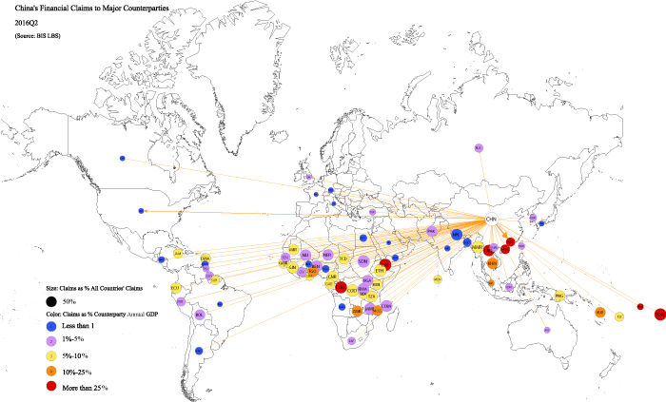**Figure 6.3.2 Chinese Bank in Map view**

Source: BIS, authors’ calculations

### 6.3.3) Unites States (US):

In paper [2], Garrett utilised a GIS model to find the relationship between State choice with respect to branching the banks and its respective group. His results shows that there is significant relationship prevailing between both of them. So, we can declare that the decisions effect is applicable to the respective groups.

# **7. DISCUSSION:**

The main issue, however, is building a traditional geographic information setup with appropriate things which can work in an optimised mode. Recognizing the lack of digital mapping infrastructure.

Furthermore, growing worldwide competitive pressures in the banking business increase the complexity and difficulty of maintaining bank networks. Customers can benefit from the design of an efficient branch network, which is accomplished by determining the ideal location of bank branches. Although this is a critical strategic challenge for any bank, it has not been fully recognised or addressed analytically. Furthermore, loan servicing is usually one of the most important bank activities for consumers. It has been in rivalry with other banks to improve its accessibility to clients.

# **8. CONCLUSION:**

Bank branches are grouped around major cities and metropolitan regions, according to spatial data. Customers or clients who are visiting a place for the first time may profit from geospatial data by understanding where existing banking facilities are located. This evaluation also covered how geospatial data is utilised to identify current banks or ATMs, as well as to select locations for future bank offices and ATM centres. This study's propositional methodologies and analysed processes are simple to understand and use. Existing bank employees with minimal GIS expertise can utilise the offered methodologies and processes to conduct the study and obtain the findings. Thus, the spatial data has helped the banking industry to grow to a greater extent. It is evident from the papers that the spatial data has played a major role in the banking industry by contributing major techniques. But still many research can be carried out to further enhance this field. That will make the industry to perform extra mill any of the countries. On increasing the banking market, the economy of a country can be increased as well. This will further increase the global economy. Also, we can use the GIS techniques to find the factors which are either affecting or helping to make the industry go further.

# **9. REFERENCES:**

1) Lamidi Adeyinka Jimoh, “Application of Geospatial Data in Retail Banking” , Received 28 July, 2019; Accepted 10 Aug , 2019 © The author(s) 2019. Published with open access at [www.questjournals.org](http://www.questjournals.org)

2) Garrett, T.A., Wagner, G.A. and Wheelock, D.C., 2005. A spatial analysis of state banking regulation. Papers in Regional Science, 84(4), pp.575-595.

3) Sonea, Andra & Guo, Weisi & Jarvis, Stephen. (2019). AN EXPLORATORY SPATIAL ANALYSIS OF ACCESS TO PHYSICAL AND DIGITAL RETAIL BANKING CHANNELS 1 * TECHNICAL REPORT. 10.5281/zenodo.3702367.

4) Wu, C., Chen, C., Lin, C. and Mai, C., 2019. The Analysis of Banking Efficiency in China: A Spatial Panel Data Approach. Journal of Quantitative Finance and Economics, 1, p.2

5) Luigi Moretti and Angela Parenti, June 8, 2009 , “Asymmetric Real Effects of Banking Market Structure : Evidence from Spatial Analysis Using Local Level Data”.

6) Fu, Yang. “Managing Customer Services Using GIS in Banks : A Case in Chinese Competitive Environment.” (2007).

7) Allahi, Sajjad & Mobin, mohammadsadegh & Vafadarnikjoo, Amin & Salmon, Christian. (2015). An Integrated AHP-GIS-MCLP Method to Locate Bank Branches.

8) Todd H. Zielsdorf ,Utilizing Geographic Information Systems to Locate Target Markets in the Retail Banking Sector Department of Resource Analysis, Saint Mary’s University of Minnesota, Winona, MN 55987.

9) Nedal Al-Hanbali, September 8 - 9, 2003 Stuttgart, Germany, BUILDING A GEOSPATIAL DATABASE AND GIS DATA-MODEL INTEGRATION FOR BANKING: ATM SITE LOCATION, Assistant Professor, Surveying and Geomatics Eng. Dept., Al-Balqa Applied University, Jordan.

10) David Ansong Gina Chowa Bernice Korkor Adjabeng , (2015),"Spatial analysis of the distribution and determinants of bank branch presence in Ghana", International Journal of Bank Marketing, Vol. 33 Iss 3 pp. 201 – 222.