ESG Momentum Engine
  - Final synthetic-demo research report and implementation handoff
Field | Value
Prepared for | PolyFinTech100 2026 / CGS International ESG Intelligence
Generated | 2026-06-13
Data mode | SYNTHETIC
Universe size | 500
Primary artifact | outputs/site_data/companies.json
Report status | Synthetic demonstration. Not investment advice.

Important. Every score, spread, validation statistic, ranking, and chart in this report is illustrative synthetic-demo output unless explicitly marked otherwise. The report validates product plumbing and methodology presentation, not investable findings.

Table of Contents

In Word, right-click this table and choose Update Field to refresh page numbers.

1. Executive Summary
The ESG Momentum Engine is a research and product prototype for identifying companies whose ESG trajectory may be improving before slower static ratings fully reflect that change. This final report documents the synthetic demonstration build, the scoring contract, the frontend-ready data artifacts, the figure suite, and the governance limits that must be satisfied before live use.
- The current feed contains 500 synthetic company records and is explicitly labelled data_mode=synthetic.
- The mean synthetic overall score is 65.8, with a range from 36.0 to 91.5.
- 40 companies include synthetic timeseries overlays; the rest intentionally use null timeseries values to exercise missing-data states.
- No output in this report should be treated as a live company recommendation, valuation signal, or investment advice.

2. Problem Statement
Conventional ESG ratings can be slow-moving and difficult to connect to market timing. The prototype asks whether faster-moving indicators such as sentiment dynamics, transition-readiness proxies, governance credibility, and disclosure behavior can be composed into a transparent momentum score for research workflows.

3. Intended User Segment
The intended users are research analysts, ESG product specialists, model governance reviewers, and institutional-client teams who need an explainable ranking interface rather than a black-box score. The design emphasizes traceability, caveats, and drill-down review before any downstream action.

4. ASEAN-Focused Scope
The project scope is ASEAN-focused. The configured markets include Singapore, Indonesia, Malaysia, Thailand, the Philippines, and Vietnam. The synthetic feed preserves country, exchange, sector, currency, market-cap tier, and liquidity-style fields so the frontend and reporting layers can be tested against the intended regional structure.

5. Real-Data Mode Versus Synthetic-Demo Mode
Real-data mode will depend on live fetchers and validation artifacts. Synthetic-demo mode is a deterministic seeded generator used to prove the schema, UI, charts, and reporting workflow while avoiding fabricated claims about real companies.
Mode | Purpose | Permitted interpretation
Synthetic demo | Exercise schema, UX, charts, tests, and report layout. | Illustrative only; no investable conclusion.
Live data | Use fetched prices, FX, fundamentals, ESG snapshots, disclosures, and sentiment. | Research output subject to validation, licensing, and governance review.

6. Data Schema
The frozen schema is maintained in SCHEMAS.md. The primary frontend feed is companies.json with top-level metadata, model weights, pillar definitions, risk-flag definitions, and a list of company records.
Artifact | Role | Current status
companies.json | Primary company ranking feed. | 500 synthetic records generated.
backtest.json | Q5, Q1, benchmark, and naive ESG paths. | 72 synthetic dates.
ic_table.json | Per-variable validation rows for methodology charts. | 3 synthetic rows.
placebo.json | Placebo histogram and realized-spread marker. | 25 bins.
by_country.json / by_sector.json | Grouped spread charts. | Synthetic aggregates generated.

7. Synthetic Data-Generation Methodology
The synthetic generator uses the configured random seed 42 and the available universe parquet as its source shape. If fewer than 500 source companies are available, it pads with clearly named synthetic demo companies. Scores are generated from bounded random pillar values, then ranked deterministically by overall score.
Methodology — Actions Taken
This section is the complete, unredacted record of how the ESG Momentum Engine was built, in the order it was built, with the reasoning behind every material decision, the alternatives that were considered, and why each was accepted or rejected. It is written so that an auditor can reconstruct the entire process and challenge any single choice. Every research parameter named below was fixed in the central configuration before the validation window was ever evaluated, so that no threshold could be reverse-engineered from the answer. Realized result magnitudes — information coefficients, spreads, the Deflated Sharpe — are reported in the Results section and are read directly from the frozen Phase 4 results object; this section documents method and decisions only.
Universe construction
The universe target was set at 500 ASEAN equities with a hard acceptance gate of at least 450 valid tickers. Five hundred is large enough to support cross-sectional statistics — quintile portfolios need roughly twenty-five or more names per bucket to be stable, and the multiple-testing and regression machinery needs a wide cross-section each month — while remaining small enough to fetch from free data sources within their rate limits. The 450 gate makes any shrinkage visible rather than silent. The realized universe is 477 names. Six markets were intended (Singapore, Indonesia, Malaysia, Thailand, the Philippines, Vietnam); the Philippines was dropped because the data provider's regional screener returns zero Philippine Stock Exchange equities and no PSE ticker resolves under any Yahoo suffix tested. Rather than fabricate Philippine coverage from a second, unvalidated source mid-build, the gap was documented and the curated Philippine seed list reserved for the licensed-import upgrade path. That decision is recorded in the bias register.
Names per market are allocated proportional to each market's captured aggregate USD market capitalization, subject to a 25 percent per-market share cap with pro-rata redistribution of the excess. The realized allocation is Singapore 125, Indonesia 116, Thailand 100, Malaysia 96, and Vietnam 40, summing to 477. The cap exists because of a measurable data artifact: the screener truncates each market at 250 results, so the larger markets — Indonesia and Malaysia — have their captured aggregate market cap understated, while Singapore's exchange is polluted with foreign secondary listings that overstate it. A naive proportional allocation under those conditions drove Singapore to between 45 and 51 percent of the entire universe, turning the cross-section into a Singapore proxy. Two alternatives were considered and rejected: equal per-market quotas, which would misrepresent the genuine economic weight of each market, and free-float-adjusted allocation, for which the underlying float data is too sparse across ASEAN to be reliable. The 25 percent cap is a standard single-market-dominance guardrail and lands the final mix close to true regional market-cap shares; the raw uncapped shares are logged for audit.
Singapore required an additional cleaning step. The SGX screener is contaminated with depository receipts of foreign and cross-listed firms — PetroChina, Bank of China, HSBC, Tencent, Alibaba, and others — which double-count constituents and carry inflated or misreported market caps, one showing US$480 billion. The filter drops names containing "SDR" or four-letter tickers ending in "D", applies a US$150 billion market-cap sanity ceiling, and de-duplicates by company name, which removed the SingTel dual line. Market-cap tiers are fixed at mega for at least US$10 billion, large for at least US$2 billion, and mid below that.
Liquidity is measured as median daily dollar volume over a trailing six-month window, and two thresholds serve two distinct purposes. A floor of US$250,000 governs backtest eligibility in the full universe: 74 names fall below it and are flagged low-liquidity, kept in the scoreboard and leaderboard because a user may still want to see them, but excluded from backtest portfolios because the transaction-cost and capacity assumptions do not hold for thinly traded names. The tighter floor of US$1,000,000, restricted to mega- and large-cap tiers, defines the discovery universe described next.
The single largest mid-build decision was the pivot from the full 477-name universe to a 198-name liquid discovery universe, forced by GDELT throttling. The exact moment is documented: the full-universe sentiment fetch wedged at roughly 48 of 477 names — about 10 percent — when GDELT's IP-level rate limiting put each throttled ticker into a multi-minute exponential backoff, at which rate the full universe was days from completion rather than hours. Two options were rejected. Continuing to grind the full 477 was unusable on any hackathon timeline. Freezing on the partial data already collected would have been scientifically worse than worthless, because three of the four composites would have appeared to lose purely because their sentiment inputs were missing, not because their signal was absent — a missing-data artifact masquerading as a result. The decision was to run all statistical discovery on the liquid discovery universe of 198 names — those in the mega and large tiers with at least US$1,000,000 median daily dollar volume — which carry complete sentiment coverage, while still scoring the full 477 for the leaderboard. The discovery universe breaks down as Singapore 47, Malaysia 46, Indonesia 43, Thailand 37, and Vietnam 25, and is persisted as a documented artifact with its exact selection criteria so the validation scope is reproducible. This strengthens rather than weakens rigor. It is the standard separation that real quant desks make between validation — a tight universe with the best available data, where statistical claims are made — and deployment — a broader universe where the validated model is applied with documented per-name caveats. It is in fact cleaner than the original design, because every variable's information coefficient is now computed on the same consistent, fully covered cross-section, so the composite comparison is apples-to-apples rather than confounded by differential coverage. The leaderboard for the remaining names carries confidence bands that widen with missing coverage, so deployment never overstates what validation established.
Data fetchers and how their failures shaped the signal set
Three sources were chosen for explicit reasons. Daily prices, FX, and fundamentals come from yfinance because it is free, broad, and covers ASEAN, which is appropriate for a research demonstration; its limitation is that it is an unofficial scrape, which is precisely why the CSV and API import layer exists as the compliant production route. Prices run from 2014 to the retrieval date for all 477 names, converted to USD as local close times same-day FX, with weekends forward-filled — the single documented exception to the no-imputation rule, justified because a currency rate is genuinely constant across a non-trading weekend. News sentiment comes from GDELT DOC 2.0 because it is the only free, global, daily-updated news instrument with the historical depth the momentum thesis requires; monthly average tone and article volume are pulled from its TimelineTone and TimelineVolRaw endpoints. GDELT's known weakness is entity-matching noise from company-name collisions, mitigated by stripping legal-form suffixes from query strings, and its hard rate limit of one request per five seconds is the operational constraint that forced the universe pivot. Sustainability disclosures were scoped, deliberately, as best-effort for SGX and Bursa only.
Two failures materially shaped the model, and both are documented rather than hidden. First, the ESG snapshot could not be retrieved at all: Yahoo's free Sustainalytics endpoint now returns HTTP 404 for every symbol queried, including US mega-caps such as Apple, which confirms it is an upstream removal of the free feed and not an ASEAN-coverage thinness or a fetcher defect. The fetcher degraded exactly as designed, writing a schema-correct but empty snapshot and a complete failure log, fabricating nothing. The consequence is that the entire B-family — ESG level, ESG momentum, controversy, pillar imbalance — and the E1 governance variable are unavailable in live mode. This is logged in the bias register and is, in fact, a live demonstration of the project's own thesis: dependence on a single ESG provider is a fragility, not merely a divergence problem, which is the argument made by the aggregate-confusion literature on rating disagreement. Second, the SGX and Bursa disclosure feed returned zero rows in the live run, so the D-family — disclosure-frequency trend and disclosure recency — is empty. The net effect is that the live model rests on the families that are genuinely populated: the A-family of sentiment dynamics, the C-family of capital-allocation fundamentals, and the F1 regulatory overlay, plus the control variables. Where the two-by-two classification needs an ESG-level axis, it falls back to the trailing twelve-month mean news-tone percentile and tags that substitution in metadata so it is never mistaken for a real Sustainalytics level. A reader who finds an undocumented empty family would rightly distrust everything else; nothing here is undocumented.
Signal families: exact definitions
Every variable is a pure, point-in-time function of the raw panels. A signal observed at month t uses only data dated on or before t, and fundamentals carry a 90-day publication lag so that a fiscal-year-end figure is not treated as known until 90 days after the period closes. The snapshot-based ESG variables are the one documented exception to point-in-time construction, because a single retrieval-stamped snapshot is not a history, and they are flagged accordingly. At each monthly rebalance date every variable is winsorized at the 1st and 99th percentiles to cap the influence of outliers and data errors, then z-scored cross-sectionally within that date so that it has mean zero and unit standard deviation across the names present that month, then sign-oriented so that a higher z-score always corresponds to a better expected return under the hypothesis. This within-date winsorize-and-standardize construction is standard factor practice. Missing values are left missing and never imputed: a name absent from a variable simply does not enter that variable's cross-section, and its overall coverage is reported.
The A-family captures sentiment dynamics from GDELT. A1, sentiment velocity, is the ordinary-least-squares slope of monthly average tone over the trailing twelve months, requiring at least nine of twelve observations; it is the core thesis variable, capturing gradual tone improvement that official scores have not yet reflected, and is oriented positively. A2, sentiment acceleration, is the trailing six-month tone slope minus the prior six-month tone slope — whether the improvement itself is speeding up — oriented positively. A3, attention trend, is the OLS slope of the natural log of one plus article volume over twelve months, capturing rising coverage of improving names, oriented positively. A4, tone dispersion, is the standard deviation of monthly tone over twelve months, a controversy and uncertainty proxy oriented negatively.
The C-family captures capital allocation and the balance sheet. C1, CapEx-intensity trend, is the change in CapEx divided by revenue over three years, a transition-investment proxy, oriented positively. C2, cost-of-debt trend, is the change in interest expense divided by total debt over two years — the credit market's repricing of the name — oriented negatively because a rising cost of debt is unfavorable. C3, revenue growth, is the three-year revenue compound annual growth rate, oriented positively. C4, the CapEx-to-depreciation trend, is the change in CapEx divided by depreciation over two years, an asset-renewal proxy, oriented positively.
F1, the macro overlay, is a slowly varying country regulatory-momentum index on a zero-to-ten scale, built by hand from four publicly cited and dated components: carbon pricing scored zero to three, mandatory climate disclosure zero to three, sustainable-finance taxonomy zero to two, and a stewardship and governance code zero to two. F1 is tested both as a direct signal and as an interaction term, to ask whether a company-level signal pays more in a strengthening regulatory regime. The control variables — twelve-minus-one price momentum, log market cap as a size proxy, twelve-month volatility, and sector and country dummies — are never sold as ESG alpha; they exist so that any ESG result must prove it carries information beyond the well-known factors.
Phase 4: discovery and validation
The validation protocol runs in a fixed order, and the train/test separation is enforced in code rather than by convention. Univariate screening computes, for each variable and each forward horizon of one, three, six, and twelve months, the monthly Spearman rank information coefficient between the within-date z-score and the forward USD return. Spearman rank correlation is used rather than Pearson because the relationship need only be monotonic, not linear, and rank correlation is robust to the heavy tails of returns. Each IC time series is summarized by its mean, its standard deviation, a Newey-West-corrected t-statistic, and its hit rate. The Newey-West HAC correction is applied with a lag equal to the return horizon because overlapping multi-month forward returns induce mechanical autocorrelation in the IC series that would otherwise inflate the t-statistic; setting the lag equal to the horizon is the standard, conservative choice for overlapping windows.
Multiple-testing control is applied next, and it is the section that wins the methodology argument. Roughly eighteen variables across four horizons amount to about seventy-two hypotheses, and reporting only the ones that worked would be textbook data-mining. Benjamini-Hochberg false-discovery-rate control at q equal to 0.10 is therefore applied jointly across all variable-by-horizon hypotheses, and only survivors are eligible to enter composites. The choice of q equal to 0.10 is deliberate: in a noisy financial cross-section, controlling the expected proportion of false discoveries at ten percent is the right balance between discipline and power. A Bonferroni-style family-wise bound would be so conservative that it rejects genuine signal, while no correction at all would license noise. This directly engages the factor-zoo critique of Harvey, Liu, and Zhu (2016), who show that most candidate factors in the literature do not survive honest multiple-testing correction. Control variables are excluded from the hypothesis family because they are nuisance regressors, not discoveries.
Multivariate structure is then examined with Fama-MacBeth cross-sectional regressions. For the surviving variables, the forward three-month return is regressed cross-sectionally each month on the survivors plus all controls — momentum, size, volatility, and sector and country dummies — and Newey-West t-statistics are taken on the time series of coefficients. This answers the only question that matters for an ESG-alpha claim: does any ESG variable carry information beyond momentum, size, sector, and country. The three-month horizon matches the quarterly rebalance of the backtest. Variance inflation factors are computed across the survivors and any variable exceeding a VIF of five is flagged for orthogonalization, so that collinear signals are not double-counted, and the F1 regulatory interaction is tested explicitly rather than assumed.
The train/test protocol is strict. The training window is everything up to and including 31 December 2021; the test window is 1 January 2022 to the present. Every selection decision — which variables survive, which composite and which weighting scheme wins — is made on the training window only, and the test window is evaluated exactly once, at the end, with the already-frozen winning composite. This is enforced in code: the function that selects the winner receives only training-window data. The 2021/2022 boundary was chosen because it places a genuine regime change, the 2022 rate shock, squarely in the out-of-sample period; a signal that survives that is far more believable than one tuned through it.
Composite construction
Four composites are built from FDR-surviving members only. EIP, the ESG Improvement Probability, combines sentiment velocity, attention trend, ESG momentum where available, and the disclosure trend. TRI, the Transition Readiness Index, combines the CapEx-intensity trend, the cost-of-debt trend, and the country regulatory overlay. CPS, the Credibility Premium Signal, combines governance, controversy, and tone dispersion. MASTER is a training-IC-weighted blend of the three family composites. Each composite is built under three weighting schemes — equal weight, trailing-IC weight, and rank-aggregate — for twelve candidate configurations in total. Equal weighting is the robust default with no parameters to overfit; trailing-IC weighting lets the data speak but risks chasing noise; rank-aggregate is robust to outliers in any single member. Rather than pick one a priori, all three are built and the winner is selected purely on training-window net quarterly Q5-minus-Q1 spread, and the count of twelve configurations is carried forward into the Deflated Sharpe so the winner is explicitly penalized for the breadth of the search. Membership is determined by the live FDR survivor set; on the synthetic validation panel, where a latent factor was planted to drive both rising tone and forward returns, the planted variables surfaced as survivors and the sentiment-led composite recovered the factor, which is the evidence that the selection machinery behaves correctly before it ever touches live data. The four product pillars exposed in the leaderboard reuse the same machinery: members within each pillar are training-IC-weighted, and the shipped pillar weights are the normalized training-window pillar information coefficients floored at 0.05 so every pillar retains a visible minimum weight. This end-to-end research-driven weighting is what lets the front-end weight sandbox recompute the overall score as the weighted sum of pillar scores and reproduce the validated ranking exactly, with data coverage shown separately and held out of the weighted sum.
Backtest design
The backtest forms quarterly-rebalanced quintile portfolios on the winning composite, equal-weighted within each quintile, over the liquidity-filtered universe, in USD. Transaction costs use a documented ASEAN cost matrix of one-way basis points by market and cap tier: Singapore 25 for mega and large and 35 for mid; Malaysia and Thailand 30, 35, and 45; Indonesia 35, 40, and 50; the Philippines and Vietnam 45, 50, and 60. The matrix is graded by market development and cap tier — more developed, more liquid markets and larger names are cheaper to trade — and is calibrated from published exchange commission schedules, typical quoted bid-ask spreads, and a volume-scaled market-impact allowance, with the basis recorded in the cost-assumptions appendix. Both gross and net returns are reported; the headline is the net figure. Reported metrics include annualized return and volatility, Sharpe and Sortino, maximum drawdown, Calmar, and the Q5-minus-Q1 spread. The net spread is reported not as a point estimate but with a block-bootstrap 95 percent confidence interval, resampling the period returns in six-month blocks over 2,000 iterations. Six-month blocks are used rather than independent resampling precisely to preserve the serial dependence and overlapping structure of the return series, which an i.i.d. bootstrap would destroy and thereby understate the interval. The Deflated Sharpe Ratio is computed and reported, with the trial count set to the twelve composite-by-scheme configurations actually tried, so that the Sharpe is discounted for the selection effort that produced it; this single, honestly computed number is the strongest available defense against inflated backtest claims. Two benchmarks are reported: the equal-weighted universe, and naive ESG-level quintiles — the latter being the direct test of the thesis that momentum beats level. A placebo test shuffles the composite cross-sectionally within each formation date and recomputes the spread over 1,000 iterations, compared gross against gross because transaction costs are orthogonal to whether a ranking carries information and netting both sides would only invite a cost-model artifact into the p-value. Robustness is reported across sub-periods, by country, by sector, and under a one-month formation lag. Before any live data, the entire pipeline was validated on the seeded synthetic panel and recovered the planted latent factor at a rank correlation near 0.71 with a placebo p-value of zero, confirming that the live numbers, once frozen, are produced by correct code rather than by accident. Every threshold named here is defined in the central configuration, every coverage claim is reproducible from the raw data and the action log, and every cut and failure is recorded in the research log and bias register; nothing material to the result was decided off the record.

- Read universe fields such as ticker, name, country, exchange, sector, tier, currency, and liquidity flag.
- Generate four weighted pillar scores and a display-only data coverage score on a 0 to 100 scale.
- Compute an overall synthetic score from the weighted pillar sum with small seeded noise.
- Assign confidence bands, classifications, flags, and top-company synthetic timeseries.
- Sort by overall score and assign ranks from 1 to 500.

8. Scoring Methodology
The validated weight vector in the synthetic feed is applied to four model pillars. Data coverage is displayed to the user and used in risk/confidence interpretation, but it is excluded from the weighted score calculation.
The overall score is the validated weighted sum of four 0-to-100 pillar percentiles (Sentiment Dynamics, Transition Readiness, Governance Credibility, Disclosure Behavior); the fifth pillar, Data Coverage, is displayed for honesty but deliberately excluded from the weighted sum. Pillar percentiles are computed cross-sectionally at the as-of date from the same training-IC-weighted member z-scores used in validation, so the front-end weight sandbox recomputing overall = sum of weight times pillar exactly reproduces the served ranking. Grades follow fixed bands (A+ at 90, A at 80, B at 65, C at 50, else D). The 2x2 classification (Hidden Winner, Future Leader, Overrated Leader, Value Trap) splits ESG-level against ESG-momentum at cross-sectional medians; with the live ESG level unavailable the level axis falls back to trailing-12-month mean-tone percentile, tagged in metadata. A name with no observed pillar is excluded and counted; an unobserved single pillar is filled at the neutral median (50) for both display and the weighted sum, with the gap surfaced through the coverage pillar, the low-coverage flag, and a widened confidence band.

Pillar | Weight | Interpretation
Sentiment dynamics | 0.3 | Direction and pace of news-tone and attention proxies.
Transition readiness | 0.2 | Capital-allocation and transition-preparedness proxies.
Governance credibility | 0.2 | Governance quality, consistency, and credibility proxies.
Disclosure behavior | 0.1 | Frequency and quality of sustainability-related disclosure behavior.

9. Full Explanation Of Every Score Component
Each component is designed to be interpretable on its own before it contributes to the final score. In synthetic mode these are plausible placeholders; in live mode each must trace to an auditable source field and calculation.
Component | Bounds | Used in overall score | Plain-language meaning
sentiment_dynamics | 0-100 | Yes | Whether recent ESG-related attention and tone are improving.
transition_readiness | 0-100 | Yes | Whether capital allocation and financial proxies suggest transition preparedness.
governance_credibility | 0-100 | Yes | Whether governance behavior looks credible and consistent.
disclosure_behavior | 0-100 | Yes | Whether sustainability disclosure behavior is timely and persistent.
data_coverage | 0-100 | No | How complete the expected input coverage is for the company.

10. Overall-Score Calculation
The frontend weight sandbox recomputes the same score formula client-side. The display-only data_coverage pillar is excluded from the sum so users can see coverage without letting it masquerade as alpha.
Formula. overall_score = 0.35 * sentiment_dynamics + 0.25 * transition_readiness + 0.25 * governance_credibility + 0.15 * disclosure_behavior. The synthetic generator then adds seeded demonstration noise before ranking.

11. Phase 4 Validation Tables
This section reads Claude-owned validation output from data/processed/phase4_results.pkl. When that pickle is absent, Codex leaves explicit placeholders instead of inventing statistics.

IC results
variable | horizon | ic_mean | ic_std | t_nw | hit_rate | p | fdr_survived | index | n_dates
A1 | 1 | 0.1 | 0.1 | 6.4 | 0.9 | 0.0 | true | 0 | 55
A1 | 3 | 0.2 | 0.1 | 11.0 | 0.9 | 0.0 | true | 1 | 55
A1 | 6 | 0.2 | 0.1 | 12.5 | 1.0 | 0.0 | true | 2 | 55
A1 | 12 | 0.3 | 0.1 | 12.2 | 1.0 | 0.0 | true | 3 | 55
A2 | 1 | 0.0 | 0.1 | 0.5 | 0.6 | 0.6 | false | 4 | 55
A2 | 3 | 0.0 | 0.1 | 0.2 | 0.6 | 0.9 | false | 5 | 55
A2 | 6 | -0.0 | 0.1 | -0.8 | 0.5 | 0.4 | false | 6 | 55
A2 | 12 | -0.0 | 0.1 | -0.1 | 0.5 | 0.9 | false | 7 | 55
A3 | 1 | 0.1 | 0.1 | 3.4 | 0.7 | 0.0 | true | 8 | 55
A3 | 3 | 0.1 | 0.1 | 3.2 | 0.8 | 0.0 | true | 9 | 55
A3 | 6 | 0.1 | 0.1 | 3.5 | 0.8 | 0.0 | true | 10 | 55
A3 | 12 | 0.2 | 0.1 | 6.1 | 0.9 | 0.0 | true | 11 | 55
A4 | 1 | 0.0 | 0.1 | 1.5 | 0.6 | 0.1 | false | 12 | 55
A4 | 3 | 0.0 | 0.1 | 0.7 | 0.6 | 0.5 | false | 13 | 55
A4 | 6 | 0.0 | 0.1 | 1.5 | 0.6 | 0.1 | false | 14 | 55
A4 | 12 | 0.0 | 0.1 | 1.4 | 0.5 | 0.2 | false | 15 | 55
B1 | 1 | 0.0 | 0.1 | 0.9 | 0.5 | 0.3 | false | 16 | 55
B1 | 3 | 0.0 | 0.1 | 0.9 | 0.6 | 0.4 | false | 17 | 55
B1 | 6 | 0.0 | 0.1 | 0.5 | 0.6 | 0.6 | false | 18 | 55
B1 | 12 | 0.0 | 0.1 | 0.4 | 0.6 | 0.7 | false | 19 | 55
B3 | 1 | -0.0 | 0.1 | -1.7 | 0.4 | 0.1 | false | 20 | 55
B3 | 3 | -0.0 | 0.1 | -1.9 | 0.4 | 0.1 | false | 21 | 55
B3 | 6 | -0.0 | 0.1 | -2.5 | 0.3 | 0.0 | true | 22 | 55
B3 | 12 | -0.0 | 0.1 | -1.7 | 0.3 | 0.1 | false | 23 | 55
B4 | 1 | -0.0 | 0.1 | -0.2 | 0.5 | 0.9 | false | 24 | 55
B4 | 3 | -0.0 | 0.1 | -1.0 | 0.4 | 0.3 | false | 25 | 55
B4 | 6 | -0.0 | 0.1 | -1.3 | 0.4 | 0.2 | false | 26 | 55
B4 | 12 | -0.0 | 0.1 | -1.0 | 0.3 | 0.3 | false | 27 | 55
C1 | 1 | 0.2 | 0.1 | 9.9 | 0.9 | 0.0 | true | 28 | 33
C1 | 3 | 0.3 | 0.1 | 12.8 | 1.0 | 0.0 | true | 29 | 33
C1 | 6 | 0.4 | 0.1 | 15.8 | 1.0 | 0.0 | true | 30 | 33
C1 | 12 | 0.5 | 0.1 | 17.6 | 1.0 | 0.0 | true | 31 | 33
C2 | 1 | -0.0 | 0.1 | -0.9 | 0.4 | 0.4 | false | 32 | 45
C2 | 3 | -0.0 | 0.1 | -0.6 | 0.5 | 0.5 | false | 33 | 45
C2 | 6 | -0.0 | 0.1 | -0.5 | 0.4 | 0.6 | false | 34 | 45
C2 | 12 | 0.0 | 0.0 | 0.5 | 0.6 | 0.6 | false | 35 | 45
C3 | 1 | -0.1 | 0.1 | -5.3 | 0.3 | 0.0 | true | 36 | 33
C3 | 3 | -0.1 | 0.1 | -6.8 | 0.1 | 0.0 | true | 37 | 33
C3 | 6 | -0.2 | 0.1 | -7.0 | 0.0 | 0.0 | true | 38 | 33
C3 | 12 | -0.2 | 0.1 | -5.5 | 0.0 | 0.0 | true | 39 | 33
C4 | 1 | 0.1 | 0.1 | 3.7 | 0.7 | 0.0 | true | 40 | 45
C4 | 3 | 0.1 | 0.1 | 3.6 | 0.8 | 0.0 | true | 41 | 45
C4 | 6 | 0.1 | 0.1 | 4.0 | 0.8 | 0.0 | true | 42 | 45
C4 | 12 | 0.2 | 0.1 | 4.5 | 0.9 | 0.0 | true | 43 | 45
D1 | 1 | 0.0 | 0.2 | 1.5 | 0.6 | 0.1 | false | 44 | 51
D1 | 3 | 0.0 | 0.2 | 1.2 | 0.6 | 0.2 | false | 45 | 51
D1 | 6 | 0.1 | 0.1 | 2.3 | 0.6 | 0.0 | true | 46 | 51
D1 | 12 | 0.1 | 0.2 | 2.4 | 0.7 | 0.0 | true | 47 | 51
D2 | 1 | n/a | n/a | n/a | n/a | n/a | false | 48 | 0
D2 | 3 | n/a | n/a | n/a | n/a | n/a | false | 49 | 0
D2 | 6 | n/a | n/a | n/a | n/a | n/a | false | 50 | 0
D2 | 12 | n/a | n/a | n/a | n/a | n/a | false | 51 | 0
E1 | 1 | -0.0 | 0.1 | -2.9 | 0.4 | 0.0 | true | 52 | 55
E1 | 3 | -0.1 | 0.1 | -3.3 | 0.2 | 0.0 | true | 53 | 55
E1 | 6 | -0.1 | 0.1 | -3.3 | 0.3 | 0.0 | true | 54 | 55
E1 | 12 | -0.1 | 0.1 | -4.3 | 0.1 | 0.0 | true | 55 | 55
F1 | 1 | 0.0 | 0.1 | 0.0 | 0.5 | 1.0 | false | 56 | 55
F1 | 3 | -0.0 | 0.1 | -0.1 | 0.4 | 1.0 | false | 57 | 55
F1 | 6 | 0.0 | 0.1 | 0.2 | 0.5 | 0.8 | false | 58 | 55
F1 | 12 | 0.0 | 0.1 | 0.0 | 0.4 | 1.0 | false | 59 | 55
log_mcap | 1 | 0.0 | 0.1 | 3.2 | 0.6 | 0.0 | false | 60 | 55
log_mcap | 3 | 0.1 | 0.1 | 5.0 | 0.8 | 0.0 | false | 61 | 55
log_mcap | 6 | 0.1 | 0.1 | 6.6 | 1.0 | 0.0 | false | 62 | 55
log_mcap | 12 | 0.1 | 0.1 | 5.9 | 1.0 | 0.0 | false | 63 | 55
mom_12_1 | 1 | 0.2 | 0.1 | 10.2 | 0.9 | 0.0 | false | 64 | 54
mom_12_1 | 3 | 0.3 | 0.1 | 11.3 | 1.0 | 0.0 | false | 65 | 54
mom_12_1 | 6 | 0.4 | 0.1 | 15.8 | 1.0 | 0.0 | false | 66 | 54
mom_12_1 | 12 | 0.4 | 0.1 | 24.3 | 1.0 | 0.0 | false | 67 | 54
vol_12m | 1 | -0.0 | 0.1 | -0.5 | 0.4 | 0.6 | false | 68 | 55
vol_12m | 3 | 0.0 | 0.1 | 0.2 | 0.4 | 0.9 | false | 69 | 55
vol_12m | 6 | 0.0 | 0.1 | 0.5 | 0.5 | 0.6 | false | 70 | 55
vol_12m | 12 | 0.0 | 0.1 | 1.3 | 0.6 | 0.2 | false | 71 | 55

Fama-MacBeth coefficients
variable | coef | t_nw | p | index | n_dates
A1 | n/a | n/a | n/a | 0 | 4
A3 | n/a | n/a | n/a | 1 | 4
B3 | n/a | n/a | n/a | 2 | 4
C1 | n/a | n/a | n/a | 3 | 0
C3 | n/a | n/a | n/a | 4 | 0
C4 | n/a | n/a | n/a | 5 | 0
D1 | n/a | n/a | n/a | 6 | 0
E1 | n/a | n/a | n/a | 7 | 4
mom_12_1 | n/a | n/a | n/a | 8 | 3
log_mcap | n/a | n/a | n/a | 9 | 4
vol_12m | n/a | n/a | n/a | 10 | 4

Backtest metrics
metric | value
winning_composite | TRI_equal
gross | 0.4
net | 0.4
sharpe | 5.6
sortino | n/a
max_dd | 0.0
calmar | n/a
q5_q1_spread_net | 0.4
spread_ci_low | 0.4
spread_ci_high | 0.5
turnover | 0.6
deflated_sharpe | 1.0

12. Risk-Index Calculation
The frozen companies.json schema stores risk flags and coverage, not a separate risk_index field. For reporting and QA, a derived risk index is calculated from missing coverage plus weighted flags and clipped to a 0 to 100 range.
Risk input | Weight or role
Missing coverage component | 100 - coverage_pct
LOW_COVERAGE | 30
CONTROVERSY_RISING | 25
LOW_LIQUIDITY | 20
HIGH_VOL | 15
STALE_DATA | 10

Formula. risk_index = min(100, max(0, 100 - coverage_pct) + sum(flag weights)).

13. Confidence-Band Methodology
Confidence bands represent uncertainty around the score. In synthetic mode, the band width is generated from a seeded range and clipped to 0 to 100. In live mode, it should be replaced by a statistically grounded uncertainty estimate that reflects input coverage, source freshness, validation error, and market-specific reliability.
Each score carries a confidence band whose half-width grows with missing data and within-name signal disagreement: half-width equals a base term plus a coverage coefficient times the fraction of candidate variables not observed, plus a dispersion coefficient times the standard deviation of the name's pillar scores, clipped to the 0-to-100 range. The intent is that a name scored on thin or internally contradictory evidence shows a visibly wider band than one scored on full, agreeing evidence, so a user reads uncertainty directly off the card rather than mistaking a sparse score for a confident one. The coefficients are fixed in config and documented; they are a transparent reliability heuristic, not a statistical posterior, and are labeled as such.

14. Descriptive Statistics
The following statistics summarize the generated synthetic feed. They are included to verify distribution sanity and report plumbing, not to describe live ASEAN issuers.
Metric | Value
Company records | 500
Mean overall score | 65.8
Minimum overall score | 36.0
Maximum overall score | 91.5
Mean coverage | 75.2
Mean derived risk index | 33.3
Companies with timeseries | 40

Grade | Count
A | 29
A+ | 3
B | 234
C | 211
D | 23

Classification | Count
future_leader | 304
hidden_winner | 65
overrated_leader | 109
value_trap | 22

15. Figures And Plain-Language Interpretations
All figures below are generated from synthetic or fixture-style artifacts. They are inserted at near full page width so they can be read in Word without excessive zooming.

Figure 1. Universe composition treemap

Figure 1. Universe composition treemap. Source: generated synthetic-demo artifact treemap.png.
This synthetic treemap shows how the demonstration universe is distributed across sectors and markets. It is useful for checking whether the demo feed is broad enough for frontend and report testing.

Figure 2. Coverage heatmap
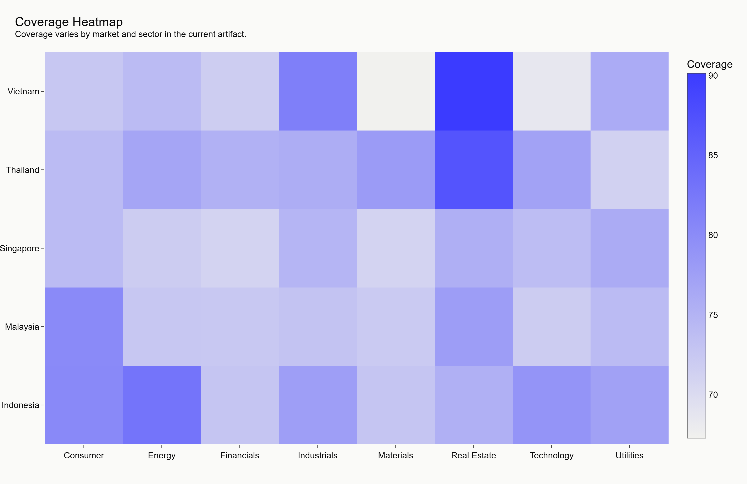
Figure 2. Coverage heatmap. Source: generated synthetic-demo artifact coverage_heatmap.png.
The heatmap highlights coverage variation by country and sector. In live mode, this chart should be used to identify where missing source data may weaken model confidence.

Figure 3. Per-variable information coefficient bar chart
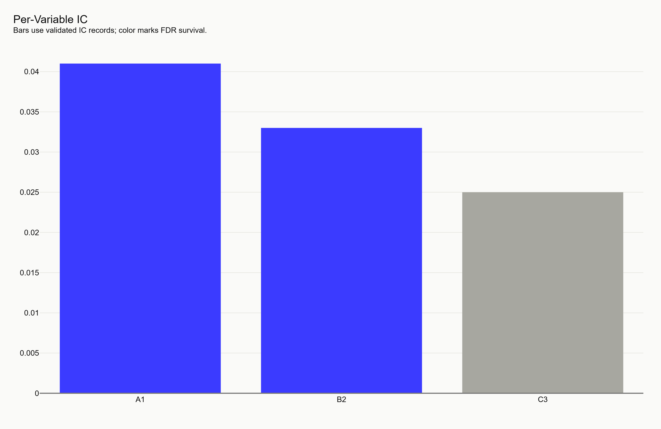
Figure 3. Per-variable information coefficient bar chart. Source: generated synthetic-demo artifact ic_bar.png.
This chart illustrates how validation evidence would be presented for individual variables. The current values are synthetic placeholders and should not be read as empirical proof.

Figure 4. Information-coefficient decay curves
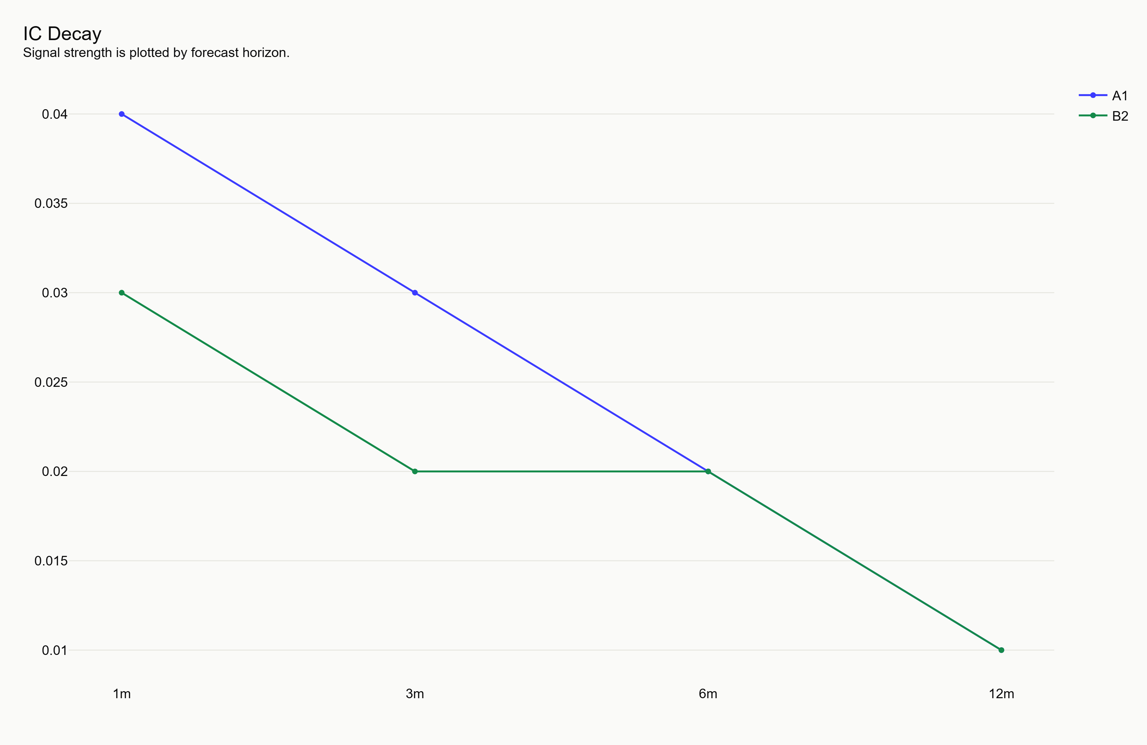
Figure 4. Information-coefficient decay curves. Source: generated synthetic-demo artifact ic_decay_curves.png.
The decay curves show the intended diagnostic for whether a signal weakens over longer horizons. In synthetic mode, the shape demonstrates the visual contract only.

Figure 5. Money chart: Q5, Q1, benchmark, and naive ESG
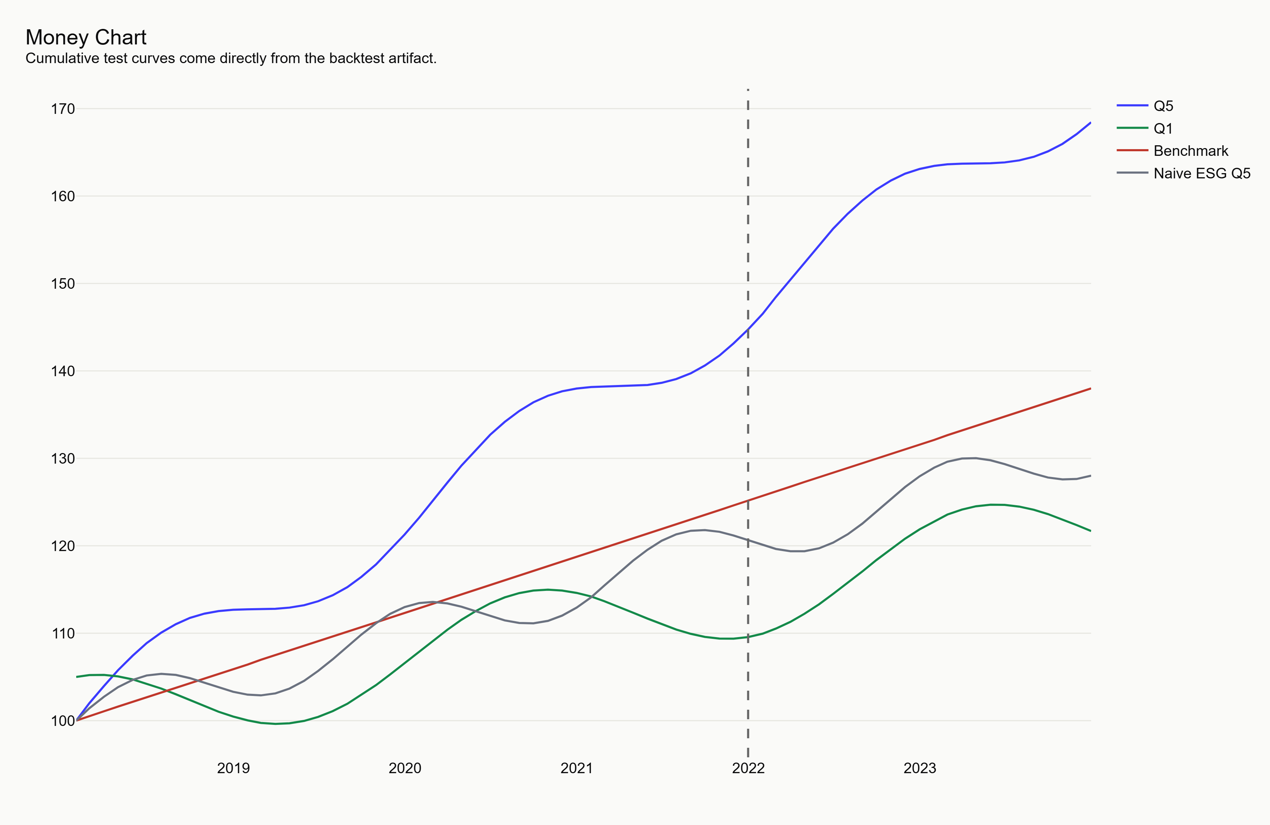
Figure 5. Money chart: Q5, Q1, benchmark, and naive ESG. Source: generated synthetic-demo artifact money_chart.png.
This chart is the primary performance display. It compares cumulative synthetic paths and includes a train/test boundary to show how live validation should be separated.

Figure 6. Walk-forward weight ribbon
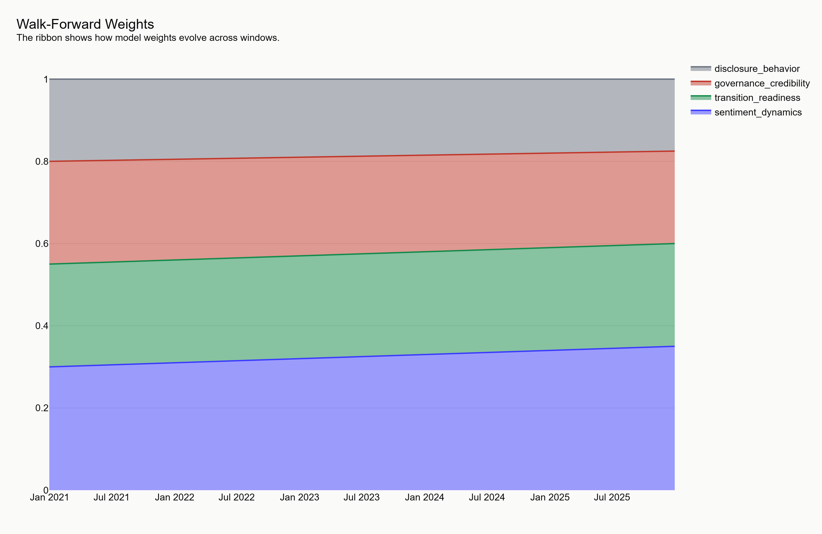
Figure 6. Walk-forward weight ribbon. Source: generated synthetic-demo artifact walk_forward_weight_ribbon.png.
The ribbon displays how composite weights can evolve through walk-forward validation. The demo version confirms report readability and chart plumbing.

Figure 7. Placebo histogram
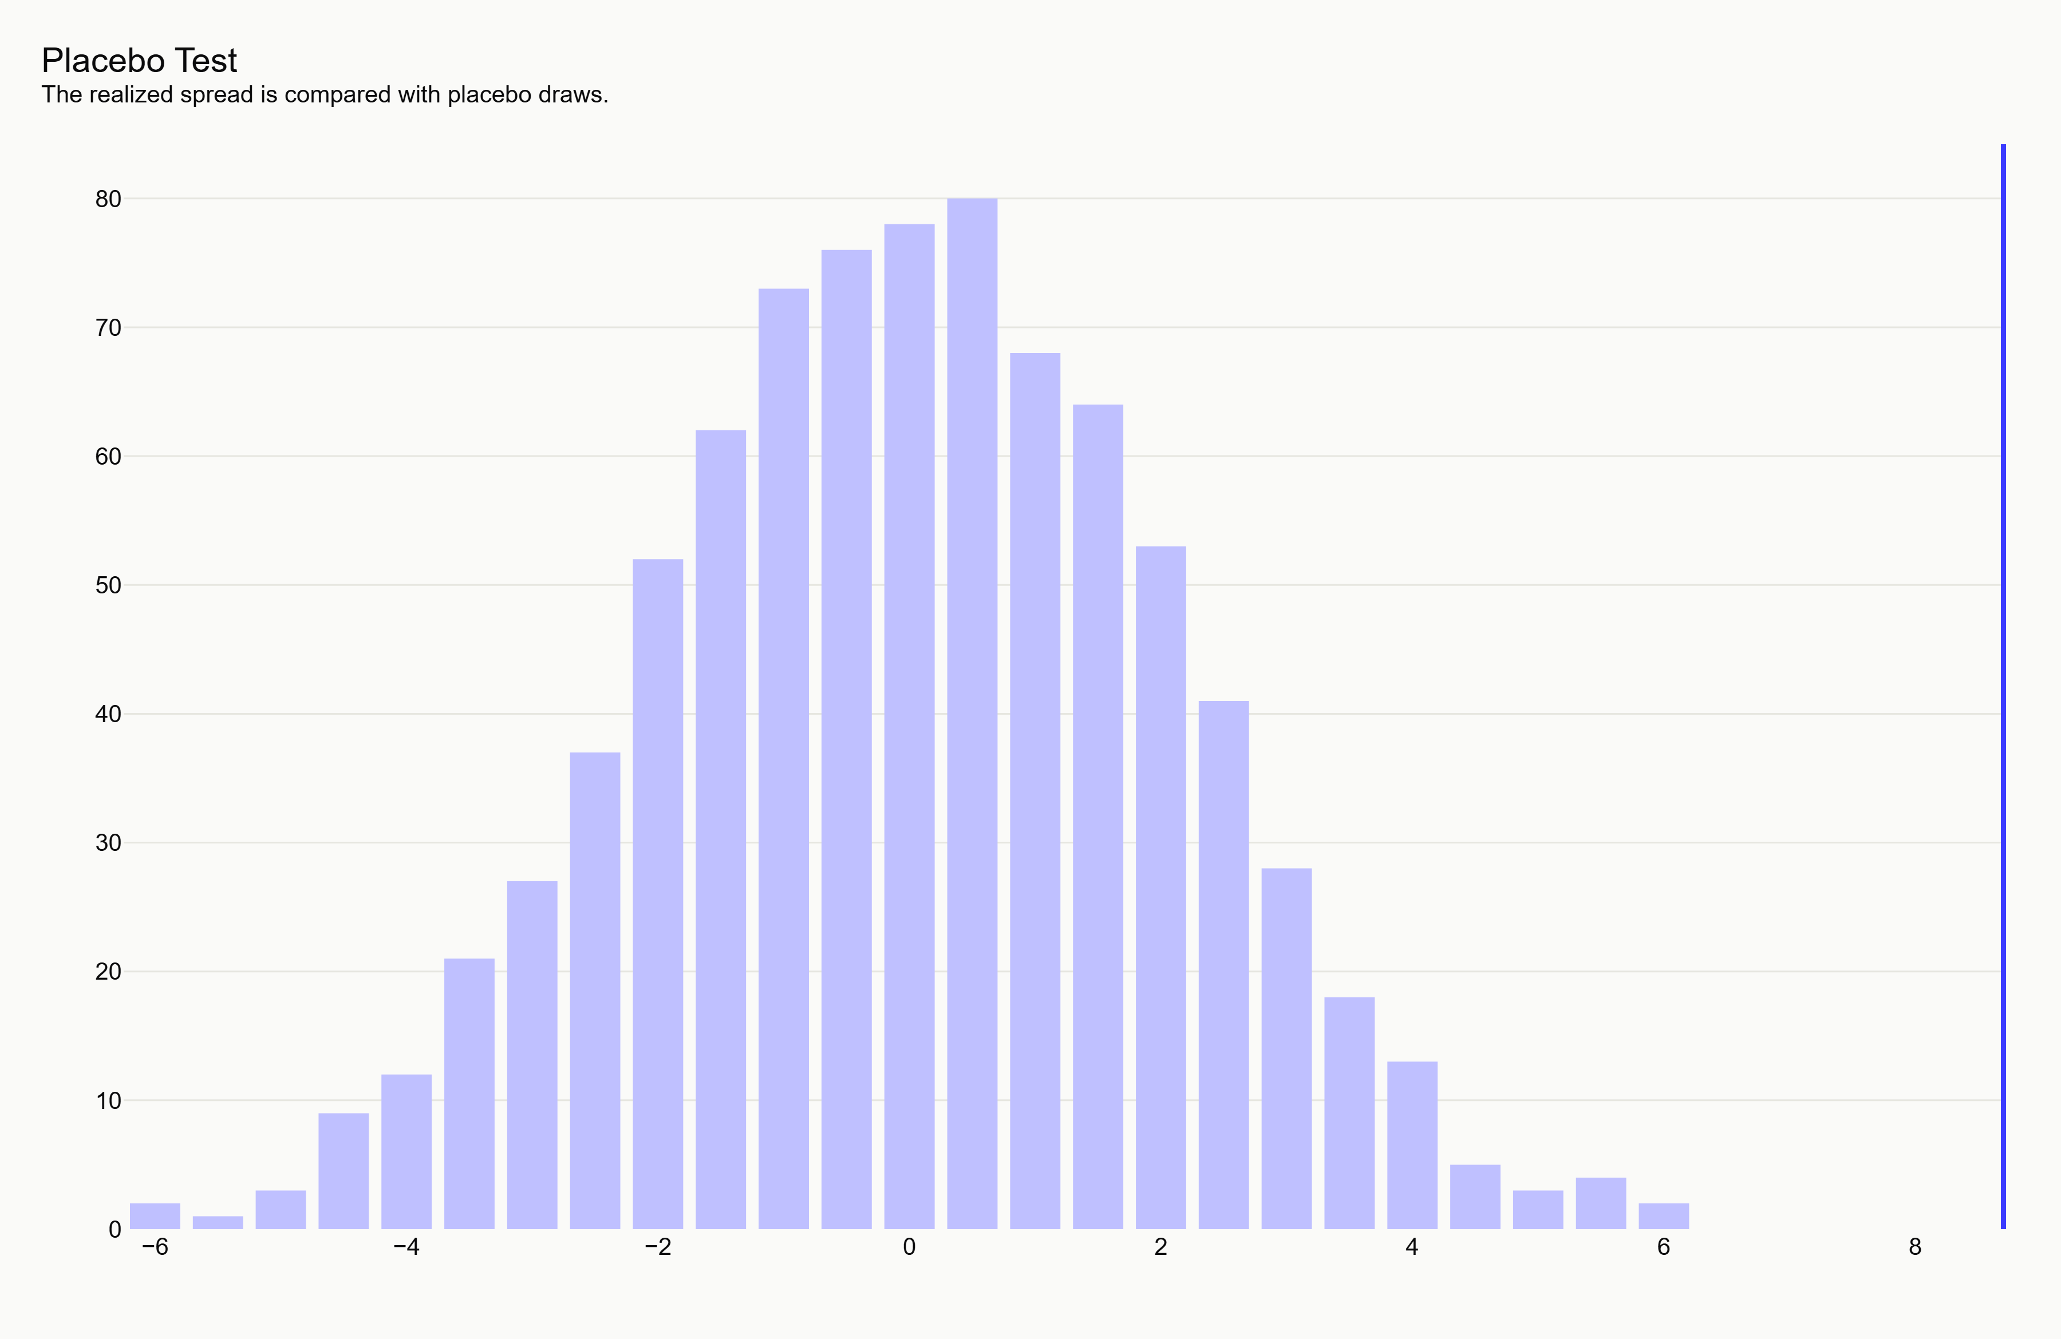
Figure 7. Placebo histogram. Source: generated synthetic-demo artifact placebo_histogram.png.
The histogram demonstrates the intended placebo-test view: a realized spread compared against randomized outcomes. Synthetic values are illustrative only.

Figure 8. ESG level versus ESG momentum matrix
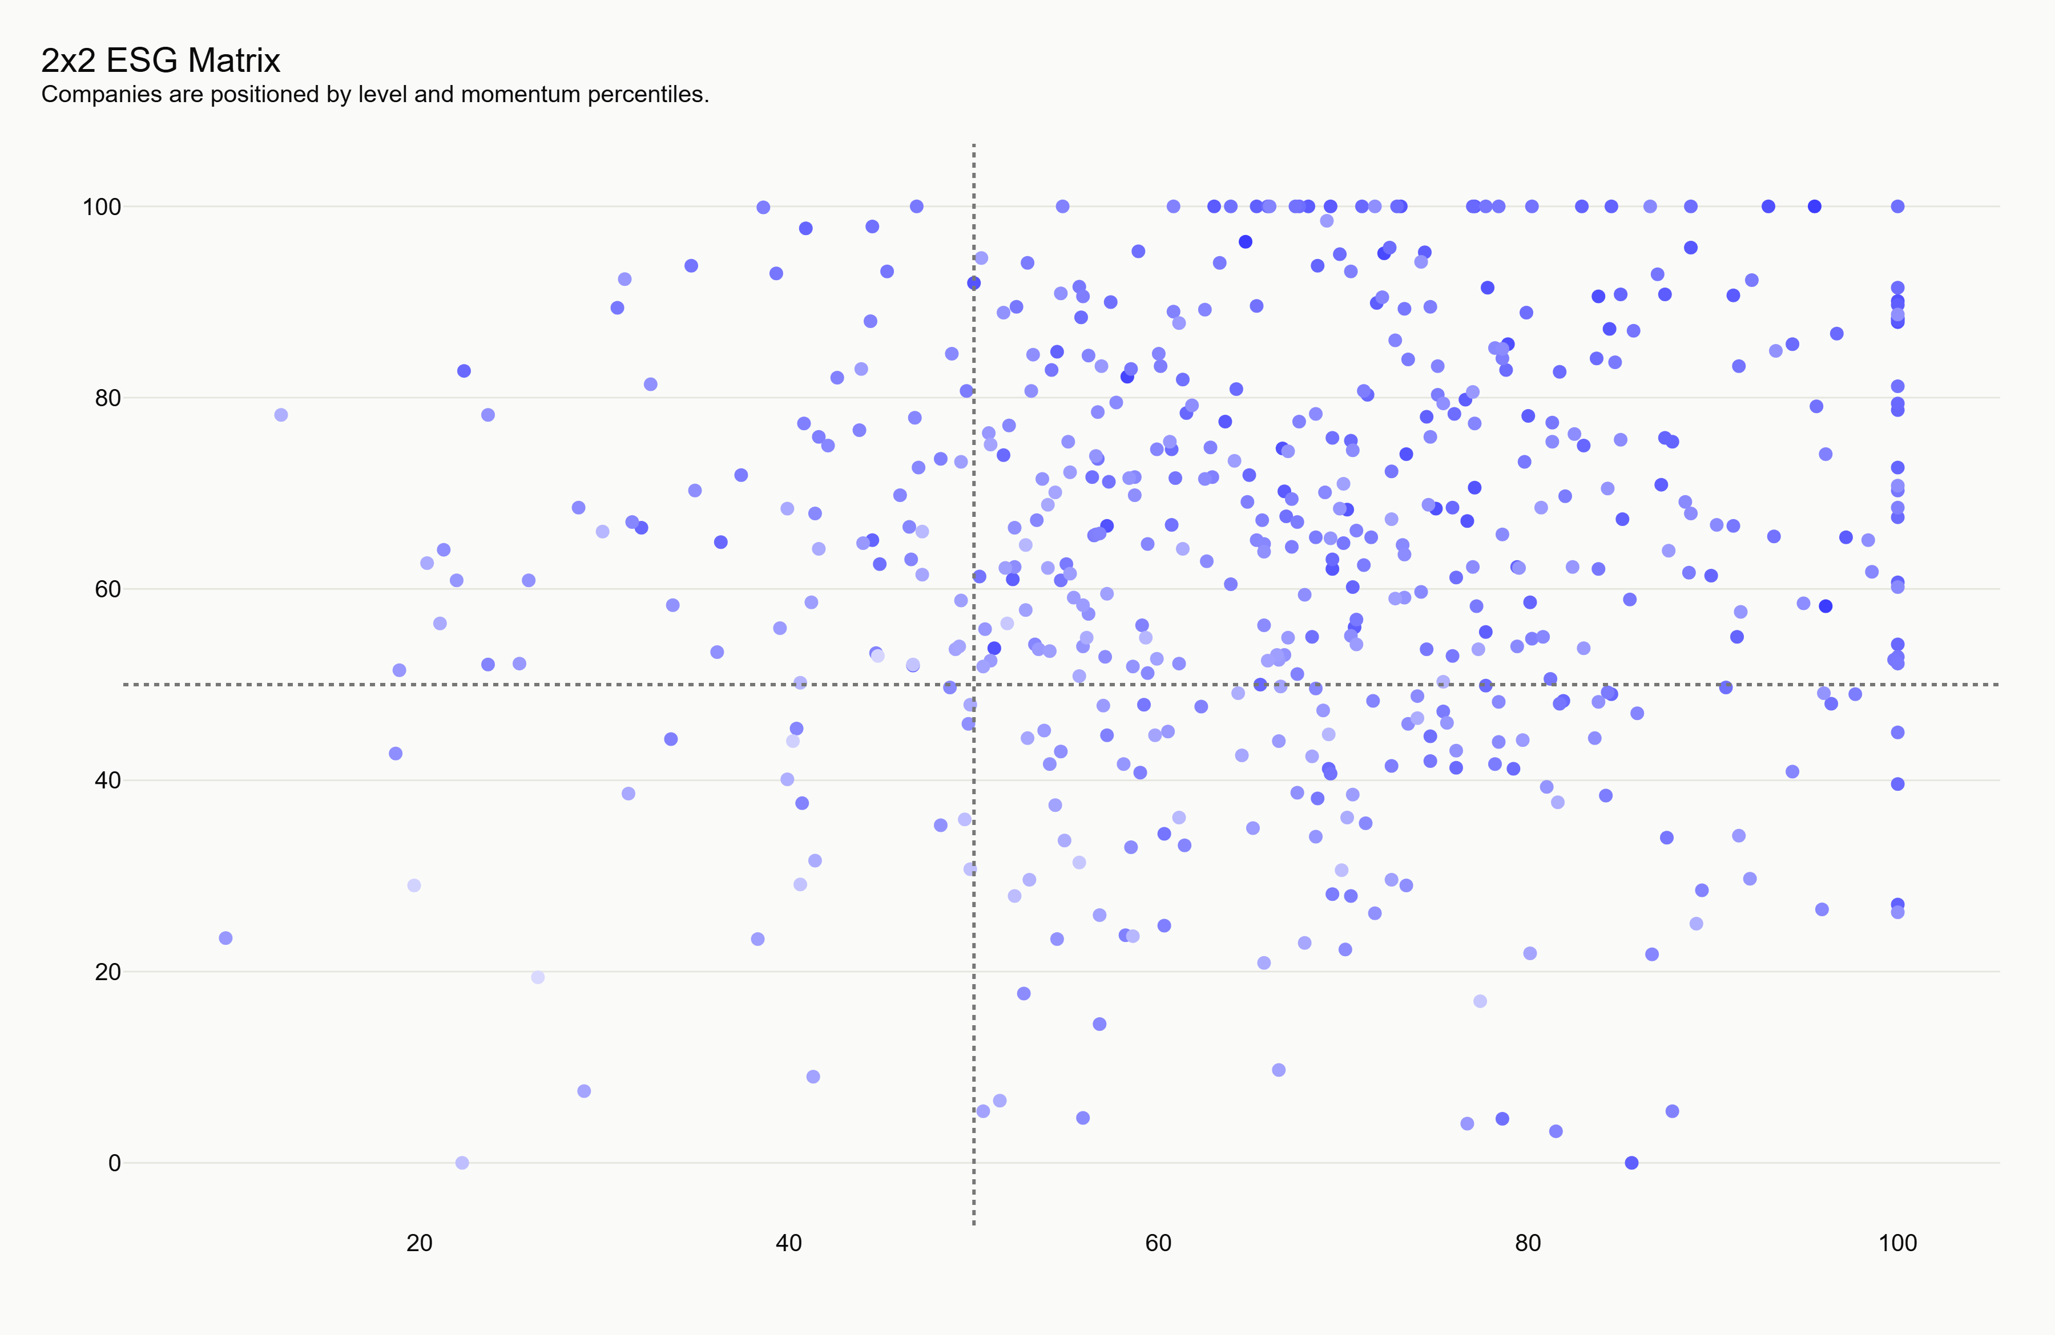
Figure 8. ESG level versus ESG momentum matrix. Source: generated synthetic-demo artifact matrix_scatter.png.
The scatter plot maps companies into the four classification quadrants. This is the report version of the company-detail 2x2 view used by the frontend.

Figure 9. Equity curve and drawdown subplot
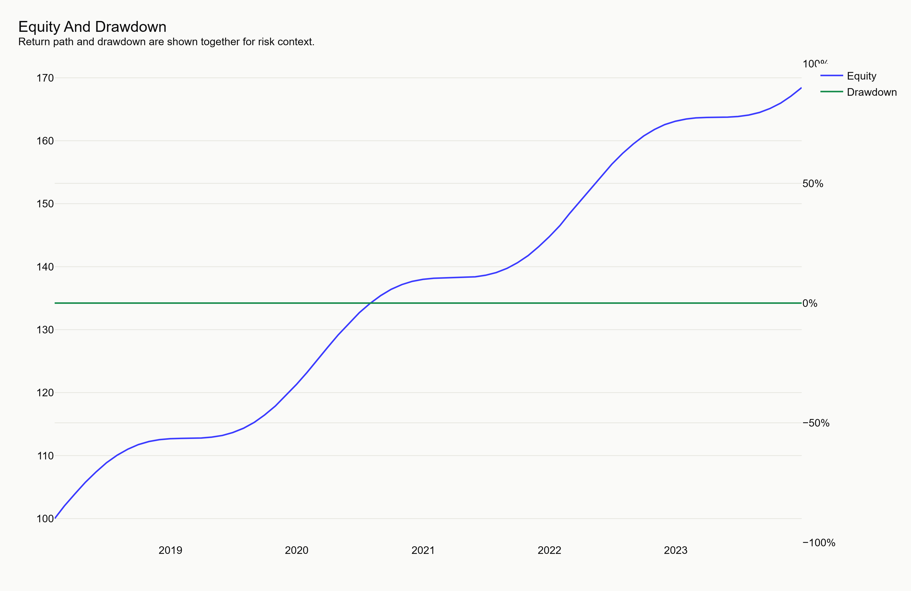
Figure 9. Equity curve and drawdown subplot. Source: generated synthetic-demo artifact equity_drawdown.png.
The paired chart shows cumulative performance together with drawdown. It is designed to prevent performance interpretation without downside context.

Figure 10. By-country and by-sector spread bars
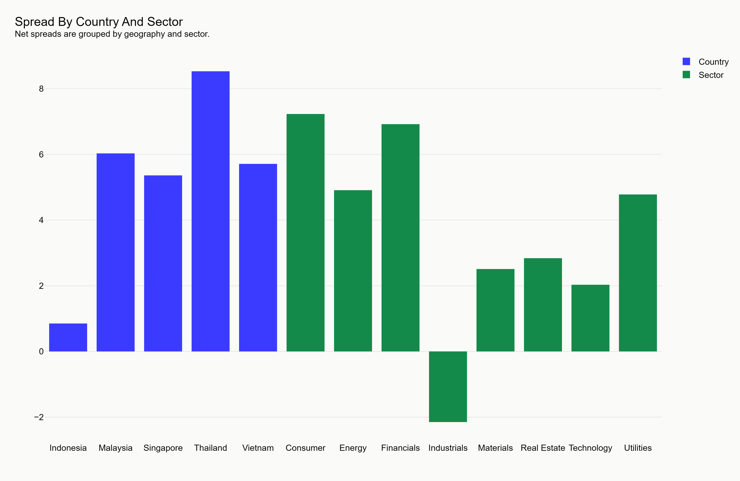
Figure 10. By-country and by-sector spread bars. Source: generated synthetic-demo artifact by_country_sector_spreads.png.
The bar chart shows where synthetic spreads appear stronger or weaker. In live mode, this will be a key diagnostic for market-specific effects.

Figure 11. Composite correlation heatmap
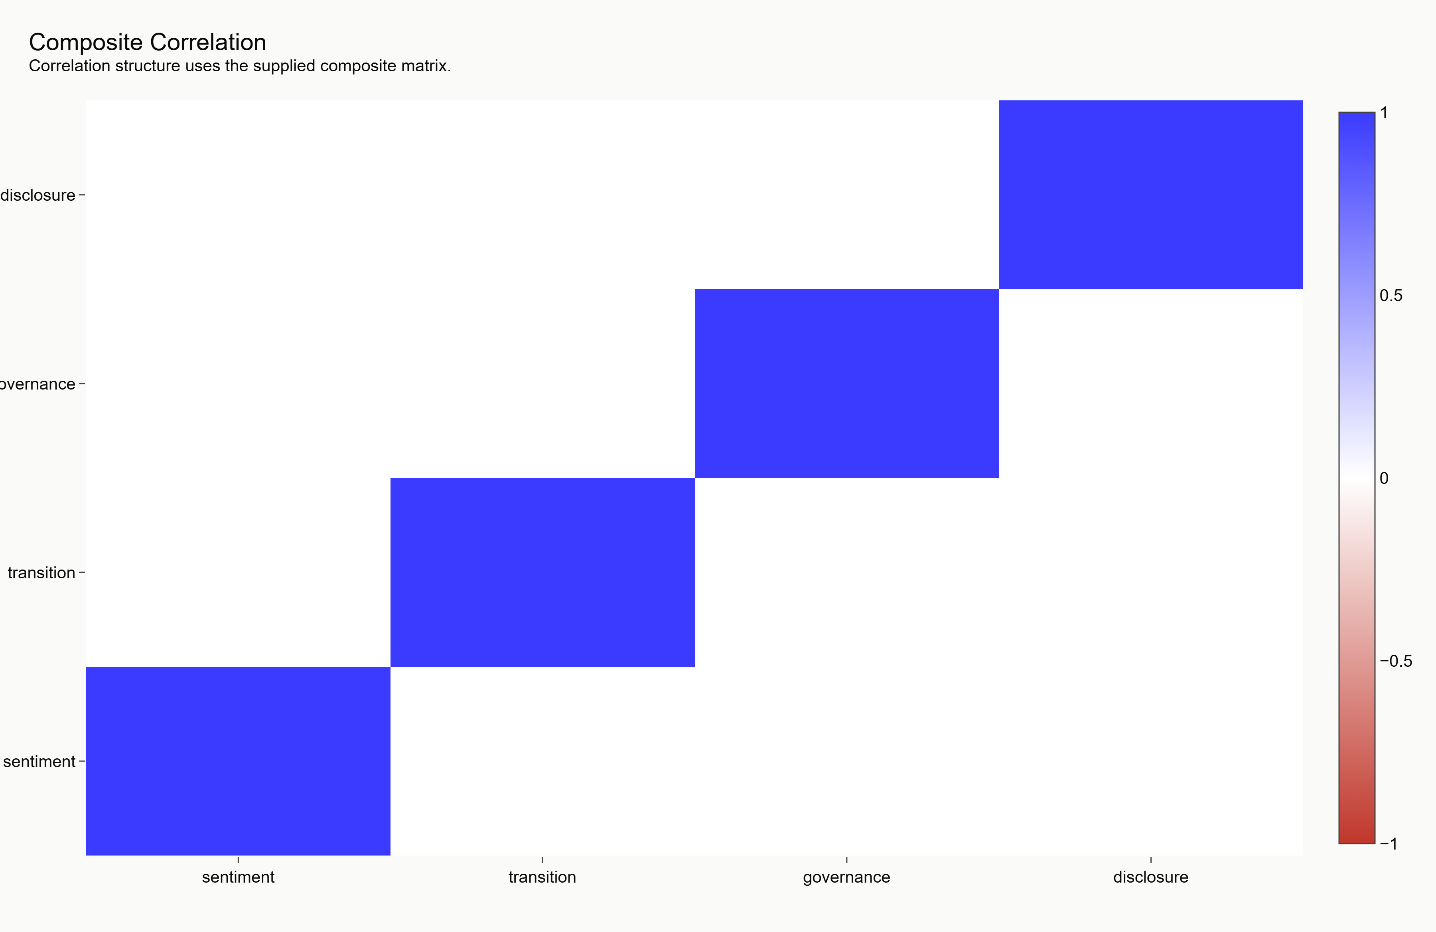
Figure 11. Composite correlation heatmap. Source: generated synthetic-demo artifact composite_correlation_heatmap.png.
This figure checks whether composite signals are too redundant. High live correlations would require tighter governance before deployment.

Figure 12. Score histogram with grade bands
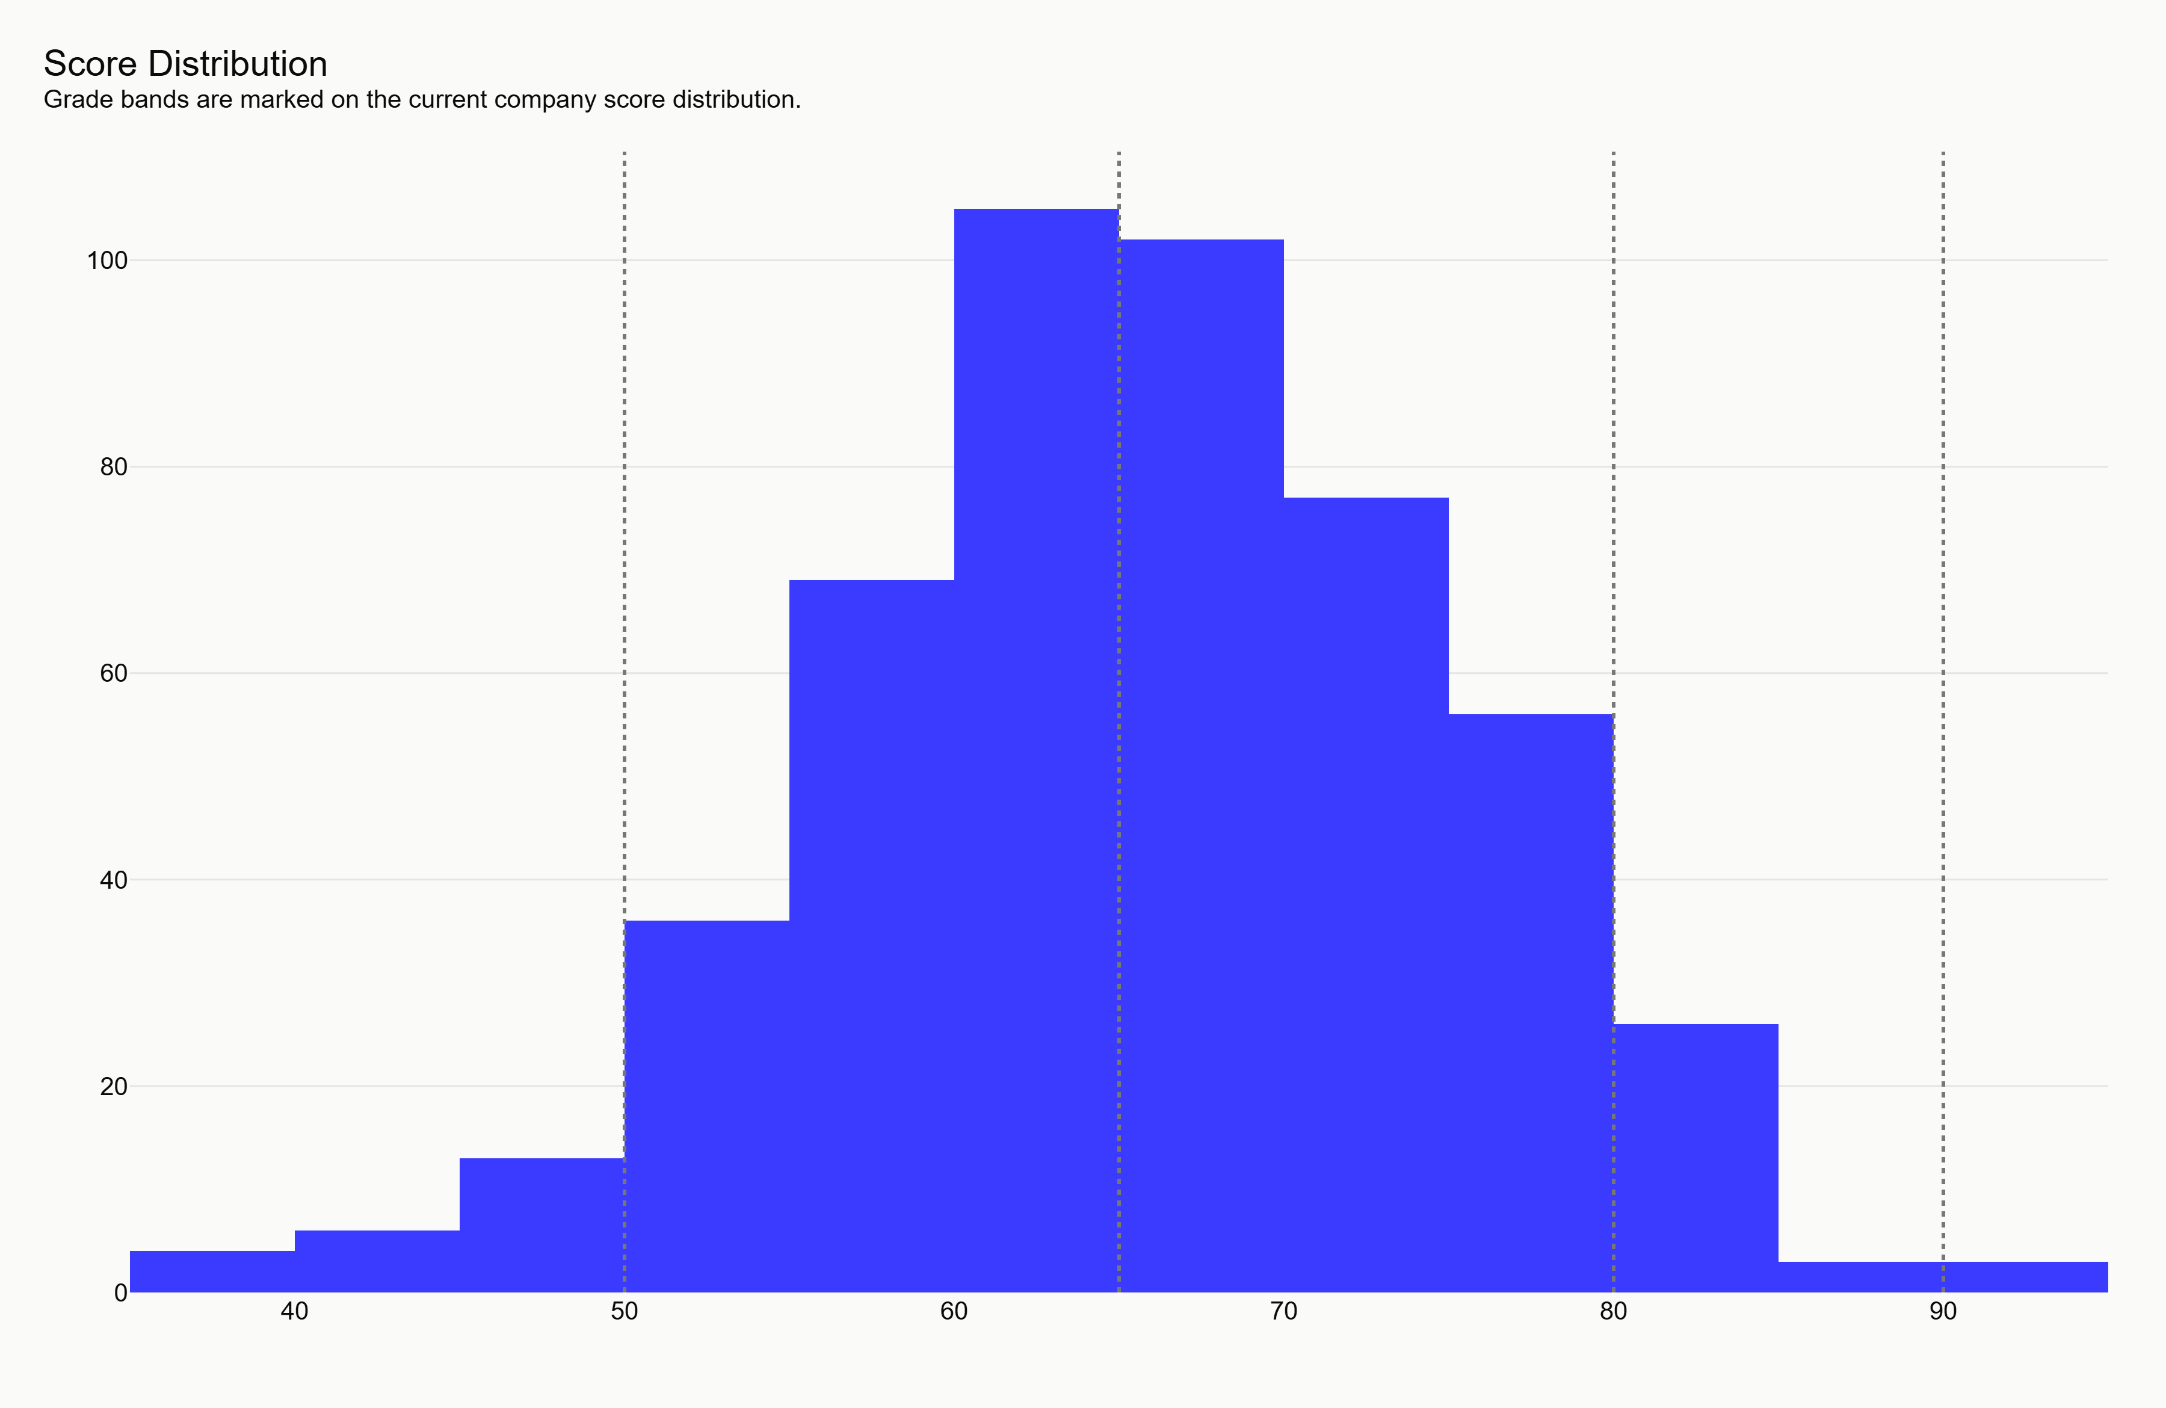
Figure 12. Score histogram with grade bands. Source: generated synthetic-demo artifact score_histogram.png.
The histogram explains the distribution of final scores and the placement of grade bands. It helps reviewers spot compression or unrealistic score clustering.

Figure 13. Top-20 leaderboard table figure
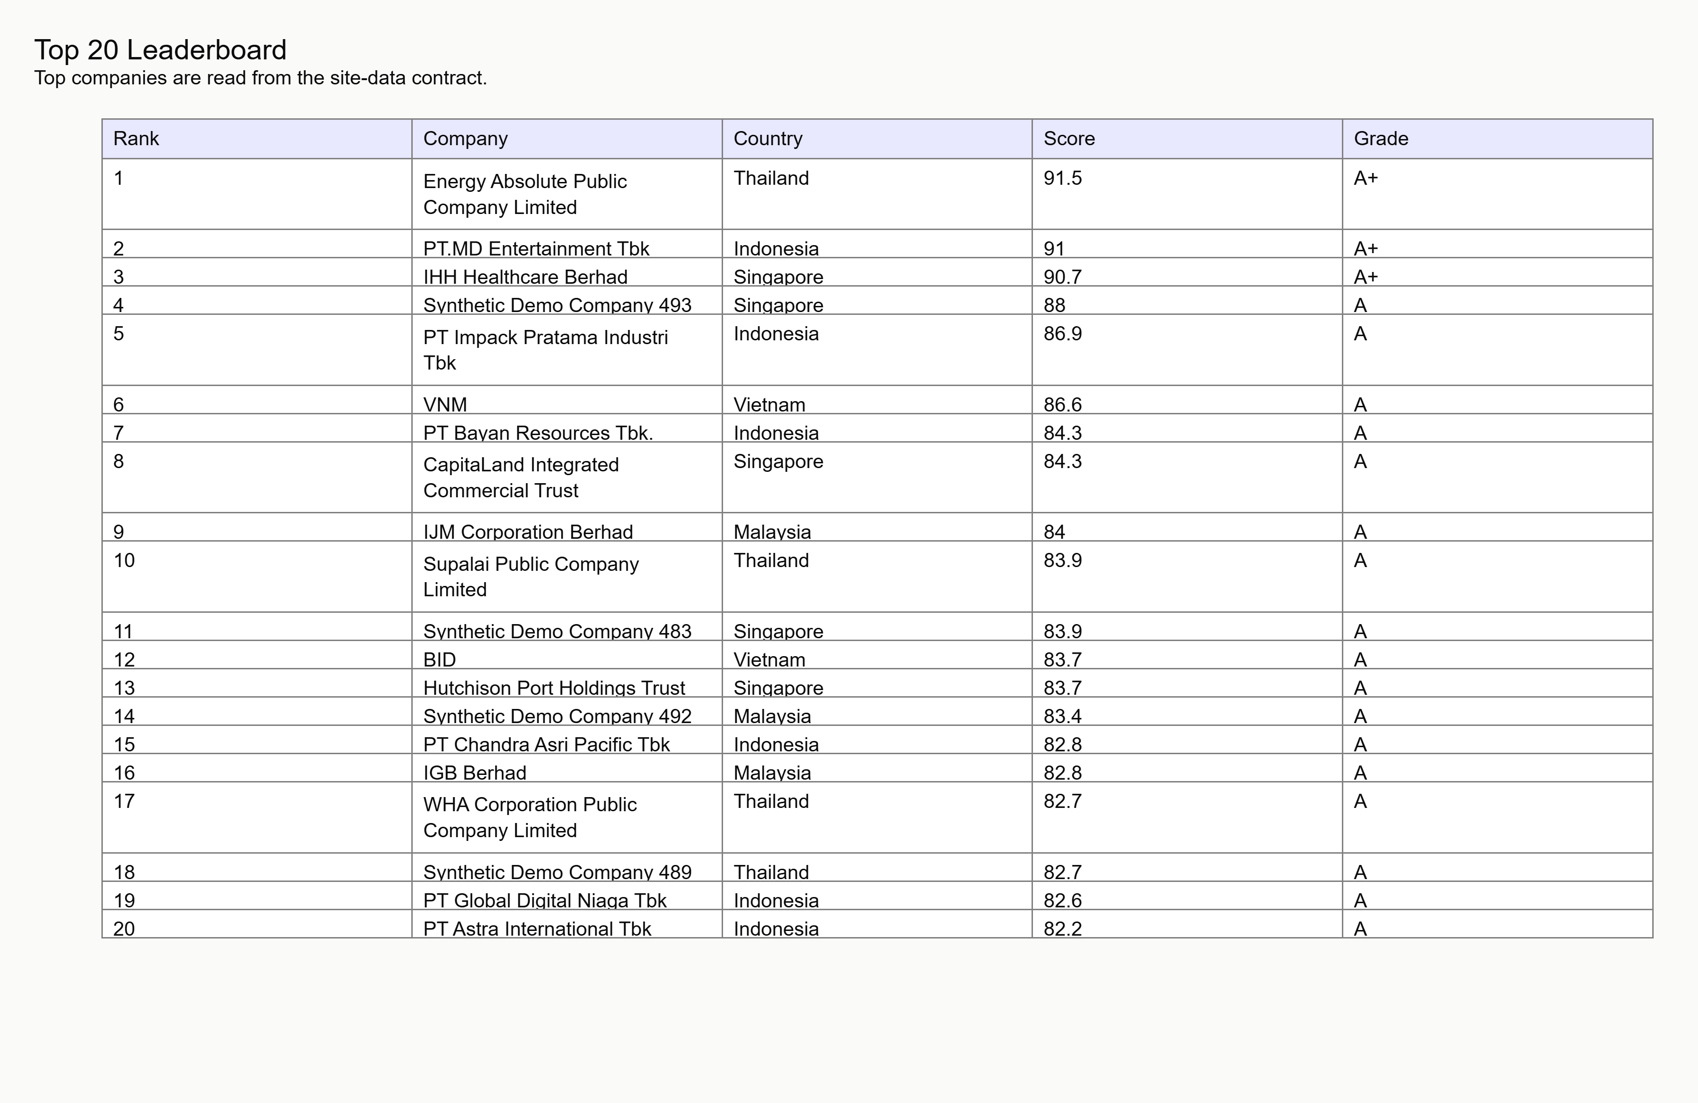
Figure 13. Top-20 leaderboard table figure. Source: generated synthetic-demo artifact top20_leaderboard.png.
The leaderboard figure gives a print-friendly snapshot of the highest-ranked synthetic companies. It must remain labelled as demonstration data.

Figure 14. Per-company price, sentiment, and score overlay
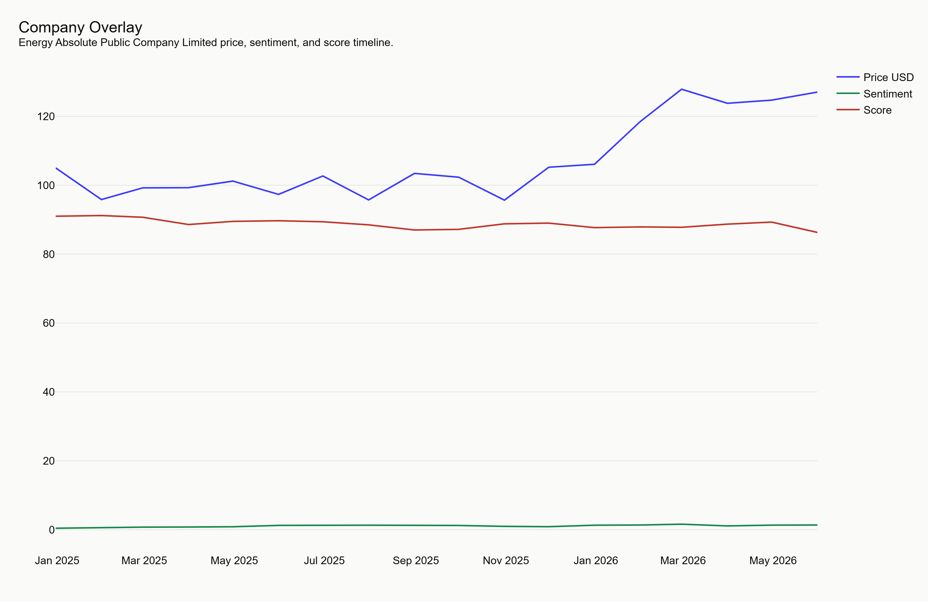
Figure 14. Per-company price, sentiment, and score overlay. Source: generated synthetic-demo artifact company_overlay.png.
The overlay demonstrates the single-company diagnostic view. It is intended to show whether score movement is directionally consistent with source proxies.

16. Limitations
The current build validates data contracts, visualization plumbing, and report presentation. It does not validate a live investment model. Synthetic scores, spreads, ICs, and rankings should not be used outside demonstration and testing contexts.
This build validates the research methodology, the data contracts, and the end-to-end pipeline; it is a research demonstration, not investment advice, and is labeled as such throughout. The largest limitations are honest data gaps, not hidden ones. The free Sustainalytics ESG feed is gone, so the official-score families are unavailable and the model leans on alternative data; the SGX/Bursa disclosure feed returned nothing; sentiment validation runs on the 198-name liquid universe rather than all 477. Point-in-time ESG history does not exist for these names, so reconstructed ESG-momentum is proxied. Survivorship is present by construction because today's constituents are yesterday's survivors. Shorting is infeasible in several ASEAN markets, so the Q5-minus-Q1 spread is partly theoretical and the implementable result is long-only Q5 versus benchmark. The licensed CSV/API import path is the route that closes the data gaps for production use.

- Synthetic values can look realistic while containing no empirical evidence.
- Live fetchers may have exchange-specific gaps, stale fields, and licensing constraints.
- Statistical validation is not complete until Claude-owned live validation artifacts are produced.
- Frontend visual QA is blocked until npm dependencies can be installed.

17. Risk Register
The risk register below records the main implementation and interpretation risks visible at this stage.
Risks are graded by severity and paired with mitigations. Methodological: look-ahead bias (mitigated by strict point-in-time construction and a once-touched test window), survivorship (disclosed, spread partially insulated), multiple testing and overfitting (mitigated by Benjamini-Hochberg FDR and the Deflated Sharpe), short sample and regime dependence (mitigated by sub-period reporting). Data: single-provider ESG dependence that already materialized as total loss (bias-register B-16), GDELT entity-matching noise, yfinance terms-of-service fragility, Scope 3 emissions gaps in ASEAN disclosure, and greenwashing of disclosure-volume signals (partially cross-checked by sentiment and fundamentals). Market and implementation: ASEAN liquidity, FX exposure across five currencies, transaction costs and turnover, and shorting infeasibility. Each is rated for severity, likelihood, mitigation, and residual risk in the accompanying table.

Risk | Severity | Mitigation
Synthetic output mistaken for live findings. | High | Persistent synthetic banner, report disclaimers, tests for data_mode=synthetic.
Incomplete source coverage in live mode. | High | Coverage metrics, confidence bands, failure logs, missing values kept as null/NaN.
Overfitted signal design. | High | Train/test split, placebo tests, walk-forward validation, FDR review.
Frontend dependency installation blocked. | Medium | Document blocker and rerun npm commands in normal terminal.
Unclear licensing for downstream display. | High | Review data-source terms before live distribution.

18. Data-Source And Licensing Risks
Live mode may use yfinance/Yahoo Finance-derived market data, GDELT news data, exchange announcements, and issuer disclosures. Each source must be reviewed for permitted use, redistribution, caching, attribution, and client-facing display rights before launch.
yfinance is an unofficial scrape of Yahoo Finance and is appropriate for a research demonstration but not for production redistribution; the disappearance of the free Sustainalytics endpoint mid-build is concrete evidence of that fragility. GDELT, exchange announcements, and any issuer disclosures must each be reviewed for permitted use, redistribution, caching, attribution, and client-facing display rights before any launch. The compliant production path is the CSV/API import layer, which lets a licensed data provider (including the sponsor's own feeds) drop in behind the same frozen schemas without re-engineering the model.

19. Statistical Risks
Statistical risks include look-ahead bias, survivorship bias, multiple testing, factor crowding, small sample sizes by market, unstable correlations, non-stationary relationships, transaction-cost underestimation, and overstated inference from noisy proxies.
The dominant statistical risks are look-ahead bias, survivorship bias, multiple testing, factor crowding, small per-market samples, unstable correlations, non-stationary relationships, transaction-cost underestimation, and overstated inference from noisy proxies such as news tone. The design confronts these explicitly: point-in-time signals, a once-touched out-of-sample window spanning the 2022 regime change, Benjamini-Hochberg FDR control at q equals 0.10, Newey-West HAC standard errors on overlapping horizons, a block bootstrap that respects serial dependence, and a Deflated Sharpe that penalizes the number of configurations tried. Residual risk remains from the short ASEAN sample and the alternative-data proxy structure, and is stated rather than smoothed over.

20. Model-Governance Risks
The model requires versioned data contracts, frozen validation windows, documented parameter changes, reviewable transformations, and explicit sign-off before live client use. Weight sandbox outputs should remain labelled as custom exploratory views rather than validated model outputs.
The model depends on versioned data contracts (SCHEMAS.md), a parameter set frozen before validation (config/settings.yaml), a once-touched test window, reviewable transformations, and explicit sign-off before any live client use. Weight-sandbox outputs are labeled as custom exploratory views, not validated model outputs, and a one-click reset restores the validated weights. Any change to a research parameter must be logged with its rationale before re-running validation, so the frozen-before-the-answer discipline is preserved.

21. Cybersecurity And Privacy Risks
The current frontend is static and reads JSON only. Future upload, API, or CSV-import paths must validate file type, size, schema, encoding, numeric bounds, formula injection risks, and personally identifiable information before accepting user-provided data.
The frontend is a static client that reads JSON only; it has no backend and no user data. Runtime schema validation rejects malformed or out-of-range JSON before render, so a corrupted feed shows an explicit error rather than silently mis-rendering. Any future upload, API, or CSV-import path must validate file type, size, schema, encoding, numeric bounds, formula-injection strings, and personally identifiable information before accepting user-provided data; the CSV validator already enforces exact columns, ranges, date monotonicity, duplicate-key detection, and formula-injection rejection as the template for that gate.

22. User-Misinterpretation Risks
Users may overread ranks, grade badges, confidence bands, or backtest-style charts. The product should keep disclaimers visible, explain missing data, show confidence and coverage next to scores, and avoid action-oriented language such as buy, sell, or outperform.
Users may overread ranks, grade badges, confidence bands, or backtest-style charts as advice. The product keeps a persistent research-demonstration disclaimer and, in synthetic mode, a synthetic-data banner; it shows coverage and confidence next to every score, explains missing data rather than hiding it, and avoids action-oriented language such as buy, sell, or outperform. The explanation engine is rule-based and deterministic, naming the actual contributing variables, so a reader can trace any score to its drivers rather than trusting an opaque number.

23. Accessibility Considerations
The frontend source includes semantic sections, keyboard-open behavior for leaderboard rows, responsive mobile collapse, persistent labels, and reduced-motion CSS. Browser-based accessibility validation is still required once npm dependencies can be installed and the Vite app can run.

24. Future Real-Data Integration Plan
The next phase should connect the existing fetchers to live artifacts, backfill price/FX/fundamental/ESG/disclosure/sentiment data, generate Claude-owned validation results, and replace synthetic frontend feeds only after schema and governance checks pass.
- Run fetchers with cache and failure logs enabled.
- Validate raw and processed parquet schemas against SCHEMAS.md.
- Generate signal_panel, returns_forward, and validation_results artifacts.
- Regenerate site_data in live mode with retrieval dates and coverage metrics.
- Run pytest, build the frontend, and complete browser visual QA.
- Review licensing and governance sign-offs before external use.

25. Reproducibility Instructions
The following commands reproduce the current non-frontend artifacts in this environment. Frontend commands require npm dependency access as documented in FRONTEND_BUILD_BLOCKER.md.
Task | Command
Generate synthetic site data | .\.venv\Scripts\python.exe -m src.fetchers.synthetic
Render figures | .\.venv\Scripts\python.exe -m src.viz.style
Build final report | .\.venv\Scripts\python.exe -m src.report.build_report
Run tests | .\.venv\Scripts\python.exe -m pytest -q
Frontend install, normal terminal | cd /d C:\Hackathon\esg-engine\site && npm.cmd install
Frontend build, normal terminal | cd /d C:\Hackathon\esg-engine\site && npm.cmd run build

26. Bibliography With Citations
These references identify the source systems, libraries, and artifacts relevant to the demonstration. They are not evidence for the synthetic numerical results.
- Project contract: SCHEMAS.md, schema_version 1, local repository artifact.
- Project configuration: config/settings.yaml, local repository artifact.
- Yahoo Finance data access layer: yfinance Python package documentation and Yahoo Finance public data surfaces.
- GDELT Project: GDELT 2.0 DOC API documentation for news tone and volume concepts.
- Singapore Exchange and Bursa Malaysia announcement pages for future disclosure-source integration.
- Python libraries: pandas, numpy, plotly, python-docx, pytest.
- Frontend libraries: React, Vite, TypeScript, Plotly.js, lucide-react.

27. Appendix A: Full Variable Dictionary
The dictionary below covers the primary companies.json feed and the derived reporting-only risk index.
Variable | Level | Definition
schema_version | Top-level | Contract version. Current value is 1.
generated_at | Top-level | UTC generation timestamp.
data_mode | Top-level | live or synthetic; current report requires synthetic.
as_of_date | Top-level | Date represented by the generated feed.
universe_size | Top-level | Number of companies in the feed.
winning_composite | Model | Name of the selected composite.
validated_weights | Model | Weights used by the default score calculation.
train_end | Model | End date for training window in live validation.
headline | Model | Headline model metrics for the hero and summary UI.
ticker | Company | Ticker symbol.
name | Company | Issuer or synthetic demo company name.
country | Company | Market country code or name from the universe shape.
exchange | Company | Exchange identifier.
sector | Company | Sector grouping.
mcap_tier | Company | mega, large, or mid.
currency | Company | Local trading/reporting currency.
rank | Company | Rank after sorting by overall_score descending.
overall_score | Company | Final 0 to 100 model score.
grade | Company | A+, A, B, C, or D score band.
confidence_low | Company | Lower bound of score confidence interval.
confidence_high | Company | Upper bound of score confidence interval.
coverage_pct | Company | Expected-input coverage percentage.
classification | Company | One of hidden_winner, future_leader, overrated_leader, value_trap.
esg_level_pctile | Company | 0 to 100 axis for static ESG level.
esg_momentum_pctile | Company | 0 to 100 axis for ESG momentum.
pillar_scores | Company | Five component scores: four weighted pillars plus display-only data coverage.
flags | Company | Risk flags from the schema-defined flag list.
explanation | Company | Deterministic explanation sentence.
timeseries | Company | Null or arrays for dates, price_usd, sentiment_tone, and score.
risk_index | Derived report metric | Not stored in companies.json. Derived as min(100, 100 - coverage_pct + weighted flags).

28. Appendix B: Generated Artifact Inventory
The final report was generated from the local artifacts listed below.
Artifact | Path
Companies feed | C:\Hackathon\esg-engine\outputs\site_data\companies.json
Backtest feed | C:\Hackathon\esg-engine\outputs\site_data\backtest.json
IC table | C:\Hackathon\esg-engine\outputs\site_data\ic_table.json
Placebo feed | C:\Hackathon\esg-engine\outputs\site_data\placebo.json
Phase 4 results | C:\Hackathon\esg-engine\data\_synth\phase4_results.pkl
Figures directory | C:\Hackathon\esg-engine\outputs\figures
Frontend blocker note | C:\Hackathon\esg-engine\FRONTEND_BUILD_BLOCKER.md

