

**Automated Lighting and Ventilation Control System**

Submitted by: **ARAVINTH.S(221801003) LIO GODWIN.BR(221801029)**

**AD19541 SOFTWARE ENGINEERING METHODOLOGY**

**Department of Artificial Intelligence and Data Science**

**Rajalakshmi Engineering College, Thandalam**

**Chennai-602 105**

**BONAFIDE CERTIFICATE**

Certified that this project report “**Automated Lighting and Ventilation Control System**” is the bonafide work of **“ARAVINTH.S(221801003),LIO GODWIN.BR(221801029)”**who carried out the project work under my supervision.

**Submitted for the Practical Examination held on**

|  |  |
| --- | --- |
| **SIGNATURE** | **SIGNATURE** |
| **DR GNANASEKAR JM** | **DR MANORANJINI J** |
| **HEAD OF DEPARTMENT** | **ASSOCIATE PROFESSOR** |
| **ARTIFICIAL INTELLIGENCE AND DATA SCIENCE** | **ARTIFICIAL INTELLIGENCE AND DATA SCIENCE** |
| **RAJALAKSHMI ENGINEERING COLLEGE (AUTONOMOUS), THANDALAM,CHENNAI-602105** | **RAJALAKSHMI ENGINEERING COLLEGE (AUTONOMOUS), THANDALAM,CHENNAI-602105** |

|  |  |
| --- | --- |
| **INTERNAL EXAMINER** | **EXTERNAL EXAMINER** |

**ABSTRACT**

The "Automated Lighting and Ventilation Control System" is an innovative project designed to optimize energy usage and enhance environmental comfort in indoor spaces by automating lighting and ventilation systems. The system employs the RCWL-0516 microwave radar sensor for motion detection and an additional sensor for monitoring room temperature and humidity. Lights are automatically activated or deactivated based on occupancy, ensuring they are used only when necessary. Simultaneously, the ventilation system is controlled based on environmental conditions, engaging the fan only when the temperature or humidity exceeds preset thresholds. This dual-sensor approach allows for efficient energy management, significantly reducing unnecessary power consumption and operational costs. The project integrates hardware and software components to provide real-time, responsive automation that minimizes manual intervention. It also presents a scalable framework adaptable for use in various settings, such as residential, commercial, and educational environments. This report details the design, implementation, results, and potential improvements for further enhancing system performance, offering insights into its applicability in sustainable energy solutions for smart buildings.

**TABLE OF CONTENT**

|  |  |  |
| --- | --- | --- |
| **CHAPTER NO.** | **TITLE** | **PAGE NO.** |
|  | **ABSTRACT** | **I** |
|  | **LIST OF FIGURES** | **III** |
| **1** | **INTRODUCTION** | **1** |
| **2** | **LITERATURE REVIEW** | **2** |
| **3** | **SYSYTEM OVERVIEW** | **3** |
| **4** | **SYSTEM REQUIREMENTS** | **4** |
| **5** | **SYSTEM DESIGN** | **9** |
| **6** | **TESTING** | **6** |
| **7** | **PROGRAM CODE** | **18** |
| **8** | **SOFTWARE DEVELOPMNT LIFECYCLE MODEL** | **20** |
| **9** | **UML** | **22** |
| **10** | **OUTPUT** | **23** |
| **11** | **UML DIAGRAMS** | **24** |
| **12** | **RESULTS AND DISCUSSION** | **26** |
| **13** | **CONCLUSION AND FUTURE ENHANCEMENT** | **27** |
|  | **REFERNCES** | **28** |

**LIST OF FIGURES**

|  |  |  |
| --- | --- | --- |
| **FIGURE NO.** | **FIGURE NAME** | **PAGE NO.** |
| **5.1** | **SYSTEM ARCHITECTURE** | **9** |
| **5.2.1** | **RCWL-0516 MICROWAVE RADAR SENSOR** | **10** |
| **5.2.2** | **LDR(LIGHT DEPENDENT RESISTANT) MODULE** | **11** |
| **5.2.3** | **HUMIDITYSENSOR MODULE** | **12** |
| **8.1** | **V-SHAPED MODEL** | **20** |
| **10.1** | **OUTPUT SCREENSHOTS** | **23** |
| **11.1** | **DATAFLOW DIAGRAM** | **24** |
| **11.2** | **USECASE DIAGRAM** | **24** |
| **11.3** | **SEQUENCE DIAGRAM** | **25** |
| **11.4** | **ACTIVITY DIAGRAM** | **25** |

**CHAPTER 1 INTRODUCTION**

* 1. **GENERAL**

In today’s world, automation plays a critical role in enhancing efficiency, convenience, and sustainability in both residential and commercial environments. Smart systems that manage essential resources such as lighting and ventilation can significantly reduce energy consumption, improve comfort, and lower operational costs. Automated lighting and ventilation control systems can dynamically respond to human presence and environmental conditions, leading to better energy management.

This project focuses on building an automated system using the RCWL-0516 microwave radar sensor, which controls lighting based on motion detection and a second sensor that regulates ventilation through a fan. The use of sensors to detect human presence and manage environmental conditions in real-time makes this system intelligent, responsive, and energy-efficient.

* 1. **NEED FOR THE STUDY**

There is an increasing need for energy-efficient systems in homes, offices, and industrial spaces due to the rising cost of energy and growing environmental concerns. Traditional lighting and ventilation systems are often operated manually, which can lead to significant energy waste. Lights and fans are commonly left running even when rooms are unoccupied, contributing to unnecessary energy consumption and increased costs.

This project addresses the problem by automating these processes using sensors to detect occupancy and environmental conditions. By ensuring that lights and fans only operate when needed, the system reduces energy consumption, promotes environmental sustainability, and enhances user convenience. Moreover, automating these systems contributes to smarter buildings, where human intervention is minimized, and energy resources are managed more effectively.

* 1. **OBJECTIVES OF THE STUDY**

# The objectives of this project are:

* + - To design and implement an automated system that controls lighting and ventilation in a room.
    - To use the RCWL-0516 microwave radar sensor for detecting motion and ensuring that lights are turned on only when someone is present in the room.
    - To control a fan using a second sensor that monitors the room’s conditions (such as temperature or humidity) and activates the fan only when needed.
  1. **OVERVIEW OF THE PROJECT**

This project involves the development of a smart automation system for controlling lighting and ventilation. The system utilizes the RCWL-0516 microwave radar sensor, which is capable of detecting motion over a wide range without requiring a direct line of sight, making it highly effective for indoor environments. When the sensor detects motion, the system automatically turns the lights on, and when no motion is detected for a specified period, the lights are turned off, thus conserving energy.

A second sensor is responsible for controlling the ventilation system. The fan only operates when needed, such as when the temperature in the room exceeds a set threshold. This dual-sensor system ensures optimal energy usage while providing a comfortable and efficient room environment. The system is designed to integrate seamlessly into any building’s electrical infrastructure, offering an easy-to-use solution for energy management.

* 1. **INTRODUCTION:**

**CHAPTER 2 LITERATURE SURVEY**

Automation systems that use sensors to control lighting and ventilation have been the subject of numerous studies in recent years due to their potential to reduce energy consumption. A large body of literature explores the use of various sensors, such as passive infrared (PIR) sensors, ultrasonic sensors, and microwave radar sensors, for motion detection and environmental control in buildings. These studies highlight the importance of such systems in improving energy efficiency and reducing human dependency for controlling electrical appliances.

Several key frameworks have been developed in previous literature for evaluating the efficiency and effectiveness of automated systems. The use of sensors like PIR and ultrasonic sensors has been widely adopted in automated lighting systems, but these sensors come with limitations, such as restricted sensing range and false triggers caused by environmental factors.

The RCWL-0516 microwave radar sensor, on the other hand, offers several advantages over traditional sensors. Its ability to detect motion without requiring a direct line of sight makes it ideal for indoor environments where objects may obstruct the sensor’s view. Additionally, it can detect movement through walls, offering enhanced versatility for applications in home automation. Studies have shown that microwave radar sensors provide higher accuracy and reliability compared to other motion sensors in controlling lighting and ventilation systems.

There is also significant research supporting the use of environmental sensors for controlling ventilation systems, such as temperature and humidity sensors, which can optimize fan usage based on room conditions. These systems help maintain a comfortable indoor climate while reducing energy consumption.

**CHAPTER 3** **SYSTEM OVERVIEW**

* 1. **EXISTING SYSTEM**

In most buildings, lighting and ventilation systems are controlled manually. Users must switch lights on and off, and fans are often operated continuously, regardless of whether anyone is present or whether the room needs ventilation. This leads to inefficiencies such as lights being left on in unoccupied rooms or fans running when ventilation is not required. While some buildings have adopted basic motion sensors to control lighting, these systems often rely on outdated technologies, such as PIR sensors, which have limitations in terms of sensitivity and range. Additionally, manual fan control remains common, contributing to unnecessary energy use.

* 1. **PROPOSED SYSTEM**

The proposed system aims to automate both lighting and ventilation control using a combination of the RCWL-0516 microwave radar sensor and a second sensor for environmental monitoring. The system operates as follows:

Lighting Control: The RCWL-0516 microwave radar sensor detects the presence of people in the room by sensing motion. Unlike PIR sensors, the RCWL-0516 does not require a direct line of sight and can detect motion through walls, making it more versatile. When the sensor detects motion, it sends a signal to the system to turn the lights on. If no motion is detected for a set amount of time, the system automatically turns the lights off.

Ventilation Control: A second sensor, such as a temperature or humidity sensor, is used to control a fan. The fan only activates when the room reaches a certain temperature or humidity level, ensuring that ventilation is provided only when necessary. This reduces energy consumption by preventing the fan from running continuously.

This dual-sensor system not only ensures that lighting and ventilation are provided only when needed but also improves the overall efficiency of energy use in the building. By automating these processes, the system reduces the need for manual control and minimizes the risk of energy waste.

* 1. **FEASIBILITY STUDY**

**Technical Feasibility:** The technical requirements for this project are minimal and well within reach. The RCWL-0516 microwave radar sensor is

widely available and cost-effective, making it a practical choice for motion detection. The integration of the second sensor for controlling ventilation is also technically feasible, as temperature and humidity sensors are commonly used in HVAC systems. The system’s design is simple enough to be implemented using microcontrollers such as Arduino or Raspberry Pi, which can handle the logic for controlling the lights and fan.

**Economic Feasibility:** One of the key benefits of this system is its cost- effectiveness. The RCWL-0516 sensor and the additional sensor for ventilation control are both affordable, and the system itself does not require expensive infrastructure. The long-term savings from reduced energy consumption will offset the initial cost of implementation. Additionally, the system's scalability makes it suitable for small homes as well as larger commercial spaces.

**Operational Feasibility:** The system is designed to be user-friendly and reliable. Once installed, it requires no manual intervention, as all operations are automated. The sensors are capable of functioning under a wide range of conditions, making the system suitable for various environments. Additionally, the system can be easily integrated into existing electrical systems without the need for significant modifications.

**CHAPTER 4** **SYSTEM REQUIREMENTS**

* 1. **HARDWARE REQUIREMENTS**

The hardware components required for this system are crucial in detecting motion, controlling lights and fans, and processing data. Each component is selected based on its ability to meet the system’s objectives of efficiency, accuracy, and cost-effectiveness.

# RCWL-0516 Microwave Radar Sensor:

**Purpose:** Detects motion in the room to automatically control the lighting system.

# Specifications:

Operates on a 4-28V DC power supply. Motion detection range of 5-7 meters.

Detects movement through walls and obstacles.

**Benefits:** Unlike traditional PIR sensors, the RCWL-0516 sensor can detect motion without requiring a direct line of sight, enhancing the system’s reliability and flexibility.

# Humidity Sensor (DHT22)

**Purpose:** Monitors room conditions to control the ventilation (fan) based on temperature or humidity thresholds.

# Specifications:

Measures temperature with an accuracy of ±2°C and humidity with ±5% accuracy.

Operates on 3.3V-5V DC power.

**Benefits**: Ensures that the fan operates only when necessary, contributing to energy savings and maintaining a comfortable room environment.

# Microcontroller (e.g., Arduino Uno or Raspberry Pi)

**Purpose:** Acts as the central processing unit of the system, coordinating inputs from sensors and controlling the lighting and ventilation outputs.

# Specifications:

**Arduino Uno:** Based on ATmega328P microcontroller, 14 digital I/O pins, operates on 5V.

**Raspberry Pi (optional for advanced processing):** Quad-core ARM processor, multiple GPIO pins, operates on 5V.

**Benefits:** Provides an affordable and programmable solution for controlling

sensor inputs and outputs.

# Relay Modules

**Purpose:** Interfaces the microcontroller with higher voltage appliances like lights and fans.

# Specifications:

Operates with 5V signals from the microcontroller. Capable of switching up to 250V AC or 30V DC loads.

**Benefits:** Enables safe control over high-power appliances, ensuring the system can handle lighting and ventilation loads without direct microcontroller connection.

# Power Supply

**Purpose:** Provides necessary power to the microcontroller and connected sensors.

**Specifications:** Typically a 5V or 12V DC power adapter based on microcontroller and sensor requirements.

**Benefits:** Ensures the system operates reliably with continuous power supply.

* 1. **SOFTWARE REQUIREMENTS**

The software requirements include the programming environments and libraries necessary to control the hardware components, process sensor data, and manage the lighting and ventilation system’s logic.

# Arduino IDE (or Raspberry Pi OS with Python)

**Purpose:** Development environment for writing, uploading, and testing code on the microcontroller.

**Specifications:** Compatible with Arduino Uno and other microcontrollers.

# Key Features:

Easy-to-use interface for coding and debugging.

Supports a wide variety of libraries for sensor and relay control.

**Benefits**: Simplifies development and testing of the microcontroller code, especially for controlling sensors and output devices like relays.

# Sensor Libraries

**Purpose**: Pre-written libraries for interfacing with specific sensors (e.g., DHT.h for DHT11/22 sensors).

# Examples:

DHT.h library for temperature/humidity sensors. RCWL.h (or equivalent) for the RCWL-0516 sensor.

Benefits: Provides easy access to sensor data without complex coding, ensuring smooth integration with the microcontroller.

# Control Logic and Algorithms

**Purpose:** Code that defines the control rules for turning lights and fans on or off based on sensor inputs.

Details:

**Logic for lighting control:** Uses motion data from the RCWL-0516 sensor to turn lights on/off.

**Logic for fan control:** Monitors temperature/humidity levels and activates the fan when thresholds are exceeded.

**Benefits:** Ensures the system operates efficiently by activating lights and fans only when necessary, based on real-time data.

**CHAPTER 5:** **SYSTEM DESIGN**

* 1. **SYSTEM ARCHITECTURE**

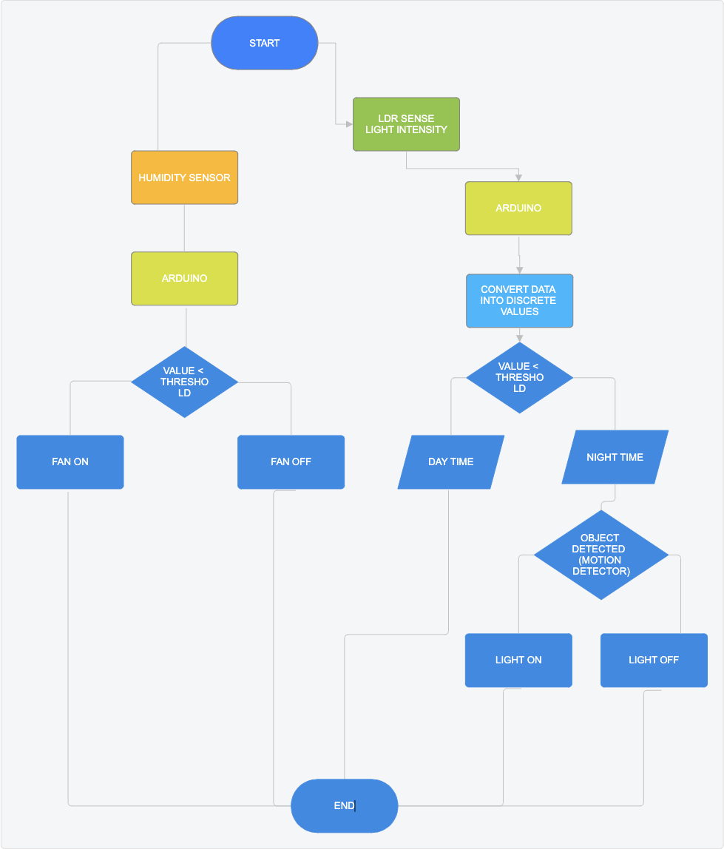

**Figure 5.1 SYSTEM ARCHITECTURE**

* 1. **MODULE DESCRIPTION**
     1. **MODULE 1: MICROWAVE SENSOR MODULE**

The RCWL-0516 Microwave Sensor is a motion detection sensor that uses Doppler radar technology to detect movement within its range. It can sense through various materials (like glass or thin walls), making it ideal for applications where PIR sensors may not work as well. This sensor outputs a high signal when motion is detected. Totally it consists of 5 ports namely VIN,OUT,GND,3V3,CDS.

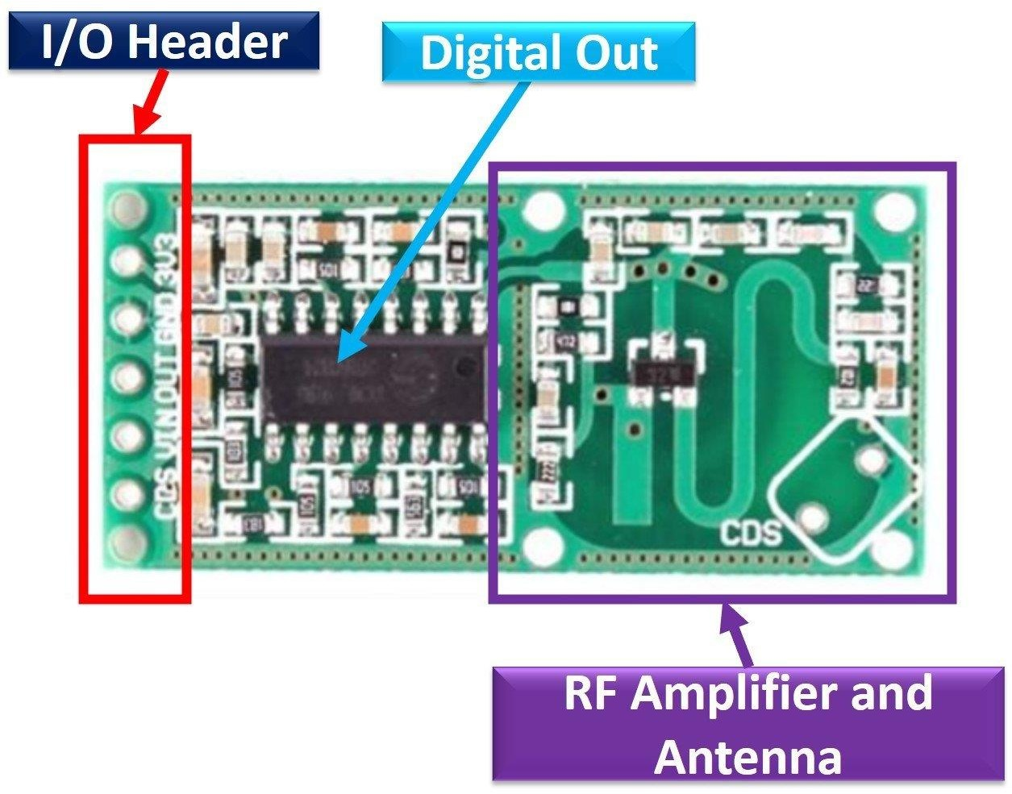

**FIGURE : 5.2.1 RCWL-0516 MICROWAVE RADAR SENSOR**

* + 1. **MODULE 2:LDR MODULE**

The Light Dependent Resistor (LDR) sensor in this circuit is used to detect light levels. An LDR's resistance decreases when exposed to light and increases in darkness, making it suitable for light-sensing applications.

# Circuit Explanation:

The circuit is powered by a 9V battery.The LDR is connected in series with a variable resistor (R2, 100kΩ), creating a voltage divider. This allows adjusting the sensitivity of the circuit to different light levels. When there is low light (dark conditions), the LDR’s resistance is high, increasing the voltage across the base of the NPN transistor (Q1, BC547).The base voltage turns on Q1, allowing current to flow from the collector to the emitter, lighting up the LED.R1 (390Ω) limits the current through the LED to protect it from excess current.

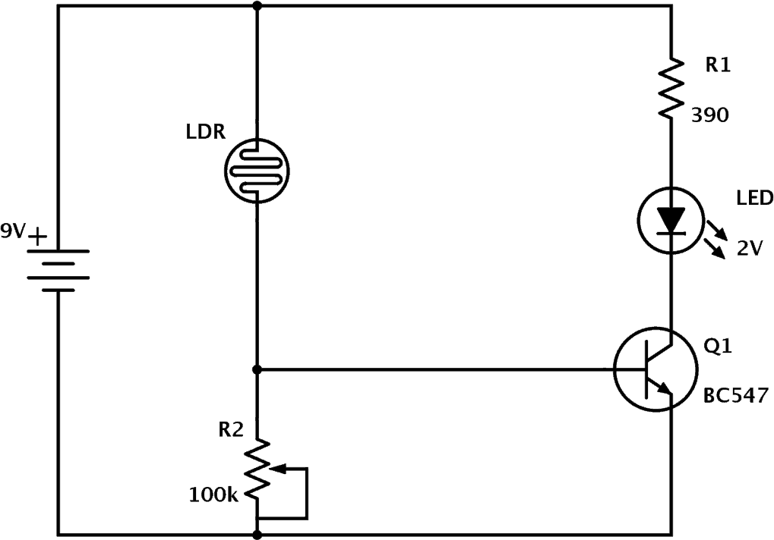

**FIGURE 5.2.2 : LDR(LIGHT DEPENDENT RESISTANT) MODULE**

* + 1. **MODULE 3: HUMIDITY SENSOR MODULE**

The humidity sensor shown in this circuit is the HIH-4000-001, a popular sensor that outputs an analog voltage directly proportional to the relative humidity. This sensor requires a 5V DC supply and provides a linear output voltage that represents the humidity level in the environment.

# Circuit Explanation:

The HIH-4000-001 sensor outputs a small analog signal proportional to the relative humidity.

RL (82 kΩ) acts as a pull-down resistor, grounding the output signal.

The output from the sensor is fed into an operational amplifier (op-amp) configured as a non-inverting amplifier, amplifying the sensor’s output to a level suitable for the PIC ADC (Analog-to-Digital Converter).

R4 (1 kΩ) and R5 (317 Ω) set the gain of the op-amp, increasing the signal to a readable range for the ADC.

The op-amp is powered by a dual supply (+5V and -5V) to handle the small signals and ensure better accuracy in the amplified output.

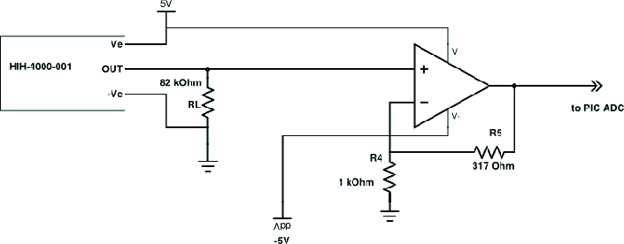

**FIGURE 5.2.3 : HUMIDITY SENSOR MODULE**

* 1. **UNIT TESTING**

**CHAPTER 6 TESTING**

Unit Testing: This type of testing focuses on validating individual components or functions of the system in isolation. It ensures that each module, like reading sensor values or controlling lights, works correctly on its own.

# Program Code:

#include <stdio.h> #include <stdbool.h> bool detect_motion() {

return true; // Example: motion detected

}

// Function to control light based on motion detection void control_light(bool motion) {

if (motion) {

printf("Light ON: Motion detected.\n");

} else {

printf("Light OFF: No motion detected.\n");

}

}

void test_light_control_on_motion() { bool motion = detect_motion(); control_light(motion);

}

int main() {

test_light_control_on_motion(); return 0;

}

**PROGRAM CODE:**

#include <assert.h> #include <stdio.h>

// Simulated function to read temperature from sensor int read_temperature() {

return 25;

}

void test_read_temperature() {

int temp = read_temperature(); assert(temp >= 0 && temp <= 100);

printf("Unit Test Passed: Temperature reading is within the valid range.\n");

}

int main() {

test_read_temperature(); return 0;

}

* 1. **INTEGRATION TESTING**

Integration testing checks if different components work together seamlessly. This verifies that modules, such as sensors and control units, communicate and function properly when combined.

**PROGRAM CODE:**

#include <assert.h> #include <stdio.h>

// Simulated function to read temperature from a sensor int read_temperature() {

return 25; // Simulated temperature value

}

// Simulated function to check if the fan should turn on based on temperature

const char* check_fan_status(int temperature) { if (temperature > 30) {

return "Fan On";

} else {

return "Fan Off";

}

}

// Unit test

void test_read_temperature() { int temp = read_temperature();

assert(temp >= 0 && temp <= 100); // Assert that the temperature is within valid range

printf("Unit Test Passed: Temperature reading is within the valid range.\n");

}

// Unit test

void test_check_fan_status() { assert(check_fan_status(25) == "Fan Off"); assert(check_fan_status(35) == "Fan On"); printf("Unit Test Passed: Fan status logic is

correct.\n");

}

// Integration test for read_temperature and check_fan_status working together

void test_integration_temperature_and_fan() { int temp = read_temperature();

const char* fan_status = check_fan_status(temp); if (temp > 30) {

assert(fan_status == "Fan On");

} else {

assert(fan_status == "Fan Off");

}

printf("Integration Test Passed: Temperature and Fan interaction works as expected.\n");

}

int main() {

// Run Unit Tests test_read_temperature(); test_check_fan_status(); test_integration_temperature_and_fan();

return 0;

}

**PROGRAM CODE:**

#include <stdio.h> #include <stdbool.h> #include <assert.h> bool detect_motion() {

return true; // Example: motion detected

}

void control_light(bool motion) { if (motion) {

printf("Light ON: Motion detected.\n");

} else {

printf("Light OFF: No motion detected.\n");

}

}

void test_integration_motion_and_light() {

// Simulate motion detected

bool motion_detected = detect_motion();

printf("Integration Test: Detecting motion...\n");

if (motion_detected) {

printf("Integration Test: Motion detected, controlling light...\n");

control_light(motion_detected); assert(motion_detected == true); //

Validate that motion detection is working

} else {

printf("Integration Test: No motion detected, controlling light...\n");

control_light(motion_detected); assert(motion_detected == false); //

Validate no motion case

}

printf("Integration Test Passed: Motion detection and light control interaction works as expected.\n");

}

int main() {

// Run Integration Test test_integration_motion_and_light(); return 0;

}

**CHAPTER 7 PROGRAM CODE**

// Pin Definitions

const int ldrPin = A0; // LDR sensor connected to A0

const int radarPin = 2; // RCWL-0516 OUT to pin 2 const int ledPin = 9; // LED connected to pin 9

// Threshold for light intensity (adjust as needed) const int lightThreshold = 500;

void setup() {

pinMode(radarPin, INPUT); // Set radar sensor pin as input

pinMode(ledPin, OUTPUT); // Set LED pin as output Serial.begin(9600); // Initialize Serial

Monitor for debugging

}

void loop() {

// Read values from LDR and Radar sensor

int lightLevel = analogRead(ldrPin); // Get light

//intensity

int motionDetected = digitalRead(radarPin); // Check

//for motion

// Print readings to Serial Monitor for debugging Serial.print("Light Level: "); Serial.print(lightLevel);

Serial.print(" | Motion Detected: "); Serial.println(motionDetected);

if (motionDetected == HIGH && lightLevel < lightThreshold) {

// Motion detected and it's dark Serial.println("Conditions met: Turning LED ON"); digitalWrite(ledPin, HIGH);

} else {

// Either no motion or sufficient brightness Serial.println("Conditions not met: Turning LED

OFF");

digitalWrite(ledPin, LOW);

}

delay(200); // Small delay for stable readings

}

**CHAPTER 8**

**SOFTWARE DEVELOPMENT LIFECYCLE MODEL**

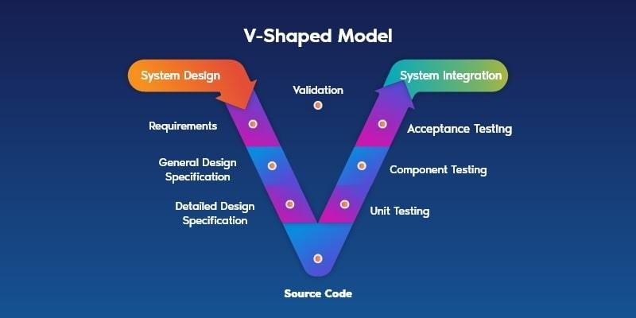

**FIGURE 8.1 V-SHAPED MODEL**

The V-Model, or Verification and Validation Model, is an effective approach for developing the Automated Lighting and Ventilation Control System as it emphasizes structured, thorough testing at each stage. Starting with Requirement Analysis, the functional needs of the system—such as occupancy-based lighting control and ventilation triggered by environmental conditions—are carefully defined. Later in the development, Acceptance Testing verifies that these initial requirements are fully met in the final system. The System Design phase focuses on creating a high-level architecture detailing how each component, like the RCWL-0516 microwave radar sensor and environmental monitoring sensors, will interact. This is followed by System Testing to ensure that the system’s integrated functionality operates as intended.

In Architectural Design, specific module interactions are planned to establish data flow from sensors to the control system. During Integration Testing, these modules are tested together to confirm seamless operation and communication. Detailed Module Design involves specifying each component, such as the motion detection and environmental monitoring logic. Unit Testing follows to confirm that each module performs accurately in isolation. During Coding and Implementation, the actual coding of each part of the system is done, with ongoing tests ensuring alignment with earlier designs. This step-by-step approach in the V-Model allows for early detection of potential issues and contributes to high system reliability, making it ideal for a project requiring precise, real-time automation to optimize energy usage and environmental comfort.

**CHAPTER 9 UML**

* 1. **DATA FLOW DIAGRAM**

The below **Figure 10.1** represents a Smart Home Automation system flowchart using motion, humidity, and light sensors. It outlines the logical sequence for turning lights and fans on or off based on detected motion, ambient light levels, and humidity conditions. The system integrates decision- making and environmental checks to ensure optimal energy efficiency and automation.

* 1. **USE CASE DIAGRAM**

The below **Figure 10.2** represents a Smart Home Automation System where the Homeowner interacts with features such as managing energy consumption, monitoring the security system, controlling temperature, and adjusting lighting. It highlights the system's functionalities aimed at enhancing convenience and energy efficiency.

* 1. **SEQUENCE DIAGRAM**

The below **Figure 10.3** represents the interaction between components in a Smart Home Automation System. It begins with an occupant's presence being detected by a motion sensor, triggering the room controller to manage devices like the humidity sensor and lights. Based on readings, the system decides whether to turn devices on or off, ensuring efficient and automated control.

* 1. **ACTIVITY DIAGRAM**

The below **Figure 10.4** illustrates the workflow of a Smart Home Automation System using sensors like motion, humidity, and light. The system checks motion to control lighting, evaluates ambient light levels to adjust brightness, and uses humidity levels to manage fan operation. The flow ensures automated, energy-efficient control of devices.

**CHAPTER 10 OUTPUT**

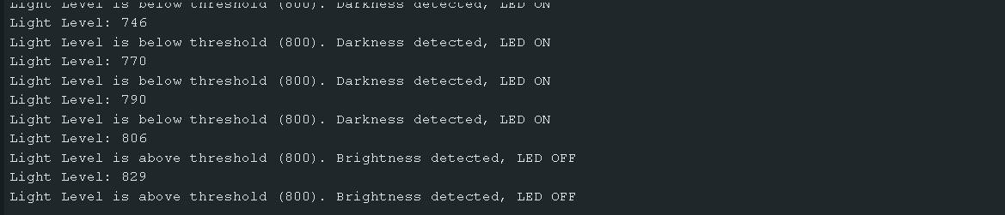

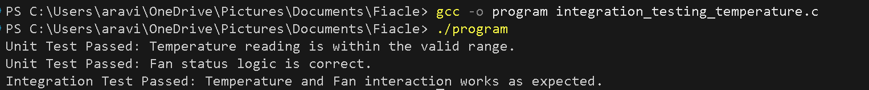

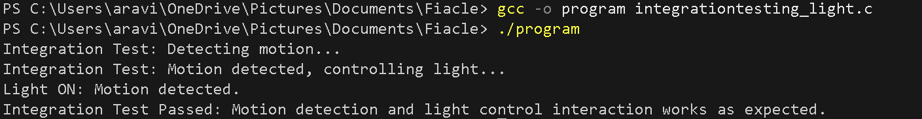

**FIGURE 10.1 OUTPUT SCREENSHOTS**

**CHAPTER 11 UML DIAGRAMS**

* 1. **DATA FLOW DIAGRAM**

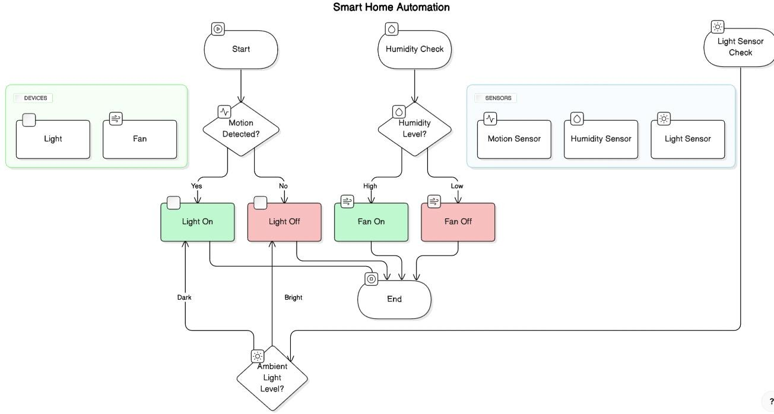

**Figure 11.1:DATA FLOW DIAGRAM**

* 1. **USE CASE DIAGRAM**

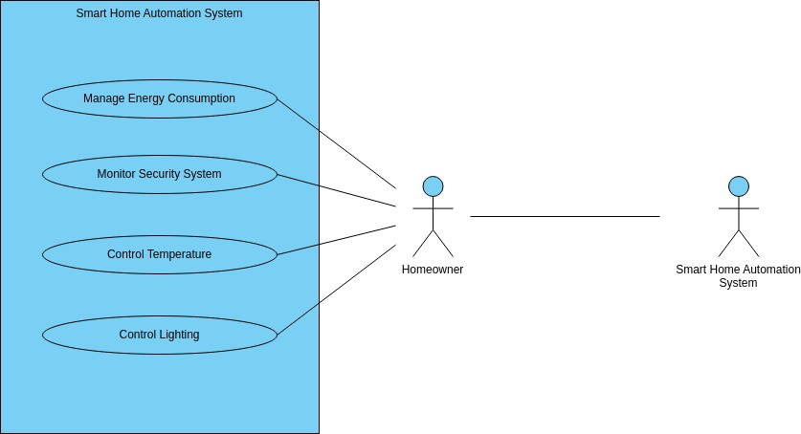

**FIGURE 11.2:USE CASE DIAGRAM**

* 1. **SEQUENCE DIAGRAM**

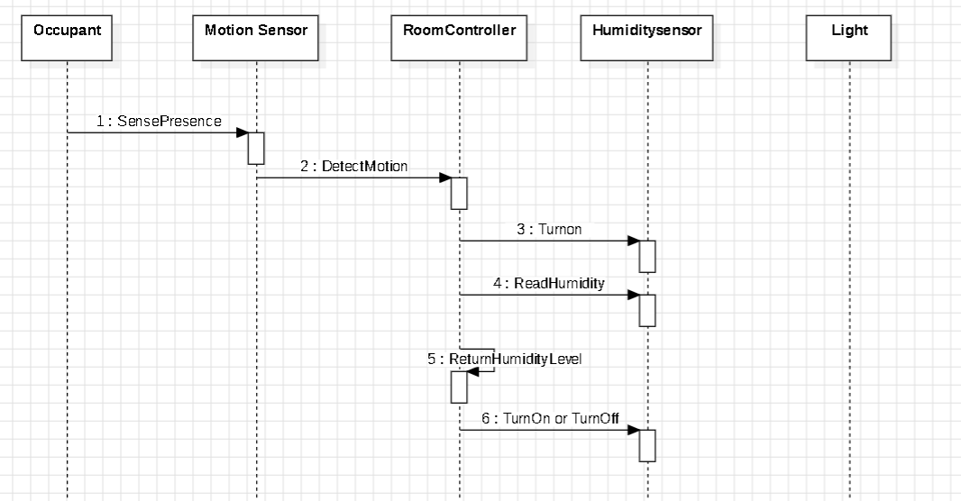

**FIGURE 11.3 SEQUENCE DIAGRAM**

* 1. **ACTIVITY DIAGRAM**

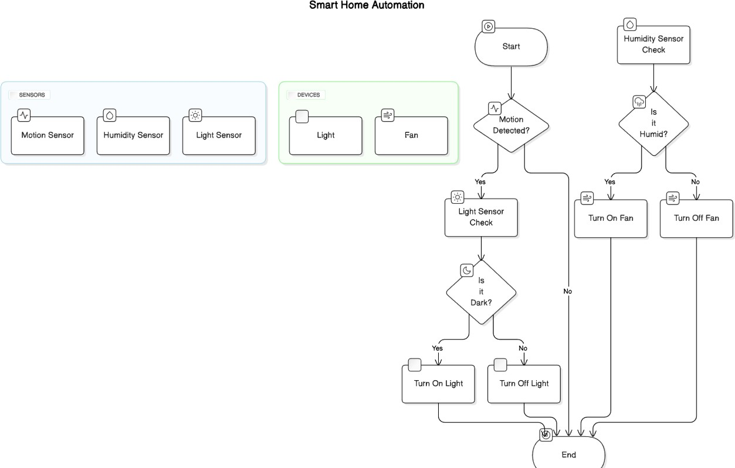

**FIGURE 11.4 ACTIVITY DIAGRAM**

* 1. **RESULTS**

**CHAPTER 12 RESULTS AND DISCUSSION**

In this subsection, the results of implementing the automated lighting and ventilation system are documented. This includes both quantitative and qualitative observations of the system’s performance under different conditions:

**Lighting Control:** The system successfully detected motion using the RCWL-0516 Microwave Radar sensor. When motion was detected, lights turned on instantly, and they turned off automatically after a preset time when no movement was detected, reducing unnecessary power usage.

**Ventilation Control:** Based on readings from the temperature/humidity sensor, the fan was automatically activated when the room’s temperature or humidity exceeded the set threshold, providing timely ventilation and ensuring comfort.

**Energy Efficiency**: The system demonstrated significant energy savings by ensuring that lights and ventilation were only active when needed, which would result in lower electricity costs over time.

* 1. **: DISCUSSION**

**System Responsiveness:** The RCWL-0516 sensor proved more effective than traditional motion sensors due to its ability to detect movement without a direct line of sight, allowing for reliable lighting control in larger rooms or rooms with obstacles.

**Sensor Precision:** The temperature and humidity sensor accurately detected changes, though minor variations in threshold settings may be necessary for environments with more frequent fluctuations.

**Power Efficiency:** The results confirmed that the system’s automatic control of lighting and ventilation contributes to energy efficiency. However, further testing in varied room conditions is recommended to fine-tune the threshold values for optimal energy savings.

**CHAPTER 13**

**CONCLUSION AND FUTURE ENHANCEMENT**

* 1. **CONCLUSION**

The automated lighting and ventilation control system met its primary objectives, demonstrating effective energy savings and environmental responsiveness. Through the RCWL-0516 Microwave Radar sensor and temperature/humidity sensor, the system provided seamless automation by detecting room occupancy and environmental conditions, enabling timely control of lighting and ventilation. This contributes to improved energy efficiency, user convenience, and operational sustainability, making the system suitable for implementation in various residential and commercial spaces.

* 1. **FUTURE ENHANCEMENT**

To improve and expand the system's capabilities, the following future enhancements are proposed:

**IoT Integration:** Incorporating IoT features with WiFi or Bluetooth connectivity would enable remote monitoring and control, allowing users to adjust settings or monitor system status through mobile applications.

**Data Analytics:** By adding a data logging feature, the system could store usage patterns and sensor readings, enabling users to track energy usage over time and adjust settings for further optimization.

**Enhanced Sensor Array**: Adding more types of sensors, such as CO₂ or air quality sensors, would enhance ventilation control by adapting to air quality in addition to temperature and humidity, further improving indoor comfort and health.

**Improved Detection Algorithms:** Fine-tuning the motion detection algorithms or using machine learning could reduce false positives and improve accuracy, especially in multi-occupancy settings or environments with background movements.

**REFERENCES**

1. Arduino.cc. (n.d.). *Getting Started with Arduino*. Retrieved from <https://www.arduino.cc/>
2. Vishay Semiconductors. (n.d.). *RCWL-0516 Microwave Motion Sensor Module*. Vishay Product Specification. Retrieved from <https://www.vishay.com/>
3. Adafruit Industries. (n.d.). *DHT Humidity & Temperature Sensor*.

Retrieved from https://learn.adafruit.com/dht

1. Wilson, S. (2018). *Smart Building IoT Automation for Lighting and Climate Control*. Journal of Engineering Technology, 15(3), 30-42.

Retrieved from [https://www.jet-journal.org](https://www.jet-journal.org/)

1. IEEE Spectrum. (2021). *Guide to IoT for Building Automation*. IEEE.

Retrieved from <https://spectrum.ieee.org/>

1. Microchip Technology. (2021). *ATmega328P Datasheet - 8-bit Microcontroller with 32K Bytes In-System Programmable Flash*. Retrieved from <https://www.microchip.com/>
2. Woyke, E. (2019). *The Future of Smart Homes: IoT-Based Lighting and Climate Control*. MIT Technology Review. Retrieved from <https://www.technologyreview.com/>
3. U.S. Department of Energy. (2022). *Energy Efficiency and Renewable Energy: Benefits of Energy Management in Commercial Buildings*. Retrieved from [https://www.energy.gov/eere/.](https://www.energy.gov/eere/) This website contains guidelines and benefits of implementing energy-efficient technologies in commercial spaces.