**Descriptive Analysis for the below table:**

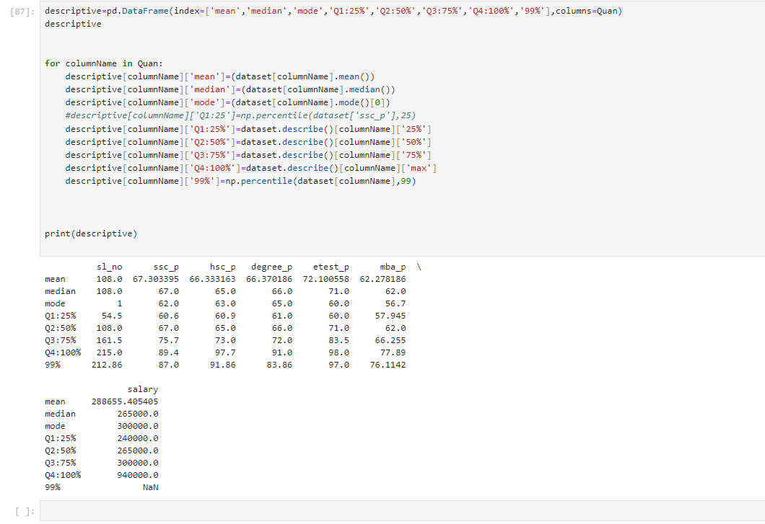

* The mean, median, and mode for all the columns except salary are very close together. This suggests that the data is symmetrically distributed and there are no outliers. For example, the mean for ssc p is 62.28, the median is 62.0, and the mode is 62.0. This means that most of the values in the ssc p column are around 62.
* The percentiles show how the data is spread out. For example, the Q1 (25th percentile) for ssc p is 54.5 and the Q3 (75th percentile) is 75.7. This means that 25% of the values in the ssc p column are below 54.5 and 25% of the values are above 75.7.
* The salary data is right-skewed. This means that there are more values on the left side of the distribution than on the right side. The mean for salary is 288,655.41, but the median is only 265,000. This suggests that there are a few very high salaries that are pulling up the mean.
* The data for all the columns except salary is symmetrically distributed. This means that there are no outliers and the data is clustered around the mean, median, and mode.
* The salary data is right-skewed. This means that there are a few very high salaries that are pulling up the mean. It might be worth looking into why these salaries are so high and whether they are representative of the rest of the data.
* The percentiles - the Q1 for ssc p is 54.5, while the Q1 for degree_p is 61.0. This suggests that students tend to score lower on their SSC exams than on their degree exams.

**IQR and the 1.5 Threshold: Identifying Outliers in Your Data**

The Interquartile Range (IQR) is a robust measure of variability in your data, and it plays a crucial role in identifying outliers – data points that deviate significantly from the main body of your data. But how do we decide what constitutes an outlier? That's where the 1.5 threshold comes in.

**Understanding IQR:**

Imagine your data points lined up from smallest to largest. The IQR captures the middle 50% of your data:

* Q1 (First Quartile): 25% of the data points are below this value.
* Q3 (Third Quartile): 75% of the data points are below this value.

IQR = Q3 - Q1

The IQR tells you how spread out the middle half of your data is. A large IQR indicates a wider spread, while a small IQR suggests your data is more tightly clustered.

**The 1.5 Threshold:**

Now, to identify outliers, we use a threshold based on the IQR. Any data point that falls more than 1.5 times the IQR below Q1 or above Q3 is considered an outlier.

The 1.5 value is chosen because it strikes a balance between sensitivity and specificity:

* Sensitivity: It captures a significant portion of true outliers (avoids missing important ones).
* Specificity: It minimizes the number of false positives (correctly identifies non-outliers).

While 1.5 is a common choice, other thresholds can be used depending on the context and desired level of strictness.

**Benefits of using IQR and the 1.5 threshold:**

* Robust to outliers: IQR is less affected by extreme values compared to measures like standard deviation.
* Easy to interpret: The IQR and thresholds are straightforward to understand and calculate.
* Visual representation: Boxplots are a helpful tool for visualizing IQR and outliers.
* IQR and the 1.5 threshold are just one approach to identifying outliers. Other methods and criteria may be suitable depending on your data and analysis goals.
* Outliers can be valuable insights, offering information about rare events or unexpected influences on your data. Investigate them carefully before discarding them.