Name : Aravinth Kumar D

Training pre-Assessment

Programming Language : Question number 1 and 3 = JAVA . Question Number 2 = C

**1.Program:**

public class Main

{

public static void main(String[] args) {

boolean married = true;

boolean unmarried = false;

boolean temporary = false;

int yearsOfExperience = 25;

if(!temporary){

if(unmarried && yearsOfExperience >= 30){

System.out.println("Eligible Loan Amount is Rs. 5,00,000");

}

else if(unmarried && yearsOfExperience < 30){

System.out.println("Eligible Loan Amount is Rs. 2,50,000");

}

else if(married && yearsOfExperience >= 30){

System.out.println("Eligible Loan Amount is Rs. 6,00,000");

}

else if(married && yearsOfExperience <= 30){

System.out.println("Eligible Loan Amount is Rs. 3,50,000");

}

}

else{

System.out.println("Eligible Loan Amount is Rs. 1,00,000");

}

}

}

Output is :

1. a married temporary job holder.



1. an unmarried temporary job holder



1. a temporary job holder with 30 years of service.



1. a married permanent job holder with 30 years’ service.

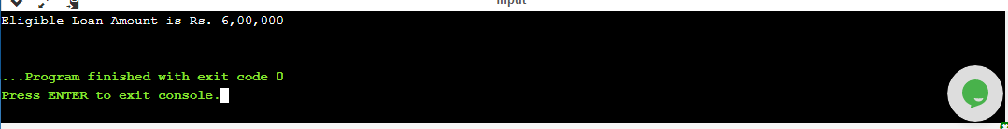

1. an unmarried permanent job holder with 30 years’ service. 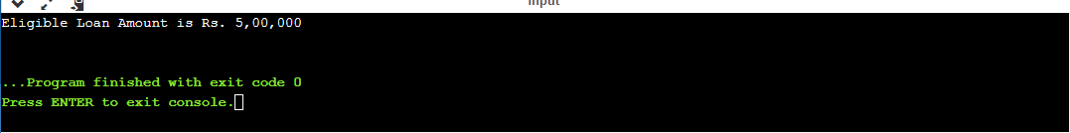

6. a married permanent job holder with 25 years of service



**2.Program:**

#include <stdio.h>

int main() {

char str[50],i;

int length = 0;

int specialCharacterCount = 0;

printf("Enter Email:");

scanf("%s",str);

//To Find the length of the string

for(i = 0; str[i]!='\0'; i++);{

length = i;

}

printf("length of email id is: %d",length );

printf("\n");

//Length should be minimum 10 and maximum 30

printf("Length should be minimum 10 and maximum 30: ");

if(length>=10 && length<=30){

printf("email is valid");

}

else{

printf("email is not valid");

}

printf("\n");

//Email id should not start with '.' ASCII value is 46 and '@' ASCII value is 64

printf("Email id should not start with '.': ");

if(str[0] == 64 || str[0] == 46){

printf("email is not valid");

}

else{

printf("email is valid");

}

printf("\n");

//Email id should end with either 'm' or 'n' ASCII value of m and n is 109 and 110 respectively.

printf("Email id should end with either 'm' or 'n': ");

if(str[length-1] == 109 || str[length-1] == 110){

printf("email is valid");

}

else{

printf("email is not valid");

}

printf("\n");

// Email id should have '@' only once

printf("Email id should have '@' only once: ");

for(int j = 0 ; j<=length; j++){

if(str[j] == 64){

specialCharacterCount++;

}

}

if(specialCharacterCount == 1){

printf("email is valid");

}

else{

printf("email is not valid");

}

return 0;

}

**OUTPUT:**

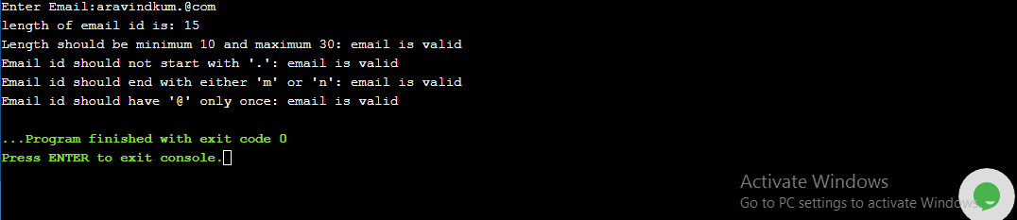

**3.Program:**

public class Main{

public static void main(String[] args) {

int orginialArrayCount = 0;

int keyArrayCount = 0;

int resultCount = 0;

int[] orginialArray = {33,10,43,33,89,10,33};

int[] keyArray = {10,43,33,65};

for(int i : orginialArray){

orginialArrayCount++;

}

for(int j: keyArray){

keyArrayCount++;

}

System.out.println("Original array count is: " +orginialArrayCount);

System.out.println("Key array count is: " +keyArrayCount);

for(int k = 0; k<=keyArrayCount; k++){

for(int l = 0; l<=orginialArrayCount; l++){

if(keyArrayCount[k] == orginialArrayCount[l]){

resultCount++;

}

System.out.print(keyArray[k]+" "+resultCount);

}

}

}}

**OUTPUT: Length Of Array without built – in Functions.**

