***NAME: ARAVINTH KUMAR D***

1.

import java.util.Arrays;

public class Main{

public static void main(String[] args) {

int[] original = {10,23,45,65,28,64};

int[] key = {10,54,64,12,23,44};

int[] found= new int[10];

int[] notfound= new int[10];

//System.out.println(Arrays.toString(original));

for(int i=0 ; i< key.length;i++){

for(int j=0 ; j< original.length;j++){

if(key[i]== original[j]){

//found[i] = key[i];

System.out.println(key[i]);

break;

}

}

if(key[i]== original[j]){

System.out.println(notfound[i]);

break;

}

}

}}

**OUTPUT:**

Found array = [10,64,23]

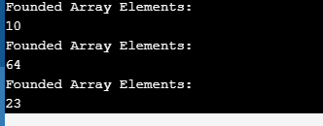

2.

**String length:**

#include <stdio.h>

int main() {

char str[50]= "Aravind";

char i;

int length = 0;

//To Find the length of the string

for(i = 0; str[i]!='\0'; i++);{

length = i;

}

printf("length of email id is: %d",length );

printf("\n");

}

**OUTPUT:**

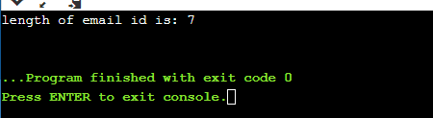

**String Reverse:**

#include<stdio.h>

#include<string.h>

int main() {

char str[100] = "Aravind";

char temp;

int i, j = 0;

i = 0;

j = strlen(str) - 1;

while (i < j) {

temp = str[i];

str[i] = str[j];

str[j] = temp;

i++;

j--;

}

printf("\nReverse string is :%s", str);

return (0);

}

**OUTPUT:**

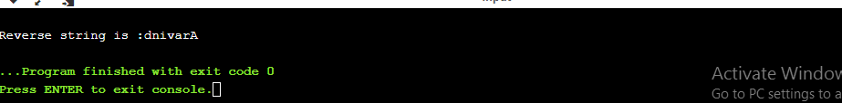

**3.**

import java.util.Arrays;

public class Main{

public static void main(String[] args) {

int[] a1 = { 1,3,33,56 };

int[] a2 = { 12,2,3,4,5,6,7,8 };

int[] concat = new int[a1.length + a2.length];

for (int i = 0, j = 0; i+j < concat.length;) {

if(i<a1.length) {

concat[i+j] = a1[i++];

}

if(j<a2.length) {

concat[i+j] = a2[j++];

}

}

System.out.println(Arrays.toString(concat));

}

}

**Output:**

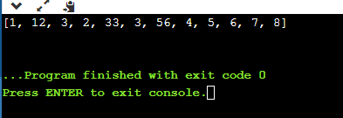

**4.**

import java.util.HashMap;

import java.util.Map;

public class Main

{

public static void main(String[] args) {

String input = "ssssdffqqqq";

//convert string to character

char [] c = input.toCharArray();

//character type is key and integertype is value

HashMap<Character, Integer> a= new HashMap<>();

for(int i = 0; i<c.length;i++){

if (a.containsKey(c[i]))

a.put(c[i],a.get(c[i])+1);

else

a.put(c[i],1);

}

System.out.println(a);

for(Map.Entry entry : a.entrySet()){

System.out.print(entry.getKey()+""+entry.getValue());

}

}

}

**OUTPUT:**

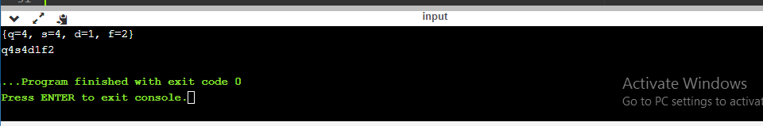

**5.**

