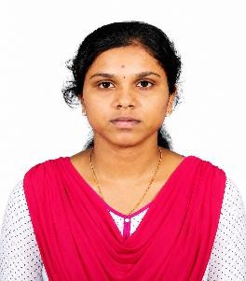
CAREER OBJECTIVE:

THAMARAISELVI U
DHARMAPURI|thamaraiselviumett2027@gmail.com|6381982416|

LikedIn : https://www.linkedin.com/in/thamaraiselvi-u-a7565b358

A motivated and passionate Metallurgical Engineering student seeking a challenging position in a reputed organization where I can apply my knowledge in Metallurgy . Eager to contribute to industrial growth while enhancing my technical skills.
PERSONAL DETAILS: DOB:27-12-2005|Gender:Female|Nationality:Indian.

EDUCATION:
BE METALLURGY: GOVERNMENT COLLEGE OF ENGINEERING, SALEM-11. CGPA:7.83%
YEAR:2023-PRESENT
12TH GRADE: R.V. HIGHER SECONDARY SCHOOL, SENDRAYMPATTI. PERCENTAGE: 92.5%
YEAR: 2022-2023

SKILLS:
TECHNICAL SKILLS: Material Testing, Foundry, Welding.
SOFT SKILLS: Decision Making, Time Management, Communication, Creative thinking.
LANGUAGES KNOWN: Tamil, English.

INTERNSHIPS:
NEYVELI LIGNITE CORPORATION [DEC 15 -DEC 27]
Gained practical exposure to bush making, crucible preheating, scrap melting, metal pouring, grinding operations, surface finishing, foundry safety , and metallurgical production processes.

QUEEN INDIA ENGINEERING SERVICES [JUNE 10 – JUNE 30]
Gained insight into non destructive testing applied identify the defects without damaging the material

MINIPROJECT: Literature Review On Fatigue Failurewith Special Reference to the Comet Aircraft Accident"

CERTIFICATION: NPTEL online certification
Material processing (casting,welding,forming).
NDT – LEVEL II COURSE CERTIFIED (VI,RT,RFI,UT,MPT,DPT)
AREA OF INTEREST: NDT and DT, Heat Treatment, Foundry
CO CURRICULAR ACTIVITIES: Hostel committee member, Industrial visit coordinator.
HOBBIES: Listening Music, Drawing.
DECLARATION: I hereby declare that the information furnished above is true to the best of my Knowledge.

