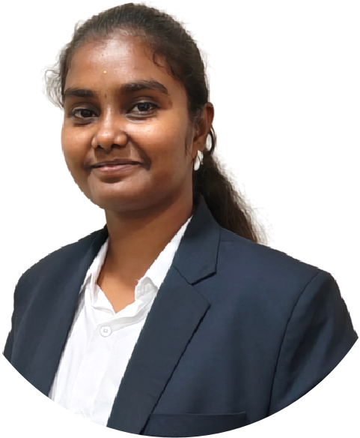
E
D
U
C
A
T
I
O
N
SONIYA
SASIKUMAR
C
O
N
T
A
C
T
+91 9042581082
ms.soniyasasikumar@gmail.com
Financial Analysis
Data Cleaning and Data
Preparation
Microsoft Excel
Python (Pandas, Numpy ,
Matplotlib )
SQL
Power BI
MS Office
Analytical Thinking
www.linkedin.com/in/
soniya-sasikumar
S
K
I
L
L
S
I
N
T
E
R
N
S
H
I
P
FORAGE - TATA GROUP COLLABORATION
Data Visualisation: Empowering Business with Effective Insights
BAJAJ FINSERV
Certificate Programme in Banking, Finance and Insurance

P
R
O
F
I
L
E
MBA student specializing in Finance with a B.Com background
and
a
strong
interest
in
Financial
Analytics
and
Business
Intelligence . Developing skills in Advanced Excel , Power BI ,
SQl , Python and Statistics to analyze financial data and identify
business trends .

KNOWLEDGE INSTITUE OF
TECHNOLOGY
Master of Business Administration
CGPA 8.4 / 10
2025-
Present
2022-2025
VIVEKANANDHA COLLEGE
OF ARTS AND SCIENCES

Bachelor of Commerce (PA)
C
GPA: 7.9/ 10
97500 00015
rgca444@gmail.com
GANESAN AND CO
Phone:

Email :
Chartered Accountant
VIDHYAA VIKAS GIRLS HIGHER
SECONDARY SCHOOL
2021-2022
HSC

Percentage - 91 %
VANI VIDHYALAYA MATRIC
HIGHER SECONDARY SCHOOL
2019-2020
SSLC

Percentage - 88 %
C
E
R
T
I
F
I
C
A
T
I
O
N
S
SALES PERFORMANCE AND BSUINESS ANALYSIS
Tools: Microsoft Excel, Advanced Formulas, PivotTables, Pivot
Charts, Slicers, Dashboard Reporting
Gained
practical
exposure
to
accounting,
auditing,
and
financial
documentation processes
GOLD PRICE PREDICTION AND CORRELATION ANALYSIS USING
STATITICAL TOOLS
EMPLOYEE DATA MANAGENT AND CLEANUNG SYSTEM USING
PYTHON
Tools: Python, Pandas, Matplotlib, Statistics, Regression Analysis
Tools & Technologies: Python, Pandas, CSV, Data Cleaning, Data
Merging, Data Joining, Data Concatenation
P
R
O
J
E
C
T
S

