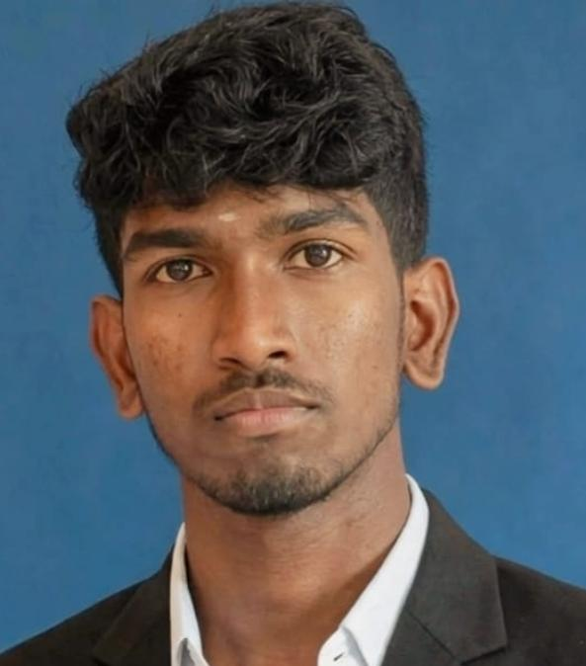
RESUME
MONISH PRASANTH .M
82/77 Ganthi nagar,
Vellakovil, Kangayam,
Tiruppur (dt)-638111

Mobile no:9384183279
Mail :monishp3279@gmail.com

OBJECTIVE:
Motivated and hardworking professional seeking an opportunity to utilize my skills and knowledge, contribute to organizational growth, and continuously develop my professional abilities while building a successful career.

ACADEMIC PROFILE:
Academic | School & College | Board & University | Percentage | Year of passing
DIPLAMO | K.S.R Institute of  Technology,  Tiruchengode. | Dote (Chennai) |  | 2026
SSLC | Government higher secondary school vellakovil | State Board  (Tamil Nadu | 41.6 | 2024
PERSONALITY TRAITS:
- Highly motivated and eager to learn.
- Strong motivational and leadership skills.
- Ability to produce strong result in challenging situation.
- Ability to work individually as well as in a group.
PROFESSIONAL SKILLS: ➢ AutoCAD
- Basic computer software & computer hardware.

CO-CURICULAR ACTIVITIES

- Won PLACE in NATIONAL LEVEL SYMPOSIUM of “CYBER CRIME AND SECURITY” at MIT Polytechnic College.

PROJECT:
- I’m currently doing my diploma project on “DIGITAL CLOCK ALARAM
- "I completed my diploma project, which involved designing and building
a IOT WEATHER SATION WITH CLOUD TELEMETRY

AREA OF INTERST:
- Manufacturing Technology
- Production Line

EXTRA-CURRICULARACTIVITIES:
- Circket

PERSONAL PROFILE:
Name : MONISH PRASANTH .m.
Father’s Name : Mr.MAHENDHIRAN .R
Date of Birth : 15.11.2006
Nationality : Indian
Languages Known : Tamil &English (Read, Write)

DECLARATION:
I hereby declare that all the details given above are true and correct to the best of my Knowledge and Belief.

Date :
Place : SIGNATURE
(MONISH PRASANTH.M.)

