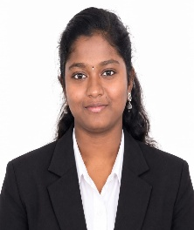
RESUME

DEVADHARSHINI M
6/44,
ANDIPALAYAM,
KORANAMPATTI,
EDAPPADI,
SALEM(DT)-637102
devadharshini.230805@gmail.com
Mobile no:9842807406

OBJECTIVE:
To start my professional career in a growth-oriented organization where I can learn new skills, apply my knowledge, and contribute to team success.

ACADEMIC PROFILE:
Academic | School & College | Board & University | Percentage | Year of passing
DIPLOMA | K.S.R Institute of  Technology,  Tiruchengode. | Dote  (Chennai) | 85% | 2027
SSLC | Krishnaveni govt girl’s higher secondary school | State Board  (Tamil Nadu) | 70% | 2021

TECHNICAL SKILLS:
- Java
- Python
- Mysql
- Html
- Ms word
- Basic computer skills

AREA OF INTEREST
- Software Development
- Artificial Intelligence
- Web Development
- Database Management Systems

SOFT SKILLS
- Quick Learning
- Problem-Solving
- Teamwork
- Communication
- Adaptability

EXTRA-CURRICULAR ACTIVITIES:
- Technical Symposium
- Workshops
- College Cultural Activities

PERSONAL PROFILE:
Name : Devadharshini m
Father’s Name : Murugesan s
Date of Birth : 23/08/2005
Languages Known : Tamil &English

DECLARATION:
I hereby declare that the information provided above is true and correct to the best of my knowledge and belief.

