JEEVA M
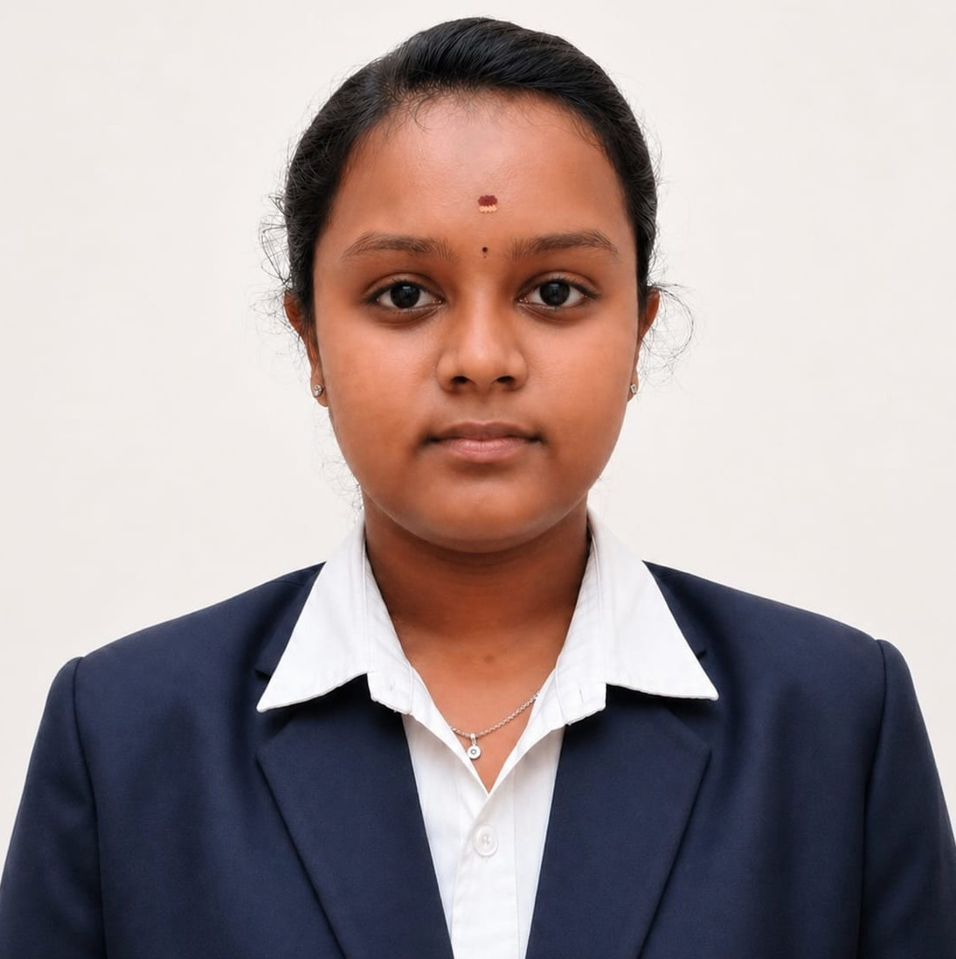

jeevamuthu29106@gmail.com  9894794013 Salem, Tamil Nadu
 linkedin.com/in/jeeva-m-071a27291
 github.com/jeeva29106

CAREER OBJECTIVE
Final-year Electronics & Communication Engineering student with a strong foundation in Java, SQL, C, Python, and OOP concepts. Seeking an Associate Software Engineer role to apply problem-solving and programming skills in developing reliable software solutions.
SKILLS
Programming: Java, C, Python, Verilog HDL
Java Technologies: Core Java, Advanced Java
Databases: SQL (Basic), MySQL
Core Fundamentals: Object-Oriented Programming (OOP), Data Structures basics, Digital Electronics, Machine Learning basics
Tools & Platforms: Git, GitHub, Hacker Rank, Code Chef, VS Code.

EDUCATION
B.E. – Electronics & Communication Engineering  K.S.R. College of Engineering, Tiruchengode | CGPA: 8.27
Higher Secondary Certificate (12th) | 83%
Govt. Hr. Sec. School, Murungapatty, Salem | 2022 – 2023
Secondary School Leaving Certificate (10th) | 100%
Govt. Hr. Sec. School, Murungapatty, Salem | 2020 – 2021
PROJECTS

Event Management Website
- Built a responsive web application using HTML, CSS, JavaScript and Java covering user registration, event booking, event details and contact features.

Shadow Detector using IC 741
- Designed a shadow-detection circuit using IC 741 and LDR to trigger an LED on light interruption, applying analog electronics for automatic lighting/security use cases.

INTERNSHIP

1.Java Full Stack Intern – EduSkills Academy [10 Weeks]

Gained hands-on exposure to Core Java, Spring Boot, Hibernate, MySQL, Git and frontend web technologies.

2.AI-ML Virtual Intern – AICTE & EduSkills (Google for Developers) [April 2025 – June 2025]

Gained practical exposure to Artificial Intelligence and Machine Learning concepts through a virtual internship.

3.Frontend Development Intern – Embuzz Technologies Pvt. Ltd. [June 2025]

Developed responsive web pages using HTML, CSS and JavaScript and gained practical exposure to frontend development.

4.Telecommunication Fundamentals Intern – BSNL, Salem [July 2024]

Gained practical exposure to telecom operations, communication infrastructure and networking concepts.

CERTIFICATIONS
- Basics of Python – Infosys Springboard (July 2025) | SQL (Basic) – HackerRank
- Introduction to Industry 4.0 & Industrial Internet of Things – NPTEL Swayam (Elite, 73%)
- Cloud Computing – NPTEL Swayam (53%)
- Full Stack Development & UI/UX Design – Novi Tech R&D Pvt. Ltd.
- RTL Design Using Verilog HDL (Level I)
- Functional Verification Using System Verilog and UVM (Level II)

