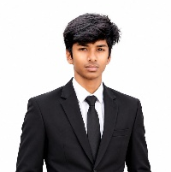
RESUME

MURUGESH M
6/7,
PULIYAMPATTIYAMPALAYAM,
ANANGUR,
KUMARAPALAYAM,
Namakkal (dt) – 637304
immurugesh.07@gmail.com
Mobile no:8056572190

OBJECTIVE:
To build a successful career in the software field by applying my technical skills, continuously learning new technologies, and contributing effectively to the organization.

ACADEMIC PROFILE:
Academic | School & College | Board & University | Percentage | Year of passing
DIPLOMA | K.S.R Institute of  Technology,  Tiruchengode. | Dote  (Chennai) | 75% | 2027
SSLC | Government High School,anangur  tiruchengode | State Board  (Tamil Nadu) | 55.8% | 2024

SOFT SKILLS
• Quick Learner
• Problem Solving
• Teamwork
• Communication Skill
• Time Management
• Adaptability
TECHNICAL SKILLS:
- MS WORD
- BASIC COMUPUTER SKILLS
- PYTHON
- JAVA
- SQL

EXTRA-CURRICULAR ACTIVITIES:
- Technical Symposium
- Workshops
- College Cultural Activities

PERSONAL PROFILE:
Name : MURUGESH M
Father’s Name : MUTHUSAMY
Date of Birth : 27/08/2009
Languages Known : Tamil &English

DECLARATION:
I hereby declare that the information provided above is true and correct to the best of my knowledge and belief.

