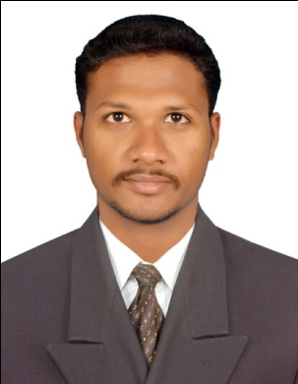
RESUME
J.SATHISHKUMAR
383/5, SALEM ROAD
TIRUCHENGODE(TK)
NAMAKKAL(DT) - 637211.
Cell: 9698184198
E.mail Id: jsathishkumar1991@gmail.com
CAREER OBJECTIVE:

To work in a globally competitive environment on challenging assignments that shall yield the twin benefits of the job satisfaction and a steady-paced professional growth.
EDUCATIONAL QUALIFICATION:

Course | University | Institution | Over All Percentage (%) | Year of Passing
MBA  (Marketing  &  Finance) | Anna University  Chennai. | Vidyaa Vikas College of Engineering and Technology,  Tiruchengode. | 74 | 2015
B.E(ECE) | Anna University  Chennai. | Mahendra  Engineering College,  Tiruchengode. | 74 | 2013
+2 | State Board | St.Antony’s.Hr.Sec.  School,  Tiruchengode. | 84 | 2009
SSLC | State Board | St.Antony’s.Hr.Sec.  School, Tiruchengode. | 84 | 2007

CERTIFICATE COURSES:
- DTP – Diplomo in Desktop Publishing
- DCA(Diploma in Computer Application)
- TALLY 9.0

COMPUTER SKILLS:
- Software Packages : Adobe Photoshop, MS Office.

Work Experience :
- I have been working in Marketing executive during (09.05.2016 to 04.10.2017) at Karur Vysya Bank
Roles:
- I worked the bank account opening forms and application (saving, current, FD, RD)
- Helpdesk work for spoke to the customer to sell the banking products.
- Adithya birla sun life insurance tie up with HDFC bank(08.05.2018 to 19.08.2019)
Roles:
- I spoke to the customer and selling the insurance products as well as build the relationship between the customer and bank staffs.
- AXIS BANK as a assistant manager for the period 27th December 2019 to 20th January 2021.
Roles:
- I go the open market and sell the banking products like CASA,TD, INSURANCE, LOAN, etc..,

- INDUSIND BANK as a cashier for the period 17th August 2022 to 28th Feb 2023
Roles:
- I worked the financial transaction like customer credit debit cash.
- I worked the all accounts transaction in the particular time duration.
- Atm cash loading and entry to the system.
- Audit files to be get ready to the given time.
- Backup to the financial statements hardcopy and soft copy.
I am extremely hard working and very easy to get along with.

AREA OF INTEREST:
- Operation, Marketing, Banking and, all financial related works.
- Computer related works
- Auditing work

PERSONAL DETAILS:
NAME : SATHISHKUMAR. J
DATE OF BIRTH : 24.12.1991
FATHER’S NAME : Jagadeesan.V
MOTHER’S NAME : Sithesvari.J
GENDER : Male
NATIONALITY : Indian
LANGUAGES KNOWN : Tamil, English
MARITAL STATUS : Married

DECLARATION
I hereby declare that the particulars furnished above are true and correct to the best of my knowledge and belief.

Place: Tiruchengode
Yours truly,

J.SATHISHKUMAR

