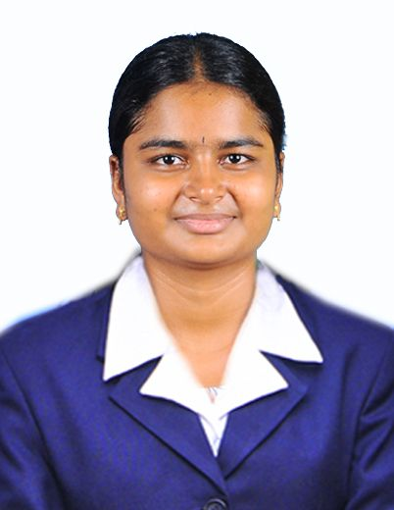
R.Susmitha
51/3vadamikadu,Rayarpalayam,
Tiruchengode(T.K),
Namakkal (DT).
9080606034,
susmithart@gmail.com

Career Objective

To get elevated in the field assigned, by exploring my skill and working hard as true to my conscience for the upliftment of the Organization as well as my personal growth.
W

Academic Qualification
Degree/ Course | Institution | University / Board | Year of Passing | %or CGPA of Marks
B.E  Electronics And Communication Engineering | K.S.Rangasamy College Of Technology (Autonomous),  Tiruchengode | Anna University, Chennai | May,  2017 | 6.71
XII | VidhyavikasMatric Higher Secondary School,  Tiruchengode | State Board | 2013 | 76.66
SSLC | VidhyavikasMatric Higher Secondary School,  Tiruchengode | State Board | 2011 | 81.4

Software Proficiency

- Language : C
- Operating systems : Windows 7,Windows 8.1,Windows 10

Areaof Interest

- C language

Certification

- Presented a paper in Erode Sengunther College of engineering on the topic 'WIRELESS HEART BEAT MONITORING SYSTEM' .
- Presented a paper in Erode Kongu engineering College on the topic 'CAR IN BLUETOOTH TECHNOLOGY'.

Project Work

Mini Project:

- Street Light Controller Using IR Sensor.
- Implementation of Wireless Network Using Fisheye Protocol.
Final Year Project:

IOT based Vehicle Diversion using Digital Image Processing.

Achievements

- Undergone workshop on INTERNET OF THINGS.
- Work shop in PSG college of technology on 'EMBEDDED SYSTEM'.

Co-Curricularactivities

- Membership on the Institution of Electronics and Telecommunication Engineers (IETE).
- Membership on Indian Society for Technical Education (ISTE).
Personal Profile

Date of Birth : 18.04.1996
Languages Know : Tamil and English
Parent’s Name : Mr.R.E.Ramasamy and Mrs.R.Thulasimani
Spouse Name : A. Satheeshkumar

Strength

- Self Motivated
- Leadership
- Hard worker
- Flexible

Hobbies

- Gardening
- Swimming

Date: Signature
Place: TIRUCHENGODE (R.SUSMITHA)

