**Phase 1 :Report**

**Problem Definition and Design Thinking:**

**Problem Definition:**

The project aims to analyze and visualize air quality data from monitoring stations in Tamil Nadu. The objective is to gain insights into air pollution trends, identify areas with high pollution levels, and develop a predictive model to estimate RSPM/PM10 levels based on SO2 and NO2 levels. This project involves defining objectives, designing the analysis approach, selecting visualization techniques, and creating a predictive model using Python and relevant libraries.

**Dataset Link:**

[**https://tn.data.gov.in/resource/location-wise-daily-ambient-air-quality-tamil-nadu-year-2014**](https://tn.data.gov.in/resource/location-wise-daily-ambient-air-quality-tamil-nadu-year-2014)

**Design Thinking:**

1. Project Objectives:

Define objectives such as analyzing air quality trends, identifying pollution hotspots, and building a predictive model for RSPM/PM10 levels.

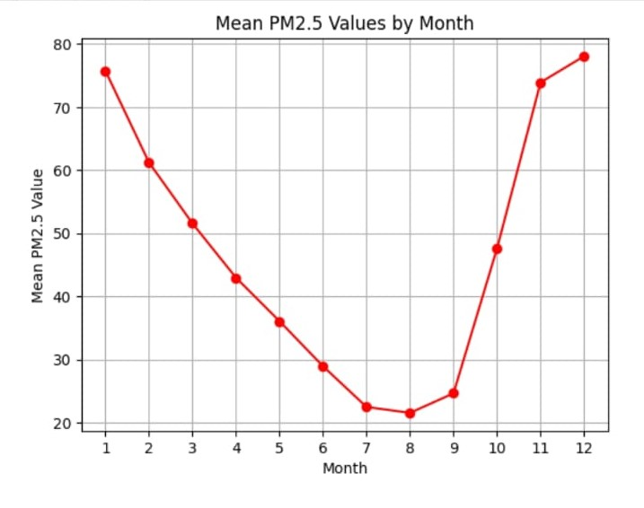

1. Analysis Approach:

Plan the steps to load, preprocess, analyze, and visualize the air quality data.

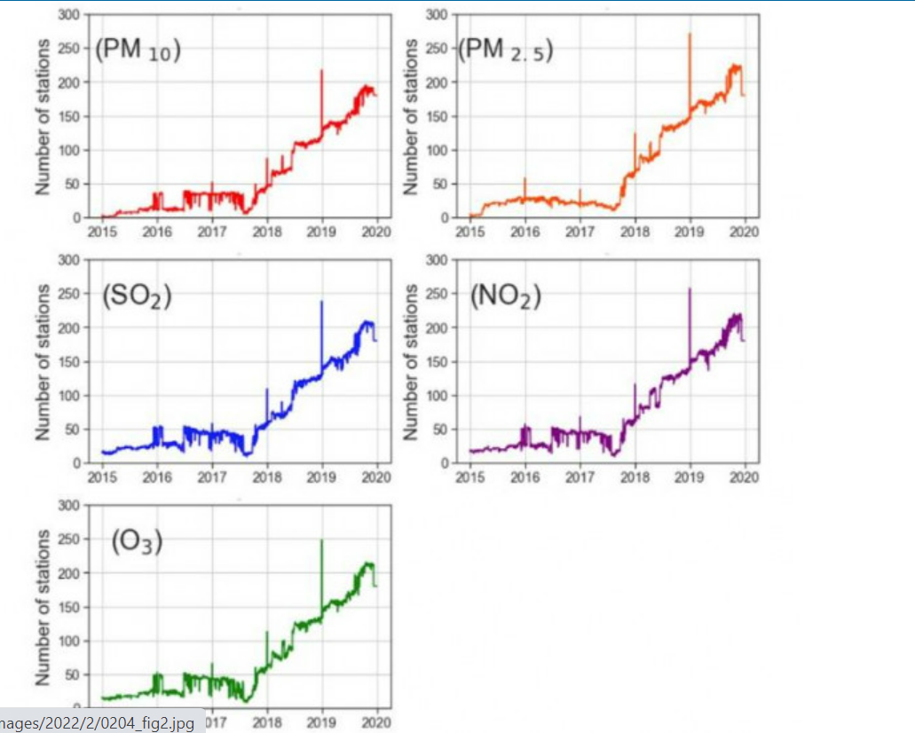

1. Visualization Selection:

Determine visualization techniques (e.g., line charts, heatmaps) to effectively represent air quality trends and pollution levels.

