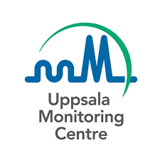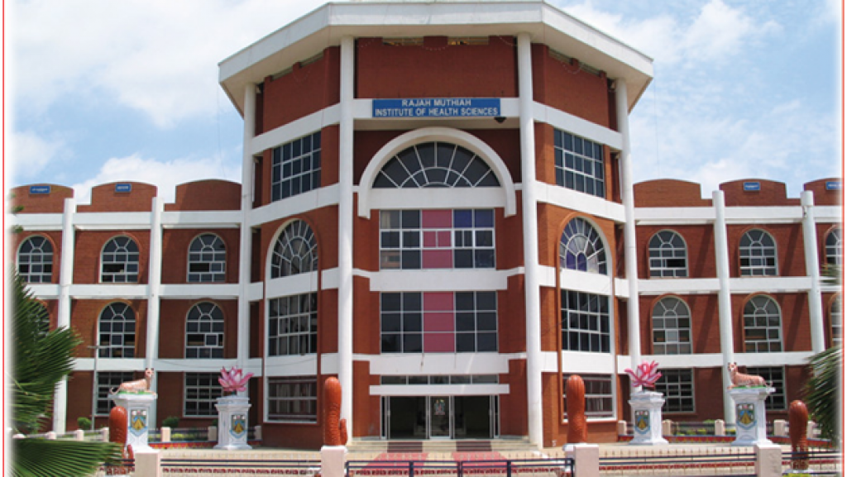

**PHARMACOVIGILANCE**

**A step towards patient's safety**

(Pharmacovigilance week 17-23 Sep 2021)

**ORGANISED BY**

DEPARTMENT OF PHARMACOLOGY

along with

MEDICAL EDUCATIONAL UNIT

RAJAH MUTHIAH MEDICAL COLLEGE

ANNAMALAI NAGAR,CHIDAMBARAM

PROGRAM’S ORGANISED:

1. 20.9.2021 - Seminar on Pharmacovigilance by post graduate students in the Department of Pharmacology.

2. 21.9.2021 & 22.9.2021 - essay writing & painting competition for undergraduates.

3. 22.9.2021 – Rally by students of RMMC.

4. 23.9.2021 – Webinar on pharmacovigilance.