Embedded Linux for BBB
Complete Study Notes

Beginner-Friendly Reference for BeagleBone Black (BBB)
Based on Udemy Course — Enhanced & Annotated
Topics Covered  12 Major Sections | Target Board  BeagleBone Black | Level  Absolute Beginner

Topics: Boot Process • U-Boot • eMMC/SD Update • Device Tree • uEnv.txt • initramfs • BusyBox • Buildroot • TFTP/NFS • Linux Source Tree

Contents
1. Linux Boot Process Overview 5
1.1 The 4-Stage Boot Chain 5
1.2 Boot Flow Diagram 6
1.3 Stage 1 — RBL (ROM Bootloader) 6
What RBL Does (in order): 6
RBL Summary Table: 8
1.4 Stage 2 — MLO / SPL (Secondary Program Loader) 8
Why Can't RBL Load U-Boot Directly? 9
What MLO Does (in order): 9
1.5 Stage 3 — U-Boot 10
U-Boot's Jobs: 10
Boot Sources Supported by U-Boot: 10
1.6 Stage 4 — Linux Kernel 10
Linux Kernel Boot Sequence (Detailed): 10
2. U-Boot — Complete Guide 12
2.1 U-Boot Source Code Structure 12
2.2 Cross Compilation — Concepts 13
Installing the Cross-Toolchain: 13
2.3 Compiling U-Boot & MLO 13
Method 1: Using the build script (easiest) 13
Method 2: Manual compilation (step by step) 14
2.4 U-Boot Environment Variables 14
Key U-Boot Commands for Environment Variables: 14
Example: Creating and Running a Custom Variable 15
2.5 Manually Booting Linux from U-Boot 15
Step-by-Step Manual Boot from MMC: 15
Decoding the UImage Header: 16
3. uEnv.txt — Automating U-Boot 19
3.1 How uEnv.txt Works 19
3.2 Complete uEnv.txt File Example and Explanation 19
Line-by-Line Explanation: 19
3.3 Creating uEnv.txt via U-Boot Shell (Serial Transfer) 20
4. SD Card Setup for Booting BBB 22
4.1 Required SD Card Partition Layout 22
4.2 Preparing the SD Card Using GParted (Ubuntu) 23
4.3 Copying Files to SD Card 24
BOOT Partition Files (copy to /dev/sdb1 mount point): 24
ROOTFS Partition Files (copy to /dev/sdb2 mount point): 24
4.4 Booting BBB from SD Card 24
5. Building the Linux Kernel from Source 25
5.1 Download the Kernel Source 25
5.2 Kernel Build Steps 25
6. Linux Device Tree 27
6.1 What Problem Does the Device Tree Solve? 27
6.2 Device Tree Files and Formats 27
6.3 Device Tree File for BBB 27
6.4 Basic Device Tree Syntax 28
6.5 How U-Boot Passes the DTB to the Kernel 28
7. initramfs — Initial RAM Filesystem 29
7.1 Is initramfs Required? 29
7.2 What Does initramfs Contain? 29
7.3 Building initramfs — Step by Step 29
Download the RFS: 29
Booting with initramfs from U-Boot: 30
Remember : Open minicom on host PC and send each files once loadx command execute the U-boot will wait for data from host PC this concept explained in section 8 30
8. Booting BeagleBone Black over Serial Port 32
8.1 How the RBL Selects UART Boot 32
How to Force UART Boot: 32
8.2 Transferring Files via xmodem 32
Complete Serial Boot Sequence: 32
9. TFTP Network Boot (Faster Development Workflow) 34
9.1 Architecture Overview 34
9.2 Setting Up TFTP Server on Ubuntu 35
9.3 On Host PC (do this first, before powering BBB): 35
9.4 TFTP Boot Commands on BBB (at U-Boot prompt) 36
9.5 Setting Up NFS Root Filesystem 36
NFS Boot Arguments (kernel bootargs): 37
At the U-Boot prompt on BBB, set the boot arguments to tell the kernel to mount root over NFS: 37
10. BusyBox — Minimal Root Filesystem 39
10.1 Why BusyBox? 39
10.2 Compiling BusyBox 40
10.3 BusyBox Init System 41
USB over Ethernet Setup 42
What is USB over Ethernet? 42
Required Directories in rootfs: 44
Loading Kernel Modules at Runtime: 45
11. Buildroot — Automated Embedded Linux Build System 46
11.1 What Buildroot Can Build 46
11.2 Getting Started with Buildroot 46
11.3 Configuring and Building for BBB 47
Key menuconfig Settings for BBB: 47
11.4 Deploying Buildroot Output 48
11.5 Enabling SSH in Buildroot 49
12. Linux Source Tree & Detailed Boot Flow 50
12.1 Linux Kernel Source Tree — Key Directories 50
12.2 Detailed Boot Flow: U-Boot to Linux User Space 51
12.3 kernel_init — Finding PID 1 52

SECTION 1 — Linux Boot Process Overview

1. Linux Boot Process Overview
When you power on a BeagleBone Black (or any ARM-based embedded Linux board), the processor does NOT immediately run Linux. Instead, it goes through a chain of small programs called bootloaders, each one handing off to the next, until finally the Linux kernel takes over. This is called the boot chain.

📝 Note
Think of it like starting a car: the ignition key triggers the starter motor, which turns the engine, which then runs on its own. Each step is necessary and happens in a fixed sequence.

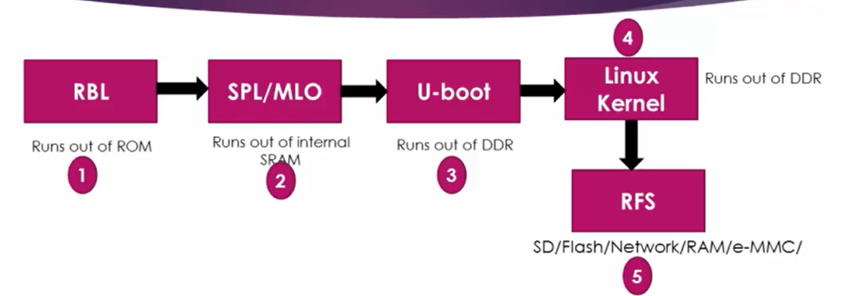
📷 Fig 1.1 — The 4-stage Linux boot chain on BBB. RBL runs from ROM (stage 1), SPL/MLO from internal SRAM (stage 2), U-Boot from DDR RAM (stage 3), then the Linux Kernel loads and mounts the Root File System (RFS) from SD/eMMC/Network (stage 4 & 5).

1.1 The 4-Stage Boot Chain
On the BeagleBone Black (AM335x SoC), booting happens in four distinct stages:

Stage | Description
Stage 1: RBL | ROM Bootloader — hardcoded in the SoC's ROM by Texas Instruments. Runs first, always. Cannot be modified.
Stage 2: MLO / SPL | Memory Loader / Secondary Program Loader — a tiny program that initializes RAM and loads U-Boot.
Stage 3: U-Boot | Universal Bootloader — a full-featured bootloader that initializes peripherals and loads the Linux kernel.
Stage 4: Linux Kernel | The actual Linux operating system starts, mounts the root filesystem, and runs user applications.

1.2 Boot Flow Diagram
Each box below represents a stage that runs in sequence on every power-on:

POWER ON
Processor resets, start at fixed ROM address 0x20000
▼
RBL — ROM Bootloader
Initializes stack, watchdog, clock → finds & copies MLO to internal SRAM
▼
MLO / SPL — Secondary Program Loader
Initializes DDR RAM, UART, PLL → copies U-Boot to DDR RAM
▼
U-Boot — Universal Bootloader
Initializes peripherals (USB, Ethernet, MMC) → loads kernel + DTB to DDR RAM
▼
Linux Kernel
Decompresses, initializes CPU/MMU → mounts rootfs → runs /sbin/init
▼
User Space
/sbin/init starts daemons, login shell appears

1.3 Stage 1 — RBL (ROM Bootloader)
The RBL (ROM Bootloader) is the very first piece of code that runs when the SoC gets power. It is burned permanently into the chip's internal ROM by Texas Instruments and cannot be changed.

What RBL Does (in order):
- Sets up the CPU stack in the small internal SRAM.
- Calls the bootloader main() function.
- It initializes and starts Watchdog Timer 1 with a 3-minute timeout. If MLO is not loaded within 3 minutes, the SoC resets automatically.
- Configure the system clock using the PLL (Phase Locked Loop) engine.
- Reads boot configuration pins SYSBOOT[14:15] to determine clock source frequency.
- Scans boot devices in order (MMC, USB, UART, SPI…) to find MLO.
- Copies MLO from the boot device into the internal SRAM of the SoC.
- Jumps to the start of MLO in SRAM.

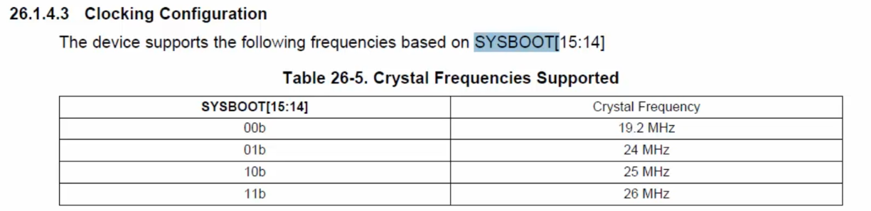

📷 Fig 1.2 — Crystal Frequencies Supported (from TI AM335x TRM, Table 26-5). This table shows how SYSBOOT[15:14] pin configuration determines which crystal frequency the RBL expects. BBB uses SYSBOOT = 01b (pin14=VCC, pin15=GND), which selects 24 MHz. The PLL then uses this 24 MHz reference to generate the 500 MHz CPU clock.

SYSBOOT[15:14] | Crystal Frequency
00b | 19.2 MHz
01b (BBB default) | 24 MHz
10b | 25 MHz
11b | 26 MHz

📝 Note
PLL (Phase Locked Loop) is a hardware circuit that takes a low-frequency input clock
(from a crystal oscillator — typically 24 MHz on BBB) and multiplies it up to a much
higher frequency for the CPU and peripherals. The RBL configures the PLL to run at
500 MHz for the BBB's default 24 MHz crystal.

📝 Note
SYSBOOT[14:15] are physical pins on the SoC. On BBB: pin 14 → VCC (high), pin 15 → GND (low).
This combination signals the PLL to use a 24 MHz reference and output 500 MHz.
This frequency cannot be changed during RBL — only MLO can later reconfigure it.

RBL Summary Table:
Task | Details
Stack Setup | Sets up initial CPU stack in internal SRAM for C code execution
Watchdog Timer | Started with 3-minute timeout as safety reset mechanism
Clock Init | Reads SYSBOOT pins → programs PLL → 500 MHz output
Boot Device Search | Scans MMC0 → MMC1 → USB → UART → SPI for MLO/SPL file
Copy MLO to SRAM | Copies MLO binary (max ~256 KB) into internal SRAM
Jump to MLO | Transfers CPU execution to MLO start address in SRAM

⚠️ Important
The RBL always looks for a file named exactly 'MLO' on the boot device.
On a FAT-formatted SD card, this file MUST be in the root directory and named 'MLO'.
Any other name will cause the RBL to fail and the watchdog will reset the board.

1.4 Stage 2 — MLO / SPL (Secondary Program Loader)
MLO stands for Memory Loader (or SPL — Secondary Program Loader). It is a small program (~100–250 KB) that bridges the gap between the RBL and U-Boot. The key problem it solves: U-Boot is too large (500 KB to 1.5 MB) to fit in with the SoC's internal SRAM (~128 KB available). MLO initializes the external DDR RAM, so U-Boot has somewhere to live.
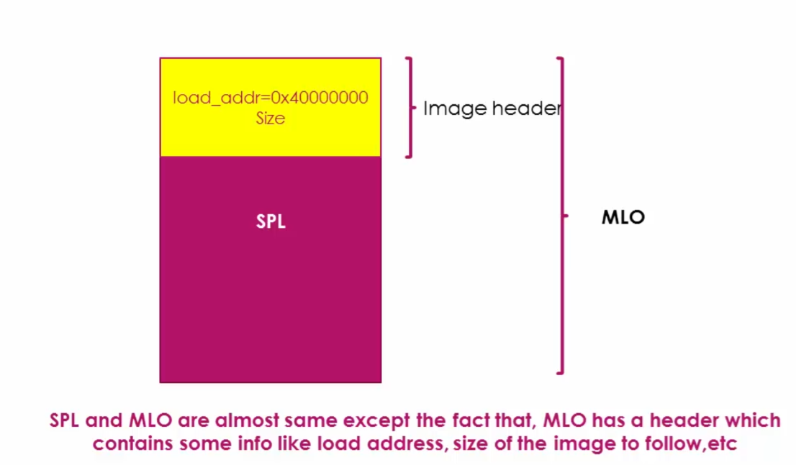
📷 Fig 1.3 — MLO vs SPL structure. Both MLO and SPL contain the same SPL executable code (shown in magenta/purple). The difference is that MLO has an Image Header prepended (shown in yellow), which contains load_addr=0x40000000 (where to load the image in SRAM) and the Size of the image. RBL reads this header first to know where to place the image in memory, then copies the SPL code there.

Why Can't RBL Load U-Boot Directly?
Resource | Details
Internal SRAM size | ~128 KB total (some reserved for stack and secure regions — effectively < 100 KB usable)
U-Boot typical size | 500 KB to 1.5 MB — doesn't fit in SRAM
DDR RAM at RBL time | DDR RAM controller not yet initialized — DDR cannot be used yet
MLO solution | MLO fits in SRAM, initializes DDR, then copies U-Boot to DDR

What MLO Does (in order):
- Initializes UART console — so you can see debug messages from this point onwards.
- Reconfigures PLL if a different clock speed is required (optional, board-specific).
- Initializes the DDR RAM controller so DDR memory becomes usable.
- Configures pin multiplexing (MUX) many SoC pins serve multiple purposes; MLO sets each pin to the function needed for booting (e.g., MMC pins).
- Reads U-Boot image from the boot device (SD card, eMMC, etc.).
- Copies U-Boot to DDR RAM at the address specified in U-Boot's header.
- Jumps to U-Boot's entry point in DDR RAM.

💡 Tip
Pin Multiplexing (MUX): A single physical pin on the SoC can be connected to different
internal hardware signals (SPI, CAN, I2C, MMC etc.) but only one at a time. MLO
configures the MUX registers to connect each pin to the right peripheral before
trying to communicate over that peripheral.

1.5 Stage 3 — U-Boot
U-Boot (Universal Bootloader) is an open-source, feature-rich bootloader used on millions of embedded devices worldwide. It is the third stage and the most configurable one.

U-Boot's Jobs:
- Initializes hardware peripherals: I2C, NAND flash, Ethernet, USB, UART, MMC, etc.
- Provide an interactive command-line interface for debugging and manual booting.
- Load the Linux kernel image (uImage or zImage) from a boot source into DDR RAM.
- Load the Device Tree Blob (DTB file) into DDR RAM.
- Set up kernel boot arguments (bootargs environment variable).
- Jump to the kernel entry point.

Boot Sources Supported by U-Boot:
U-Boot can load the kernel from: SD card (MMC0), eMMC (MMC1), USB, Ethernet (TFTP), Serial Port (xmodem), NAND flash.

1.6 Stage 4 — Linux Kernel
After U-Boot loads the kernel into DDR RAM and sets the boot arguments, it calls the kernel's entry point. The kernel takes over from here.

Linux Kernel Boot Sequence (Detailed):
- U-Boot calls kernel_entry(0, machid, r2) — r2 holds the address of the DTB in DDR RAM.
- arch/arm/boot/compressed/head.S runs — sets up basic environment in Thumb/ARM mode.
- misc.c decompresses the kernel image (zImage is a compressed kernel).
- arch/arm/kernel/head.S runs — performs CPU-specific initialization.
- head.S validates the processor architecture, sets up page tables, initializes and enables the MMU (virtual memory).
- head.S calls start_kernel() in init/main.c.
- start_kernel() initialises all kernel subsystems: memory, scheduler, IRQ, filesystems…
- start_kernel() calls rest_init() which creates two kernel threads: kernel_init and kthreadd.
- The scheduler starts running. The idle task (while(1)) runs when nothing else is scheduled.
- kernel_init frees the memory used for boot-time init functions (marked __init).
- kernel_init tries to execute the first userspace program in this order: /sbin/init → /etc/init → /bin/init → /bin/sh. The first one that exists and runs successfully becomes PID 1.

📝 Note
MMU = Memory Management Unit. It translates 'virtual addresses' that programs use
into 'physical addresses' that actually exist in RAM. Before MMU is enabled, every
address is a direct physical address. After MMU is on, processes get isolated address
spaces and can't accidentally overwrite each other's memory.

SECTION 2 — U-Boot Deep Dive

2. U-Boot — Complete Guide
U-Boot is the most important bootloader in the embedded Linux world. This section covers its source structure, environment variables, commands, and how to compile it from scratch.

2.1 U-Boot Source Code Structure
Clone URL: https://openbeagle.org/beagleboard/u-boot/-/tree/v2022.04-bbb.io-am335x-am57xx

Directory/File | Purpose
arch/ | Architecture-specific code (ARM, MIPS, x86, RISC-V, etc.)
arch/arm/cpu/ | ARM CPU-specific code
arch/arm/cpu/arm7/start.S | Entry point: the assembly file that jumps from ROM to SPL
arch/arm/lib/bootm.c | Kernel boot code — picks kernel from RAM and hands over control
board/ | Board-specific files for hundreds of hardware platforms
board/ti/am335x/ | Files specific to the BeagleBone Black (AM335x SoC)
configs/ | Default configuration files for each supported board
configs/am335x_boneblack_defconfig | Default config file for BBB — used during build
include/ | Header files and board configuration headers
common/ | Common code: command implementation, environment handling
drivers/ | Device drivers: MMC, USB, Ethernet, serial, etc.
Makefile | Top-level build system entry point

2.2 Cross Compilation — Concepts
Since your development PC runs on x86/x64 but BBB uses ARM, you cannot compile U-Boot with your PC's native GCC. You need a cross-compiler — a compiler that runs on x86 but produces ARM binary code.

Term | Meaning
Host machine | Your PC (x86_64 Linux)
Target machine | BeagleBone Black (ARM Cortex-A8)
Cross compiler | GCC that runs on host but generates code for target
CROSS_COMPILE prefix | arm-linux-gnueabihf- (hard-float ABI) or arm-linux-gnueabi-
Toolchain | Set of tools: compiler (gcc), linker (ld), assembler (as), debugger (gdb)

Installing the Cross-Toolchain:
Download from: https://releases.linaro.org/components/toolchain/binaries/latest-7/arm-linux-gnueabi/

# Extract the toolchain
tar -xf gcc-linaro-7.5.0-2019.12-x86_64_arm-linux-gnueabi.tar.xz

# Add to PATH permanently — edit your shell profile:
vi ~/.bashrc
# Add this line at the end:
export PATH=$PATH:/home/user/gcc-linaro-7.5.0-2019.12-x86_64_arm-linux-gnueabi/bin

# Apply changes:
source ~/.bashrc

# Verify installation:
arm-linux-gnueabihf-gcc --version

2.3 Compiling U-Boot & MLO

Method 1: Using the build script (easiest)
# Give execution permission
sudo chmod +x build-am335x.sh

# Run the script
sudo ./build-am335x.sh

Method 2: Manual compilation (step by step)

Step 1: Clean previous build artifacts
make CROSS_COMPILE=arm-linux-gnueabihf- distclean
This deletes all previously compiled object files so you start fresh.

Step 2: Apply board default configuration
make CROSS_COMPILE=arm-linux-gnueabihf- am335x_boneblack_defconfig
This reads the defconfig file from configs/ and writes a .config file.
Output: 'configuration written to .config'

Step 3: Optional: Open menuconfig for customisation
make CROSS_COMPILE=arm-linux-gnueabihf- menuconfig
A text-based GUI opens. You can enable/disable features. Press Escape when done.

Step 4: Compile with parallel jobs
make ARCH=arm CROSS_COMPILE=arm-linux-gnueabihf- -j4 # for 4-core CPU
make ARCH=arm CROSS_COMPILE=arm-linux-gnueabihf- -j8 # for 8-core CPU
The -j flag tells 'make' to run N compilation jobs in parallel (speeds up build).
After successful compilation, these files are generated:
• u-boot.img — the U-Boot bootloader binary
• MLO — the SPL/Secondary Program Loader
• spl/u-boot-spl.bin — SPL binary (same as MLO)

2.4 U-Boot Environment Variables
U-Boot maintains a set of environment variables that control its behaviour. These can be viewed, created, and modified at the U-Boot prompt.

Key U-Boot Commands for Environment Variables:
Command | What it Does
printenv | Lists ALL environment variables and their values
printenv bootargs | Shows the value of a specific variable (bootargs in this example)
setenv serverip 192.168.7.1 | Creates or updates an environment variable
setenv bootargs console=ttyO0,115200 | Sets the kernel boot arguments
run bootcmd | Executes the commands stored inside the bootcmd variable
saveenv | Saves all current environment variables to persistent storage
env import -t 0x82000000 36 | Imports environment variables from memory address 0x82000000 (36 bytes)

Example: Creating and Running a Custom Variable
# Create a variable that holds a command:
setenv my_mmc_list 'mmc list'

# Check it was saved:
printenv my_mmc_list
# Output: my_mmc_list=mmc list

# Run the command stored in the variable:
run my_mmc_list
# Output:
# OMAP SD/MMC: 0 (SD) <-- SD card slot
# OMAP SD/MMC: 1 <-- eMMC storage

2.5 Manually Booting Linux from U-Boot
You can boot Linux manually from the U-Boot prompt without any uEnv.txt file. This is useful for debugging. Press any key when you see 'Hit any key to stop autoboot 3' to enter the U-Boot shell.

Step-by-Step Manual Boot from MMC:

# Step 1: List of available MMC devices
mmc list
# OMAP SD/MMC: 0 (SD) <-- mmc 0 = SD card
# OMAP SD/MMC: 1 <-- mmc 1 = eMMC

# Step 2: Load kernel image into DDR RAM
# Syntax: load mmc <device>:<partition> <address> <filename>
load mmc 0:1 0x82000000 uImage
# '0:1' means device 0 (SD card), partition 1 (BOOT partition, FAT)
# '0x82000000' is the DDR RAM target address

# Step 3: Load Device Tree Blob (DTB) into DDR RAM
load mmc 0:1 0x88000000 am335x-boneblack.dtb

# Step 4: Set kernel boot arguments
setenv bootargs console=ttyO0,115200 root=/dev/mmcblk0p2 rw
# ttyO0 = UART0 serial console at 115200 baud
# root=/dev/mmcblk0p2 = mount partition 2 of SD card as root filesystem

# Step 5: Boot the kernel
# Syntax: bootm <kernel_addr> - <dtb_addr>
bootm 0x82000000 - 0x88000000
# The '-' in the middle is a placeholder for initramfs (not used here)

📝 Note
Address Map for BBB DDR RAM:
0x82000000 → Load kernel image (uImage) here
0x88000000 → Load Device Tree Blob (.dtb) here
0x88080000 → Load initramfs here (if used)
These are conventions — you can use other addresses if they don't overlap.

Decoding the UImage Header:
A uImage is a zImage (compressed kernel) with a 64-byte U-Boot header prepended. You can inspect this header.
uImage Structure
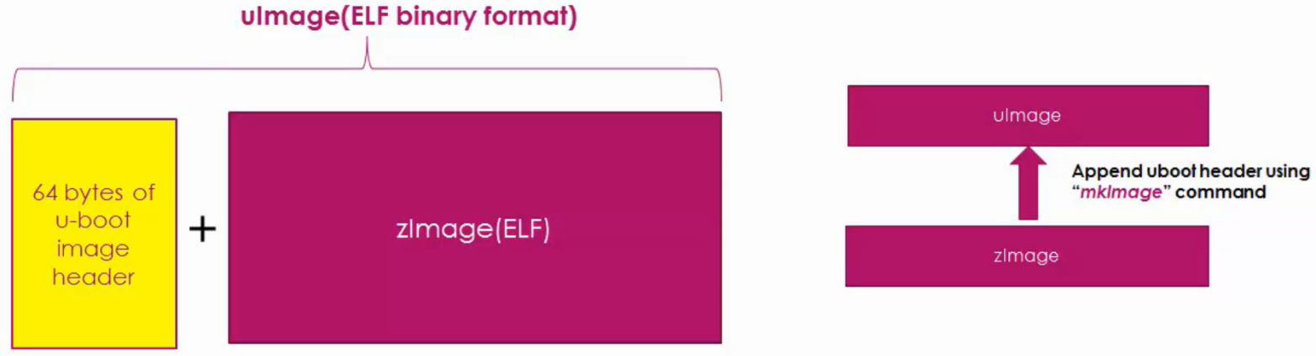
s
📷 Fig 2.1 — uImage structure. A uImage (ELF binary format) is created by taking the standard zImage (the compressed Linux kernel ELF binary) and prepending a 64-byte U-Boot image header using the 'mkImage' command. The header tells U-Boot: where to load the image in DDR RAM, the image size, CRC checksum, architecture type, and entry point address.
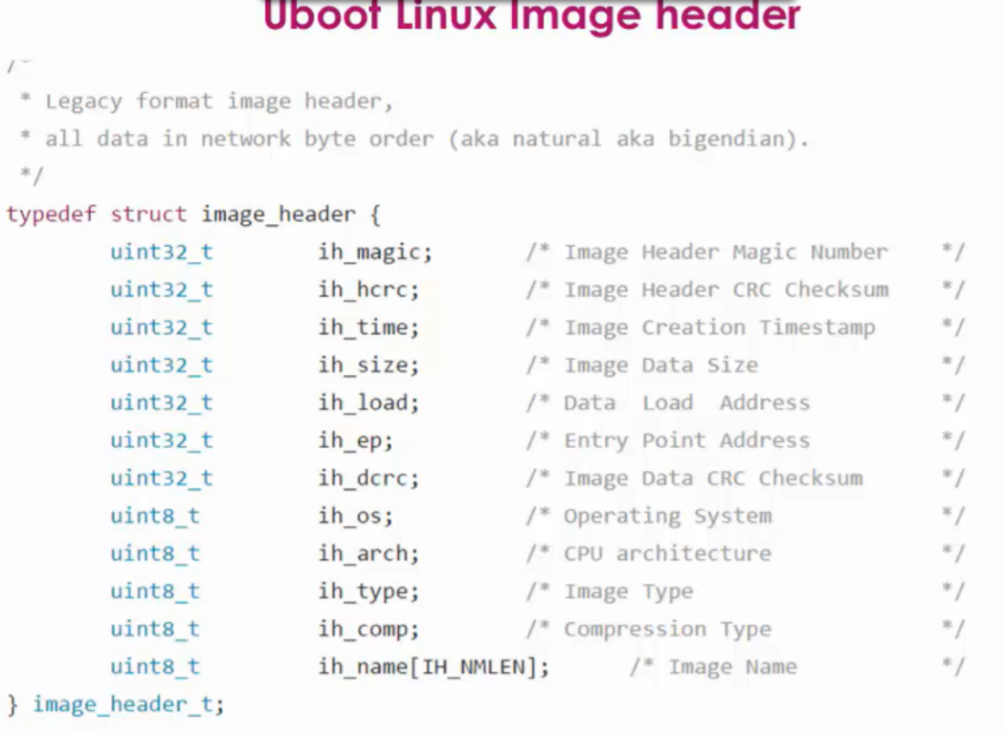
📷 Fig 2.2 — U-Boot Linux Image Header C structure (image_header_t). This is the actual C struct definition from U-Boot source code (include/image.h). Each field is a 32-bit or 8-bit integer stored in big-endian (network byte order). ih_magic identifies the file as a U-Boot image, ih_hcrc verifies the header itself, ih_dcrc verifies the data payload, ih_load is where to put the image in RAM, ih_ep is the first instruction to run (entry point), ih_name is a 32-character human-readable name.

Manually Reading the uImage Header at U-Boot Prompt
After loading uImage to DDR RAM at 0x82000000, you can inspect its header two ways:

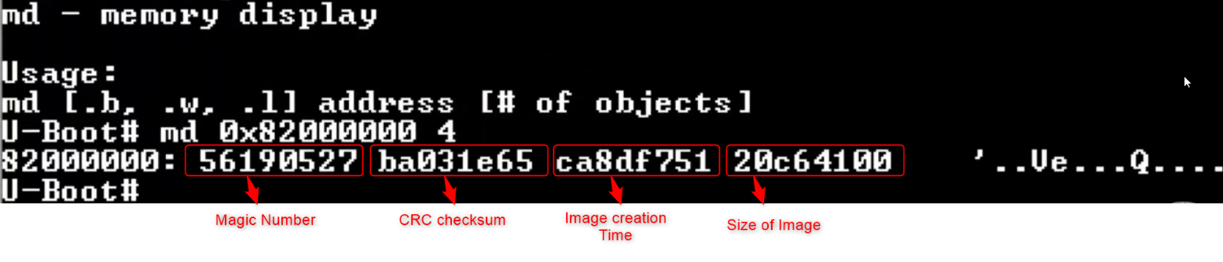
📷 Fig 2.3 — Using 'md' (memory display) command at U-Boot prompt to read raw header bytes. Command: 'md 0x82000000 4' displays 4 words (16 bytes) starting at 0x82000000. The four highlighted values are (in order): Magic Number (0x56190527 — this is the U-Boot magic 'IH_MAGIC'), CRC Checksum of the header, Image Creation Timestamp (Unix timestamp), and Size of Image in bytes. These are raw hex values in big-endian format.

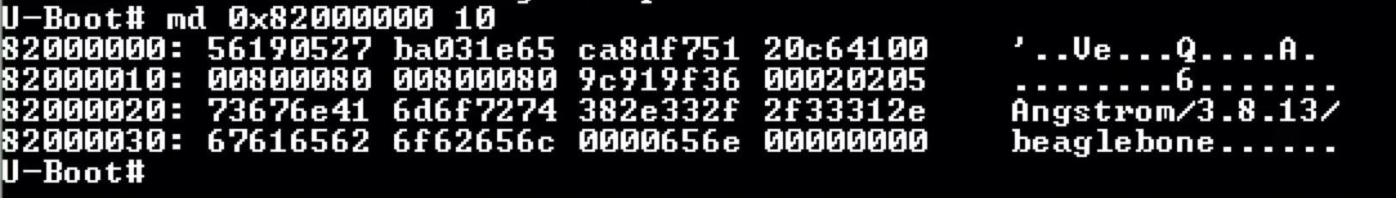

📷 Fig 2.4 — Extended 'md 0x82000000 10' output showing 16 words (64 bytes = full header). The highlighted text on the right side shows 'Angstrom/3.8.13/beaglebone’ this is the ih_name field decoded as ASCII. Reading the rows: Row 1 (magic, CRC, timestamp, size), Row 2 (load address 0x80008000, entry point 0x80008000, data CRC, OS/arch/type/comp bytes), Rows 3-4 (the 32-byte image name string).

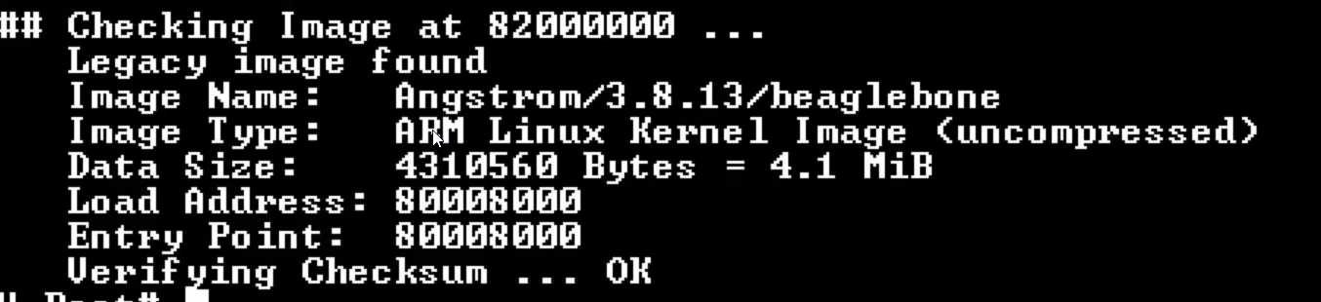

📷 Fig 2.5 — Using 'imi 0x82000000' command — the Image Info command. This is the proper way to decode the U-Boot header. It prints all fields in human-readable format: Image Name, Image Type (ARM Linux Kernel), Data Size (4.1 MiB), Load Address (0x80008000), Entry Point (0x80008000), and Checksum verification result (OK). This is much easier to read than raw hex from 'md'.

# The two commands to read uImage header:
md 0x82000000 4 # Raw hex dump of first 16 bytes (manual decoding)
imi 0x82000000 # Formatted image info (recommended — much clearer)

U-Boot Boot Log — What Success Looks Like

# After loading uImage to DDR RAM:
imi 0x82000000

# Example output:
# Image Name: Linux-4.4.62-ti-r99
# Created: 2017-xx-xx
# Image Type: ARM Linux Kernel Image (uncompressed)
# Data Size: 11334208 Bytes = 10.8 MiB
# Load Address: 80008000
# Entry Point: 80008000
# Verifying Checksum ... OK

📷 Fig 2.6 — Successful U-Boot kernel boot log in minicom. Reading line by line: '## Booting kernel from Legacy Image at 82000000' — U-Boot found the kernel at the DDR address; Image Name, Type, Size, Load Address, Entry Point are printed from the uImage header; 'Verifying Checksum ... OK' — CRC check passed; '## Flattened Device Tree blob at 88000000' — DTB found at its DDR address; 'Loading Kernel Image ... OK'; 'Using Device Tree in place at 88000000'; 'Starting kernel ...' — this is U-Boot's

⚠️ Important
'Starting kernel ...' is the last message printed by U-Boot.
Everything after that comes from the Linux kernel itself.
If the screen goes blank after 'Starting kernel ...' it means the kernel
crashed or the console (ttyO0) is not configured correctly in bootargs.

SECTION 3 — uEnv.txt File

3. uEnv.txt — Automating U-Boot
Instead of typing boot commands manually at the U-Boot prompt every time, you can create a file called uEnv.txt and place it on the SD card's BOOT partition. U-Boot reads this file automatically and executes the commands inside it. This is how BBB automates the Linux boot process.

📝 Note
uEnv.txt must be placed in the BOOT partition (FAT formatted, partition 1) of the SD card,
NOT in the ROOTFS partition. U-Boot can only read FAT partitions; it cannot read ext3/ext4.

3.1 How uEnv.txt Works
When U-Boot starts its boot process (the 'boot' command), it automatically looks for a file named uEnv.txt on the boot device. If found, it reads the variables defined in the file and adds them to U-Boot's environment, then executes the 'uenvcmd' variable if it exists.

3.2 Complete uEnv.txt File Example and Explanation
console=ttyO0,115200n8
ipaddr=192.168.7.2
serverip=192.168.7.1
loadaddr=0x82000000
fdtaddr=0x88000000
loadfromsd=load mmc 0:2 ${loadaddr} /boot/uImage;load mmc 0:2 ${fdtaddr} /boot/am335x-boneblack.dtb
linuxbootargs=setenv bootargs console=${console} root=/dev/mmcblk0p2 rw
uenvcmd=setenv autoload no; run loadfromsd; run linuxbootargs; bootm ${loadaddr} - ${fdtaddr}

Line-by-Line Explanation:
Variable | Explanation
console=ttyO0,115200n8 | Sets the Linux kernel console to UART0 at 115200 baud, 8N1 (no parity, 1 stop bit). 'n8' means 'no parity, 8 data bits'.
ipaddr=192.168.7.2 | Sets the IP address of the BBB board (used for TFTP/NFS networking).
serverip=192.168.7.1 | Sets the IP address of the host PC (TFTP/NFS server).
loadaddr=0x82000000 | A variable storing the DDR address where the kernel image will be loaded.
fdtaddr=0x88000000 | A variable storing the DDR address where the Device Tree Blob (DTB) will be loaded. 'fdt' = Flattened Device Tree.
loadfromsd=load mmc 0:2... | Loads uImage from SD card (mmc 0, partition 2) to loadaddr, then loads DTB to fdtaddr. ';' chains two commands.
linuxbootargs=setenv bootargs... | Builds the kernel command line tells the kernel to use ttyO0 for console, mount mmcblk0p2 (SD partition 2) as root, read-write.
uenvcmd=... | The main auto-execute variable. Disables auto DHCP, runs loadfromsd, sets bootargs, then boots the kernel.

📝 Note
mmc 0:2 breakdown:
mmc 0 = First MMC device (SD card in the card slot)
mmc 1 = Second MMC device (eMMC soldered to board)
0:2 = Device 0, Partition 2 (the ext3 ROOTFS partition)
0:1 = Device 0, Partition 1 (the FAT BOOT partition)
mmcblk0p2 = Linux device name for SD card partition 2 (same as 0:2)

3.3 Creating uEnv.txt via U-Boot Shell (Serial Transfer)
During development, you can transfer a uEnv.txt file directly from your PC to the BBB over the serial port using U-Boot's loady command (ymodem protocol), without touching the SD card. Here is how to do it:

Step 1 — Create uEnv.txt on your PC
Open a text editor, write your environment variables one per line, and make sure there is a blank new line at the end of the file. Example:
mypcip=setenv serverip 192.168.1.2

Step 2 — Stop autoboot and enter U-Boot shell
Power on the BBB. When you see the countdown in minicom:
Hit any key to stop autoboot: 3
Press any key to stop autoboot and reach the U-Boot prompt:
U-Boot#

Step 3 — Prepare U-Boot to receive the file
At the U-Boot prompt, run:
U-Boot# loady 0x82000000
This tells U-Boot to wait for an incoming ymodem transfer and place the received file at DDR address 0x82000000. U-Boot will sit silently waiting.
Step 4 — Send the file from minicom
In minicom, press Ctrl+A then S, select ymodem, navigate to your uEnv.txt file, press Space to select it, then Enter to start the transfer. After completion, minicom reports the number of bytes transferred — note that number (for example, 36 bytes).

Step 5 — Import variables into U-Boot environment
Once the transfer is done, import the file contents into U-Boot's active environment:
U-Boot# env import -t 0x82000000 36
- -t means the data is plain text
- 0x82000000 is where the file sits in DDR RAM
- 36 is the exact file size in bytes reported after the transfer

Step 6 — Verify and run the imported variables
Check the variable was imported correctly:
U-Boot# printenv mypcip
mypcip=setenv serverip 192.168.1.2
Now run it:
U-Boot# run mypcip
U-Boot# printenv serverip
serverip=192.168.1.2
run mypcip executes the command stored inside that variable, which creates the serverip variable as confirmed by printenv.

Note: Variables imported this way only exist for the current U-Boot session. They are lost on reboot unless you run saveenv or place the uEnv.txt on the SD card BOOT partition so U-Boot loads it automatically every time.

SECTION 4 — SD Card Setup & Booting from SD

4. SD Card Setup for Booting BBB
To boot BBB from an SD card (instead of the default eMMC), you need to prepare the SD card with two specific partitions and copy the correct boot files to each partition.

4.1 Required SD Card Partition Layout
Partition | Details
Partition 1: BOOT | Format: FAT16 or FAT32 | Label: BOOT | Size: 1 GB | Flag: bootable | Contents: MLO, u-boot.img, uEnv.txt
Partition 2: ROOTFS | Format: ext3 | Label: ROOTFS | Size: Remaining space | Contents: Extracted root filesystem (all Linux files)
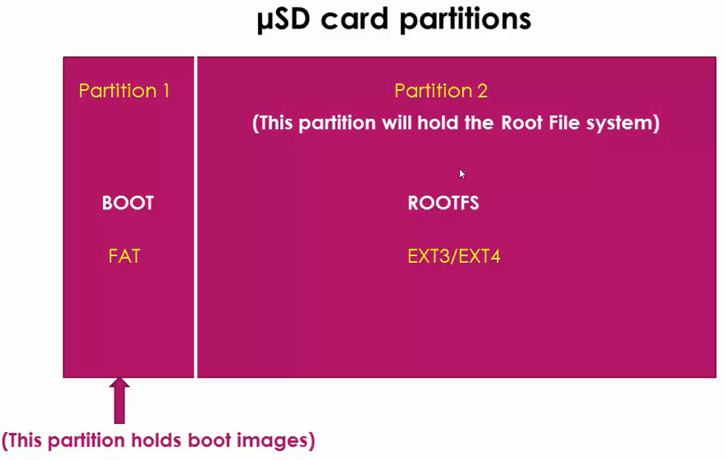
📷 Fig 4.1 — µSD Card Partitions diagram. The SD card must be divided into exactly two partitions: Partition 1 (BOOT) — formatted as FAT filesystem, holds boot images (MLO, u-boot.img, uEnv.txt). This is the partition U-Boot reads because U-Boot only understands FAT. Partition 2 (ROOTFS) — formatted as EXT3 or EXT4, holds the complete Linux root filesystem (all system files, libraries, init scripts, user applications). The arrow at the bottom points to Partition 1 with the label 'This partition holds boot images'.

📝 Note
Why two partitions?
U-Boot can only read FAT filesystems (BOOT partition). The Linux kernel needs an
ext3/ext4 filesystem for the root filesystem (ROOTFS partition). They must be separate
because each has different filesystem format requirements.

4.2 Preparing the SD Card Using GParted (Ubuntu)
- Connect SD card reader to PC.
- Open a terminal and run: dmesg to identify the SD card device name (e.g., /dev/sdb).
- Install GParted if not already: sudo apt-get install gparted
- Open GParted and select the SD card from the device drop-down.
- Delete all existing partitions: right-click each → Delete.
- Create BOOT partition: right-click unallocated → New → Filesystem: fat16 → Label: BOOT → Size: 1024 MB → Add.
- Create ROOTFS partition: right-click remaining unallocated → New → Filesystem: ext3 → Label: ROOTFS → Size: all remaining → Add.
- Click Apply (green checkmark) to write changes.
- Right-click BOOT partition → Manage Flags → tick 'boot' → Close.

# Alternative: Use command line with fdisk (for advanced users)
sudo fdisk /dev/sdb
# Then follow n (new), p (primary), partition numbers, sizes
# Then: t (type), change partition 1 to FAT16 (type 6)
# Then: a (bootable flag on partition 1)
# Then: w (write and exit)

# Format the partitions:
sudo mkfs.vfat -F 16 -n BOOT /dev/sdb1
sudo mkfs.ext3 -L ROOTFS /dev/sdb2
GParted Result — Correct Partition Configuration
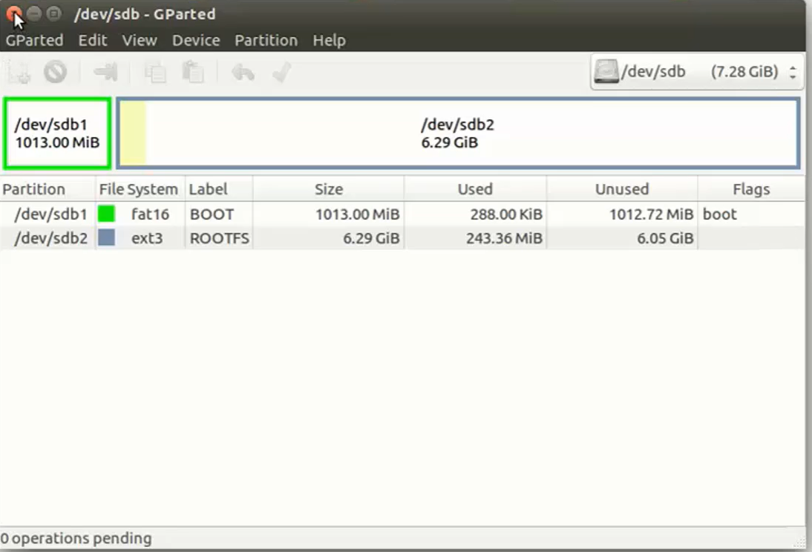
📷 Fig 4.2 — GParted showing the correctly partitioned SD card (/dev/sdb, 7.28 GiB total). The graphical bar at the top shows the two partitions visually. The table confirms: /dev/sdb1 = fat16 filesystem, labelled BOOT, 1013 MiB, with the 'boot' flag set (critical — RBL only boots from a partition with this flag). /dev/sdb2 = ext3 filesystem, labelled ROOTFS, 6.29 GiB remaining space. The 'boot' flag on sdb1 is what tells the RBL this is the bootable partition.

4.3 Copying Files to SD Card

BOOT Partition Files (copy to /dev/sdb1 mount point):
File | Source / Notes
MLO | Rename 'MLO-beaglebone-2013.04' to 'MLO'. This exact name is required.
u-boot.img | Rename 'u-boot-beaglebone-2013.04-r0.img' to 'u-boot.img'. Exact name required.
uEnv.txt | Your custom boot configuration file (optional but recommended).

ROOTFS Partition Files (copy to /dev/sdb2 mount point):
# Mount ROOTFS partition
sudo mount /dev/sdb2 /mnt/rootfs

# Extract root filesystem (requires root for correct permissions)
sudo tar -xf Angstrom-systemd-image-eglibc-ipk-v2012.12-beagleboard.rootfs.tar.xz -C /mnt/rootfs

# Unmount when done
sudo umount /mnt/rootfs

⚠️ Important
Always use 'sudo' when copying to SD card partitions.
Regular user permissions will cause 'permission denied' errors and the files won't copy correctly.

4.4 Booting BBB from SD Card
By default, BBB boots from the internal eMMC storage. To force it to boot from the SD card, use the S2 (boot) button:
- Insert the prepared SD card into the BBB SD card slot.
- Connect the UART-USB debug cable to your PC (for minicom serial output).
- Open minicom on your PC: minicom -D /dev/ttyUSB0 -b 115200
- Power off the BBB by long pressing the power button until the power LED turns off.
- Press and HOLD the S2 button (boot button, located near the SD card slot).
- While holding S2, press the power button to power on the board.
- Release S2 after a few seconds — the board will now boot from SD card instead of eMMC.

📝 Note
S2 is the small button next to the SD card slot on the BBB board.
It forces RBL to change its boot sequence to check the SD card first.
Without pressing S2, the board always boots from eMMC by default.

SECTION 5 — Linux Kernel Build

5. Building the Linux Kernel from Source
The Linux kernel is the core of the operating system. When building for BBB, we cross-compile it on our x86_64 PC to generate an ARM binary. The output is a 'uImage' — a compressed kernel with a U-Boot header.

5.1 Download the Kernel Source
# Clone the BBB-specific kernel (v5.10.168 with TI real-time patches):
git clone https://github.com/beagleboard/linux.git
cd linux
git checkout v5.10.168-ti-rt-r76

5.2 Kernel Build Steps

Step 1: Clean previous build artifacts
make ARCH=arm CROSS_COMPILE=arm-linux-gnueabihf- distclean

Step 2: Apply board default configuration
make ARCH=arm CROSS_COMPILE=arm-linux-gnueabihf- bb.org_defconfig
For kernel v4.11 and later, use: omap2plus_defconfig
This generates the .config file with all the driver selections for BBB.

Step 3: Customize kernel configuration (optional)
make ARCH=arm CROSS_COMPILE=arm-linux-gnueabihf- menuconfig
In the menuconfig UI:
[*] = built into kernel (compiled in)
[M] = loadable module (compiled as .ko file, loaded at runtime)
[ ] = disabled (not compiled at all)
Removing unnecessary drivers reduces the final kernel size.

Step 4: Compile the kernel and Device Tree
make ARCH=arm CROSS_COMPILE=arm-linux-gnueabihf- uImage dtbs LOADADDR=0x80008000 -j4
uImage = compressed kernel with U-Boot header
dtbs = Device Tree Blobs for all supported boards
LOADADDR = the physical RAM address where the kernel will run
Output: arch/arm/boot/uImage and arch/arm/boot/dts/am335x-boneblack.dtb

Step 5: Compile loadable kernel modules
make ARCH=arm CROSS_COMPILE=arm-linux-gnueabihf- -j4 modules
Compiles all drivers selected as [M] in menuconfig into .ko files.
These files are needed to load device drivers at runtime.

Step 6: Install modules to root filesystem
make ARCH=arm CROSS_COMPILE=arm-linux-gnueabihf- INSTALL_MOD_PATH=<path/to/RFS> modules_install
Copies all .ko files into <RFS>/lib/modules/<kernel-version>/
Replace <path/to/RFS> with your root filesystem path, e.g., /srv/nfs/bbb

📝 Note
LOADADDR=0x80008000 — this is where the kernel will be placed in physical RAM.
The U-Boot 'load' command copies the uImage binary to the DDR address 0x82000000,
but the kernel itself decompresses and relocates to 0x80008000 before running.
These are two different addresses and both must be correct for the kernel to boot.

SECTION 6 — Linux Device Tree

6. Linux Device Tree
The Device Tree is a data structure that describes the hardware of a board to the Linux kernel. Before Device Trees existed, hardware descriptions were hardcoded into the kernel source code — which meant maintaining thousands of board-specific kernel forks. Device Trees solved this problem.

6.1 What Problem Does the Device Tree Solve?
On x86 PCs, the BIOS/UEFI firmware discovers hardware automatically (via PCI, USB enumeration). On ARM embedded boards, there is no such automatic discovery — every peripheral (UART, SPI, I2C, GPIO, ethernet) is at a fixed memory address and the kernel must be told exactly where each one is.

The Device Tree is essentially a hardware description file. It says: 'There is a UART at address 0x44E09000, connected to interrupt 72, running at 48 MHz clock.' The kernel reads this file and configures the appropriate driver.

6.2 Device Tree Files and Formats
Extension | Description
.dts | Device Tree Source — human-readable text file that describes the hardware. Written by developers.
.dtsi | Device Tree Source Include — a shared fragment included by multiple .dts files (e.g., common SoC peripherals).
.dtb | Device Tree Blob — binary compiled version of the .dts file. This is what U-Boot loads and passes to the kernel.
dtc | Device Tree Compiler — tool that compiles .dts → .dtb or decompiles .dtb → .dts

6.3 Device Tree File for BBB
The main Device Tree file for BeagleBone Black is:
arch/arm/boot/dts/am335x-boneblack.dts
It includes the SoC-level file:
arch/arm/boot/dts/am335x.dtsi (AM335x SoC peripherals)
arch/arm/boot/dts/am33xx.dtsi (AM33xx family peripherals)

6.4 Basic Device Tree Syntax
/ {
/* Root node — represents the entire system */

model = "TI AM335x BeagleBone Black";
compatible = "ti,am335x-bone-black", "ti,am335x-bone", "ti,am33xx";

cpus {
cpu@0 {
compatible = "arm,cortex-a8";
};
};

memory@80000000 {
device_type = "memory";
reg = <0x80000000 0x20000000>; /* 512 MB DDR starting at 0x80000000 */
};

uart0: serial@44e09000 {
compatible = "ti,am3352-uart";
reg = <0x44e09000 0x2000>; /* register base address, size */
interrupts = <72>;
status = "okay"; /* enabled */
};
};

📝 Note
The 'compatible' property is how the kernel matches a device’s node to a driver.
The kernel's driver database is searched for a driver that lists 'ti,am3352-uart'
in its compatible table. When found, that driver is used to control the UART.
status = 'okay' means the device is enabled. status = 'disabled' means it's off.

6.5 How U-Boot Passes the DTB to the Kernel
U-Boot loads the .dtb file into DDR RAM at fdtaddr (typically 0x88000000) and then passes this address to the kernel as parameter r2 when calling kernel_entry(0, machid, r2). The kernel reads the hardware description from this memory location during boot.
# U-Boot: Load DTB and pass it to kernel
load mmc 0:2 ${fdtaddr} /boot/am335x-boneblack.dtb
bootm ${loadaddr} - ${fdtaddr}
# ^kernel ^ DTB address

SECTION 7 — initramfs (Initial RAM Filesystem)

7. initramfs — Initial RAM Filesystem
initramfs (Initial RAM File System) is a temporary, compressed root filesystem that is loaded into RAM during early kernel boot. It gives the kernel a minimal working environment before the actual root filesystem (on SD card / eMMC / NFS) is mounted.

7.1 Is initramfs Required?
No — initramfs is optional. Most desktop Linux distributions use it (to load drivers needed for the real disk). In embedded Linux, it is optional and commonly used when:
- The real root filesystem requires a driver that is not compiled into the kernel.
- You want to boot entirely in RAM (no SD card / eMMC needed).
- You need a recovery environment.

With initramfs | Without initramfs
Kernel boots → loads initramfs → runs /init from RAM → mounts real rootfs | Kernel boots → directly mount real rootfs (SD/eMMC) → runs /sbin/init
Useful: loads missing drivers before mounting real rootfs | Simpler: fewer components, faster if all drivers are built-in
Required if root-disk driver is a loadable module | Works fine if all needed drivers are compiled into the kernel

7.2 What Does initramfs Contain?
- Device drivers (as loadable modules if needed)
- Firmware files for hardware initialization
- /init script — the first program run from initramfs
- Essential utilities (mount, pivot_root, switch_root)
- Boot scripts and configuration files

7.3 Building initramfs — Step by Step

Download the RFS:

Step 1: Create cpio archive from your root filesystem directory
cd <your_rootfs_directory>
find . | cpio -H newc -o > ../initramfs.cpio
'cpio' = Copy In/Out. '-H newc' = new (SVR4) portable format. '-o' = output mode.
This creates a single archive file containing all files in the current directory.

Step 2: Compress the cpio archive with gzip
gzip < ../initramfs.cpio > ../initramfs.gz
Compresses the archive significantly (typically 3–5x smaller).

Step 3: Install U-Boot tools
sudo apt-get install u-boot-tools
This installs the 'mkimage' utility needed for Step 4.

Step 4: Add U-Boot header with mkimage
mkimage -A arm -O linux -T ramdisk -C none -a 0x80800000 -n "Root Filesystem" -d ../initramfs.gz ../initramfs
-A arm = target architecture
-O linux = operating system
-T ramdisk = image type is ramdisk (initramfs)
-C none = not compressed at this stage (already gzipped)
-a 0x80800000 = load address in DDR RAM
-n "Root ..." = image name/description
-d ../initramfs.gz = input file
Output: 'initramfs' binary ready to be loaded by U-Boot

Booting with initramfs from U-Boot:

Remember : Open minicom on host PC and send each files once loadx command execute the U-boot will wait for data from host PC this concept explained in section 8
# Load kernel image
loadx 0x82000000 # or: load mmc 0:1 0x82000000 uImage

# Load DTB
loadx 0x88000000 # or: load mmc 0:1 0x88000000 am335x-boneblack.dtb

# Load initramfs
loadx 0x88080000 # or: load mmc 0:1 0x88080000 initramfs

# Set boot args: root=/dev/ram0 tells kernel to use initramfs as root
setenv bootargs console=ttyO0,115200 root=/dev/ram0 rw initrd=0x88080000

# Boot: note all three addresses are given
bootm 0x82000000 0x88080000 0x88000000
# ^kernel ^initramfs ^dtb

SECTION 8 — Booting BBB via Serial Port

8. Booting BeagleBone Black over Serial Port
If no SD card, USB, or SPI device is available, the BBB's RBL will fall back to UART boot mode. This allows you to load MLO, U-Boot, kernel, and DTB directly from your PC to the BBB using the xmodem serial transfer protocol via minicom.

8.1 How the RBL Selects UART Boot
The RBL scans boot sources in this fixed order: SPI → MMC0 (SD card) → USB → UART. When all other sources fail or are absent, it starts printing 'CCC...' on the UART — this is the xmodem CRC handshake signal, indicating it is ready to receive data.

How to Force UART Boot:
- Remove SD card from BBB.
- Do NOT connect any USB storage to the P4 mini-USB port.
- Connect only the UART debug cable (UART0 RX/TX/GND pins) to your PC.
- Open minicom on PC (baud rate 115200, 8N1).
- Hold the S2 (boot) button and press power button. You will see 'CCCC...' in minicom.

8.2 Transferring Files via xmodem
Once you see 'CCC...' in minicom, transfer files using the xmodem protocol:
# In minicom, to send a file using xmodem:
# Press: Ctrl+A, then release, then press S
# A menu appears. Select 'xmodem' using arrow keys, press Enter
# Navigate to your file, press Space to select it, press Enter to start transfer

Complete Serial Boot Sequence:
- See 'CCC...' — RBL is waiting. Send SPL binary (sp.bin or MLO.byteswap) via xmodem. SPL is written to internal SRAM.
- SPL loads and prints messages. It now waits for U-Boot. Send u-boot.img via xmodem. U-Boot is written to DDR RAM.
- U-Boot starts. Press Space bar to stop autoboot and get the U-Boot prompt.
- Transfer kernel image to DDR RAM:
loadx 0x82000000
# Then send uImage via xmodem from minicom
- Transfer DTB:
loadx 0x88000000
# Then send am335x-boneblack.dtb via xmodem
- Transfer initramfs (optional):
loadx 0x88080000
# Then send initramfs via xmodem
- Set boot arguments and boot:
setenv bootargs console=ttyO0,115200 root=/dev/ram0 rw initrd=0x88080000
bootm 0x82000000 0x88080000 0x88000000

💡 Tip
Serial boots are mostly useful for recovery or first-time board bring-up.
For regular development, TFTP boot (Section 9) is much faster because
you don't have to manually transfer each file — TFTP downloads them over Ethernet.

SECTION 9 — TFTP Network Boot

9. TFTP Network Boot (Faster Development Workflow)
TFTP (Trivial File Transfer Protocol) allows U-Boot on BBB to download the kernel, DTB, and initramfs from a TFTP server running on your host PC over an Ethernet cable. This is the fastest way to test new kernel or rootfs changes during development — no SD card re-flashing is needed.
Hardware Connection
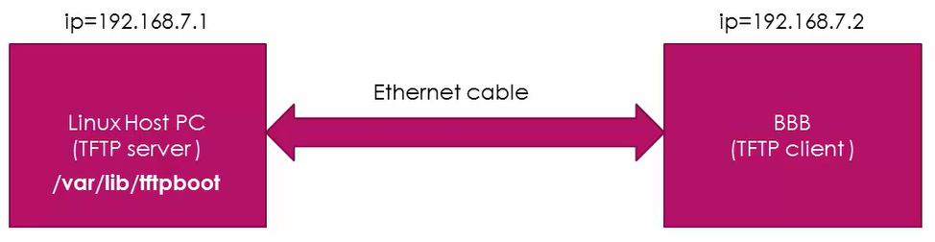
📷 Fig 9.1 — TFTP network connection diagram. Linux Host PC (left, IP=192.168.7.1) acts as the TFTP server — it runs tftpd and the kernel files are stored in /var/lib/tftpboot on this machine. BeagleBone Black (right, IP=192.168.7.2) acts as the TFTP client — U-Boot on BBB connects to the host PC and downloads the files. Both are connected with a direct Ethernet cable (crossover or standard, depending on your NICs). The bidirectional arrow shows TFTP data flows in both directions (request from BBB, data from PC).
TFTP booting Required Setup
- Power the board using either connecting to PC via USB cable or using DC adapter.
- Connect Ethernet port of the BBB hardware to PC's Ethernet port using Ethernet cable.
- We will also use SD card for this experiment.

9.1 Architecture Overview
The big picture: store MLO, u-boot.img, and uEnv.txt on eMMC to boot up to U-Boot, then transfer kernel and DTB from your PC using TFTP and mount the root filesystem from your PC using NFS.

Component | Location
MLO + u-boot.img | eMMC or SD card (FAT partition)
uEnv.txt | eMMC or SD card (FAT partition)
uImage (kernel) | Host PC TFTP server directory: /var/lib/tftpboot/
am335x-boneblack.dtb | Host PC TFTP server directory: /var/lib/tftpboot/
initramfs | Host PC TFTP server directory: /var/lib/tftpboot/
Root Filesystem | Host PC NFS server directory: /srv/nfs/bbb/

9.2 Setting Up TFTP Server on Ubuntu

Step 1: Update and install TFTP daemon
sudo apt-get update
sudo apt-get install tftpd-hpa

Step 2: Configure the TFTP server
sudo vim /etc/default/tftpd-hpa
Add/edit these lines:
TFTP_USERNAME="tftp"
TFTP_DIRECTORY="/var/lib/tftpboot"
TFTP_ADDRESS=":69"
TFTP_OPTIONS="--create --secure"

Step 3: Create and configure the TFTP directory
sudo mkdir -p /var/lib/tftpboot
sudo chown tftp:tftp /var/lib/tftpboot
sudo chmod -R 777 /var/lib/tftpboot
Copy uImage, am335x-boneblack.dtb, and initramfs to this directory.

Step 4: Start the TFTP service
sudo systemctl start tftpd-hpa
sudo systemctl enable tftpd-hpa # start on boot

9.3 On Host PC (do this first, before powering BBB):
# Check your Ethernet interface name first
ifconfig
# It will show something like eth0, enp3s0, enp1s0 — use whatever yours shows

# Assign static IP to the Ethernet port connected to BBB
sudo ifconfig eth0 192.168.27.1 up

# Verify it was set
ifconfig eth0
Then make sure your TFTP files are in place:
# Your kernel, DTB, initramfs must already be here
ls /var/lib/tftpboot/
# Should show: uImage am335x-boneblack.dtb initramfs

# TFTP service must be running
sudo systemctl status tftpd-hpa

9.4 TFTP Boot Commands on BBB (at U-Boot prompt)
# Set network addresses
setenv ipaddr 192.168.27.2 # BBB's IP address
setenv serverip 192.168.27.1 # Host PC's IP address

# Test connectivity
ping 192.168.27.1

# Download files from TFTP server to DDR RAM
tftpboot 0x82000000 uImage
tftpboot 0x88000000 am335x-boneblack.dtb
tftpboot 0x88080000 initramfs

# Set boot arguments
setenv bootargs console=ttyO0,115200 root=/dev/ram0 rw initrd=0x88080000

# Boot
bootm 0x82000000 0x88080000 0x88000000

9.5 Setting Up NFS Root Filesystem
NFS (Network File System) allows BBB to mount its root filesystem from the host PC over the network. Combined with TFTP, this gives you a fully network-booted BBB with no local storage required — perfect for development.

Step 1: Install NFS server on host PC
sudo apt-get install nfs-kernel-server

Step 2: Configure NFS exports
sudo vim /etc/exports
Add this line:
/srv/nfs/bbb 192.168.27.2(rw,sync,no_subtree_check,no_root_squash)
This exports /srv/nfs/bbb directory to the BBB at 192.168.27.2
📷 Fig 9.2 — /etc/exports file entry for NFS server. This single line exports the /srv/nfs/bbb directory to the BBB (IP 192.168.7.2) with options: rw (read-write access), sync (write operations complete before returning), no_root_squash (allows root on BBB to have root access to NFS files — needed for device files and permissions), no_subtree_check (performance improvement). After editing, run 'sudo exportfs -rv' to apply changes.

Step 3: Configure host PC network interface
sudo vim /etc/network/interfaces
Add these lines (replace enp1s0 with your actual Ethernet interface name) with static IP 192.168.27.1
auto enp1s0
iface enp1s0 inet static
address 192.168.7.1
netmask 255.255.255.0
network 192.168.7.0
gateway 192.253.7.1
dns-nameservers 8.8.8.8

Apply the network configuration:
sudo ifup enp1s0
# or
sudo ifconfig enp1s0 192.168.7.1 up

Step 4: Apply NFS settings
sudo exportfs -a
sudo exportfs -rv
sudo service nfs-kernel-server restart
sudo service nfs-kernel-server status

NFS Boot Arguments (kernel bootargs):

At the U-Boot prompt on BBB, set the boot arguments to tell the kernel to mount root over NFS:
setenv bootargs console=ttyO0,115200 root=/dev/nfs nfsroot=192.168.27.1:/srv/nfs/bbb,v3 rw ip=192.168.27.2
bootm 0x82000000 - 0x88000000

bootm runs
↓
Kernel decompresses and starts
↓
Kernel reads bootargs: sees root=/dev/nfs and ip=192.168.7.2
↓
Kernel brings up Ethernet interface using ip=192.168.7.2
↓
Kernel connects to NFS server at 192.168.7.1
↓
Kernel mounts /srv/nfs/bbb/ as its root filesystem (no copying)
↓
Kernel runs /sbin/init from that NFS folder
↓
Every file access (read a config, run a command, load a library)
goes over Ethernet to your PC in real time

💡 Tip
TFTP + NFS workflow for daily development:
1. Edit source code on your PC
2. Compile new kernel or application
3. Copy binary to /var/lib/tftpboot/ or /srv/nfs/bbb/
4. Reboot BBB — it downloads fresh binaries automatically
No SD card re-flashing ever needed!

SECTION 10 — BusyBox

10. BusyBox — Minimal Root Filesystem
BusyBox is a single executable binary that contains minimized versions of over 300 Unix/Linux command-line utilities. It replaces the need for separate binaries like ls, cp, mv, grep, sed, awk, etc. BusyBox is the standard way to create a minimal root file system for embedded Linux products.

10.1 Why BusyBox?
Standard Linux (PC) | BusyBox (Embedded)
/bin/ls (separate binary) | busybox ls (same binary handles all commands)
/bin/cp (separate binary) | busybox cp
/bin/grep (separate binary) | busybox grep
Total /bin: ~162 commands as separate files | BusyBox /bin: 89 commands — 1 file, symlinked
/bin size: several MB | busybox binary: ~1.4 MB total for all commands
Cannot customize easily | Remove any command you don't need at compile time

📝 Note
BusyBox uses symbolic links (symlinks) as a clever trick. The single 'busybox' binary
checks argv[0] (the name it was called with) to decide which command to run.
So 'ls' is just a symlink pointing to busybox. When you run 'ls', busybox sees
Its name is 'ls' and runs ls functionality. This saves enormous amounts of storage.

10.2 Compiling BusyBox
Download from: https://busybox.net/downloads/

Step 1: Apply default configuration
make ARCH=arm CROSS_COMPILE=arm-linux-gnueabihf- defconfig

Step 2: Customize (optional) — enable static build
make ARCH=arm CROSS_COMPILE=arm-linux-gnueabihf- menuconfig
Navigate to: BusyBox Settings → Build BusyBox as a static binary (no shared libs)
Select this option and save.
Why static?
Embedded boards may not have the standard C library (glibc) installed.
A statically linked BusyBox has everything built in and runs anywhere.

Step 3: Compile and install to your rootfs directory
make ARCH=arm CROSS_COMPILE=arm-linux-gnueabihf- CONFIG_PREFIX=<install_path> install
Replace <install_path> with your workspace directory, e.g., /home/user/BBB_RFS
After install, your rootfs will contain:
bin/ → 89 commands (all symlinks to busybox)
sbin/ → 70 system commands (all symlinks to busybox)
usr/ → additional utilities
linuxrc → symlink to busybox (used with initramfs)
Verify: du -sh <install_path> → approximately 1.4 MB total

Step 4: Install kernel modules into rootfs
make ARCH=arm CROSS_COMPILE=arm-linux-gnueabihf- INSTALL_MOD_PATH=<install_path> modules_install
This creates <install_path>/lib/modules/<kernel-version>/kernel/drivers/
Also manually create: mkdir <install_path>/dev (empty device directory)

10.3 BusyBox Init System
BusyBox provides its own init program which becomes PID 1 (the first user space process). It reads /etc/inittab and runs scripts from /etc/init.d/ in alphabetical order. Understanding this is crucial for embedded Linux system startup customization.
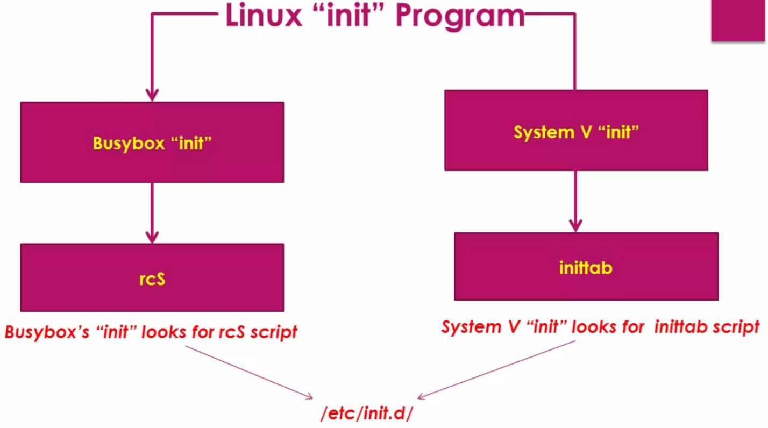
📷 Fig 10.1 — Linux 'init' Program — two implementations. LEFT branch: BusyBox 'init' — when BusyBox is PID 1, it reads /etc/inittab and then runs the rcS script from /etc/init.d/. rcS is the master startup script. RIGHT branch: System V 'init' — the traditional Linux init used on desktop systems, which reads /etc/inittab for service configuration. Both implementations ultimately look for scripts in /etc/init.d/ (shown at bottom where both arrows converge). For embedded BBB with BusyBox, we use the LEFT branch: BusyBox init → rcS → individual S## scripts.

Script Name | Purpose
rcS | Master startup script — mounts /proc, runs all S* scripts in /etc/init.d/
rcK | Master shutdown script — runs all K* scripts to stop services
S01Logging | First to run — starts syslog (system log) and klog (kernel log)
S02module | Loads kernel modules (e.g., g_ether for USB-over-Ethernet)
S04network | Brings up network interfaces (runs 'ifup -a')
S05sshd (or S50sshd) | Starts the SSH daemon for remote access

📝 Note
Script naming convention: S + two-digit number + name
S = Start script (run by rcS during boot)
K = Kill/stop script (run by rcK during shutdown)
Number = execution order (01 runs before 50)
Example: S01Logging runs before S04network which runs before S50sshd

USB over Ethernet Setup
After BusyBox rootfs is mounted (either via NFS or SD card), the init system starts. But before networking works properly, the correct kernel driver must be loaded. In BBB's case, USB over Ethernet uses a kernel module called g_ether which is not loaded automatically — you have to load it manually first, then automate it through the init scripts.

What is USB over Ethernet?
The BBB has a mini USB port (P4). Using the g_ether kernel module, this USB port can act as a virtual Ethernet adapter. When you connect BBB to your PC via USB cable, both your PC and BBB get a network interface — usb0 on BBB side and something like enx... or enc0s20u3u2 on PC side. This gives you a network connection between BBB and PC without needing a separate Ethernet cable.
Step 1 — Load the g_ether module manually first
At the BBB terminal, load the USB Ethernet driver:
modprobe g_ether

modprobe is an intelligent module loader — it checks dependencies first and only loads what is needed. After this command the usb0 interface appears on BBB.

Verify it loaded:
lsmod # g_ether should appear in the list

Step 2 — Bring up usb0 interface on BBB
ifconfig usb0 192.168.6.2 up
ifconfig
# usb0 should now appear with IP 192.168.6.2

Step 3 — Bring up the USB Ethernet interface on host PC
On your host PC, the USB Ethernet interface appears with a name like enc0s20u3u2 or enx.... Assign it an IP:
# Check what interface name appeared on PC side
ifconfig

# Assign IP to it
sudo ifconfig enc0s20u3u2 192.168.6.1 up

Step 4 — Test the connection
From host PC, ping BBB:
ping 192.168.6.2

From BBB, ping host PC:
ping 192.168.6.1

Both should succeed. You now have a working network connection between PC and BBB over USB cable.

Step 5 — Automate module loading at startup
Manually typing modprobe g_ether every boot is inconvenient. The solution is to create an init script named S02module inside /etc/init.d/. The number 02 is important — it runs before the network script S04network, because the USB Ethernet interface (usb0) must exist before the network script tries to bring it up.
Create the file /etc/init.d/S02module with this content:

#!/bin/sh

case "$1" in
start)
echo "Loading kernel modules..."
modprobe g_ether
;;
stop)
echo "Unloading kernel modules..."
modprobe -r g_ether
;;
*)
echo "Usage: $0 {start|stop}"
exit 1
esac

Give it executable permission:
chmod 777 /etc/init.d/S02module

Step 6 — Configure the network interface file
Create /etc/network/interfaces on BBB rootfs with this content:
auto lo
iface lo inet loopback

auto usb0
iface usb0 inet static
address 192.168.6.2
netmask 255.255.255.0

This tells the S04network script (which runs ifup -a) exactly how to configure the usb0 interface — static IP 192.168.6.2 — every time it starts.

Step 7 — Create missing required directories and files
Two files that ifup needs must exist, even if empty:

mkdir -p /etc/network/if-pre-up.d
touch /run/network/ifstate
# or
touch /var/run/network/ifstate

Without these, ifup throws errors like:
if-pre-up.d: No such file or directory
ifstate.new: No such file or directory

Step 8 — Reboot and verify everything is automatic
After reboot, the startup sequence runs automatically in this order:

rcS runs
↓
S01Logging → starts syslog and klog
↓
S02module → loads g_ether → usb0 interface appears
↓
S04network → runs ifup -a → usb0 gets IP 192.168.6.2
↓
S50sshd → SSH daemon starts

After boot complete, run ifconfig on BBB — usb0 should appear with 192.168.6.2 automatically without any manual steps.

📝 Note
The order of script numbers matters strictly. S02 must come before S04 because the network script cannot bring up usb0 if the g_ether module has not been loaded yet. This is the whole reason the module loading script is named S02 and not S05 or S10.

Required Directories in rootfs:
mkdir -p etc/init.d # init scripts
mkdir -p proc # virtual filesystem for process info
mkdir -p sys # virtual filesystem for hardware info
mkdir -p dev # device files
mkdir -p etc/network # network configuration

Loading Kernel Modules at Runtime:
# Manually load a kernel module:
modprobe g_ether
# modprobe is intelligent — it checks dependencies first

# List loaded modules:
lsmod

# After loading g_ether, USB0 network interface appears:
ifconfig usb0 192.168.6.2 up
ifconfig # usb0 now visible

SECTION 11 — Buildroot

11. Buildroot — Automated Embedded Linux Build System
Buildroot is a tool that automates everything we have done manually in the previous sections. Instead of individually downloading and compiling U-Boot, the Linux kernel, BusyBox, and third-party packages, Buildroot does it all with a single 'make' command. It generates a complete, ready-to-use embedded Linux image.

11.1 What Buildroot Can Build
- Cross-compilation toolchain (or use an external one like Linaro)
- Bootloader (U-Boot, MLO/SPL)
- Linux kernel (with Device Tree Blobs)
- Root filesystem (using BusyBox, plus optional packages)
- Additional packages: OpenSSH, Python, web servers, databases, and hundreds more

💡 Tip
Think of Buildroot as a 'recipe book' for your embedded Linux system.
You tell it what hardware you have (BBB), what features you want (SSH, specific kernel version),
and it downloads, compiles, and packages everything automatically.

11.2 Getting Started with Buildroot
Download from: https://buildroot.org/download.html

Directory | Contents
configs/ | Pre-made configurations for popular boards (beaglebone_defconfig is here)
board/ | Board-specific files, post-build scripts, and READMEs
board/beaglebone/ | BBB-specific overlay files and build scripts
board/beaglebone/readme.txt | Step-by-step instructions for building for BBB
package/ | Package recipes for hundreds of software packages
output/images/ | All compiled output files appear here after build

11.3 Configuring and Building for BBB

Step 1: Load BBB default configuration
cd buildroot-2017.05
make beaglebone_defconfig

Step 2: Open configuration menu
make menuconfig

Key menuconfig Settings for BBB:
Menu Path | Setting
Toolchain → Toolchain Type | Select 'External toolchain' (to use your Linaro installation)
Toolchain → Toolchain | Linaro (auto-detected if installed)
Toolchain → Toolchain origin | Pre-installed toolchain
Toolchain → Toolchain path | Path to your toolchain bin/ directory
System configuration → System hostname | Your custom hostname (e.g., my-bbb)
System configuration → System banner | Welcome message (e.g., Welcome to Buildroot-BBB)
System configuration → Init system | BusyBox
System configuration → Root password | Set a root password
System configuration → getty (login prompt) | ttyO0 at 115200 baud
Linux kernel → Defconfig name | bb.org (or omap2plus for kernel 4.11+)
Linux kernel → Kernel binary format | uImage
Linux kernel → Load address | 0x80008000
Linux kernel → Device tree source | am335x-boneblack
Target packages → Networking → openssh | Enable for SSH access
Bootloader → U-Boot | Disable (we already have our own)

Step 3: Build everything
make -j4
This can take 30–90 minutes on first run (downloads and compiles everything).
Output files in buildroot-2017.05/output/images/:
MLO, u-boot.img, uImage, am335x-boneblack.dtb, rootfs.tar
Buildroot Output Files

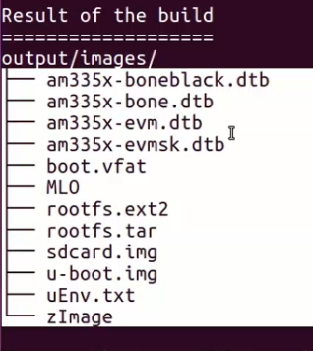
📷 Fig 11.1 — Result of the Buildroot build showing output/images/ directory contents. After 'make -j4' completes, these files are generated: am335x-boneblack.dtb (Device Tree for BBB), am335x-bone.dtb, am335x-evm.dtb, am335x-evmsk.dtb (DTBs for other AM335x boards), boot.vfat (FAT boot partition image), MLO (Secondary Program Loader), rootfs.ext2 (root filesystem in ext2 format), rootfs.tar (root filesystem as tarball — use this to extract to NFS), sdcard.img (complete SD card image ready to dd), u-boot.img (U-Boot bootloader), uEnv.txt (auto-generated boot script), zImage (compressed kernel). The sdcard.img is the most convenient — you can dd it directly to an SD card.

11.4 Deploying Buildroot Output
# Remove old rootfs from NFS directory
sudo rm -rf /srv/nfs/bbb/*

# Extract new rootfs
sudo tar -xf output/images/rootfs.tar -C /srv/nfs/bbb

# Copy kernel and DTB to TFTP directory
cp output/images/uImage /var/lib/tftpboot/
cp output/images/am335x-boneblack.dtb /var/lib/tftpboot/

# Reboot BBB and it will use the new images

11.5 Enabling SSH in Buildroot
After enabling OpenSSH in menuconfig and rebuilding, you may need to configure the sshd config on the target:
# On host PC, edit the rootfs (before extracting) or after SSH fails:
vi /srv/nfs/bbb/etc/ssh/sshd_config

# Uncomment or add:
PermitRootLogin yes

# Restart NFS service:
sudo service nfs-kernel-server restart

# From host PC, SSH into BBB:
ssh -l root 192.168.7.2
# Enter root password when prompted

# From BBB, SSH into host PC:
ssh kiran@192.168.7.1

SECTION 12 — Linux Source Tree & Boot Flow

12. Linux Source Tree & Detailed Boot Flow
Understanding the Linux source tree structure and the detailed boot flow is essential for any embedded Linux developer. This section maps the boot sequence to exact source files.

12.1 Linux Kernel Source Tree — Key Directories
Directory/File | Contents & Purpose
arch/ | Architecture-specific code (arm, x86, mips, riscv, arm64, etc.)
arch/arm/boot/ | ARM boot files: head.S, compressed/, dts/
arch/arm/boot/compressed/head.S | FIRST file executed after U-Boot hands over control. Decompresses kernel.
arch/arm/boot/compressed/misc.c | Kernel decompression logic — unzips the compressed kernel image
arch/arm/kernel/head.S | SECOND head.S — CPU init, MMU setup, calls start_kernel()
arch/arm/kernel/head-common.S | Calls the C main function after assembly setup completes
arch/arm/lib/bootm.c | U-Boot file: implements boot_jump_linux() to call kernel entry
arch/arm/mm/ | ARM memory management (page tables, cache, TLB)
arch/arm/boot/dts/ | All Device Tree source files for ARM boards
init/main.c | Architecture-independent kernel main — start_kernel() is here
kernel/ | Core kernel: scheduler, timers, signals, modules
mm/ | Memory management subsystem
drivers/ | All hardware device drivers (tens of thousands of files)
fs/ | Filesystem implementations (ext4, fat, nfs, proc, sys, etc.)
net/ | Network protocols (TCP/IP, UDP, NFS, etc.)
include/ | Kernel header files
Documentation/ | Extensive kernel documentation
Makefile | Top-level build system
Kconfig | Configuration system (what menuconfig reads)
.config | Generated after menuconfig — contains all kernel settings

12.2 Detailed Boot Flow: U-Boot to Linux User Space
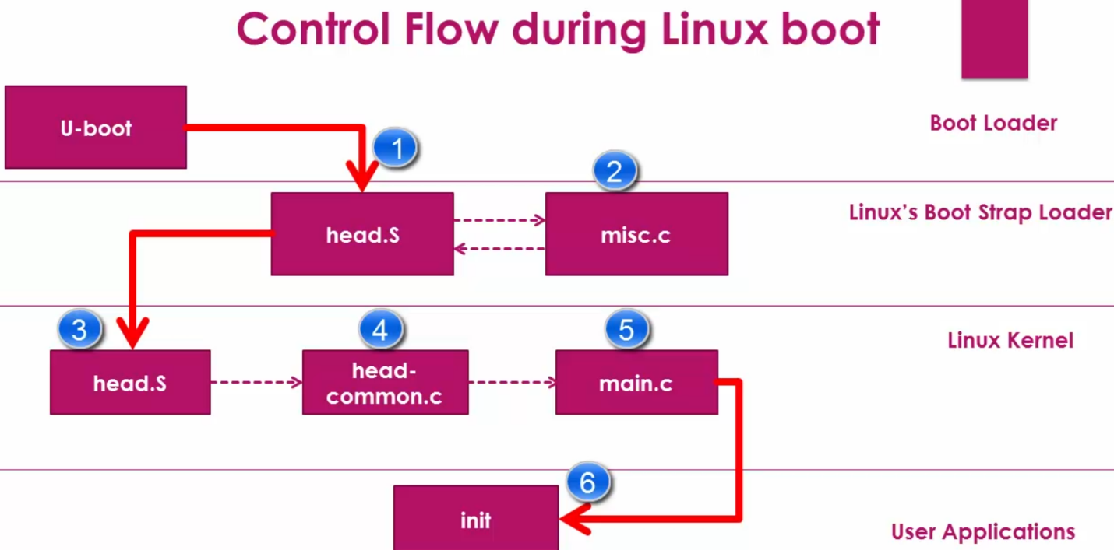
📷 Fig 12.1 — Control Flow during Linux Boot (source file level diagram). U-Boot (top-left) calls into Linux's Boot Strap Loader layer (step 1): arch/arm/boot/compressed/head.S runs first, which calls misc.c (step 2) to decompress the kernel, then head.S regains control. Step 3: the second head.S at arch/arm/kernel/head.S runs (CPU/MMU initialisation). Step 4: head-common.S bridges to C code. Step 5: init/main.c start_kernel() function is called. Step 6: start_kernel() eventually launches the init process (PID 1) in User Applications layer.

# | Source File | What Happens
1 | arch/arm/lib/bootm.c (U-Boot) | boot_jump_linux() creates kernel_entry function pointer. Calls kernel_entry(0, machid, r2). r2 = DTB address in DDR RAM.
2 | arch/arm/boot/compressed/head.S | First kernel assembly code runs. Sets up basic environment, prepares for decompression.
3 | arch/arm/boot/compressed/misc.c | Decompresses the kernel image from its compressed format to plain binary in RAM.
4 | arch/arm/kernel/head.S | CPU-specific initialisation, validates processor architecture, sets up page tables, enables MMU.
5 | arch/arm/kernel/head-common.S | Final setup, then calls the C function start_kernel().
6 | init/main.c: start_kernel() | Arch-independent kernel init: memory, interrupts, scheduler, filesystems, devices all initialised.
7 | init/main.c: rest_init() | Creates two kernel threads: kernel_init (PID 1 candidate) and kthreadd (PID 2, kernel thread manager).
8 | kernel_init thread | Frees __init memory. Tries to exec /sbin/init → /etc/init → /bin/init → /bin/sh in order.
9 | /sbin/init or busybox init | PID 1 starts. Reads /etc/inittab, runs /etc/init.d/rcS, starts all services.

12.3 kernel_init — Finding PID 1
The kernel_init thread tries to find and run the first user space program in this exact order:
/* From init/main.c */
if (execute_command) {
run_init_process(execute_command); /* init= kernel argument */
}
run_init_process("/sbin/init");
run_init_process("/etc/init");
run_init_process("/bin/init");
run_init_process("/bin/sh");
/* If ALL fail: */
panic("No init found. Try passing init= option to kernel");

📝 Note
You can specify a custom init program by passing 'init=<path>' in the kernel bootargs.
Example: setenv bootargs ... init=/bin/myapp
This is useful in embedded systems where the default /sbin/init is not needed.

