ZEPHYR - Installation manual

Note: Admin Access Required to proceed the following
Version: 3.3.0
Link: Getting Started Guide — Zephyr Project Documentation
Enable the admin access in IT toolkit.
- Proxy settings:
- Open ‘Edit the system environment variables’ from windows search bar.
- Click on the Environment Variables button.
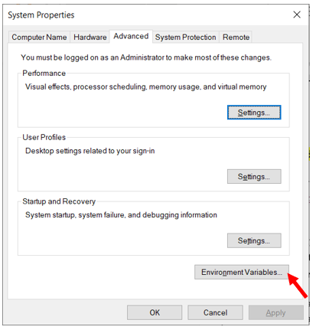

- Click on the New button and add the below items to the list.
- Variable Name : http_proxy, Variable Value : http://rb-proxy-de.bosch.com:8080
- Variable Name : https_proxy, Variable Value : http://rb-proxy-de.bosch.com:8080
- Variable Name : no_proxy, Variable Value : 127.0.0.1,localhost

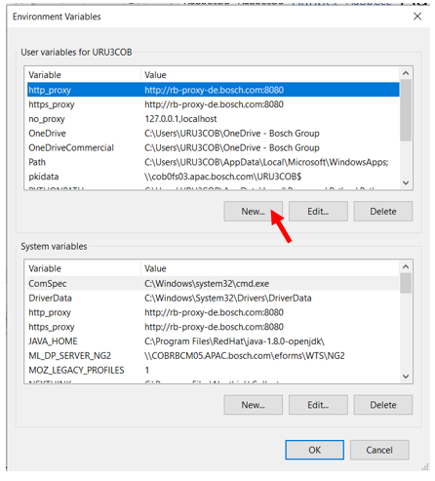
- PX-Proxy Installation:
- Install PX
  - Download and the PX (px.exe) from here:
  - Create a folder (e.g., C:\px) and place the px.exe there.
  - Run the exe file once. (It will not open any popups)
  - Open your Windows Command line (run as administrator) and type.
px --proxy=rb-proxy-de.bosch.com:8080 –save
click on enter key after the execution of 2 lines.
px --install.

PX is now configured and added to the Windows registry to run on startup.
Now you can close the Command line.
To Test if PX works correctly, navigate to ‘C:\px’ folder and in path type cmd and enter
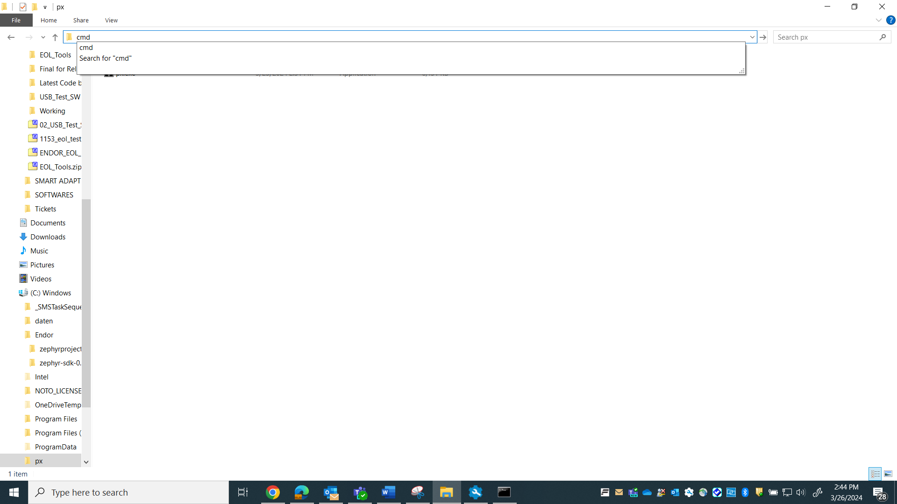
In the command prompt, type curl google.com and enter
If everything is correctly configured, you should see something similar to the following:
<HTML><HEAD><meta http-equiv="content-type" content="text/html;charset=utf-8">
<TITLE>301 Moved</TITLE></HEAD><BODY>
<H1>301 Moved</H1>
The document has moved
<A HREF="http://www.google.com/">here</A>.
</BODY></HTML>.

- Configure the proxy environment variables
- Navigate to ‘C:\px’ folder and in path type cmd and enter
- In the command prompt, type the following one by one.
setx HTTP_PROXY http://localhost:3128
setx HTTPS_PROXY http://localhost:3128
setx NO_PROXY localhost,*.bosch.com,127.0.0.1
- Install dependencies:
Download the below mentioned tools and follow the process.
- CMAKE:
Open CMake site from the link CMake and click on DOWNLOAD button.
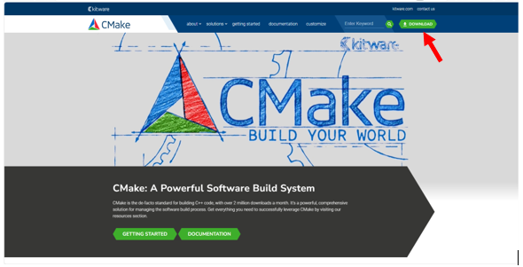
Click Latest Release
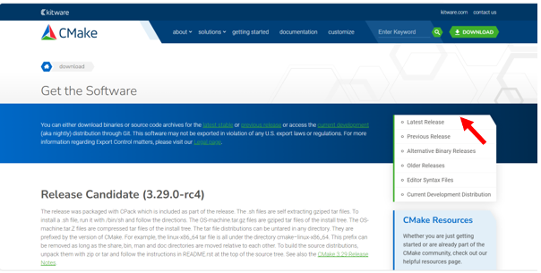
Download windows x64 installer file.
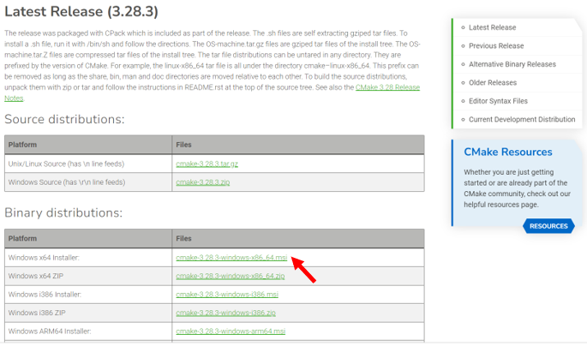
Bosch security policy prevents running installer files from “Downloads” folder.
Move the downloaded file to ‘Documents’ folder and open it.
Follow the steps below for installation. Make sure the checkboxes are ticked as in the screenshots.
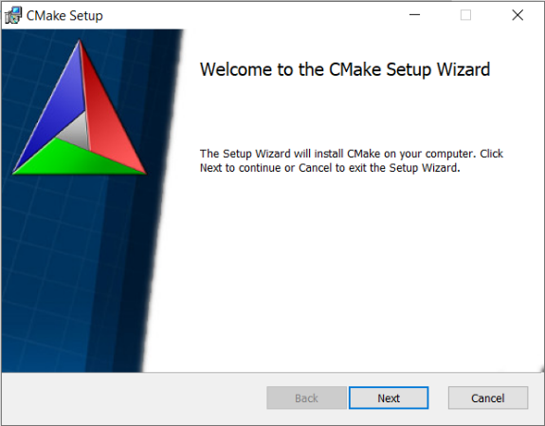
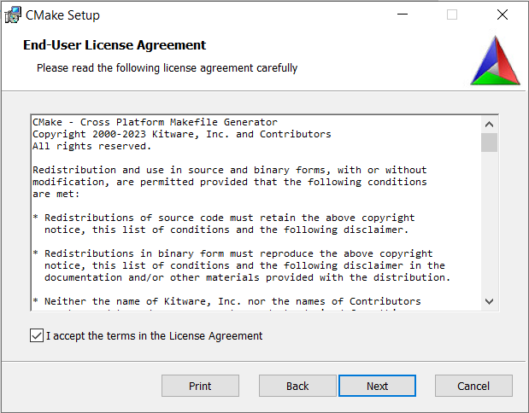
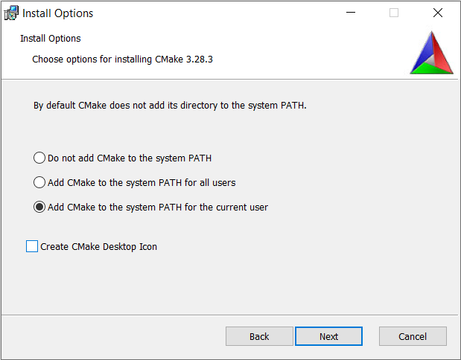
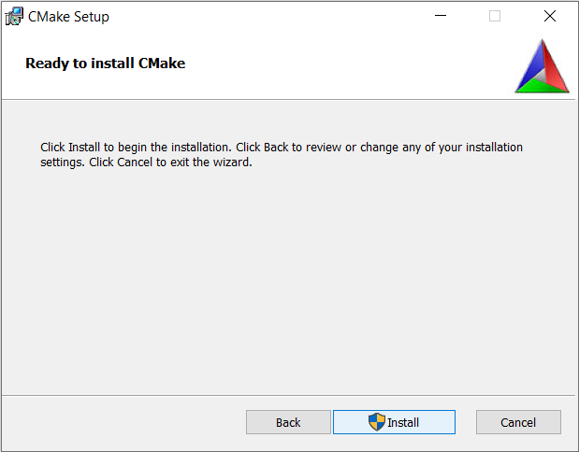
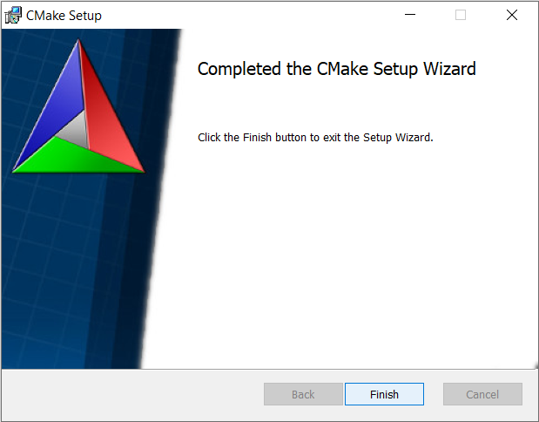

- PYTHON:
Open Python site from this Python and click on download.
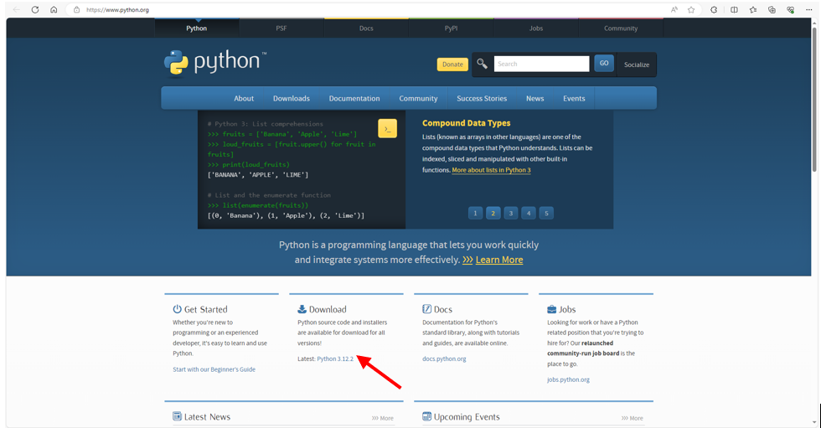
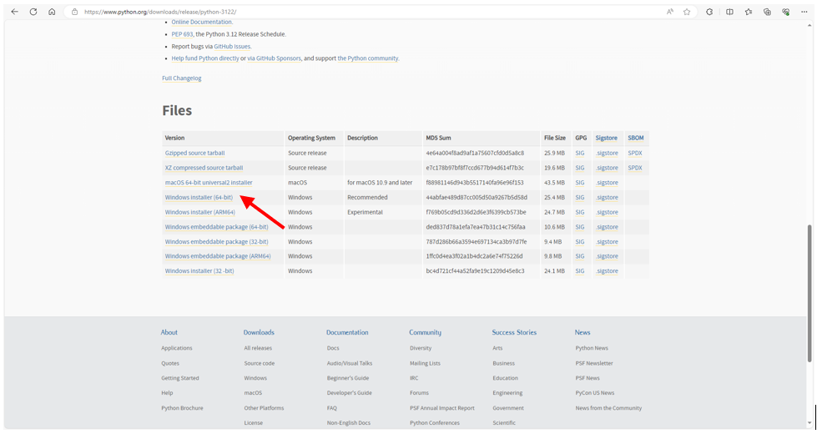
Bosch security policy prevents running installer files from “Downloads” folder.
Move the downloaded file to ‘Documents’ folder and open it.
Follow the steps below for installation. Make sure the checkboxes are ticked as in the screenshots.

Tick mark Add python.exe to PATH in this step.
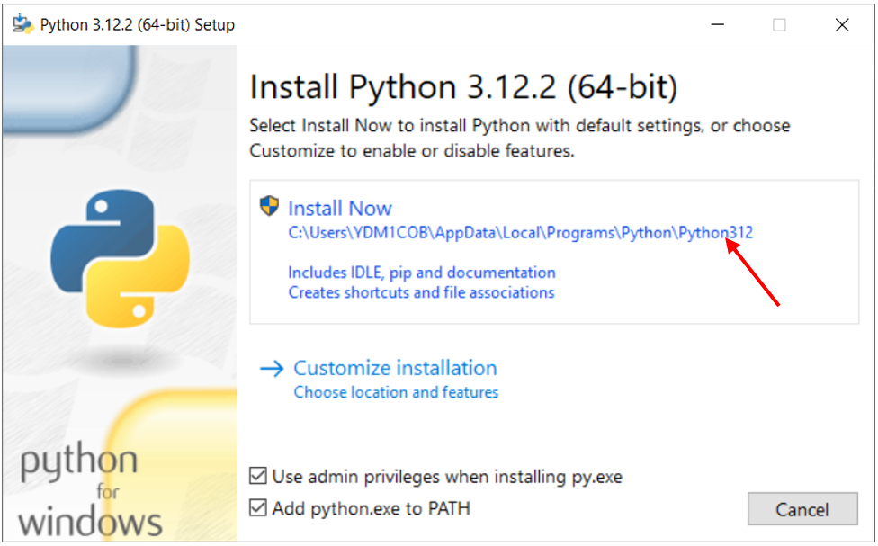
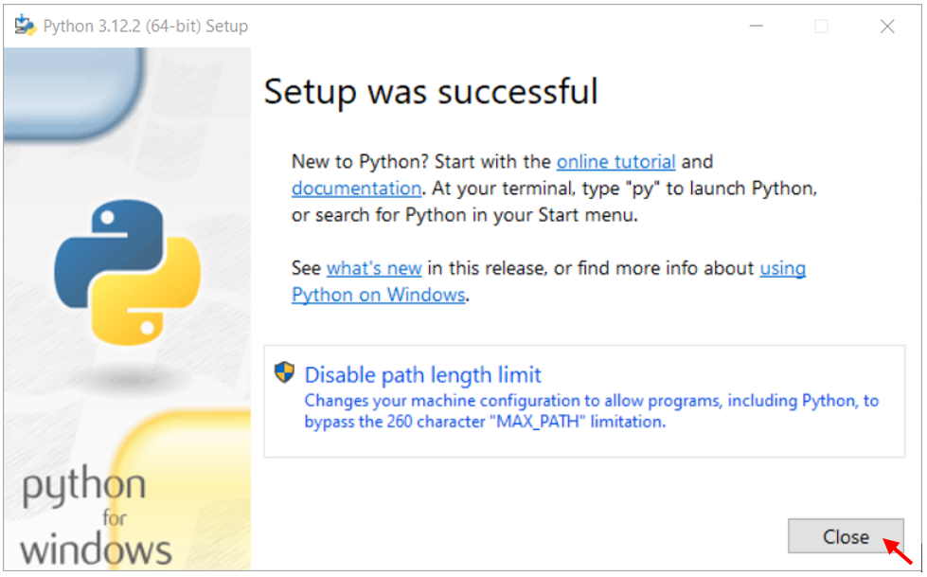
- Chocolatey
Open Command prompt as administrator and run the below command (It’s a single command line):
@powershell -NoProfile -ExecutionPolicy Unrestricted -Command "[Net.WebRequest]::DefaultWebProxy.Credentials = [Net.CredentialCache]::DefaultCredentials; iex ((New-Object Net.WebClient).DownloadString('https://chocolatey.org/install.ps1'))" && SET PATH=%PATH%;%systemdrive%\chocolatey\bin

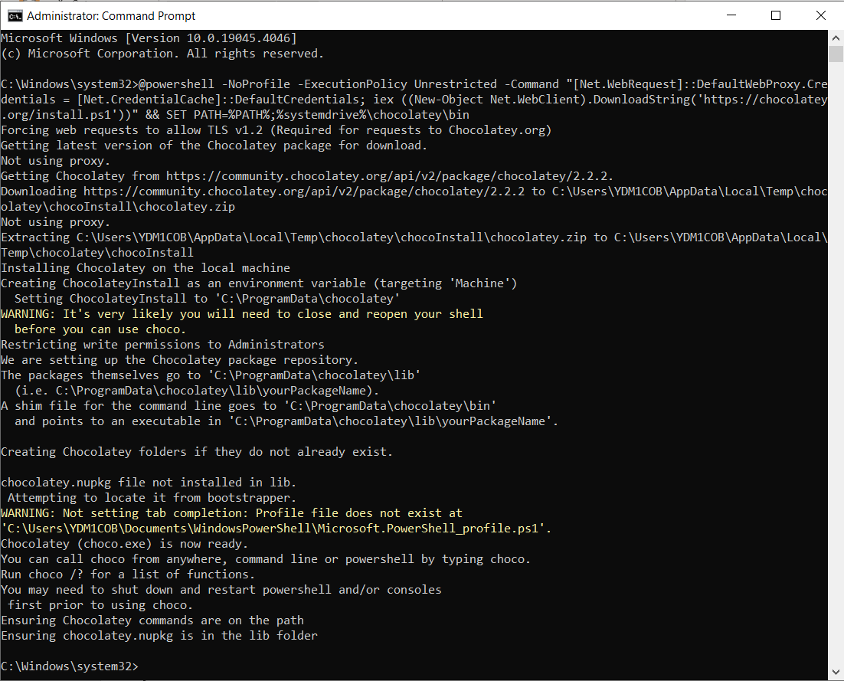
Close the command prompt and open it again. Run the command choco to verify the installation.
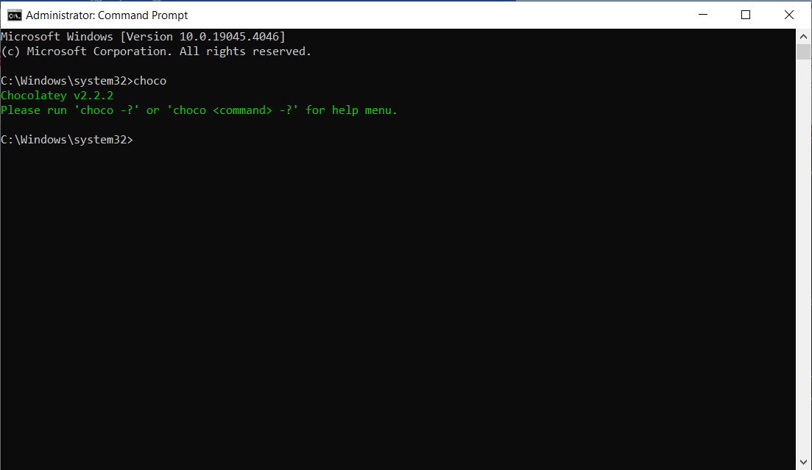
To avoid having to confirm the installation of individual programs, run the below command choco feature enable -n allowGlobalConfirmation
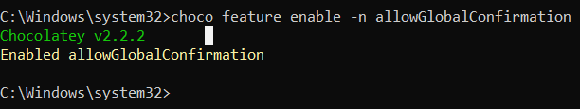
Configure the Chocolatey with the below commands:
- Set Proxy: choco config set proxy http://rb-proxy-de.bosch.com:8080
- Set Proxy User: choco config set proxyUser <yourusername>
<yourusername> is your ntid
- Set Proxy Password: choco config set proxyPassword <yourpassword>
<yourpassword> is your login password
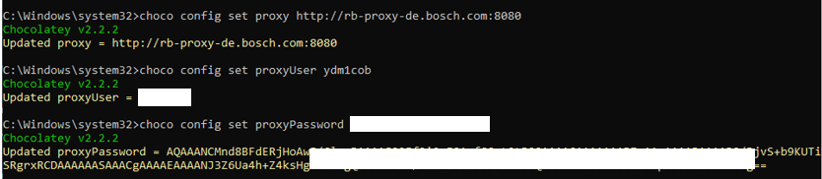
To install the required dependencies, run the below commands:
choco install cmake --installargs 'ADD_CMAKE_TO_PATH=System'
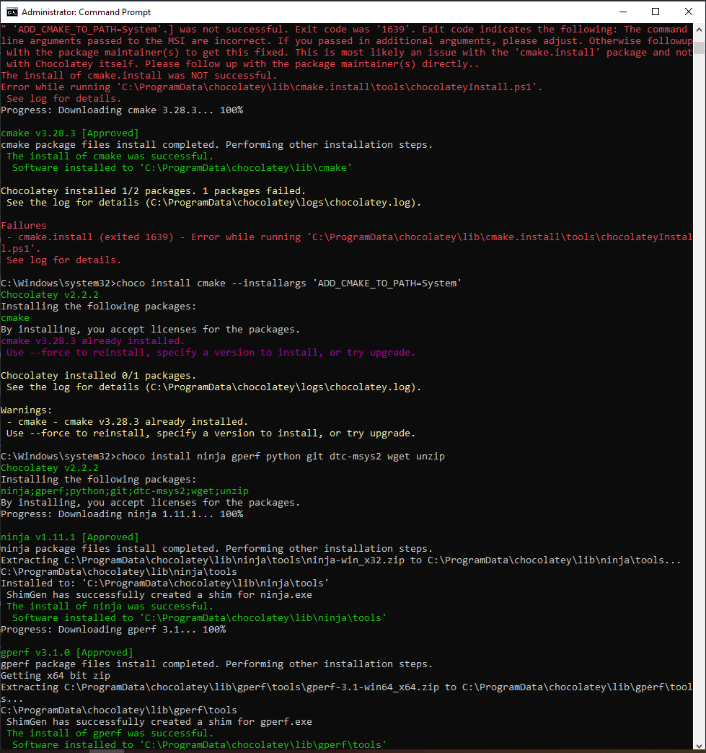
choco install ninja gperf python git dtc-msys2 wget unzip

- To Get Zephyr and install Python dependencies:
To Clone Zephyr and its modules into a new west workspace named zephyrproject
Open Command prompt in normal user (not run as administrator).
Install west using the command pip3 install -U west
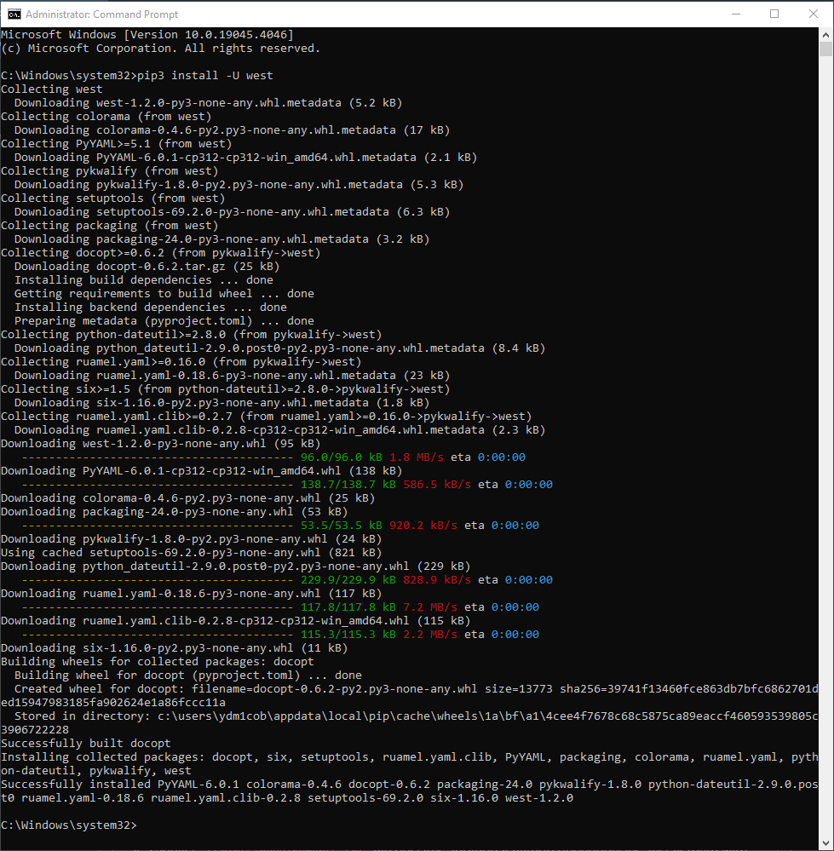
Create a folder ‘Endor’ in C:\
Open the folder and type cmd in the path and enter.
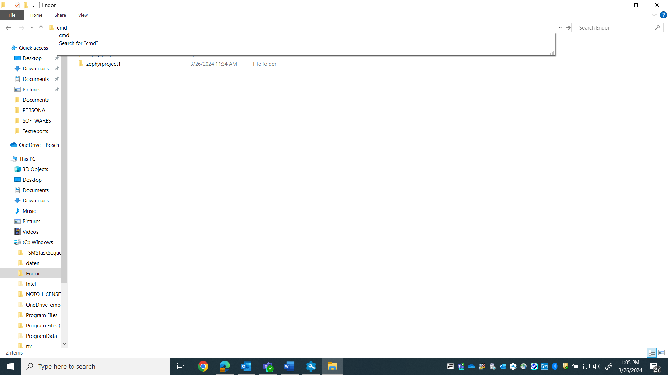
Follow the below commands:
west init zephyrproject
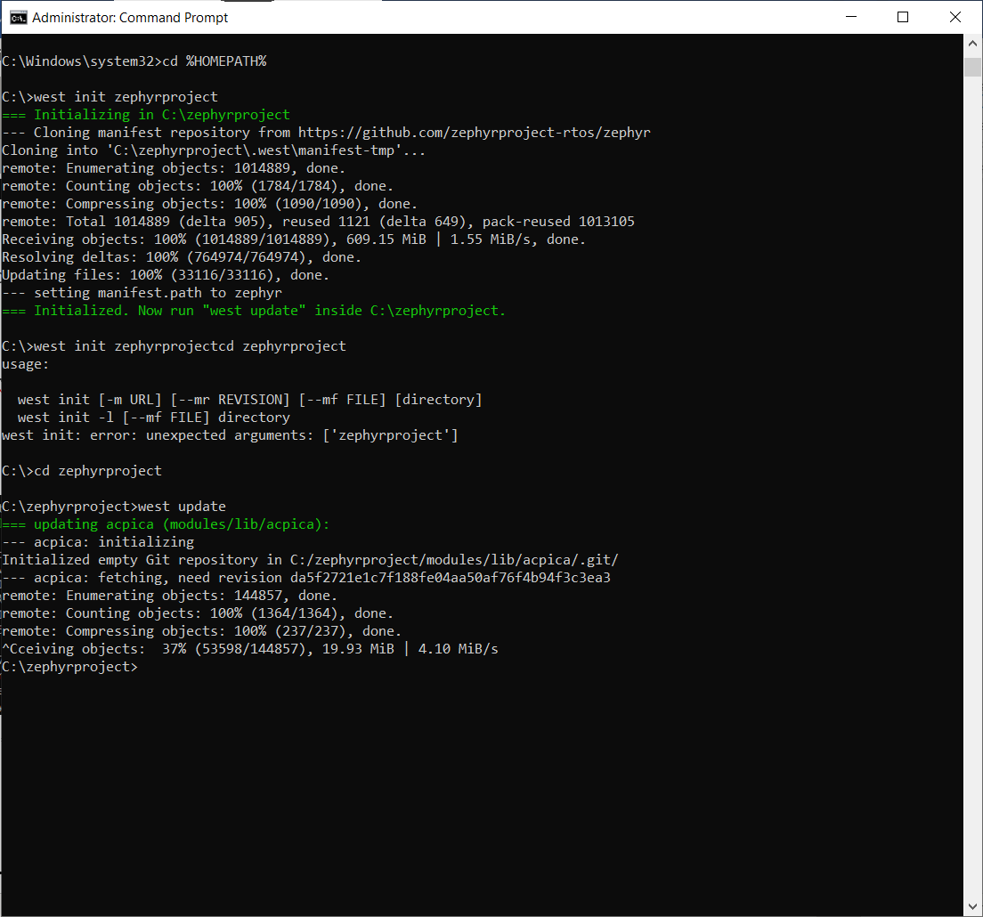
The above command may take around 5–10 min
cd zephyrproject
west update

***************************Takes around 15 minutes************************
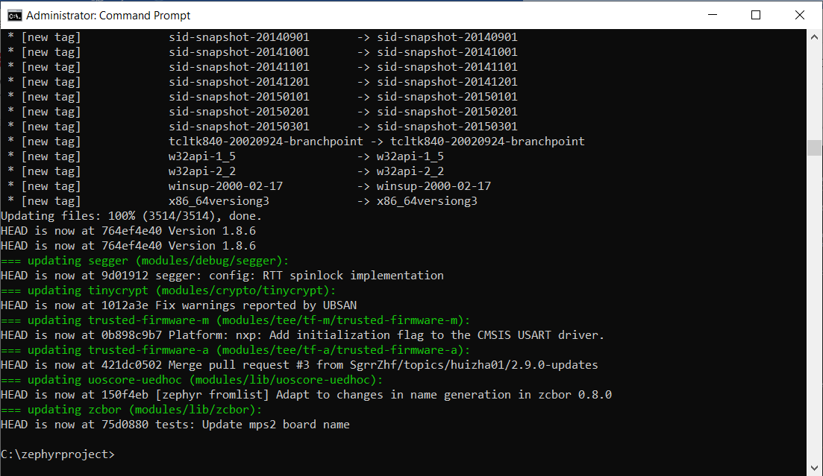
Export a Zephyr CMake package using the below command. This allows CMake to automatically load boilerplate code required for building Zephyr applications.
west zephyr-export
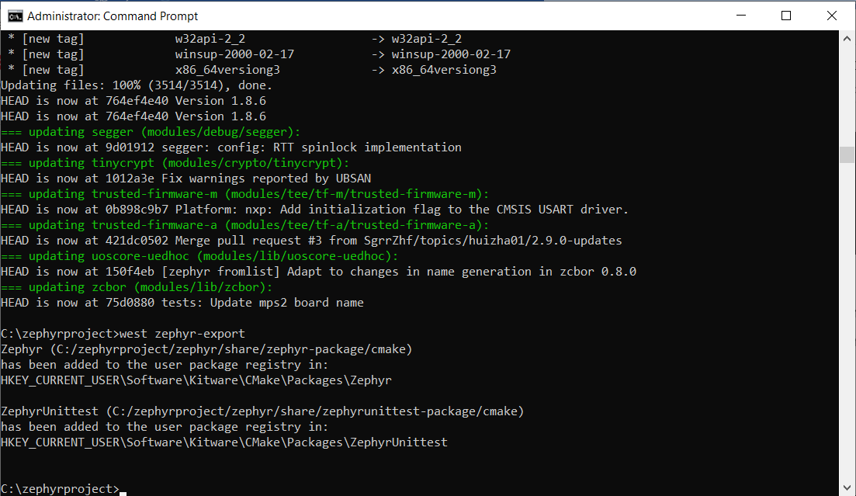
Zephyr’s scripts\requirements.txt file declares additional Python dependencies. Install them with the command pip3 install -r .\zephyr\scripts\requirements.txt
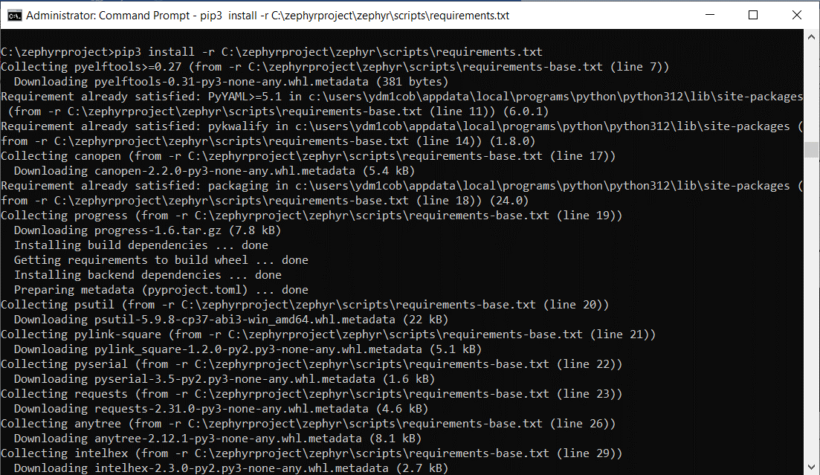
***************************Takes around 5 minutes************************
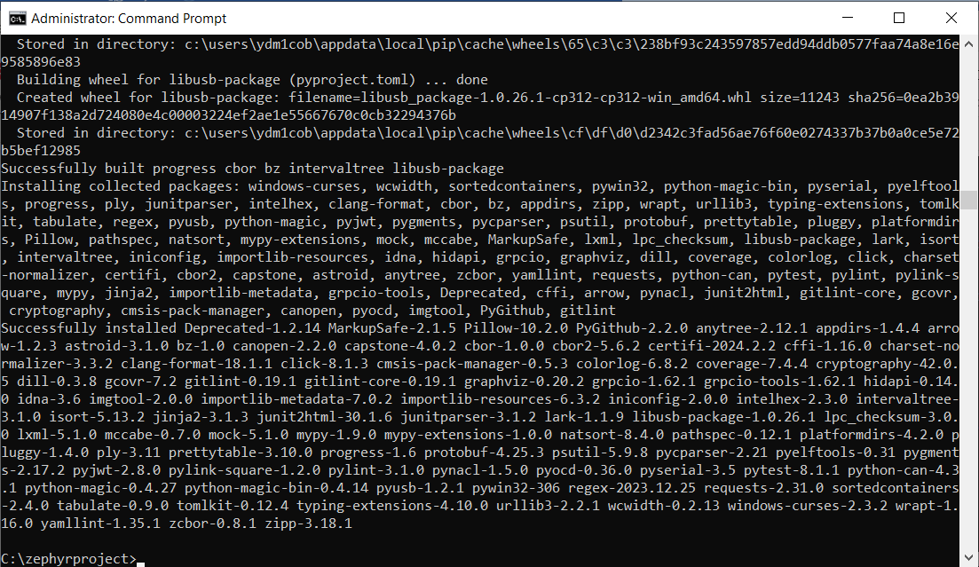

- Tortoise Git Installation:
Follow this link and download the latest version.
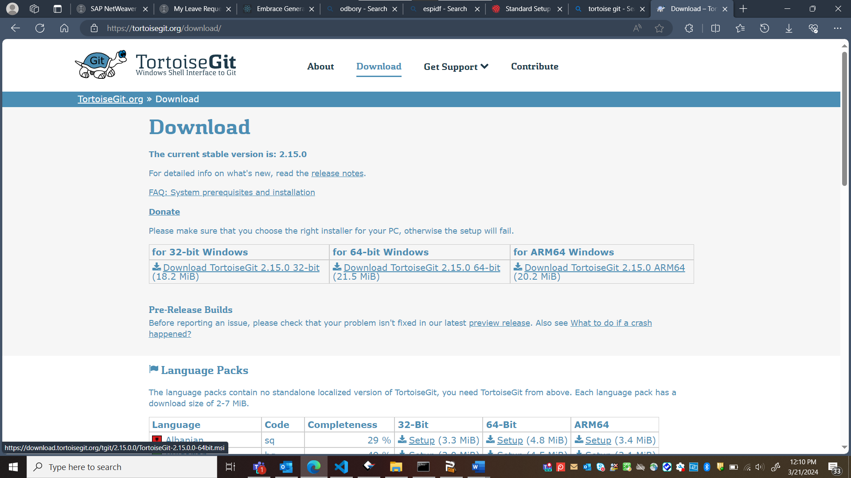
Open the downloaded .msi file and do the installation by following the below screenshots.
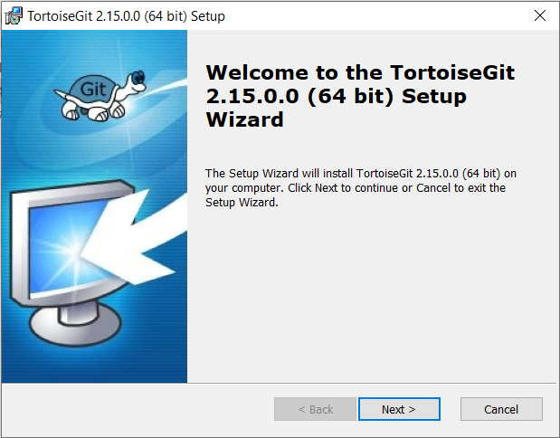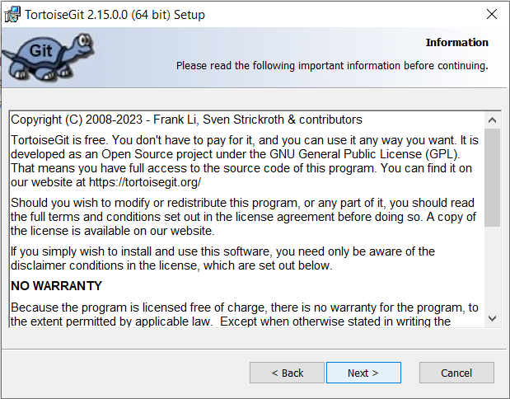
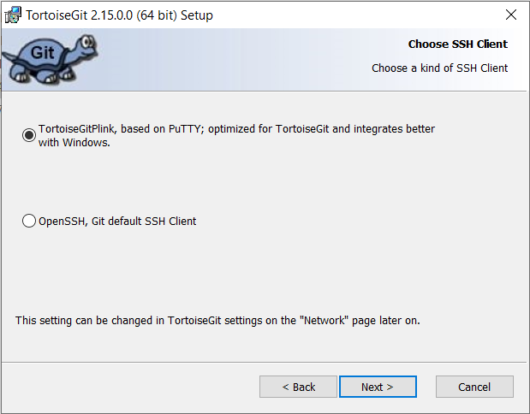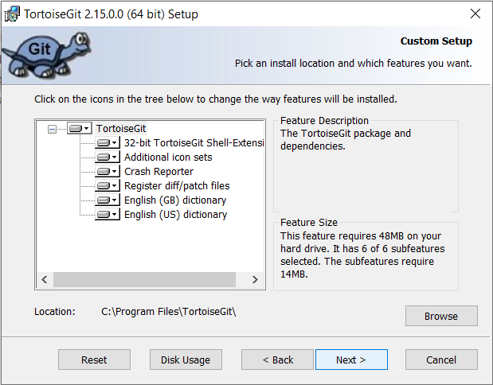
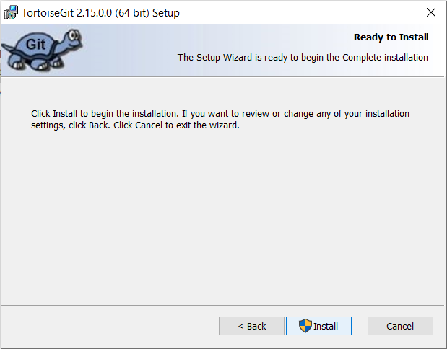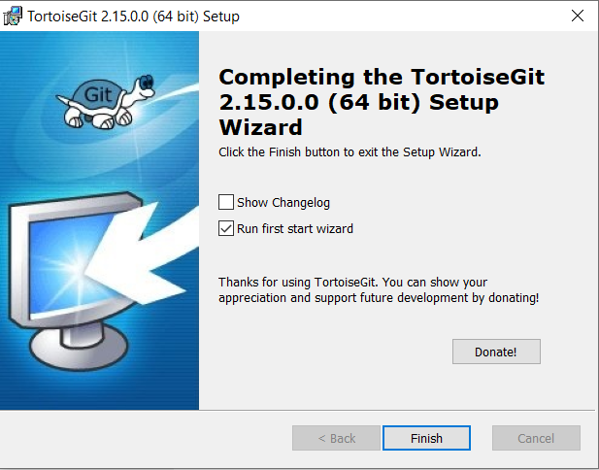
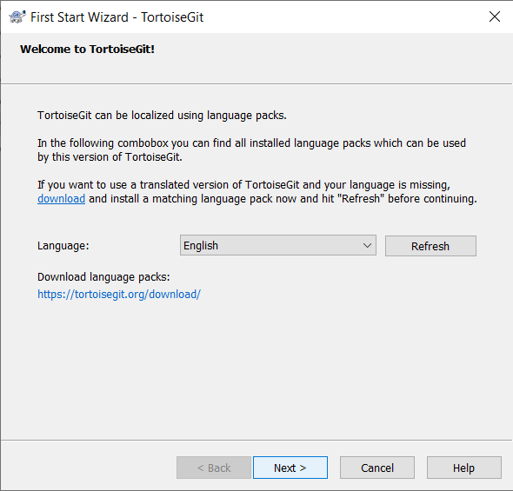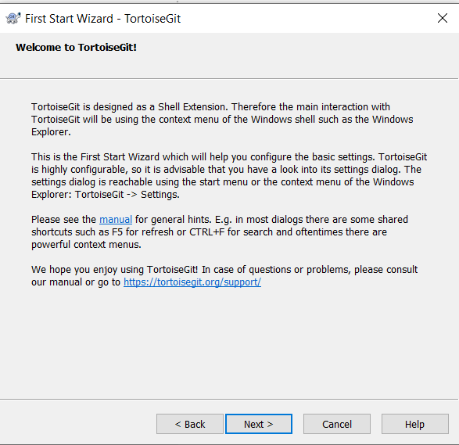
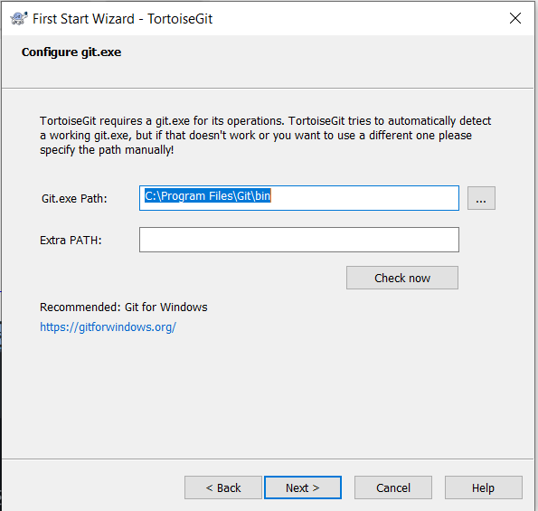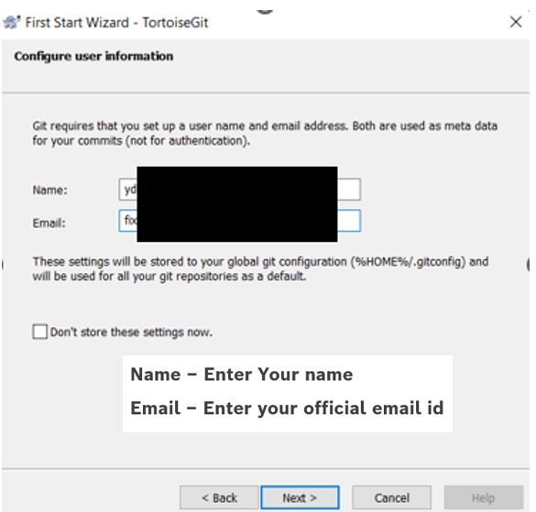

Click Next and Finish
In File explorer navigate to the C:\endor\zephyrproject\zephyr folder and right-click “switch/checkout”:
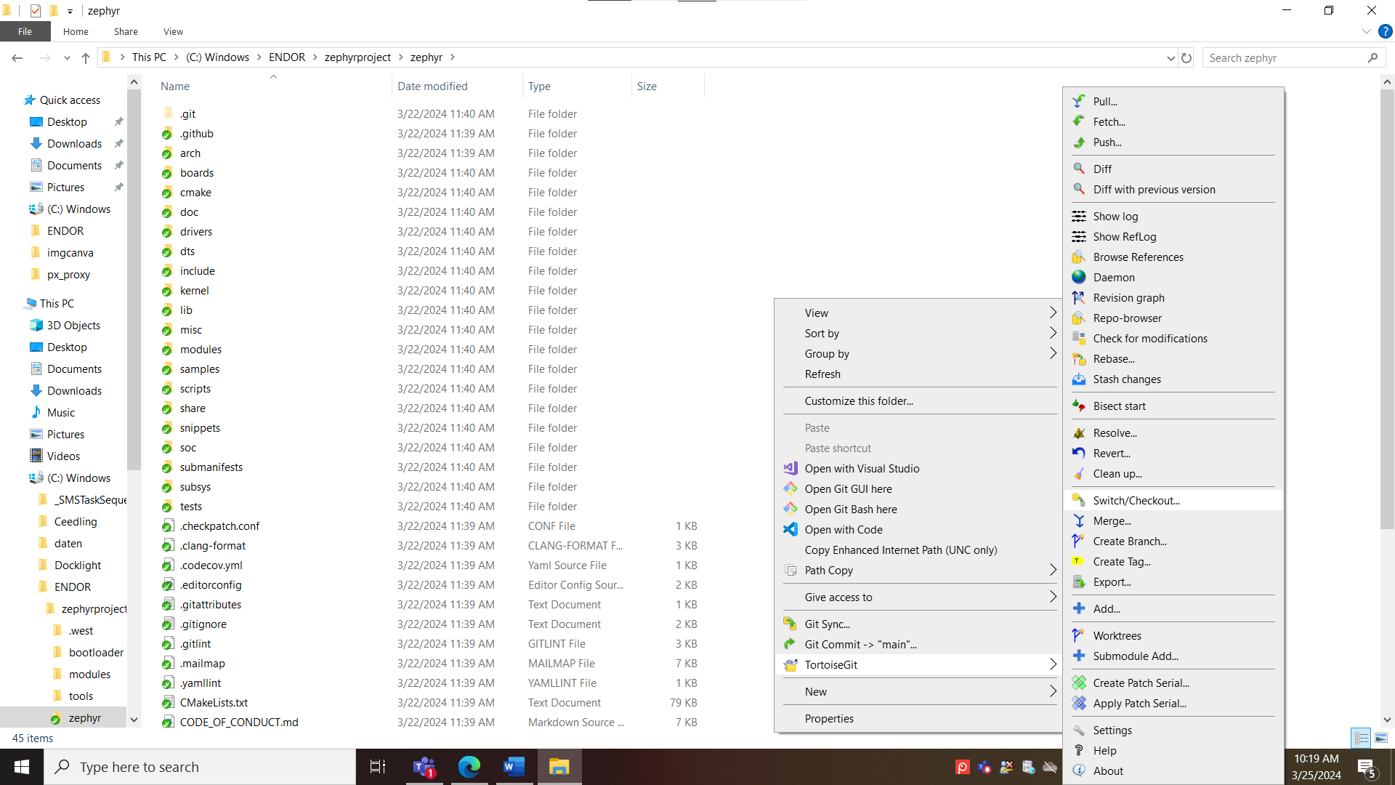
Select the “v3.3.0” in the Tag option and click ok:
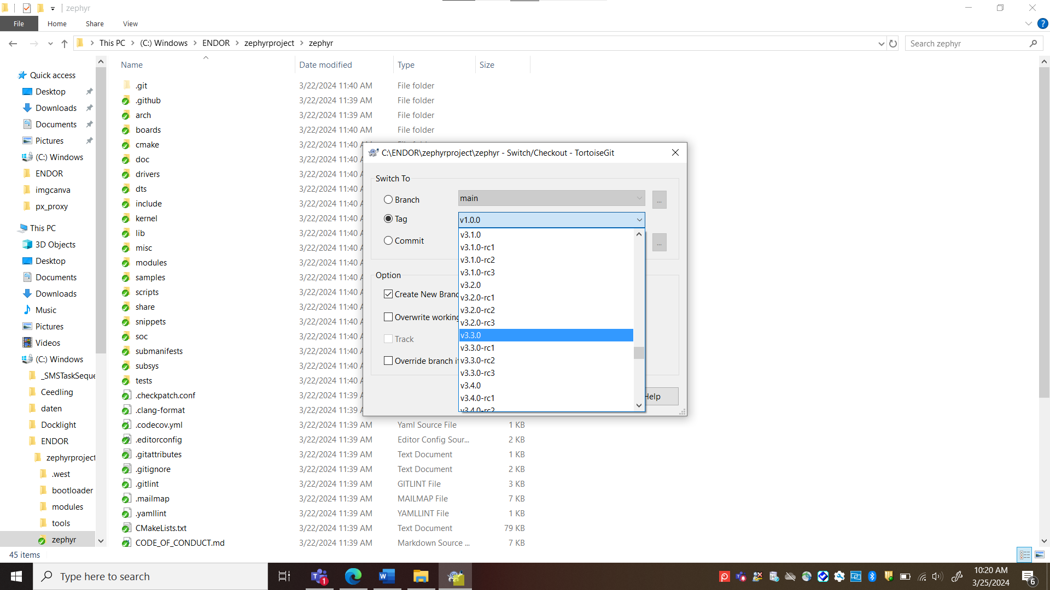
Wait till you get the success as in below image
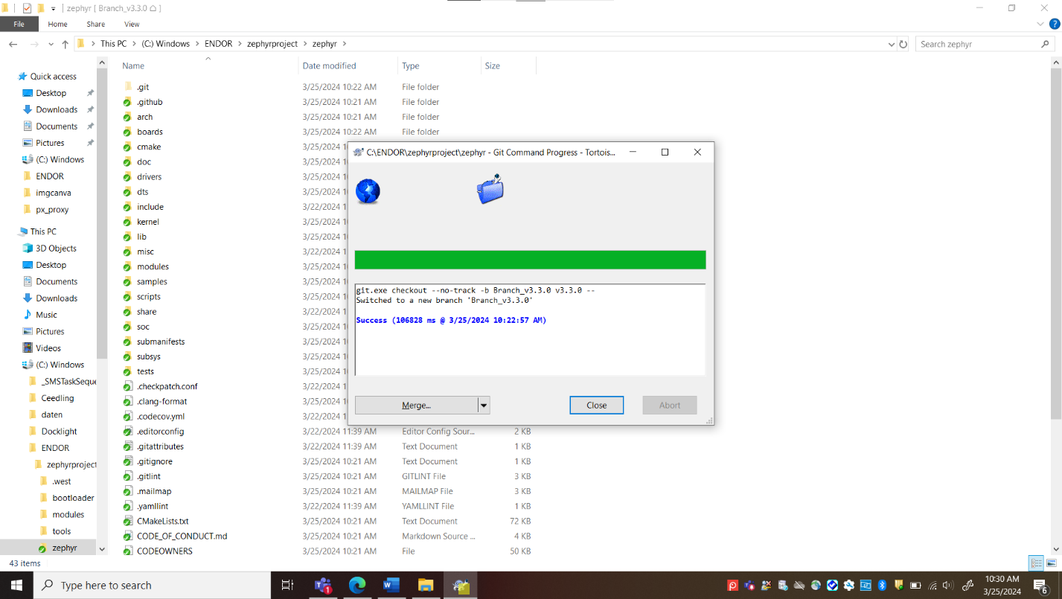
Open the “VERSION.txt” file and check the updated version
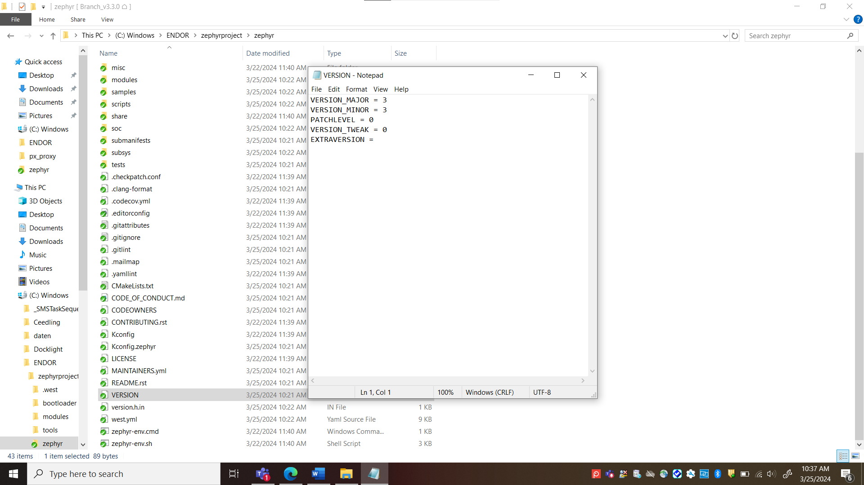
Run the west update command:
Navigate to the C:\endor\zephyrproject
type cmd in the path and enter.
Run the command west update
- Install Zephyr SDK
Download the file Zephyr SDK 0.15.2
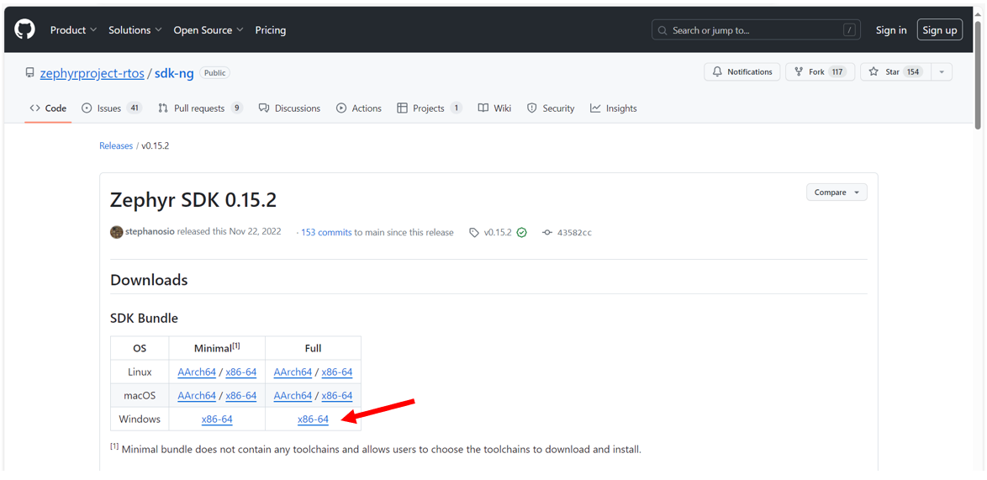
Extract the Zephyr SDK bundle archive in C:\endor
Open a command prompt by typing cmd in path and enter
Follow the below commands
cd zephyr-sdk-0.15.2
setup.cmd

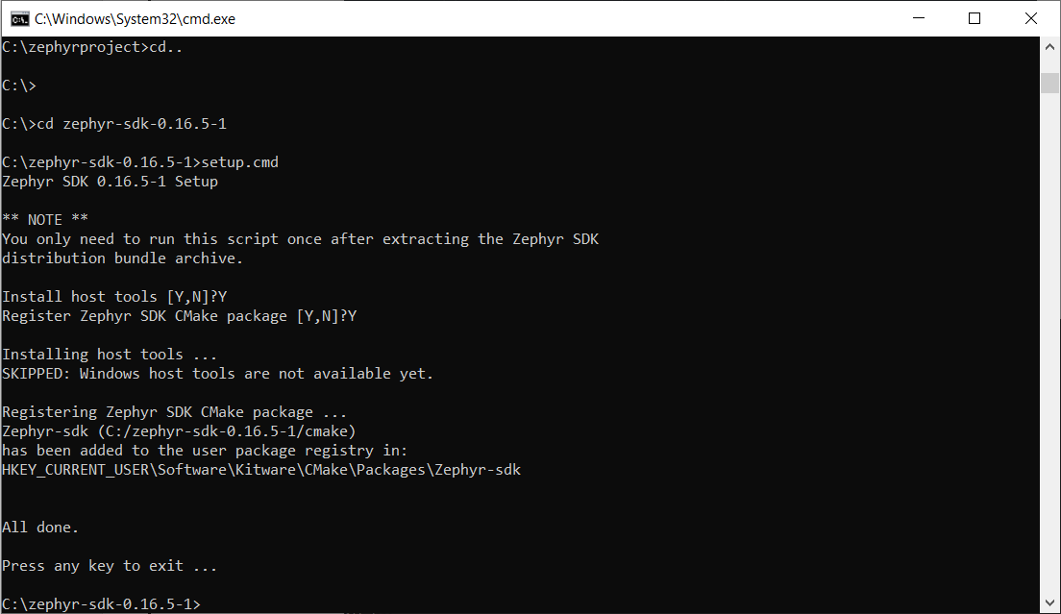
Building your first hello-world code:
Navigate to the C:\endor\zephyrproject\zephyr and type cmd in the path and enter
execute the command west build -b qemu_x86 samples/hello_world
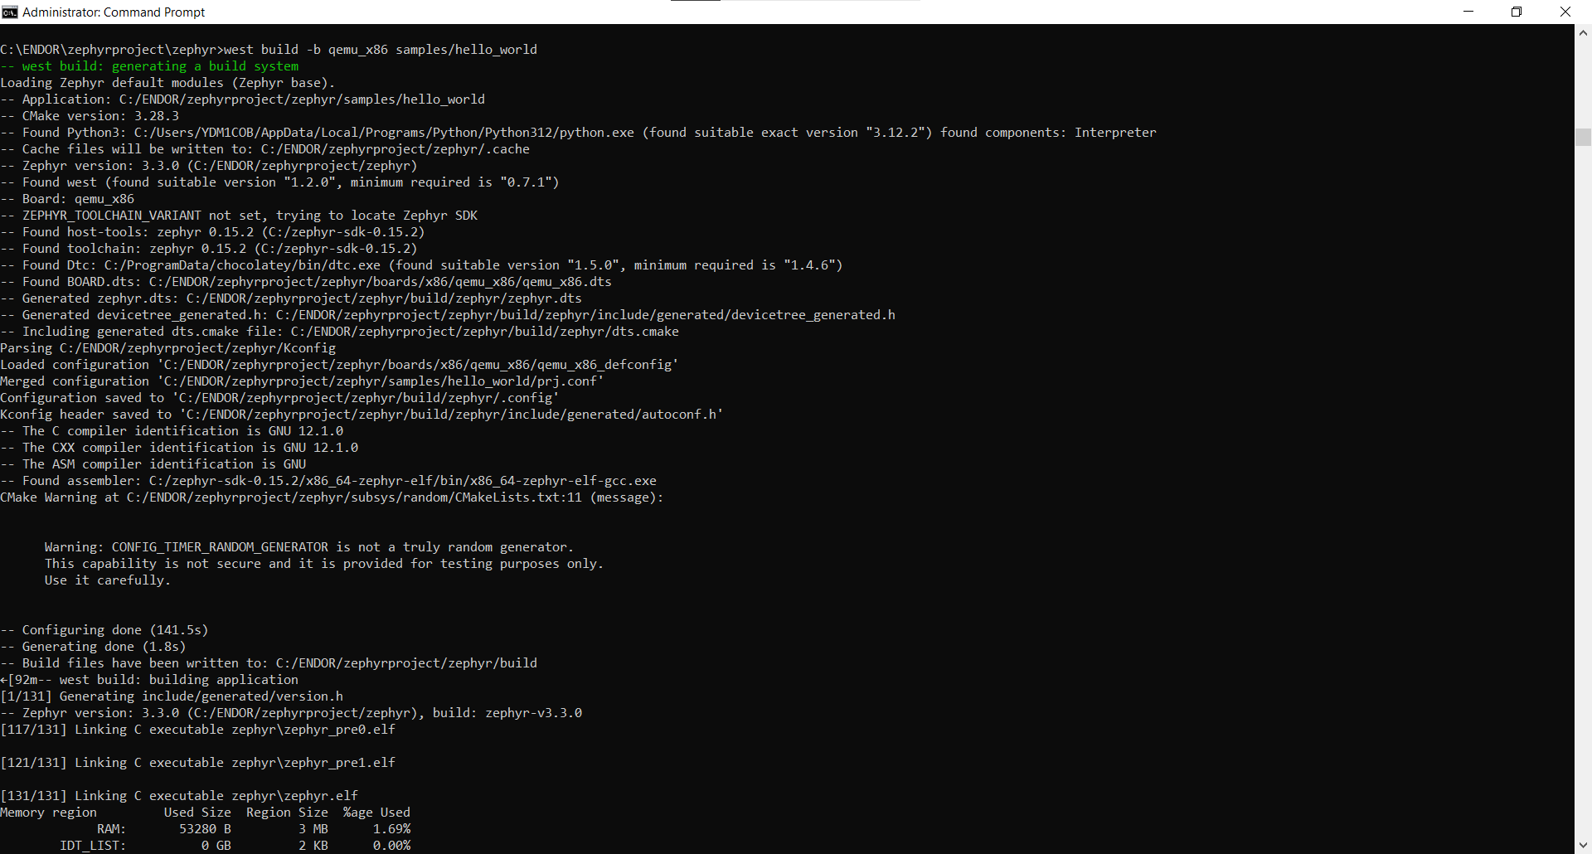

Build is successful.

