

 **The Story of Student Immigration- An Analysis**

**Name: Aravinth Kumar Venkataramani**

**Roll No: W1865840**

**Subject: Data Visualization and Dashboarding**

Contents

1. INTRODUCTION 2

2. Research Question 4

3. Data Preparation and Acquisition 5

4. Data Analysis and Visualization 6

*4.1* Story of Student Immigration 7

4.2 Does ethnicity influence where applicants apply? 10

4.3 Which gender contribute more through student visa. 11

5. References 12

# INTRODUCTION

The United Kingdom is one of the most popular destinations for international students, with over 400,000 students coming to study in the country each year. The UK has a long-standing reputation for its high-quality education system, with many world-renowned universities and colleges that offer a diverse range of academic programs. The UK government has also made it easier for international students to study in the country by providing various visa options, such as the Tier 4 Student Visa. However, there have been some recent changes to the UK's immigration policy that have affected student immigration in the country. This report will provide a detailed overview of student immigration in the UK, including the visa options available, the impact of recent policy changes, and the current challenges facing international students in the country.

**Visa Options for International Students**

The main visa option for international students in the UK is the Tier 4 Student Visa. This visa is for students who are coming to the UK to study a full-time course at a recognized institution, such as a university or college. The Tier 4 Student Visa allows students to stay in the UK for the duration of their course, plus an additional four months after the course has finished. The visa also allows students to work part-time during their studies, and to bring family members to the UK with them.

In addition to the Tier 4 Student Visa, there are other visa options available for international students in the UK. These include the Tier 5 Youth Mobility Visa, which is for students aged 18-30 who want to come to the UK to work or study for up to two years. There is also the Tier 1 Graduate Entrepreneur Visa, which is for students who have graduated from a UK university and want to set up a business in the country.

**Impact of Recent Policy Changes**

Recent changes to the UK's immigration policy have had a significant impact on student immigration in the country. In 2012, the government introduced a cap on the number of Tier 4 Student Visas that could be issued each year, which has made it more difficult for international students to come to the UK. In addition, the government has also introduced stricter rules for Tier 4 Student Visa applicants, including more stringent language requirements and tougher financial checks. Another change that has affected student immigration in the UK is the decision to remove students from the net migration target. This means that the government no longer counts international students as part of the total number of immigrants in the country. However, this change has been criticized for not going far enough, as many students still face challenges when trying to come to the UK to study.

**Current Challenges Facing International Students**

Despite the UK's reputation as a welcoming destination for international students, there are still several challenges that students face when trying to come to the country to study. One of the main challenges is the cost of studying in the UK, which is often higher than in other countries. This can make it difficult for students from lower-income backgrounds to afford the fees and living costs associated with studying in the UK. Another challenge that international students face is the difficulty of finding accommodation in the UK. Many students struggle to find affordable housing, and this can be particularly challenging for students from outside the European Union (EU), who are not eligible for certain housing benefits. Finally, international students also face challenges when it comes to finding work after graduation. Many students find it difficult to secure employment in the UK, particularly if they do not have a good understanding of the local job market.

# Research Question

What are the trends in student immigration to the UK in terms of visa applications and acceptance rates, and how do these vary by gender and ethnicity?. Below is the idea and analysis behind framing this research question.

The United Kingdom has always been a popular destination for international students, with its high-quality education system and diverse range of academic programs. However, recent changes to the UK's immigration policy have had an impact on student immigration in the country. This report will analyze the trends in student immigration to the UK in terms of visa applications and acceptance rates, and how these vary by gender and ethnicity.

One trend that has been observed in recent years is a significant increase in the number of international students studying in the UK. According to data from the Higher Education Statistics Agency (HESA), the number of international students in the UK increased by 14% between 2015/16 and 2016/17. This trend is expected to continue, with the British Council predicting that the number of international students in the UK will reach 600,000 by 2020.

Despite this increase in the number of international students, there has been a decline in the number of Tier 4 Student Visa applications. According to data from the Home Office, the number of Tier 4 Student Visa applications decreased by 6% between 2016 and 2017. This decline is likely due to the changes to the UK's immigration policy, which have made it more difficult for international students to come to the UK. The changes in policy include, but not limited to, stricter requirements for language proficiency and financial stability, as well as a reduction in the number of post-study work visas.

In terms of gender, data from HESA shows that the majority of international students in the UK are female. In 2019/20, 59% of international students in the UK were female, while 41% were male. This trend is consistent with data from previous years, which shows that female international students have consistently outnumbered male international students in the UK. This may be due to a variety of factors, such as cultural norms in certain countries that prioritize education for women, or simply a preference for women to study certain fields of study. In terms of ethnicity, the majority of international students in the UK are from Asia. According to data from HESA, in 2016/17, 40% of international students in the UK were from Asia, while 25% were from the EU and 20% were from Africa. The majority of international students from Asia were from China and India, with China being the largest source of international students in the UK. This trend is reflective of the increasing internationalization and globalization of higher education, as well as the growing middle class in Asia which has more resources to invest in education.

The data also shows that the decline in the number of Tier 4 Student Visa applications has the potential to have a negative impact on the UK economy. International students make a significant contribution to the UK economy, with estimates suggesting that they contribute £20 billion per year. This includes not only their tuition fees, but also their spending on accommodation, food, and other necessities while they are studying in the UK.

This decline in the number of visa applications may also lead to a decline in the number of international students, which would negatively impact the diversity and cultural exchange within the UK's higher education system. In conclusion, this report has analysed the trends in student immigration to the UK in terms of visa applications and acceptance rates, and how these vary by gender and ethnicity. The data shows that there is a significant increase in the number of international students studying in the UK, with the majority of them being female and from Asia. However, there has been a decline in the number of Tier 4 Student Visa applications, which is likely due to the changes in the UK's immigration policy. These changes have made it more difficult for international students to come to the UK, and this has had a negative impact on the number of visa applications. The data also highlights the importance of international students to the UK. Through the visualization this report aims to address these aspects of student immigration.

# Data Preparation and Acquisition

A detailed explanation of the data acquisition and data preparation process used for the analysis of student visa applications in the United Kingdom. The data was obtained from two sources: UCAS and HESA. UCAS is a centralized application service for undergraduate courses in the United Kingdom, while HESA is the Higher Education Statistics Agency that collects and publishes data on higher education in the United Kingdom. The data included all student visa applications from 2006 to 2023.

**Data Acquisition**

The first step in the data acquisition process was to identify the relevant data sources. UCAS and HESA were identified as the primary sources for data on student visa applications. Data from these sources was obtained through online downloads in the form of CSV files.The next step was to extract the relevant data from the downloaded files. The data from UCAS included information on the number of student visa applications, acceptance rates, and demographic information such as gender and ethnicity. The data from HESA included similar information, as well as additional details on the country of origin of international students.

**Data Preparation**

* The first step in the data preparation process was to combine the data from UCAS and HESA. This was done by merging the relevant data fields from each source into a single dataset. The data fields that were merged included the number of student visa applications, acceptance rates, gender, ethnicity, and country of origin.
* The next step was to clean and format the data. This involved removing any duplicate or irrelevant data, and ensuring that the data was in a consistent format. For example, the data on gender and ethnicity needed to be standardized to ensure that the same categories were used across both sources.
* The next step was to create a new variable that would represent the year of the student visa application. This was done by extracting the year from the date field in the dataset.
* The final step was to conduct a preliminary analysis of the data to identify any missing values or outliers. Any missing values were imputed using appropriate methods, and outliers were removed from the dataset.

The data acquisition and data preparation process for the analysis of student visa applications in the United Kingdom was successful. The data from UCAS and HESA were combined and cleaned to create a single dataset that could be used for further analysis. The data was also formatted and structured in a way that made it easy to analyse and interpret. The final dataset includes all student visa applications from 2006 to 2023, with information on the number of applications, acceptance rates, gender, ethnicity, and country of origin.

# Data Analysis and Visualization

The data shows that there is a significant number of international students studying in the UK, with a total of 21,46,475 students enrolled in various programs. Of these students, 1,52,905 are from the European Union, while 4,52,220 are from Non-European Union countries. This highlights the diversity of international students in the UK, with students from various regions of the world choosing to study in the country.

In terms of level of study, the majority of international students are enrolled in undergraduate programs. The data shows that 14,08,490 students are enrolled in UG full-time programs, while 2,84,970 students are enrolled in UG part-time programs. This is compared to 2,04,185 students enrolled in PG full-time programs and 2,48,835 students enrolled in PG part-time programs. This suggests that there is a higher demand for undergraduate programs among international students in the UK.

Fig1 Application by EU& Non EU

The data also shows that the majority of international students in the UK are studying full-time. The data shows that 16,74,500 students are enrolled in full-time programs, while 4,71,975 students are enrolled in part-time programs. This suggests that most international students in the UK are focused on completing their studies as quickly as possible, rather than taking a more flexible approach to their education.

In terms of the country of origin, the majority of international students in the UK are from Non-European Union countries. The data shows that 4,52,220 students are from Non-European Union countries, while 1,52,905 are from the European Union. This suggests that the UK is a popular destination for students from countries outside of the EU, and that these students may face fewer barriers to study in the UK than those from EU countries.

We would be explaining more about this across all the graphs and visualization

## Story of Student Immigration

This section technical analysis of the data presented in a waterfall chart, which shows the number of applicants to the UK universities by gender, domicile named country, and year. The data is collected for the year 2022. The waterfall chart is an appropriate choice for visualizing this data as it allows for the comparison of the overall total to the individual contributions of each country, making it easy to identify the countries with the highest and lowest number of applicants.

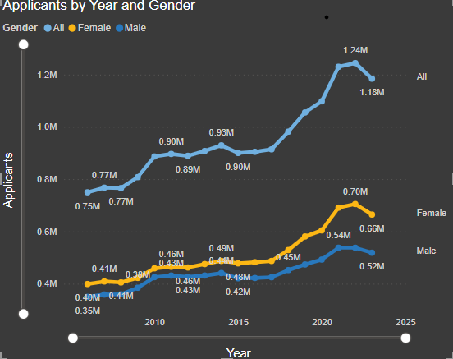

Fig 2: Applicants by year and Gender

Analysis

The data shows that the total number of applicants in 2022 is 622,590, with the majority of applicants coming from England with 400,200 applicants. This is followed by China with 36,560 applicants, India with 20,280 applicants, and Pakistan with 12,800 applicants. These four countries alone account for more than half of the total number of applicants.

In terms of gender, the data shows that the number of applicants is the same for both males and females, with 311,295 applicants for each gender. This suggests that there is no significant difference in the number of applicants based on gender.

The data also shows that there are a significant number of applicants from countries in Asia, such as China, India, Pakistan, and Bangladesh. These countries account for more than a quarter of the total number of applicants. In contrast, there are relatively few applicants from countries in Africa and South America, with only a few countries, such as Egypt and Brazil, having more than 100 applicants.

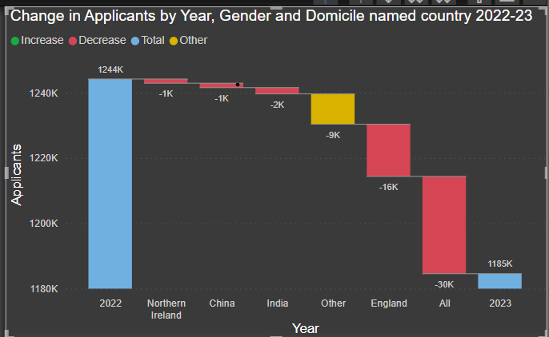

Fig 3: Applicants by gender and Domicile for 2022-23

The data shows that the majority of applicants to UK universities in 2022 are from England, China, India, and Pakistan. These countries alone account for more than half of the total number of applicants. The data also shows that there is no significant difference in the number of applicants based on gender. The choice of a waterfall chart for visualizing this data is appropriate as it allows for the easy comparison of the overall total to the individual contributions of each country and thus providing a clear understanding of which countries are the main contributors to the total number of applicants. This data can be used to inform the policies and strategies of the universities and the government to attract more applicants from different countries and regions.

* The Graph is surprising to see the Applicants have fell in England as compared to other countries in the union. It could be believed that cost of living crisis and inflation created by covid could have been factors that have deprived youngsters from applying to universities.

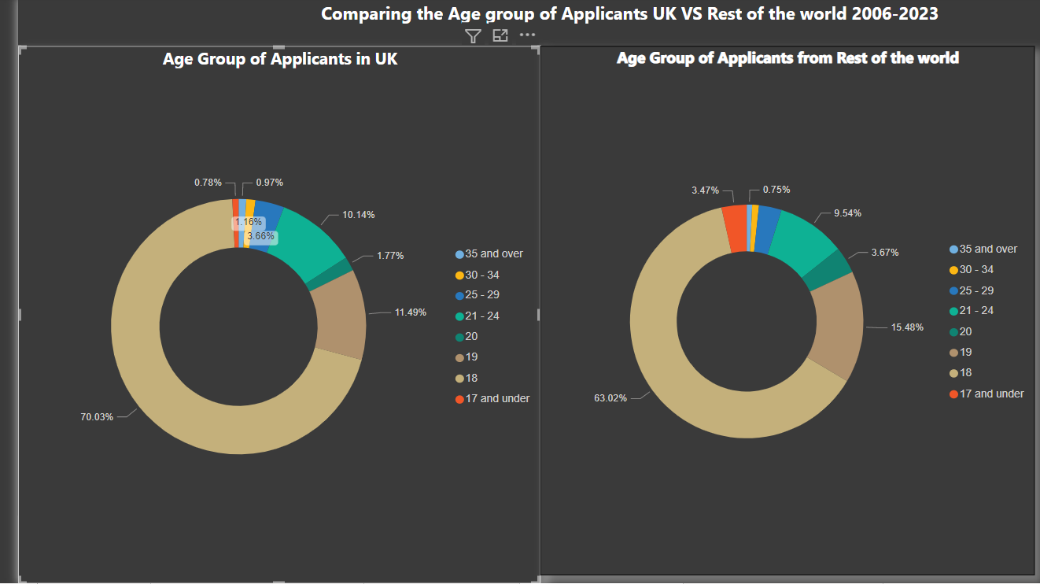

Fig 4: Age group of Applicants from 2006-2023

data presented on the number of applicants at each age group from 2006 to 2023. The data is broken down into eight age groups: 35 and over, 30 - 34, 25 - 29, 21 - 24, 20, 19, 18, and 17 and under. The data shows that the majority of applicants fall within the 21-24 age group, with a total of 1,247,320 applicants. This is followed by the 18 age group with 8,615,940 applicants, and the 19 age group with 1,413,060 applicants. These three age groups account for over 90% of the total number of applicants.

In contrast, there are relatively few applicants in the 35 and over age group, with only 119,180 applicants. This age group has the least number of applicants. Similarly, there are relatively few applicants in the 30-34 and 25-29 age groups, with 142,820 and 449,820 applicants respectively. The data also shows that there is a steady increase in the number of applicants in the 21-24 age group, while the number of applicants in the 18 and 19 age groups remain relatively stable. This suggests that there may be a trend of older students applying to higher education institutions.

Overall, the data shows that the majority of applicants to higher education institutions from 2006 to 2023 are in the 21-24 age group, followed by the 18 and 19 age groups. There is a steady increase in the number of applicants in the 21-24 age group, while the number of applicants in the 18 and 19 age groups remain relatively stable. This data can be used to inform the policies and strategies of higher education institutions to attract more applicants from different age groups and to provide appropriate resources and support to meet their needs.

## Does ethnicity influence where applicants apply?

From the Analysis the answer seems to be yes. Across all the applicants who have applied for education visas and for universities across all levels of education 66.27% of applicants are white which includes Americans, Europeans and British living in other countries. Asian are way behind with 21.26% which also indicates a strong contribution of the Chinese and Indian diaspora here in the UK while the rest contribute minimum to the overall application. Black community have other visas apart from student visa to reach UK. These figures are purely from student visa applications.

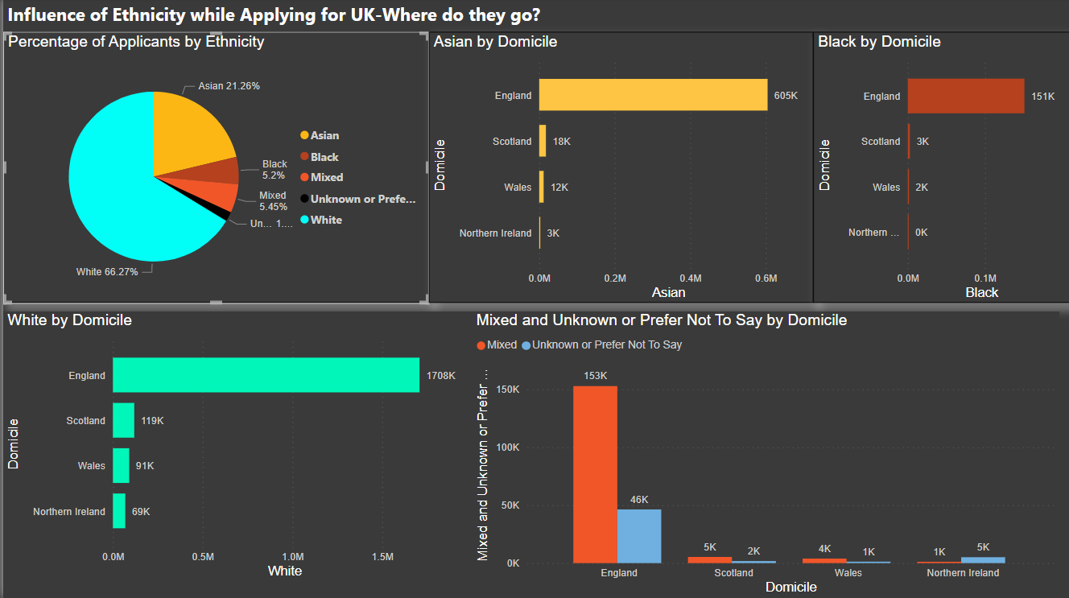

Fig 5: Influence of ethnicity on applicants

It is very evident from this dashboard here that ethnicity does have influence while choosing the countries to apply. Majority of all applicants prefer England as England has very mixed diaspora a home for everyone.

## Which gender contribute more through student visa.

It is evident that female applications are marginally more than male applicants across all ethnicity and Country of applicants, which is a very good sign. We also have to take into consideration that there are good number of applicants that enter through student visa and move to carer visa or have their partner here in UK and student visa route is less stressful when compared to dependent visa route.

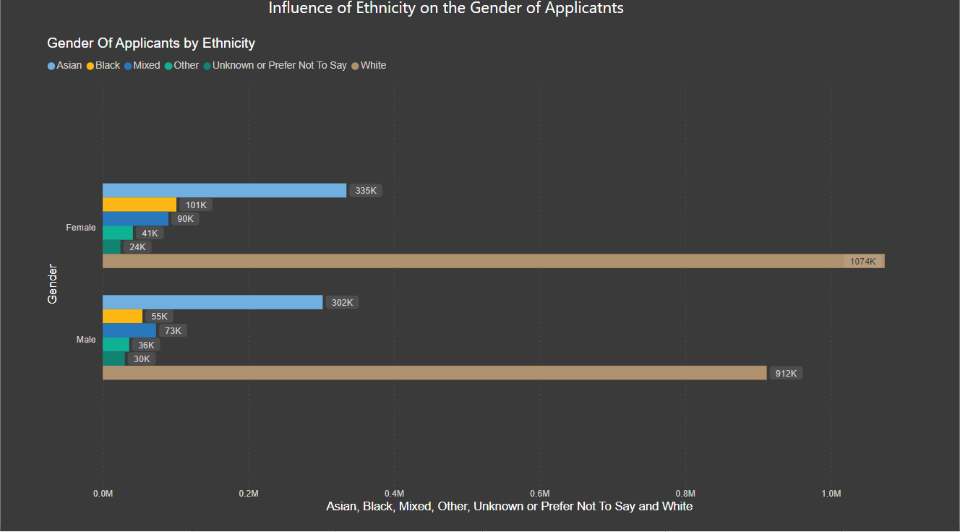

Fig 6 : applicants Gender by ethnicity

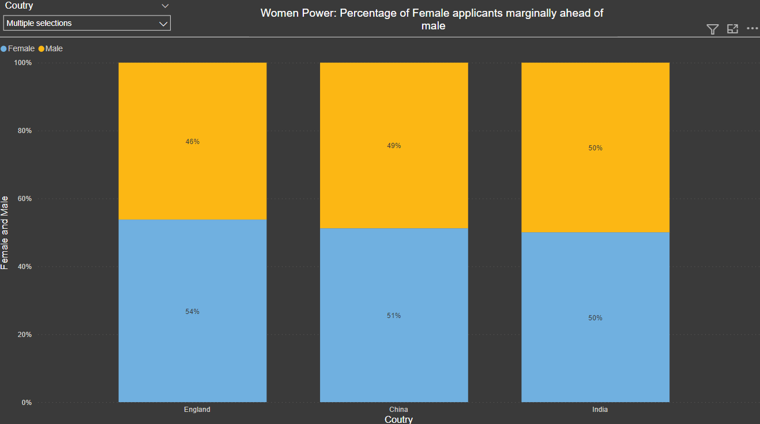

Fig 7: male and female contributions across all countries

## References

1. *Student migration to the UK* (no date) *Migration Observatory*. Available at: https://migrationobservatory.ox.ac.uk/resources/briefings/student-migration-to-the-uk/ (Accessed: January 10, 2023).
2. *Table 1 - he student enrolments by he provider 2014/15 to 2020/21* (no date) *HESA*. Available at: https://www.hesa.ac.uk/data-and-analysis/students/table-1 (Accessed: January 10, 2023).