## LAB 4 Report

## Haimin Hu, Rui Wang, Yujian An

## Cart Dynamics

The system representation that we used in this lab is transfer function.

## The Quanser Hardware

We have turned off the amplifier after we finished the lab :)

## Using the Actual Hardware: Find Encoder-Distance Conversion

1. **Initialization**

Before we start to set the Read Encoder Block, it is necessary to add on two auxiliary blocks for the system, the **HIL Initialize block** and **timing block**, which are shown as follows:

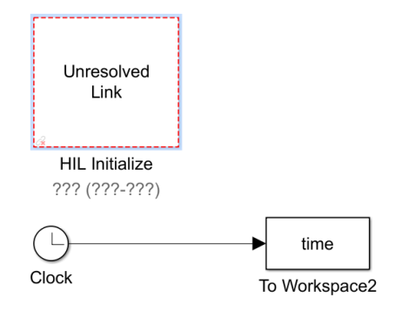

Figure 1 Initialization and timing block

The timing block will get the simulation time and store it into a mat file.

1. **MATLAB Simulink Block for Position Encoder Reading**

The following diagram created in Simulink is used to read the encoder data via the interface provided by Quanser from the actual hardware. The **HIL Read Encoder** block is the Quanser encoder MATLAB interface; the **simout** block is used to read and store the encoder data as mat files; the **Display** block is to show the (unconverted) raw encoder data in real time.

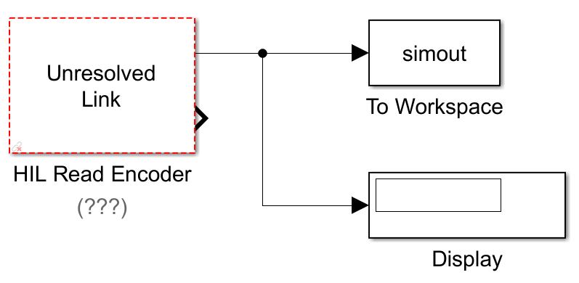

Figure 2 Read Encoder Block

1. **Encoder Data Conversion**

The conversion procedure follows the data included in the form below:

Table Data for calculating the encoder conversion ratio

|  |  |  |
| --- | --- | --- |
| **Raw counts** | **Distance travelled (m)** | **Counts/m** |
| 4606 | 0.105 | 43680 |
| 4578 | 0.104 | 44060 |
| 4680 | 0.107 | 43560 |

The resulting encoder resolution is given by averaging the data which is 43770 counts/m.

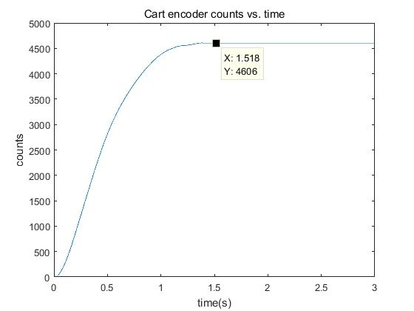

Figure 3 Plot of cart encoder counts vs. time

The “actual” encoder resolution is:

$$\frac{4096}{2πr_{pp}}=\frac{4096}{2π×0.01482975}=43958 counts/m$$

The discrepancy between the estimated and the actual encoder resolution is approximately 0.428%.

## Using the Actual Hardware: Cart Step Response

1. **Re-simulation with a step input function of magnitude 0.15**

K = 10 is enough for the system to meet its design specifications in this case. Note that this feedback gain is the same as the one in my (Haimin’s) prelab. The reason why we can directly use the previous gain is because the regulation signal getting smaller implies that the cart will need to travel a shorter distance, which is (heuristically) easier to regulate (a reasonable overshoot) and reach the goal (yields a shorter rising time).

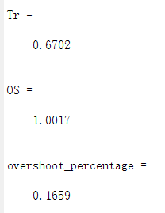

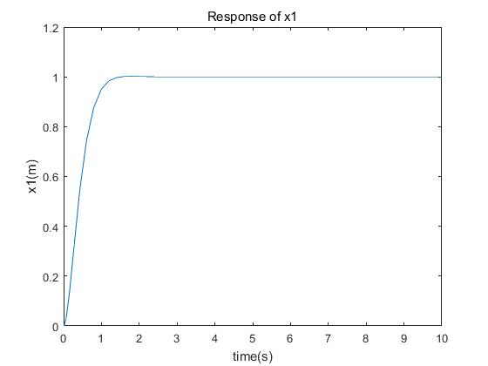

Figure System performance with a step function of height 0.15

1. **Control the actual hardware via Simulink**

The Simulink block diagram for controlling the Quanser cart is shown as follows. Note that the gain in between HIL Read Encoder and Display is set to $\frac{1}{43770}$, which is the conversion ratio obtained in the previous section.

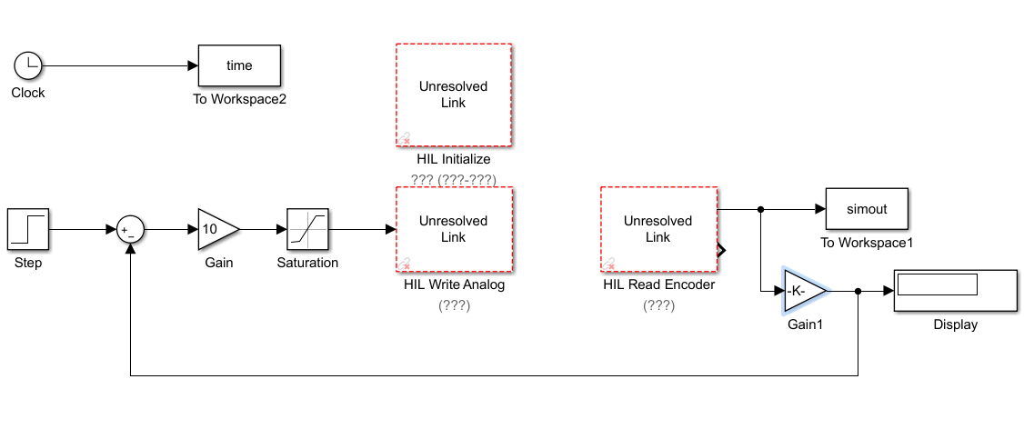

Figure Simulink diagram for controlling the Quanser cart

The initial hardware response with K = 10 is shown as follows,

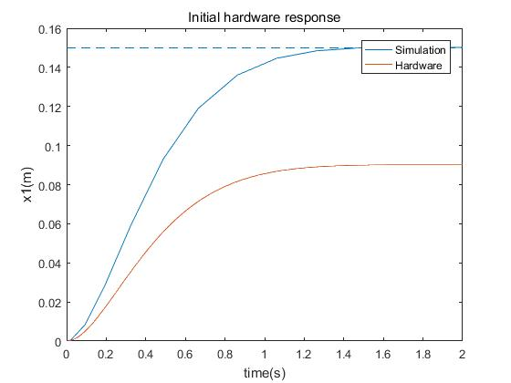

Figure Initial hardware response comparing to the simulation result

As is depicted in the above figure, the actual trajectory of x1 is far away from the simulation result and the reference. It is the large friction of the track that counts for the cart not being able to reach the reference point.

The new gain that we choose is **K = 30**. Using this feedback gain, the specified performance criterion, $t_{r}<0.3s$ and $maximum overshoot <12\%$, can be met. The plot is as follows,

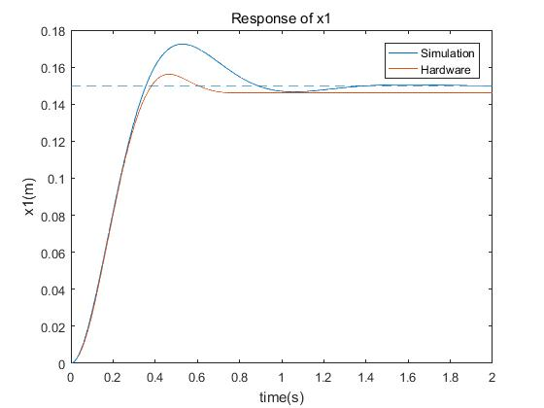

Figure Hardware response that satisfies the specifications with K = 30

Table System performance of simulation and actual hardware

|  |  |  |
| --- | --- | --- |
| **Response of x1** | **Rising time (s)** | **Overshoot (%)** |
| **Simulation** | 0.240 | 14.97 |
| **Hardware** | 0.288 | 6.80 |

The reason why K is different is related to what we have discussed previously about the friction. A larger K yields a “stronger” feedback action which offers a larger traction force to the cart. It results in a shorter rising time but a larger overshoot and drags the cart closer to the reference position.

Note in Table 2 the overshoot of simulation does not meet the specifications but the actual hardware does. This is again because of the friction that has compensated for the overshoot, which makes it possible for the actual hardware to meet the specifications, while the simulation does not take the friction into account.