**ME C134 Lab4 Report**

**Rui Wang | Haimin Hu | Yujian An**

**5.1 Propotional Control**

1.Minimal K value such that the rise time is less than 0.2s.

After tests, the minimal value for K is decided to be 53.

Note that in all figures in this section, the unit of the y-axis is cm instead of m.

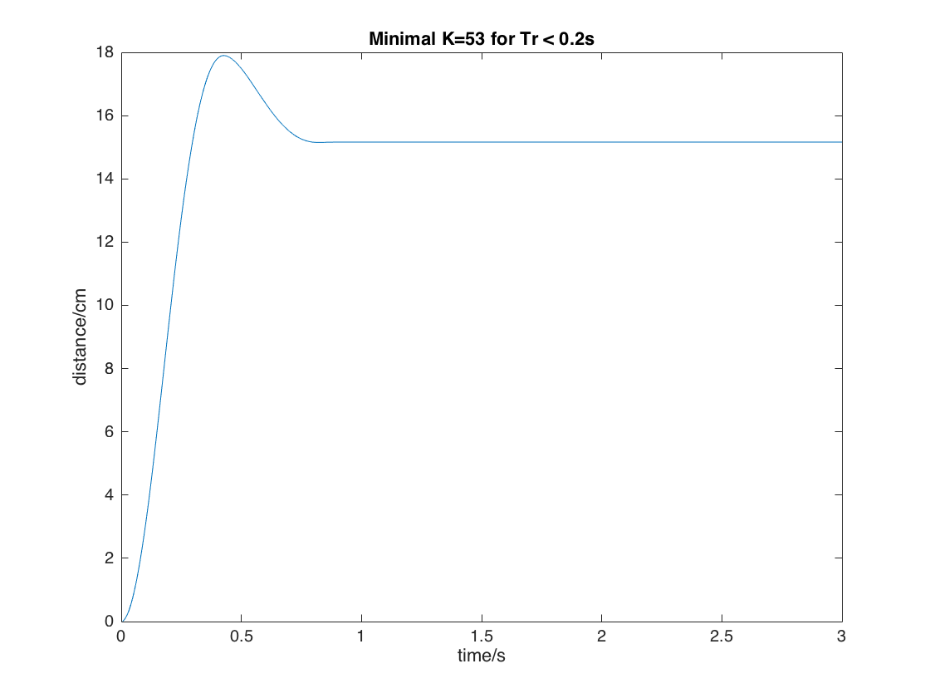

Figure 1. System Response for K=53

2. Maximal K value such that the overshoot is less than 8%

The maximal value for K is 40.

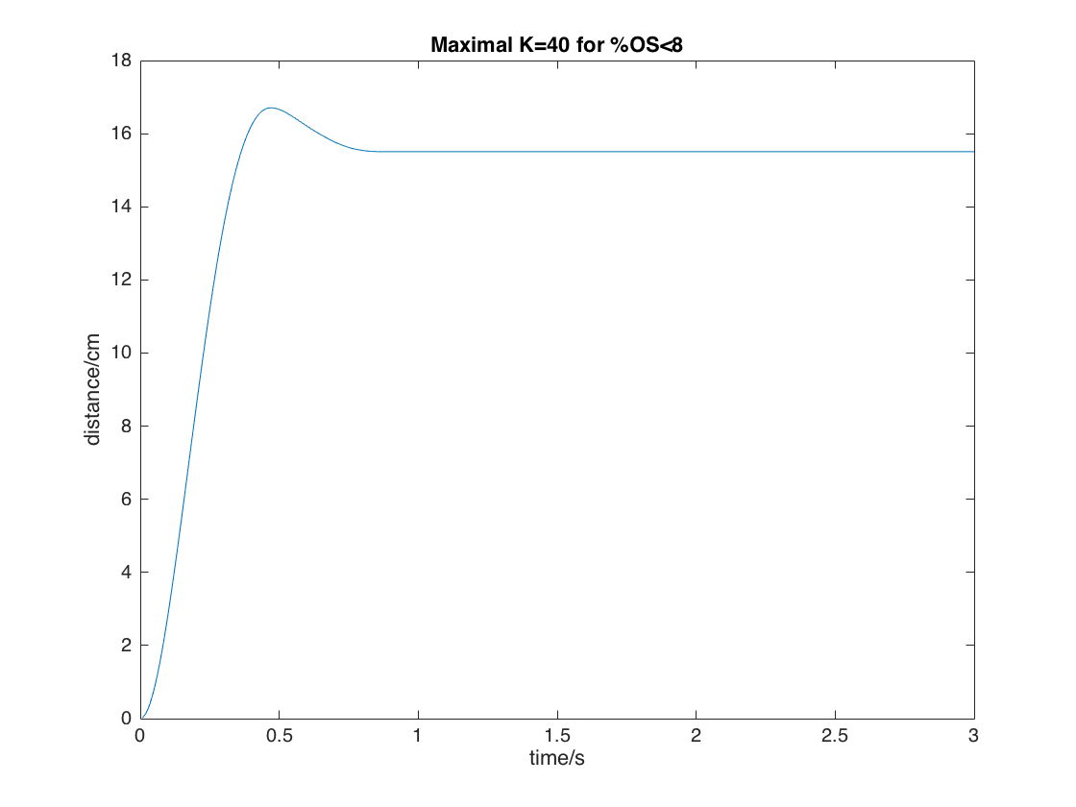

Figure 2. System Response for K=40

3. One value between the two

We chose the value 45.

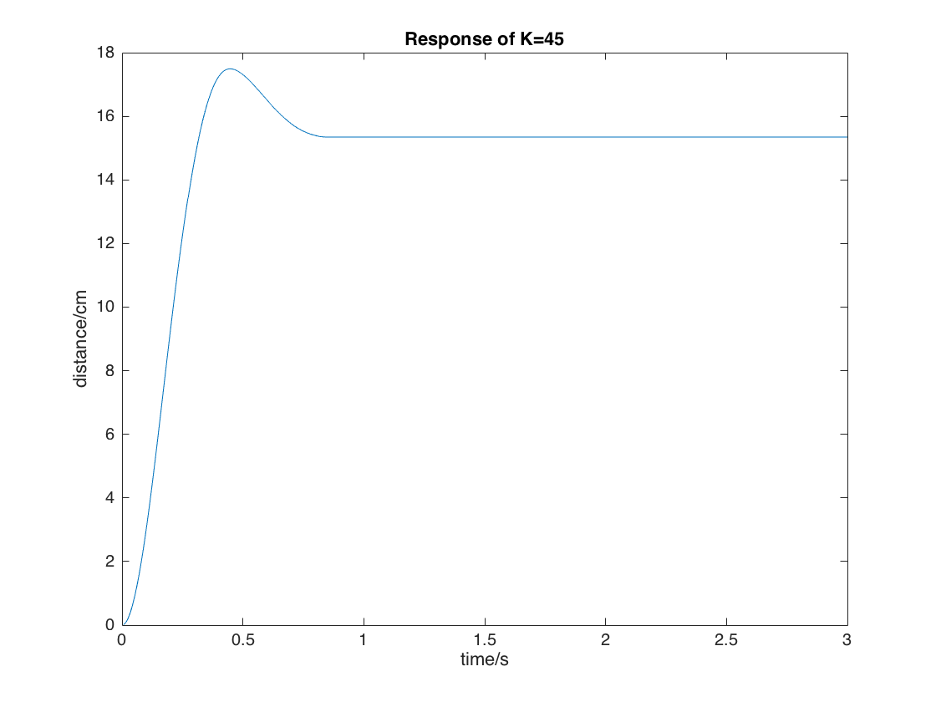

Fig 3. System Response for K=45

4. There is a non-zero steady state error of the system. This is because of the friction and forces from the wire that impede the cart’s motion. As a result of these forces, the actual block diagram should be different from our theoretical derivation.

5.Response of system for K=100

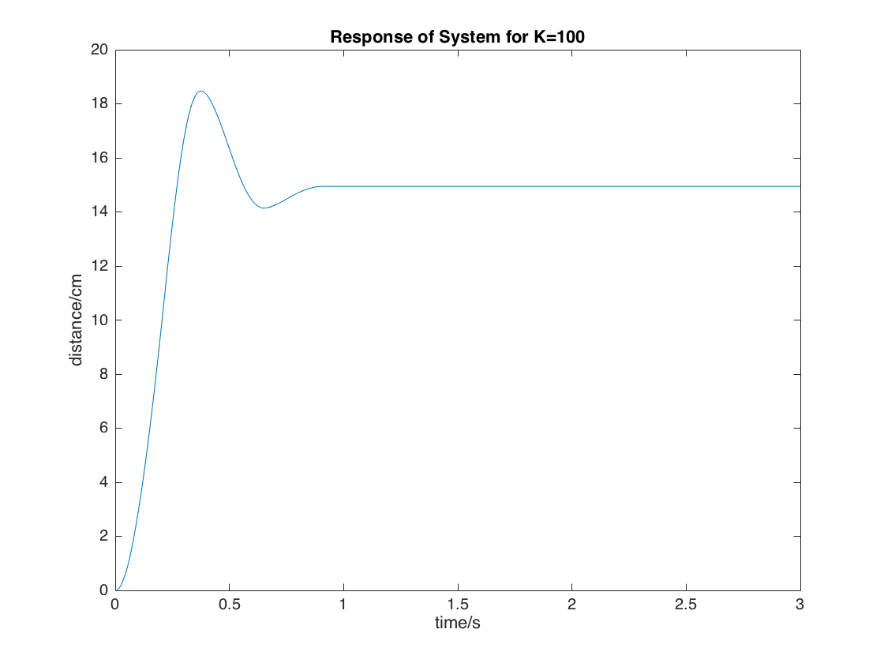

Fig 4. System Response for K=100

Compared to the response in simulation from Pre-lab, the rising time is **longer**, the overshoot is **smaller**. The impeding forces such as friction and constraints from the wires account for this.

**5.2 PD Control**

1.The performances are not met. For example, let Kd = 10, and we obtain:

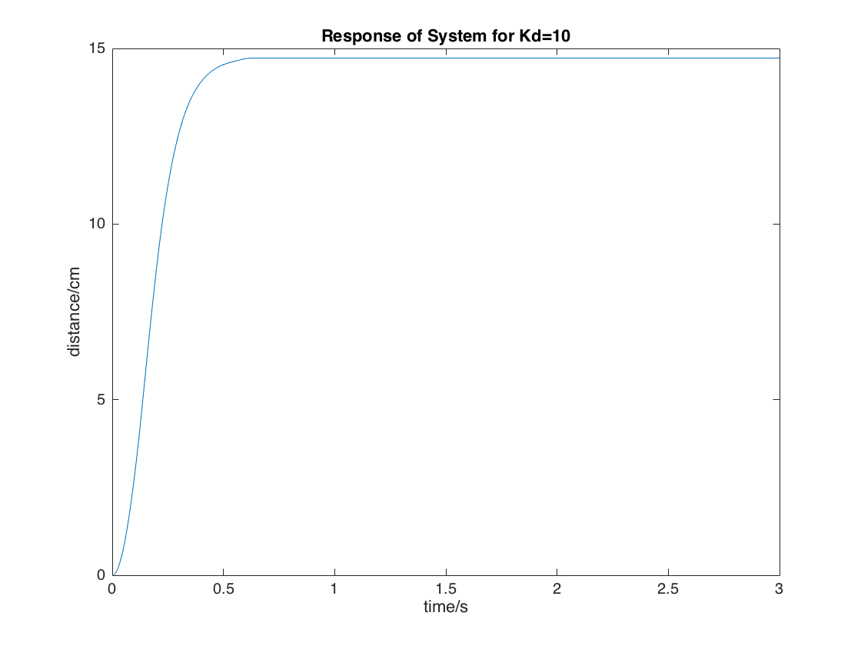

Fig 5. PD Control System Response for Kd=10, Kp/Kd=12

2. The final value we chose are Kd = 10, Kp/Kd = 20.

Rising time = 0.196s, while %OS = 0.88. These values meet the requirements of the system.

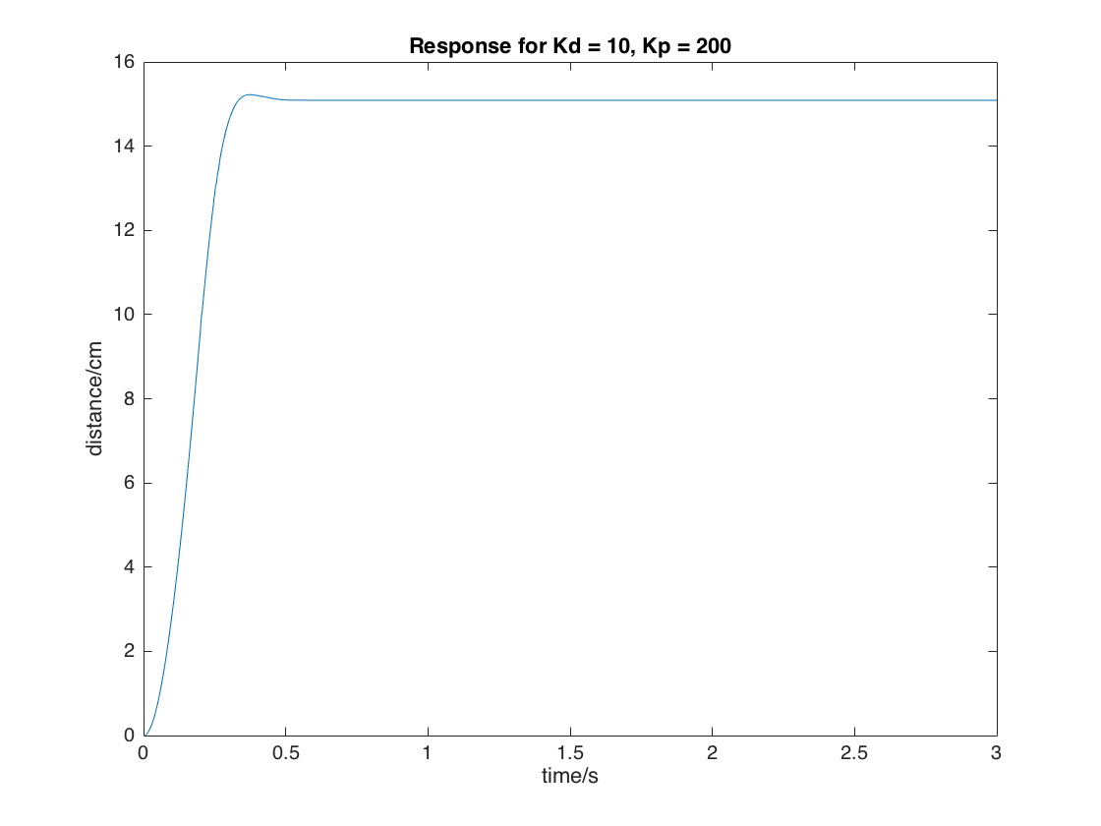

Fig 5. PD Control System Response for Kd=10, Kp/Kd = 20

Note that all systems below use the same configuration as this PD Controller, with Kd = 10 and Kp/Kd = 20.

**5.3 Performance for Different Input Signals**

1. Below is the block diagram for PD controller with pulse input signal of 4s period, 50% pulse width, 0.075 amplitude.

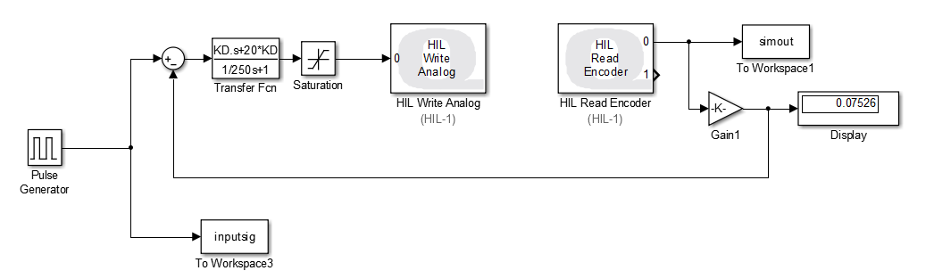

Fig 6. Pulse Input Block Diagram

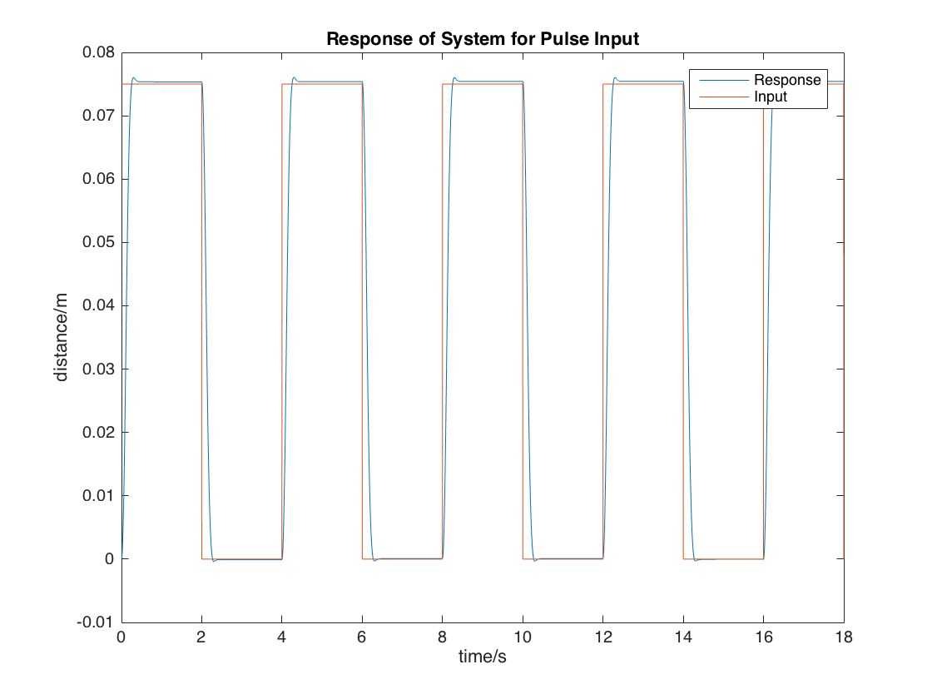

Fig 7. Input Signal and its System Response

2. Input signal of sinusoidal wave, frequency of 1Hz, amplitude of 0.01

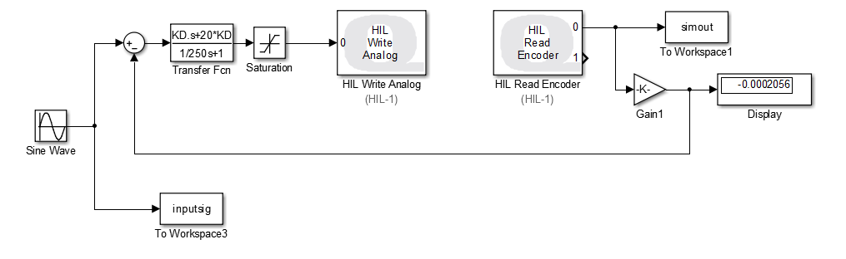

Fig 8. Sine Input Block Diagram

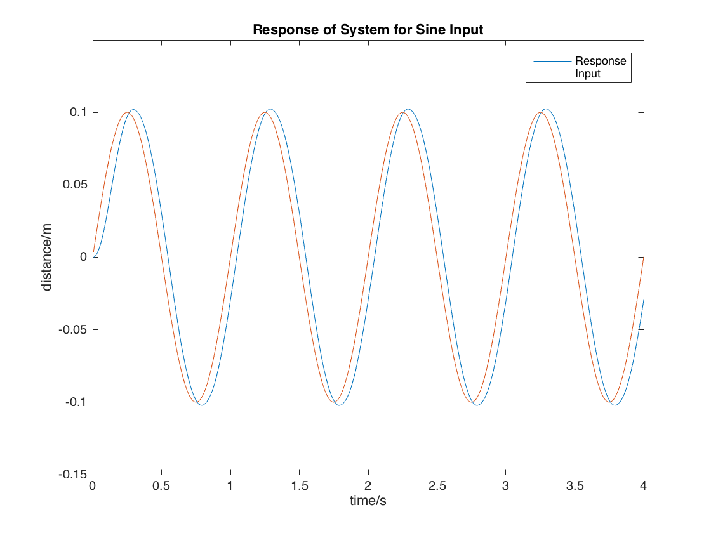

Fig 9. Sine Input Response

3.Input signal of saw wave with amplitude 0.05, frequency 0.1 Hz.

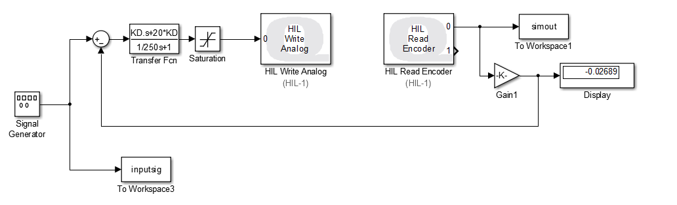

Fig 10. Block Diagram for Saw Input

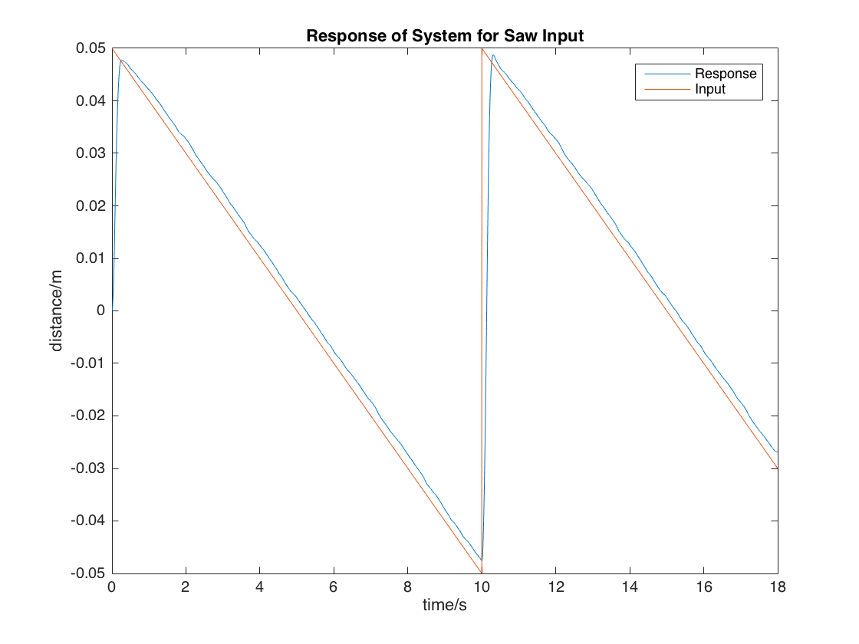

Fig 11. System Response for Saw Wave Input

4.Input signal of sine wave with exponentially decaying amplitude, with the function of 0.15sin(3t)exp(-0.3t). Note that time constant here has to be very small in order for the system to have enough oscillation, therefore the power is chosen to be -0.3.

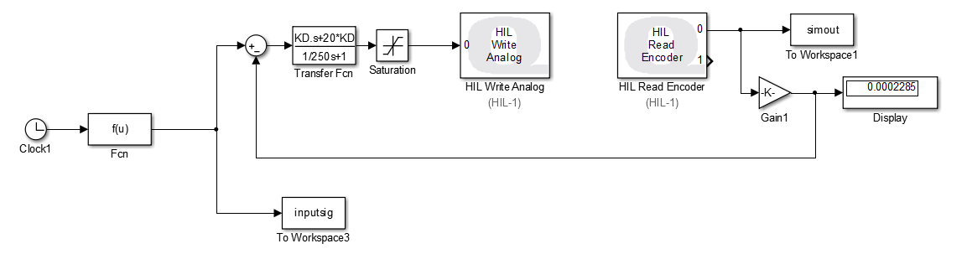

Fig 12. Block Diagram of Exponentially Decaying Sine Wave Function

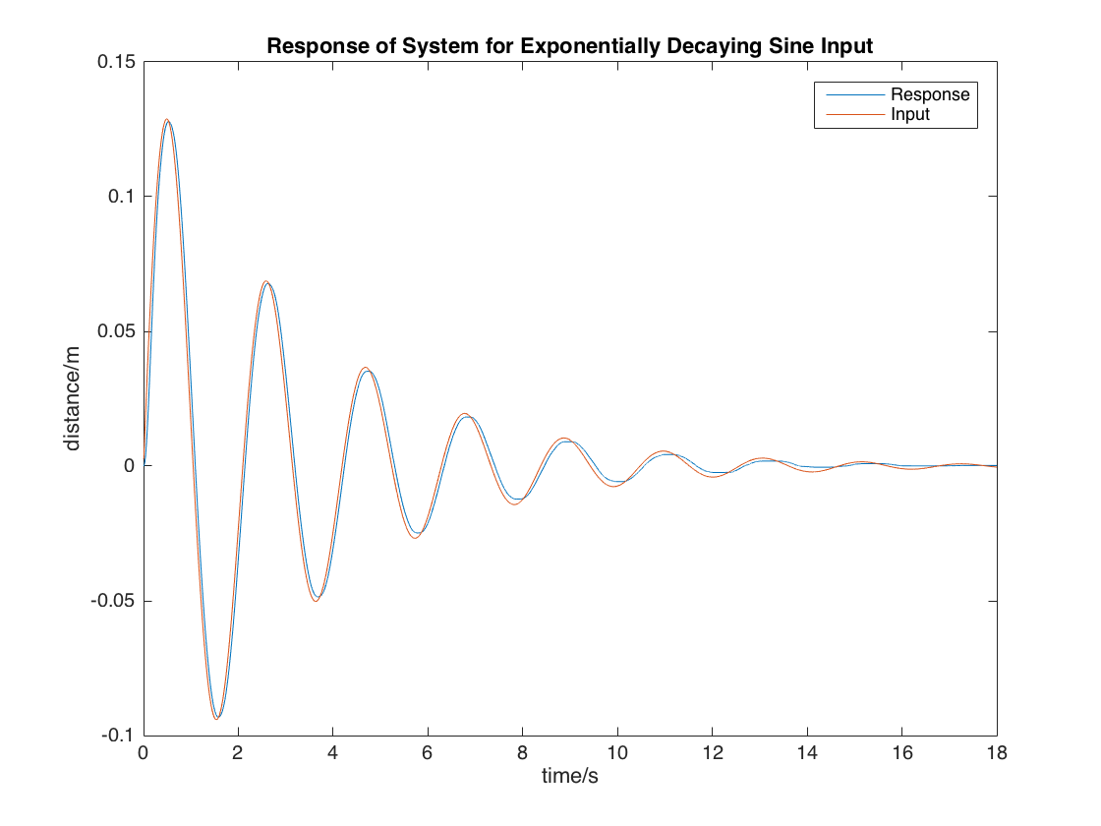

Fig 13. System Response for Exponentially Decaying Sine Wave Function

5. The performance of the controller for different input signals:

a. Generally, the PD controller can track all these inputs relatively well, with small deviations.

|  |  |
| --- | --- |
| Pulse | The response has a slight overshoot, but is able to become steady quickly. The rise time is slower than input but is relatively desirable. |
| Sine | The response quickly stabilizes into a periodical pattern. But always lags behind a bit. A little overshoot. |
| Saw | The rise time is short, but can not reach the maximal or minimal value. |
| Exp Sine | Follows well at first, then damps more quickly than the input, possibly due to drag and other forces |

b. Which signal can the controller track easily? Why?

The controller can track most signals easily. For pulse inputs, it has a slight overshoot, while for others overshoot is insignificant. This is mainly due to the wave’s shape. A sinusoidal wave will decelerate as it goes up, easing the tracking of the controller. On the other hand, for pulse inputs there are a good portion of time that the output coincides with the output, while for other waves there is always some deviation (such as a slight lagging behind). For saw input, response is quick, but is slightly overdamped. It is hard to say which is better.

5.4

1. For step input:

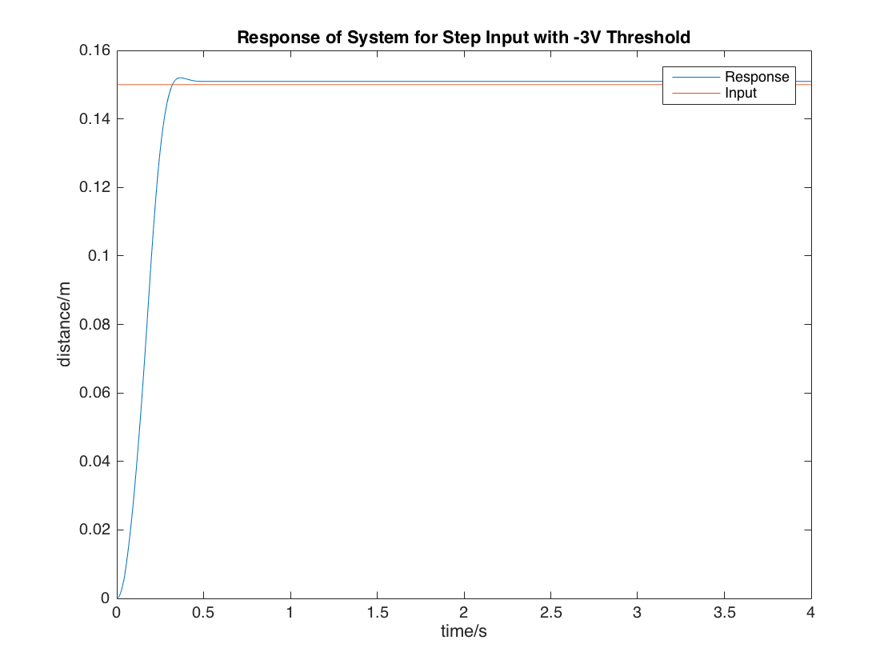

Including a voltage of -3V will affect the performance of the cart. Rise time does not change much, the deviation is probably due to experiment settings. This is because during the rising phase, negative threshold will not affect the cart. Maximum peak increases, probably because of the threshold resulting in the cart’s slower pulling back from going forward too much. Settling time slightly decreases. Again, we can not make sure that whether this value is really decreasing since the deviation is so small that it may well be the system deviation.

|  |  |  |
| --- | --- | --- |
|  | -6V threshold | -3V threshold |
| Rise time: | 0.196 | 0.194 |
| Maximum peak | 0.6545% | 0.6977% |
| Settling time | 0.438s | 0.434s |

2. For sine input:

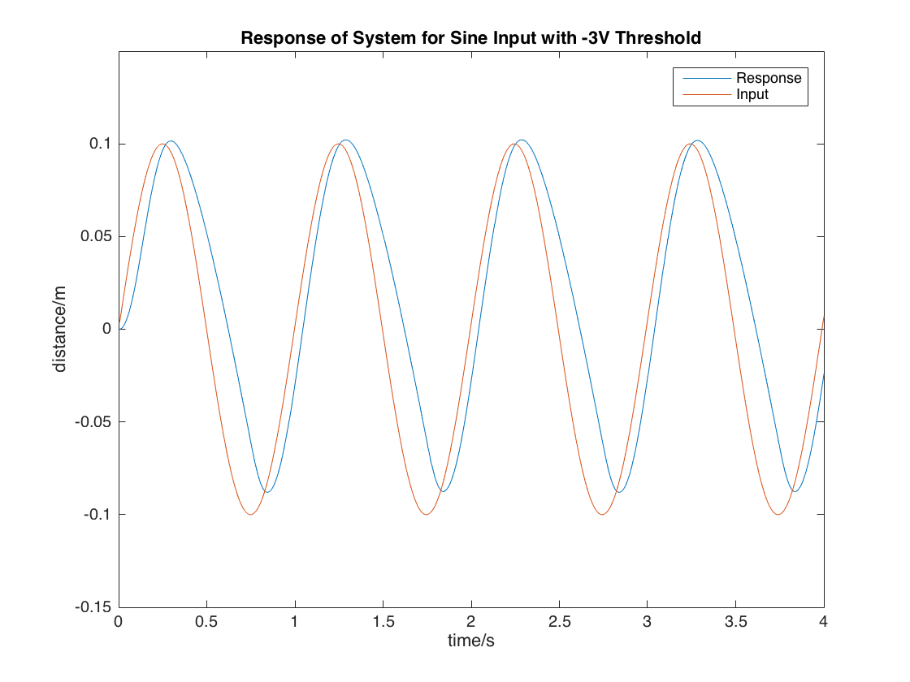

As is shown in the figure, for sine functions, the response rises more rapidly with steeper inclination and less time, while declines more gently. This is because the threshold restricts the cart’s acceleration to move in the inverse direction.