**ME C134 Lab4 Report**

**Rui Wang | Haimin Hu | Yujian An**

**4.1 Implementing Controller in SIMULINK**



Figure 1. Block Diagram of Controller

Note that the question marks on the block diagram were QC board-related blocks. Also, the system input could be changed to anything, including a step input.

**4.2 Running the Controller on the Hardware**

1. Stable, with reference **r** = [0 0 0 0]T

What happens if pendulum is in stable position: it will try to move accelerate to one end of the track and eventually bump into the wall.

2. Manually apply small perturbations

(a) The controller accelerates the cart towards that direction. For example, if the pendulum inclines towards the right due to perturbation, the cart will accelerate to the right until it overtakes the pendulum in the right direction to that it can impose forces to the left on the pendulum and stabilize it.

(b) Plot the cart and pendulum position

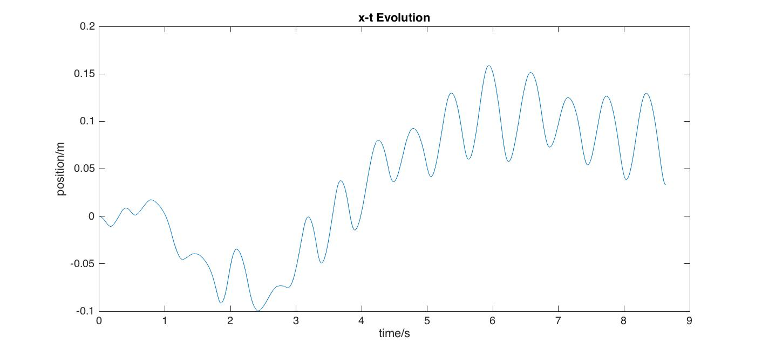

Fig 2. Cart position variation with time

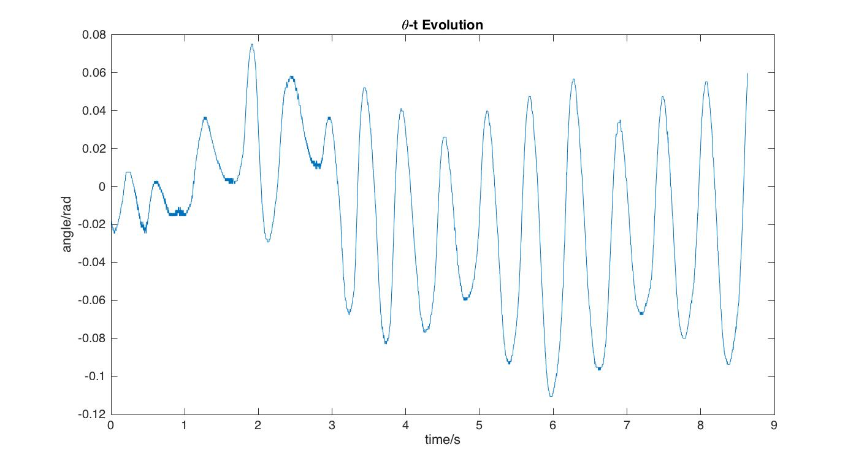

Fig 3. Pendulum angle variation with time

The general performance of the controller is OK. The cart position is smooth, possibly due to friction. It is oscillating a lot about the equilibrium point, overshoot might be large. The pendulum tends to oscillate a lot and there are many small noises on the curve. This implies that the controller still has problems.

The hardware’s oscillation is because that the system is in unstable equilibrium state and any small perturbation will cause it to fail, therefore it needs to actively balance and compensate for any small inequilirium induced.

3. Introduce a sine wave reference signal. **r** = [Msinwt 0 0 0]T

(a) **Note that in this section (a), the cart velocity is very noisy and will pollute out plot, so we decide to plot them separately from cart position.**

(a1) M = 0.05, w = 1

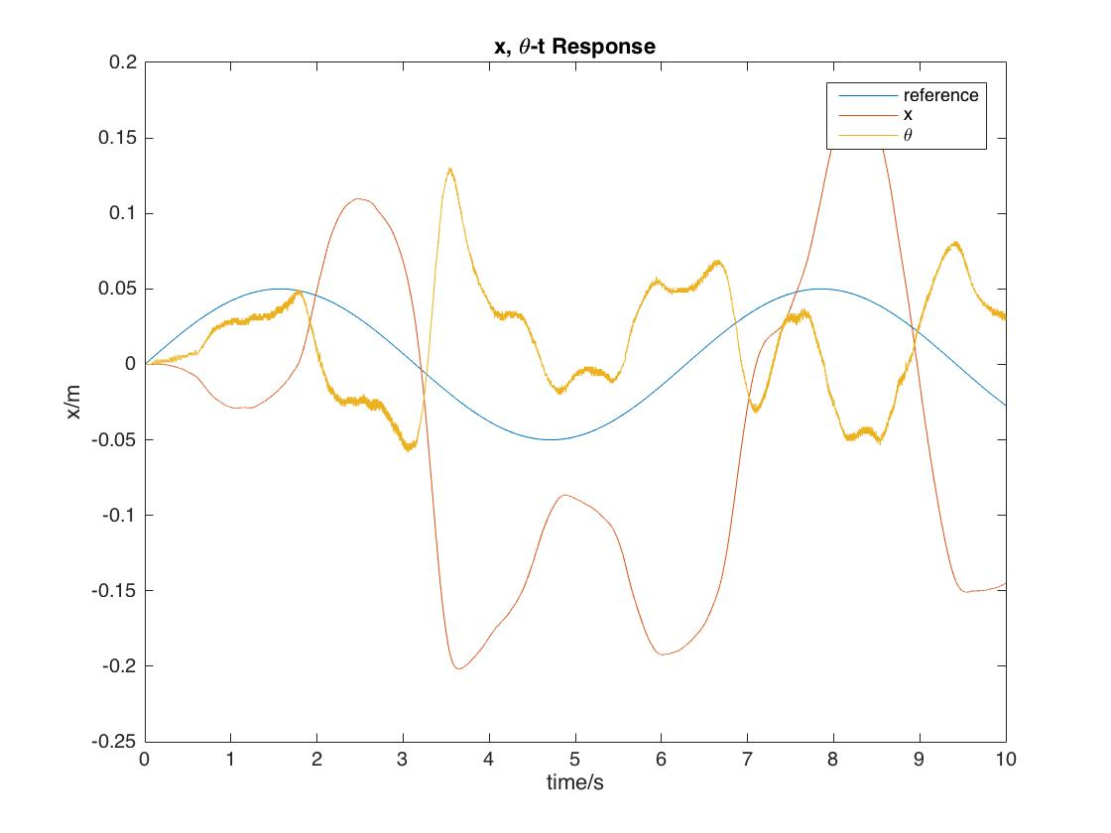

Fig 4. System response for M = 0.05, w = 1

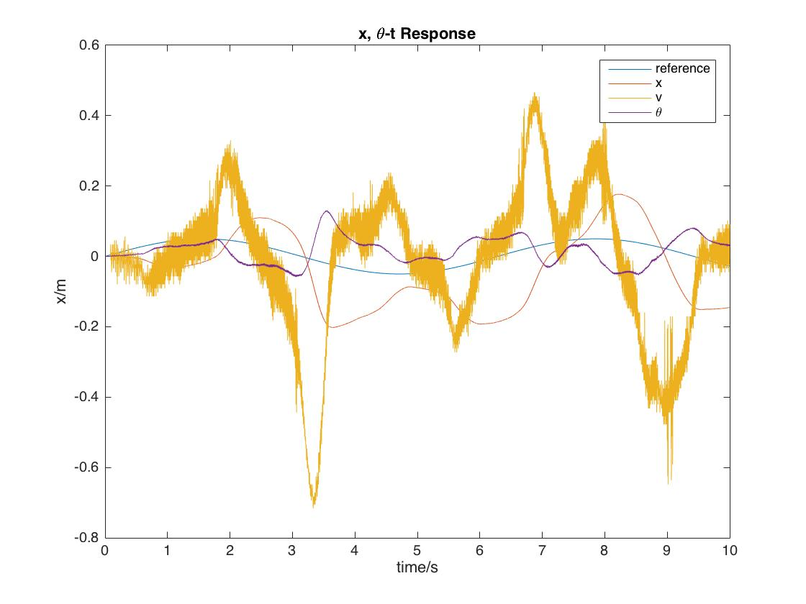

Fig 5. Including velocity into the plot above

Calculate the gain and phase with MATLAB data cursor tool: gain: 3.2 Phase:270-0.12 $π$

(a2) M = 0.1, w = 2

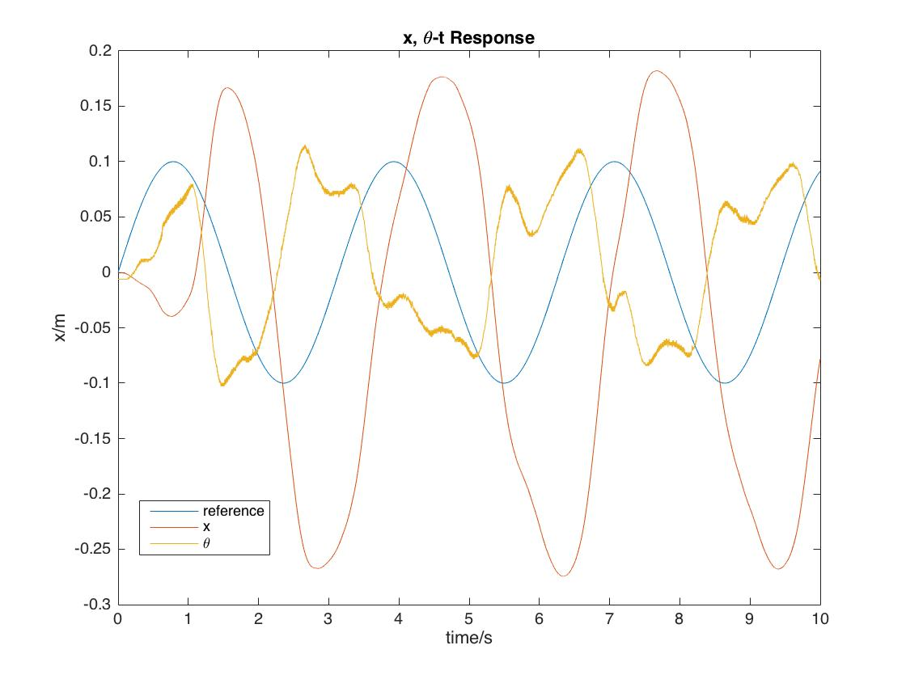

Fig 5. System response for M = 0.1, w = 2

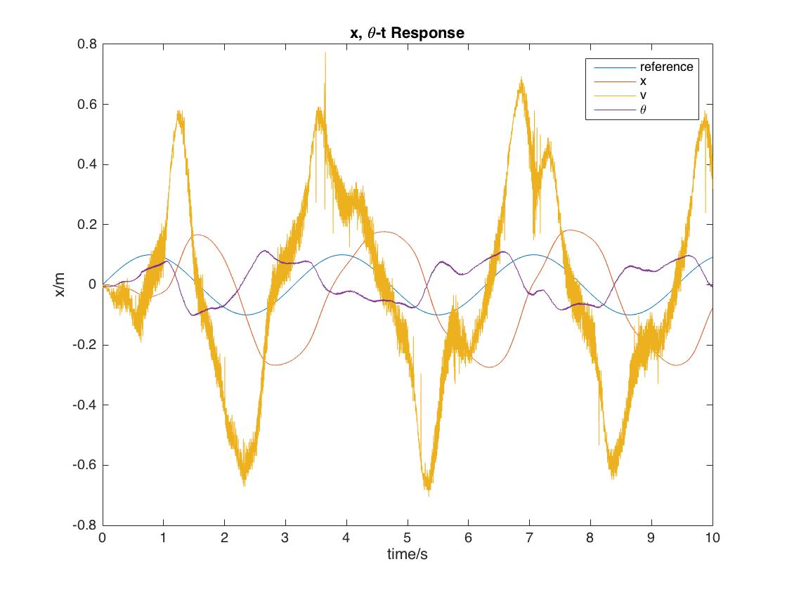

Fig 5. Including velocity into the plot above

Calculate the gain and phase with MATLAB data cursor tool: gain: 2.25 Phase:270-0.445 $π$

(a3) M = 0.1, w = 5

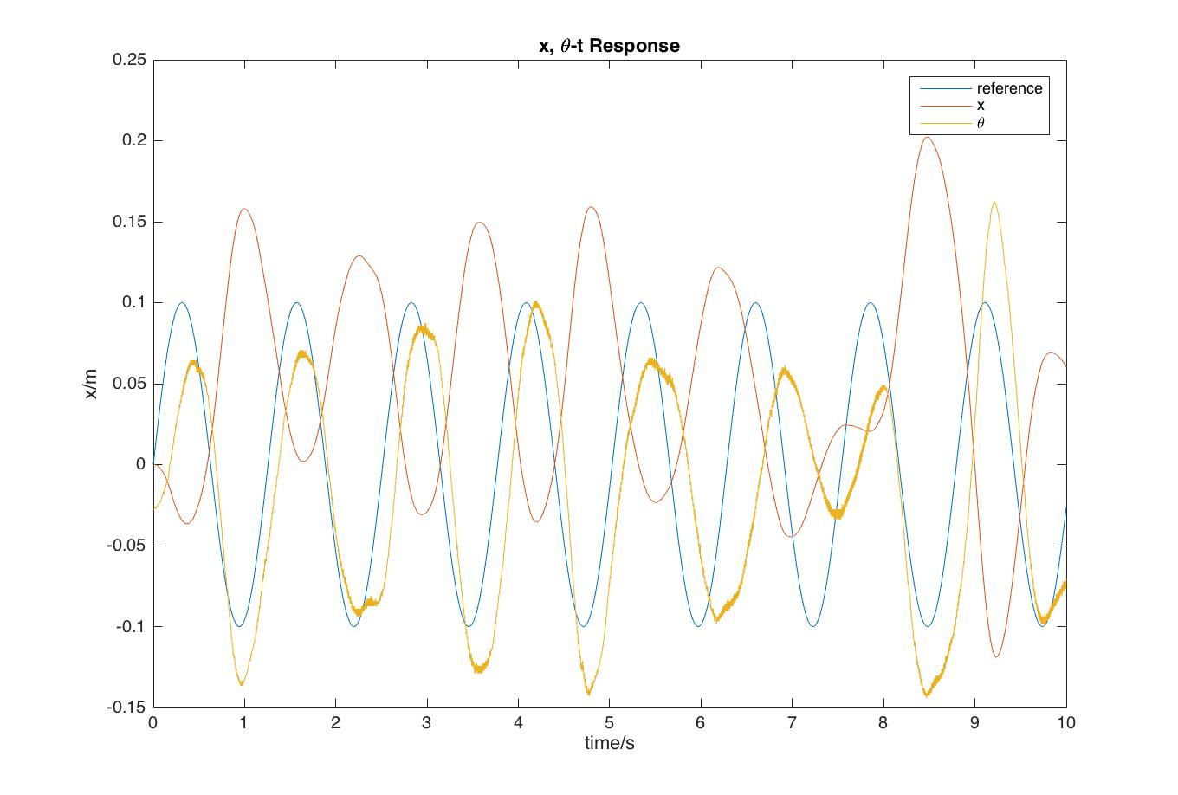

Fig 5. System response for M = 0.1, w = 5

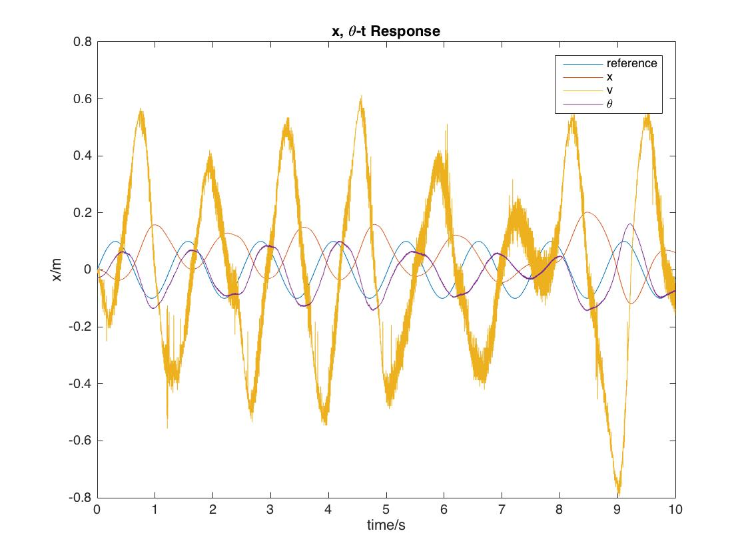

Fig 5. Including velocity into the plot above

Calculate the gain and phase with MATLAB data cursor tool: gain: 1.5 Phase: 270-1.1 $π$

(a4) Locate these frequencies on Bode plot and see compare them to theoretical results.

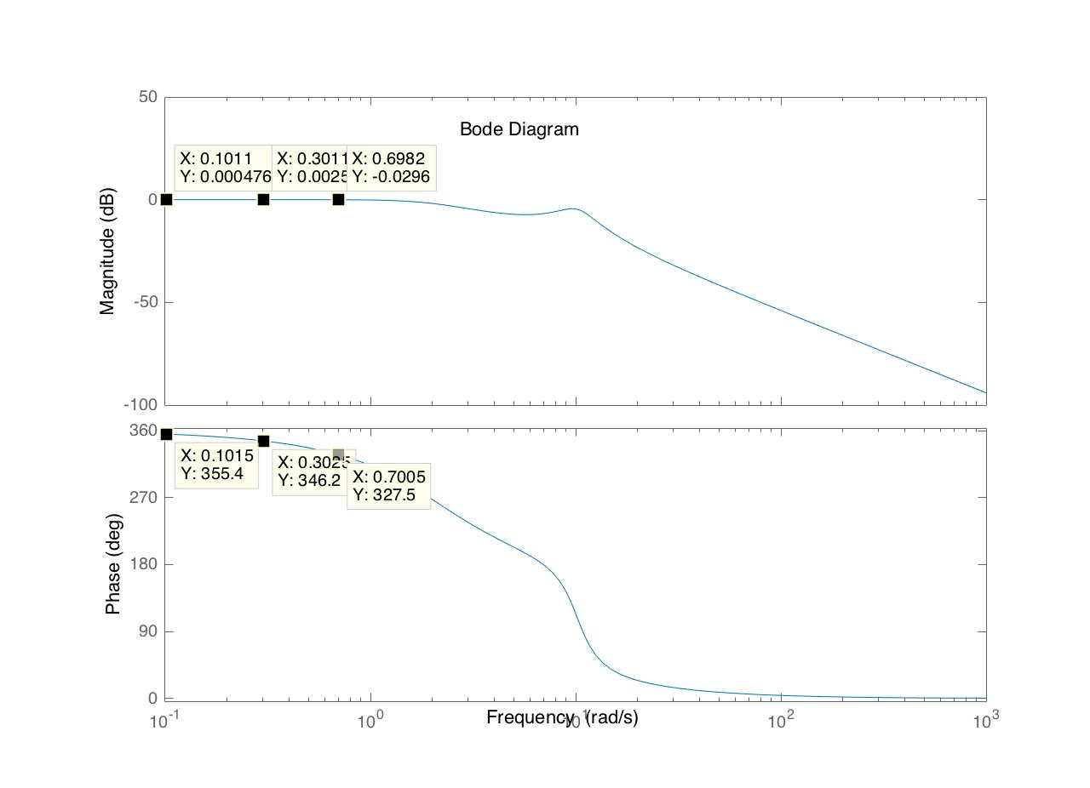

|  |  |  |  |  |  |
| --- | --- | --- | --- | --- | --- |
| w | 20Log Gain | Gain theoretical | Gain actual | Phase theoretical | Phase actual |
| 1 | -0.163 | 0.98 | 3.2 | 313.2 | 338.4 |
| 2 | -1.821 | 0.81 | 2.25 | 267.4 | 279.9 |
| 5 | -7.162 | 0.44 | 1.5 | 203.3 | 172 |

The value obtained on Bode Diagram is different from that from the experiment plot, for magnitude they are very different, but for phase the general trend is the same. This is because the cart is not behaving exactly according to the model. Friction and other factors are inducing deviations that are significant.

W=1: 0, 0;

W=2: 0.3010, 0.00256;

W=5: 0.6989, -0.0296.

(b) After changing the pole to -7.2+2.9i, -7.2-2.9i, -2+1.7i, -2-1.7i, K can be derived with equation det(sI - Ak) = 0. K = [-13,-15,-50,-10].

We obtain the following results. We can see from the graph that there is not too much difference, since our poles are not moved to very far away.

Note that due to hardware problems, we decided not to let the cart run with a sinusoidal input. Instead we let it run with a stable input (x is constant 0). The cart is still able to stabilize under with this changed closed-system pole.

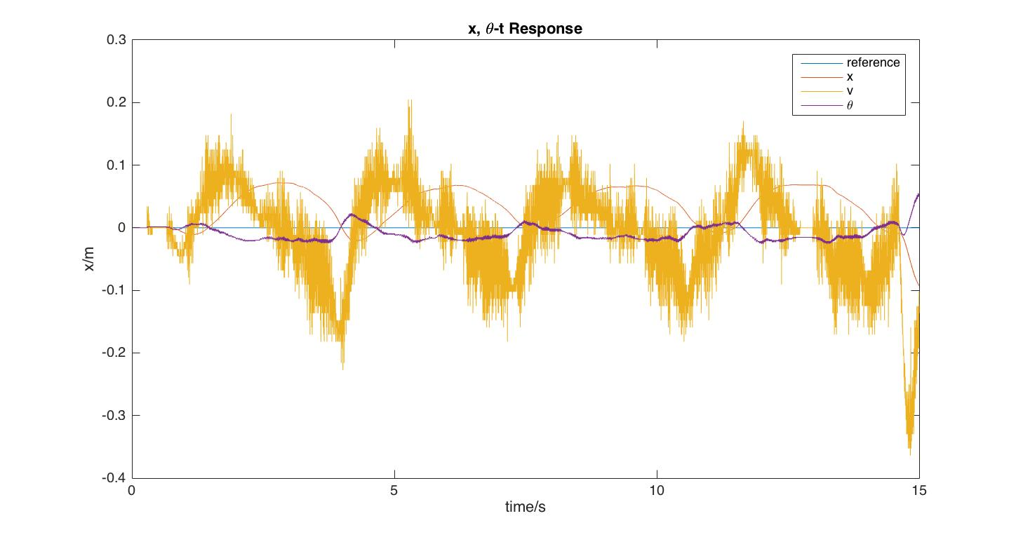

Figure 7. System Response

**4. Plot the cart velocity and pendulum’s angular velocity**

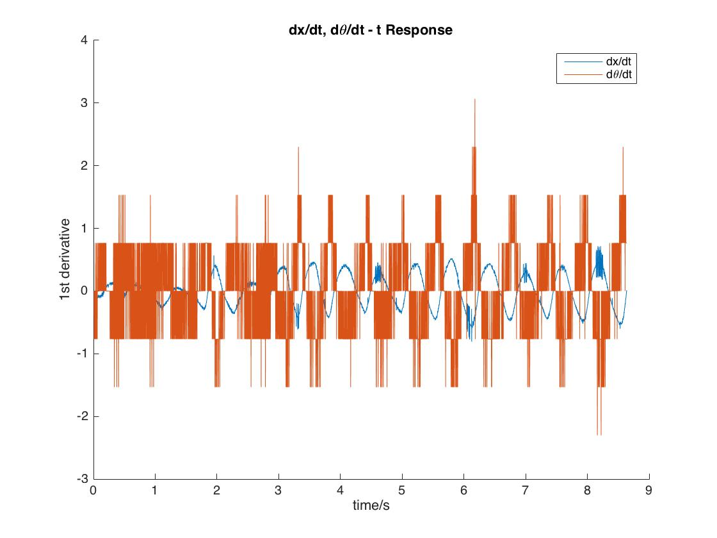

Fig. The angular velocity and velocity response

This plot shows the behavior of the system when input is zero, namely, when we want it to stabilize at origin.

The result shows that there are a lot of noises for the first derivative of the cart position and pendulum angle. Especially for the pendulum, the velocity is oscillating very fast. This indicates that our system is not robust and steady enough.