**ME C134 Lab6b Report**

**Rui Wang | Haimin Hu | Yujian An**

**4.1 Implementing Controller in SIMULINK**



Figure 1. Block Diagram of Controller

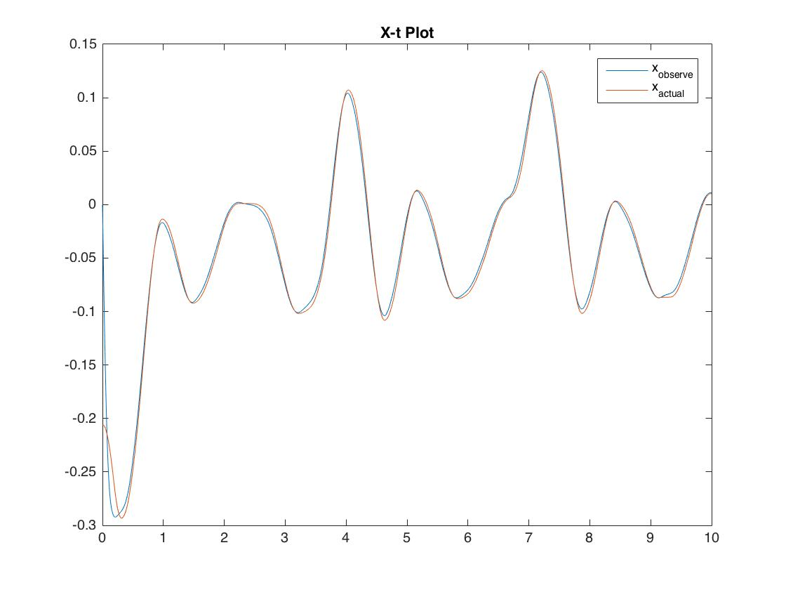

Figure 2. Comparison between estimated and actual x

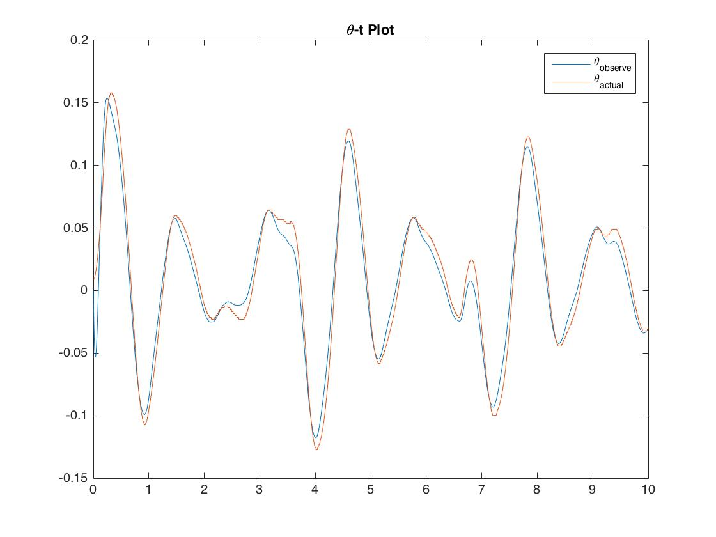

Figure 3. Comparison between estimated and actual theta

We can see that the estimation follows the actual state variables quite well. (Zero reference with small perturbation).

**4.2 Experiments**

**4.2.1 Zero Reference**

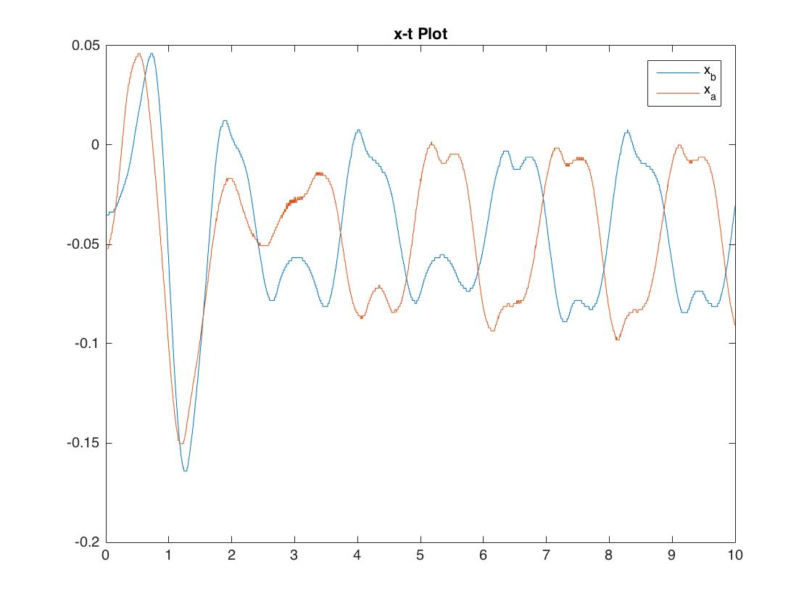

Figure 4. Comparison with(b) and without(a) an observer

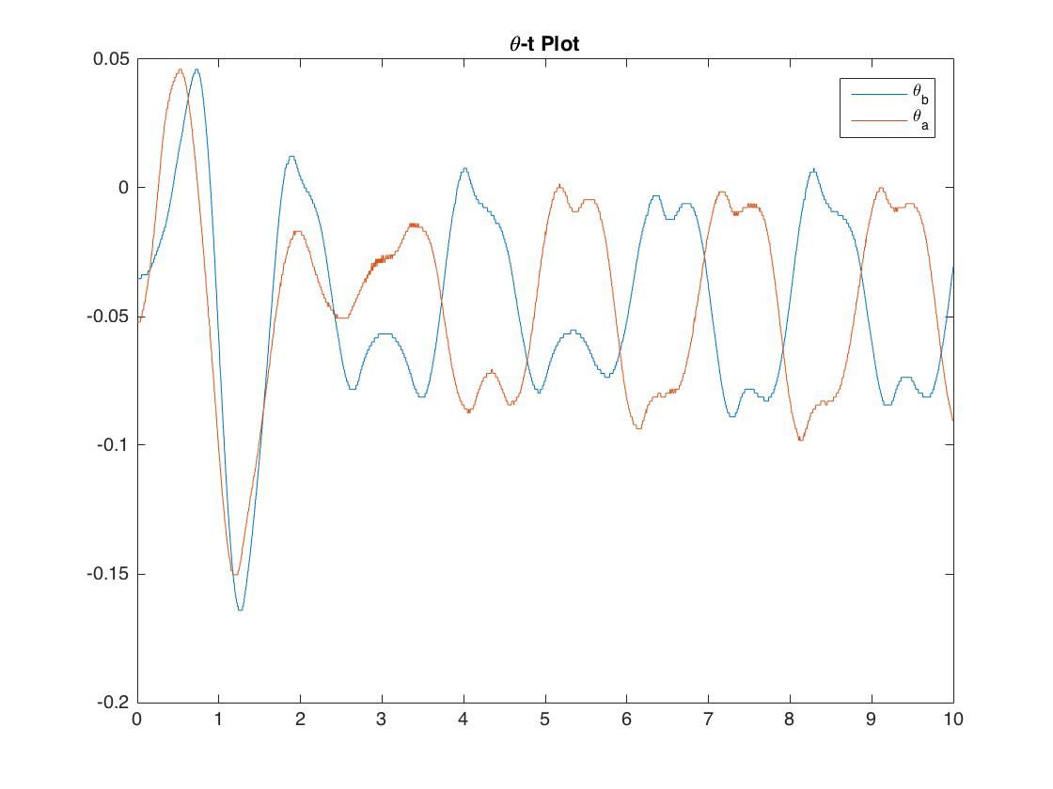

**Figure 4. Comparison with(b) and without(a) an observer**

We can see that for zero input, both performances look similar, except that with an observer, the curve is a bit smoother.

**4.2.2 Zero with Perturbation**

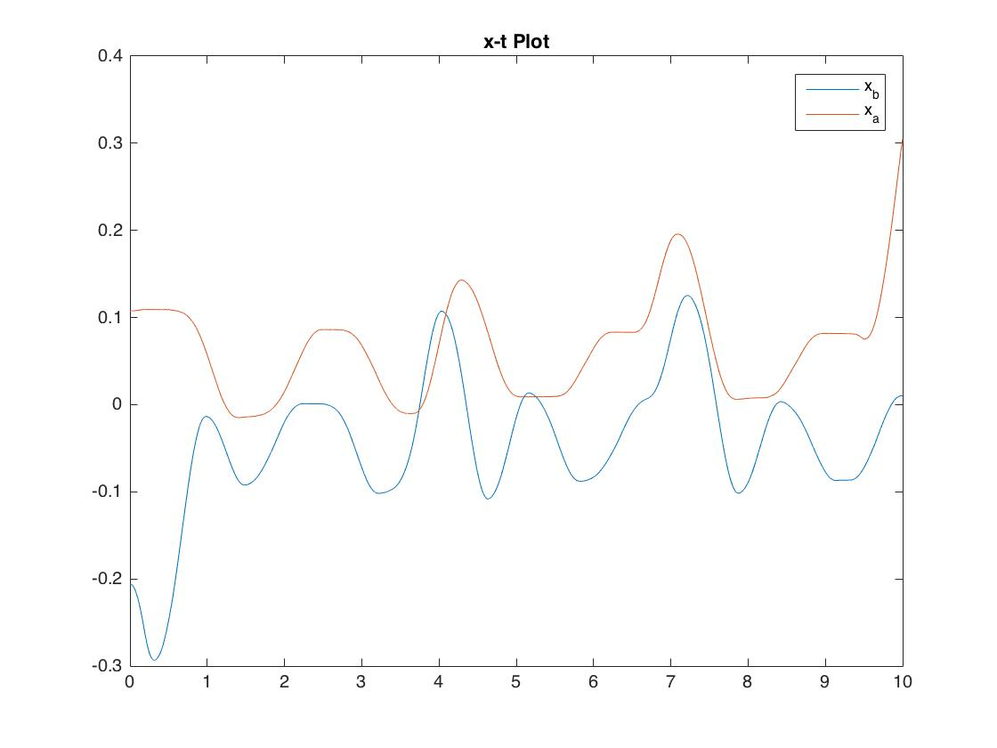

Figure 6. Comparison with(b) and without(a) an observer

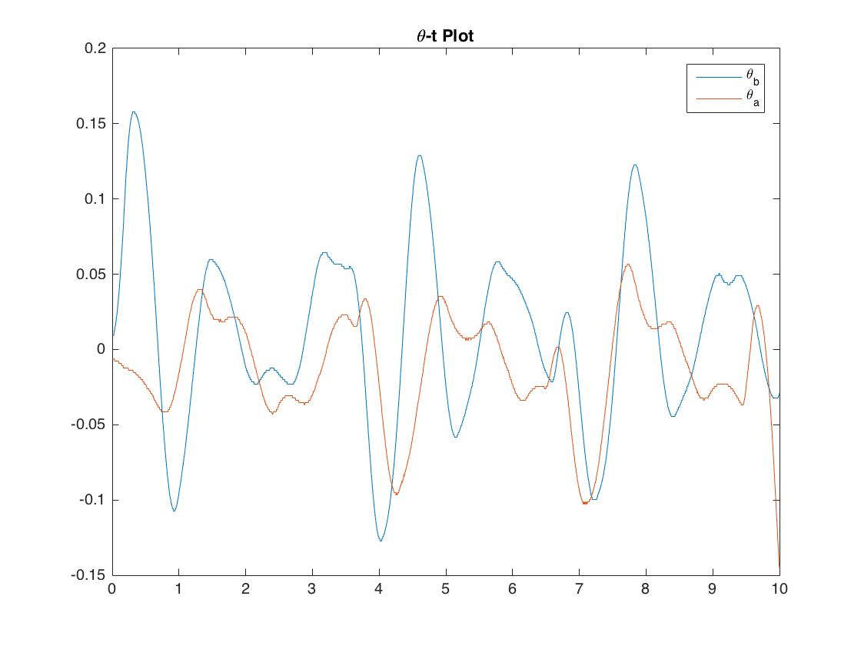

Figure 6. Comparison with(b) and without(a) an observer

From the comparison we can see that for x, with an observer the cart error is smaller. For theta, observer does not alleviate the oscillation, but it makes the curve a bit smoother. However, since the perturbation is not exactly the same, we can not guarantee the effect of observer from this comparison.

4.2.3 Sine

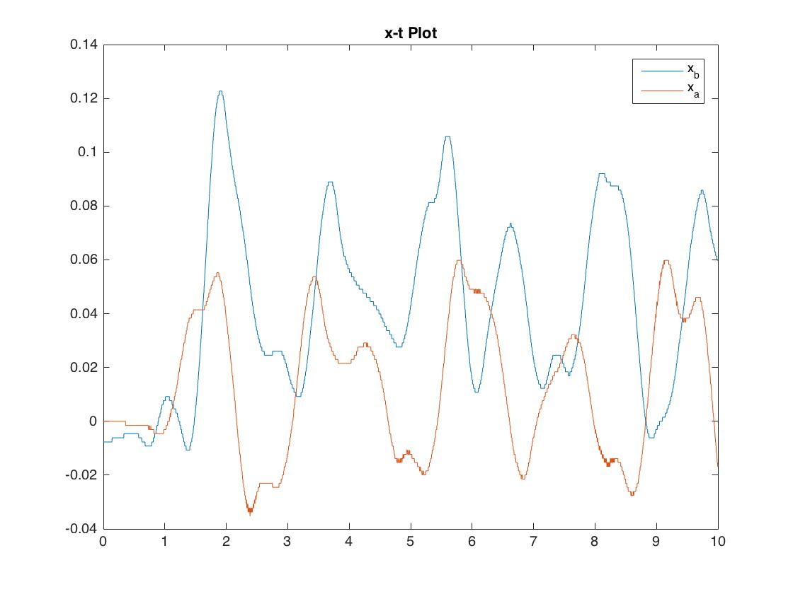

Figure 8. Comparison with(b) and without(a) an observer

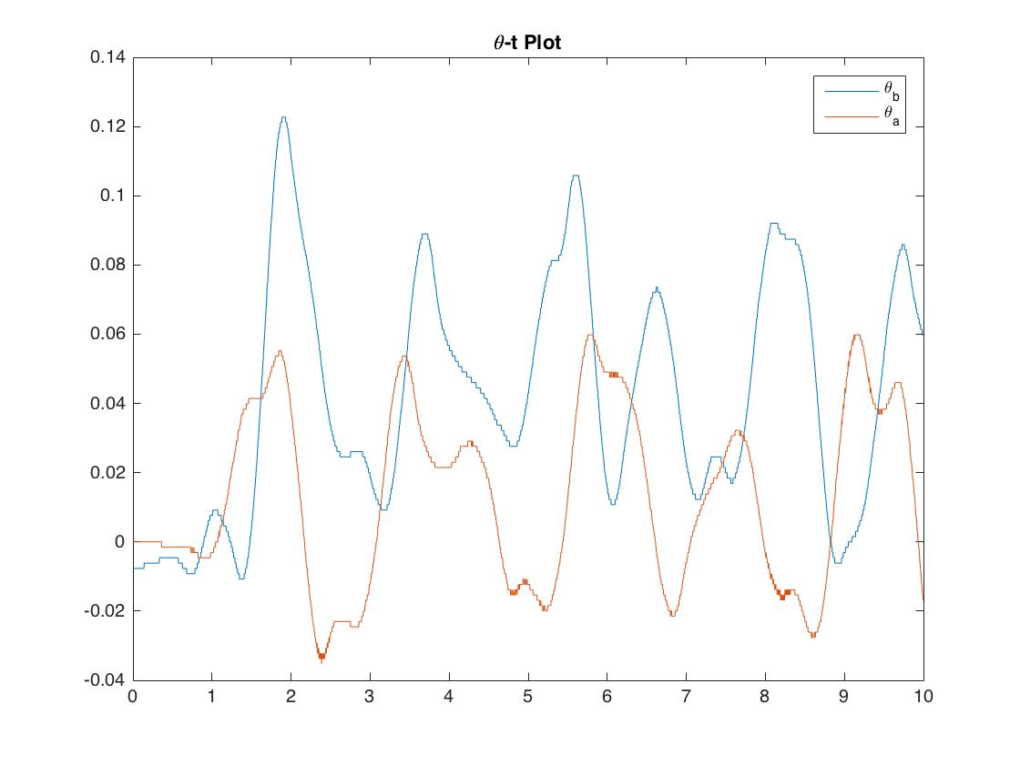

Figure 9. Comparison with(b) and without(a) an observer

For sinusoidal oscillation, the performance with an observer seems worse. There is a little shift upwards, and oscillation is a bit greater. This is might be due to friction and other factors that affect the performance and estimation.

**4.3 Velocity**

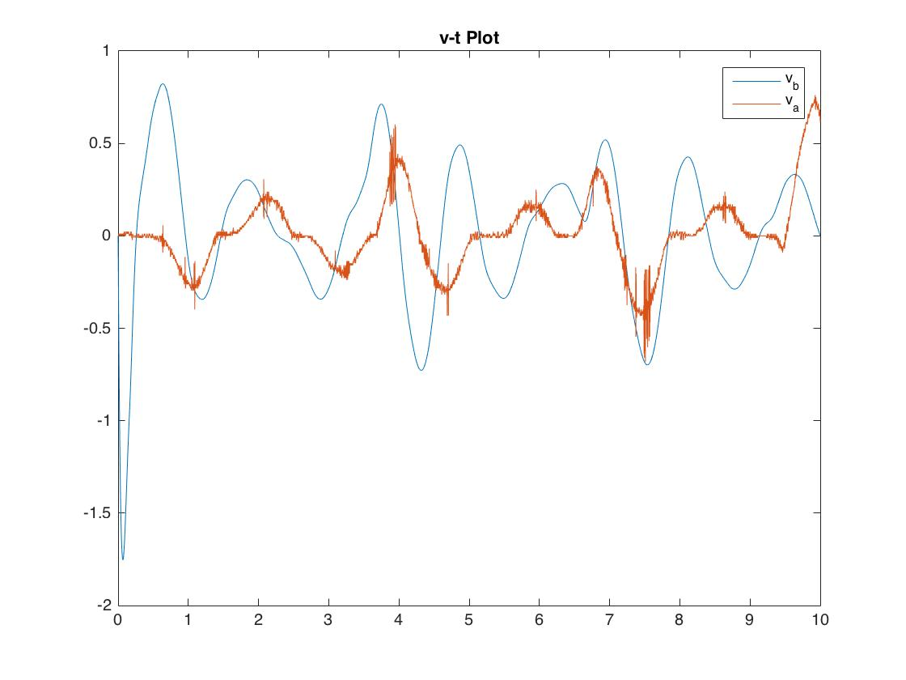

Figure 9. Comparison of cart velocity with(b) and without(a) an observer

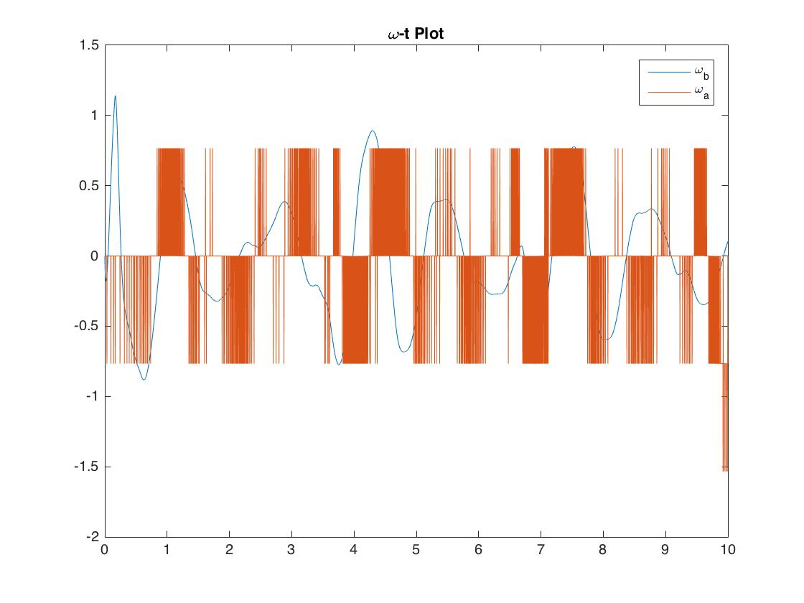

Figure 10. Comparison of angular velocity with(b) and without(a) an observer

We can see that the estimated velocity is much smoother than the measured velocity. Noises are filtered. While for the derivative method, the velocity is very fussy and cannot represent the real velocity because all noises are magnified.

**4.4 Which scheme yields better performance?**

For this problem alone, the one without observer seems better. Because it is following the input more closely and the oscillation is smaller in most cases. And we are only interested in the cart position and pendulum angle so the velocity does not matter much here. However, the noises are magnified and in other potential applications (for example if we want the cart to follow a certain velocity), the controller with an observer might behave better.